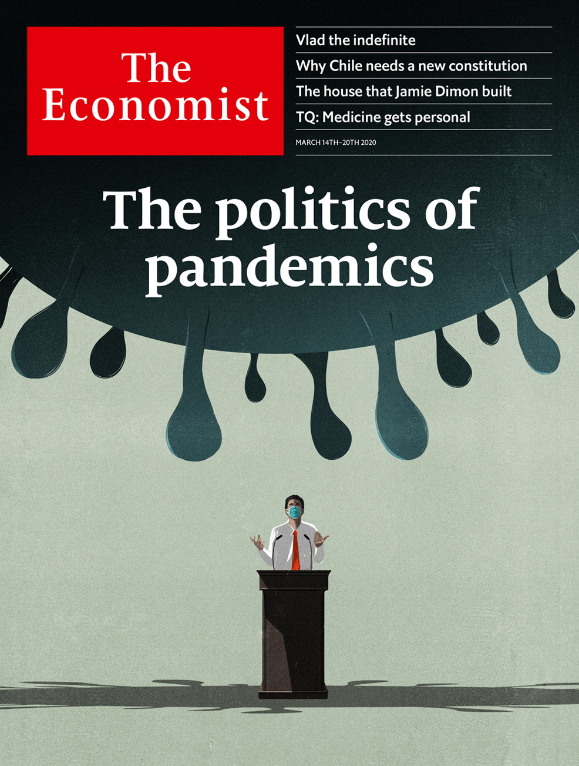

# Table of Contents

The world this week

Politics this week

Business this week

KAL’s cartoon

Leaders

Covid-19: The politics of pandemics

Financial conditions: V is for vicious

Russia: Vlad the indefinite

Latin America: How to reform Chile

Succession at JPMorgan Chase: Mission accomplished

Letters

Letters to the editor: On Bernie Sanders, green technology, Mexico, Chinese MBAs, facial expressions

Briefing

The covid-19 virus: Anatomy of a killer

JPMorgan Chase: The house that Jamie built

United States

Public health: Dropping the ball

Covid-19 and the economy: Spluttering

The Democratic primaries: Berning out

Climate change: Green Texas

Rural policing: Country cops

Lexington: Digital myths and political reality

The Americas

Chile: A model country in need of remodelling

Asia

Myanmar’s army: Making war and law

Traffic on Everest: High and climbing

Politics in Afghanistan: Twin peaks

Sectarianism in India: First the mob, then the law

Banyan: Apocalypse, but no deliverance

China

Politics and the coronavirus: A gesture to the sequestered

Covid-19 and farmers: The other 40%

Chaguan: When nationalism bites back

Middle East and Africa

The politics of cheap oil: The big squeeze

Tanzania and the World Bank: Bankrolling bigotry

Traffic in Nigeria: Two wheels bad, four wheels better

Iran and covid-19: Sickly state

Lebanon: Resilient no more

Europe

Russia: The prisoner in the Kremlin

French local elections: A kicking on the way

Women and work: Why Germany’s pay gap is so large

Charlemagne: Pour décourager les autres

Britain

The NHS and covid-19: Is it ready?

The Budget: Economic medicine

Scottish politics: Sturgeon at bay

House names: Dun Namin’

Technology startups: Unicorn lead

Policing the police: Watchdogs without bite

Looking for gardeners: Green gods

Bagehot: The meaning of conservatism

International

Covid-19: All’italiana

Deaths from covid-19: Where will it be worst?

Technology Quarterly

Personalised medicine: Populations of one

The human genome project: Welcome to you

Genes and treatment: Side-effects include death

Congenital disease: Broken

The pharmaceutical industry: Kill or cure?

The sum of all lives: The coming of the datome

Business

Technology in India: Silicon subcontinent

Coronavirus and business: The anti-covid industrial complex

Bartleby: In sickness and in health

Cloud business: Altocumulus

Corporate purpose: Going in circles

Schumpeter: The rise and rise of Accenture

Finance and economics

The cash question: In a sea of debt

Oil prices: Scorched earth

Italy in crisis: Mr Conte counts the costs of covid

The bear facts: Entering a bear market

Indian banks: When Yes means no

Buttonwood: Involuntary code

Free exchange: The ravages of time

Science and technology

Big wet data: An ocean of things

Ecology: Siren smell

Atomic energy: Fun-sized fission

Palaeontology: The smallest dinosaur?

Books and arts

Music and protest: The beat goes on

Global scourges: The famished

Future histories: Fragments and ruins

Fiction of reality: Brothers in arms

Johnson: Old wine, new bottles

Economic and financial indicators

Economic data, commodities and markets

Graphic detail

Covid-19 in cities: Ghost towns

Obituary

Freeman Dyson: Infinite possibilities



### Friday, March 13, 2020

|  |  |
| --- | --- |
| The world this week | 3 |
| Leaders | 5 |
| Letters | 1 |
| Briefing | 2 |
| United States | 6 |
| The Americas | 1 |
| Asia | 5 |
| China | 3 |
| Middle East and Africa | 5 |
| Europe | 4 |
| Britain | 8 |
| International | 2 |
| Technology Quarterly | 6 |
| Business | 6 |
| Finance and economics | 7 |
| Science and technology | 4 |
| Books and arts | 5 |
| Economic and financial indicators | 1 |
| Graphic detail | 1 |
| Obituary | 1 |

|  |  |  |
| --- | --- | --- |
|  | Sections | Leaders |

The world this week

Politics this week

.

Business this week

.

KAL’s cartoon

.

|  |  |  |
| --- | --- | --- |
|  | Sections | Leaders |

|  |  |  |  |
| --- | --- | --- | --- |
|  | Articles | Sections | Next |

# Politics this week

Mar 14th 2020 |

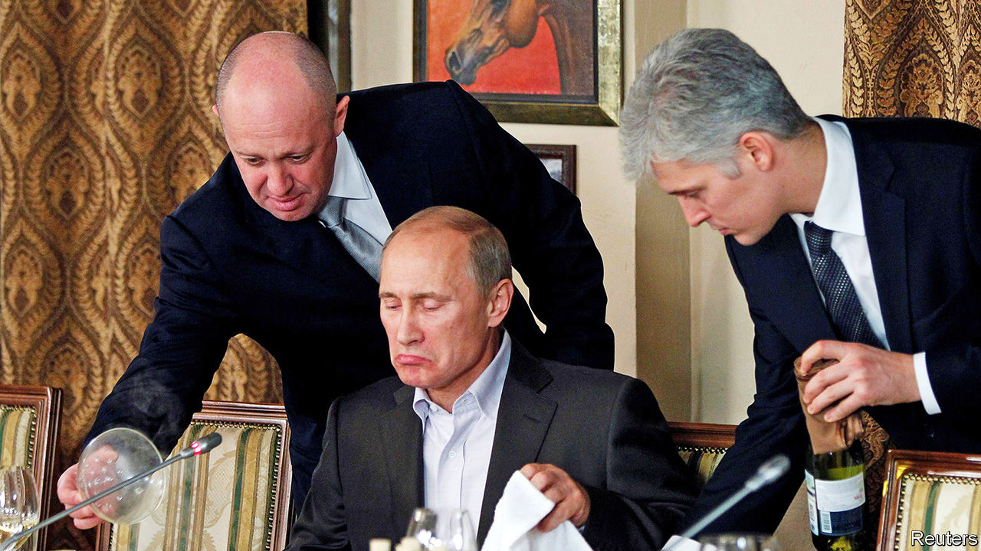

Vladimir Putin, Russia’s president, said that he would be prepared to continue in office past 2024, when his fourth and supposedly final presidential term expires. The Russian parliament voted this week to amend the constitution to reset to zero the number of consecutive terms that he has already served. See article.

The trial began in the Netherlands of four men—three Russians and a Ukrainian—who are charged with involvement in the shooting down of Malaysian Airlines flight MH17 over eastern Ukraine in 2014. The four were not in court, having refused to turn themselves in, but the court decided that the trial can go ahead without them.

Rishi Sunak, Britain’s new chancellor of the exchequer, had been expected to increase borrowing. But the scale of fiscal loosening in the government’s budget was still surprising. A package of measures tallied up to a £30bn ($38bn) splurge, almost half of it for the emergency response to covid-19. The National Health Service will benefit the most, but a reserve fund for businesses and workers will also help with the economic hit the virus will cause. See article.

## Bernie burned by Biden

Joe Biden won the Michigan primary and several other states in the latest Democratic contests. Bernie Sanders could not repeat the surprise win he chalked up in Michigan four years ago. Kamala Harris and Cory Booker, two former candidates, endorsed Mr Biden, who looks like he has the nomination all but sewn up. See article.

Harvey Weinstein was sentenced to 23 years in prison for his recent convictions for rape and sexual assault. The movie mogul has been cleared of charges that carry even lengthier prison terms.

Donald Trump ditched Mick Mulvaney as his chief of staff, and named Mark Meadows, a loyal congressman, as his replacement. Mr Mulvaney was the president’s third chief of staff, but fell foul of his boss some time ago, especially when he went off script about Mr Trump withholding aid from Ukraine in return for political favours.

## Fighting for her life

Millions of Mexican women stayed home from work and school to protest against murders of women. The strike was spurred by recent brutal killings. The country classified 980 murders last year as “femicides”, that is, committed because of the victim’s sex, up from 411 in 2015.

Jair Bolsonaro, Brazil’s president, dined with Donald Trump at his Florida estate, Mar-a-Lago. Brazil and America signed an agreement on defence technology that could lead to more American purchases of Brazilian weaponry.

Guyana’s chief justice blocked the Elections Commission from declaring the result of a general election in the country’s biggest electoral district after foreign observers said vote counting had “lacked credibility and transparency”. Initial results gave victory to the government.

## Circles of power

Both the incumbent, Ashraf Ghani, and his main electoral opponent, Abdullah Abdullah, were sworn in as president of Afghanistan in rival inauguration ceremonies. In the meantime, talks between Afghan politicians and the insurgents of the Taliban, which had been due to start on March 10th, are on hold, as the two sides argue about a planned prisoner exchange. See article.

Myanmar’s army vetoed constitutional amendments that would have reduced its political power. The ruling National League for Democracy, led by Aung San Suu Kyi, had proposed shrinking the proportion of MPs appointed by the army and making it easier to amend the constitution, among other things. See article.

North Korea launched several missiles into the Sea of Japan in an apparent military drill. It was its second missile test in the space of a week.

## Lebanese bind

Mired in economic crisis, Lebanon did not repay a $1.2bn Eurobond, defaulting on its debts for the first time. Foreign reserves have plummeted and unemployment is rising. The government will try to negotiate a restructuring with its creditors, as it struggles with debt that is about 170% of GDP. See article.

Two Americans and a Briton were killed by a rocket attack on a military base near Baghdad. Tensions have been high in Iraq, as Iranian-backed militia have sworn revenge for America’s assassination of a senior Iranian commander at Baghdad airport in January.

Prince Ahmed bin Abdel-Aziz, a brother of Saudi Arabia’s King Salman, and Prince Muhammad bin Nayef, a nephew of his who was previously the crown prince, were arrested with several other senior figures. The arrests were presumably ordered by the current crown prince, Muhammad bin Salman, who runs the show. This suggests that opposition to the crown prince’s authoritarian ways may be stirring in rival royal circles.

Abdalla Hamdok, the prime minister of Sudan, survived a gun-and-bomb attack on his motorcade. The assassination attempt highlights the precariousness of the country’s transition towards democracy.

## The coronavirus crisis

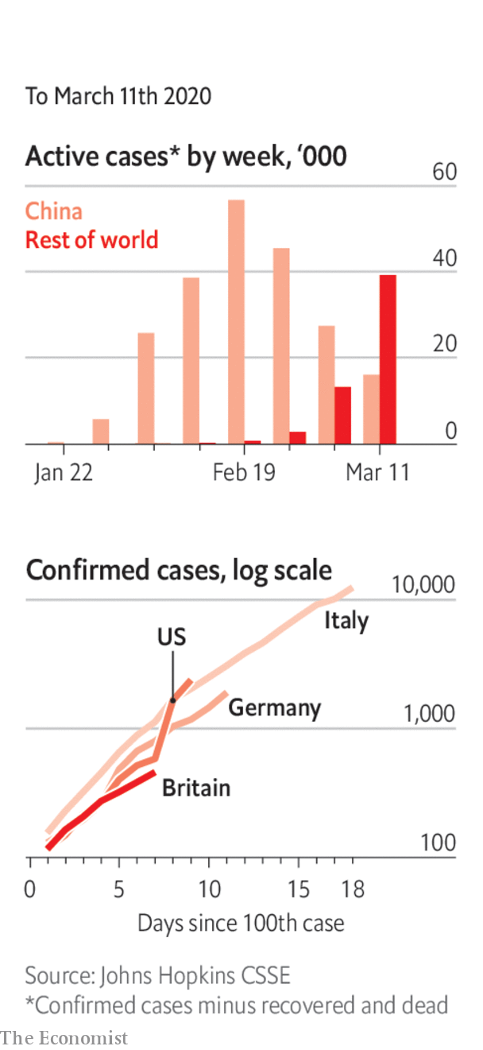

The World Health Organisation officially declared covid-19 to be a pandemic: “We have rung the alarm bell loud and clear.” See article.

America announced a travel ban on visitors from Europe (except Britain and Ireland).

The lockdown in northern Italy was extended to the whole country. Most shops were ordered to close.

In Germany, Angela Merkel said that 60-70% of the country’s population may contract the disease at some point.

Xi Jinping said there had been a positive turn to contain covid-19 in the province of Hubei. Outside Hubei, China reported three days with no newly confirmed cases of local infection.

The central bank of Nigeria will, in effect, ban imports of hand sanitiser. The governor said this would boost local production.

For our latest coverage of the virus and its consequences please visit [economist.com/coronavirus](http://economist.com/coronavirus) or download the Economist app.

This article was downloaded by calibre from <https://www.economist.com/the-world-this-week/2020/03/14/politics-this-week>

|  |  |  |  |
| --- | --- | --- | --- |
|  | Articles | Sections | Next |

|  |  |  |  |
| --- | --- | --- | --- |
| Previous | Articles | Sections | Next |

# Business this week

Mar 14th 2020 |

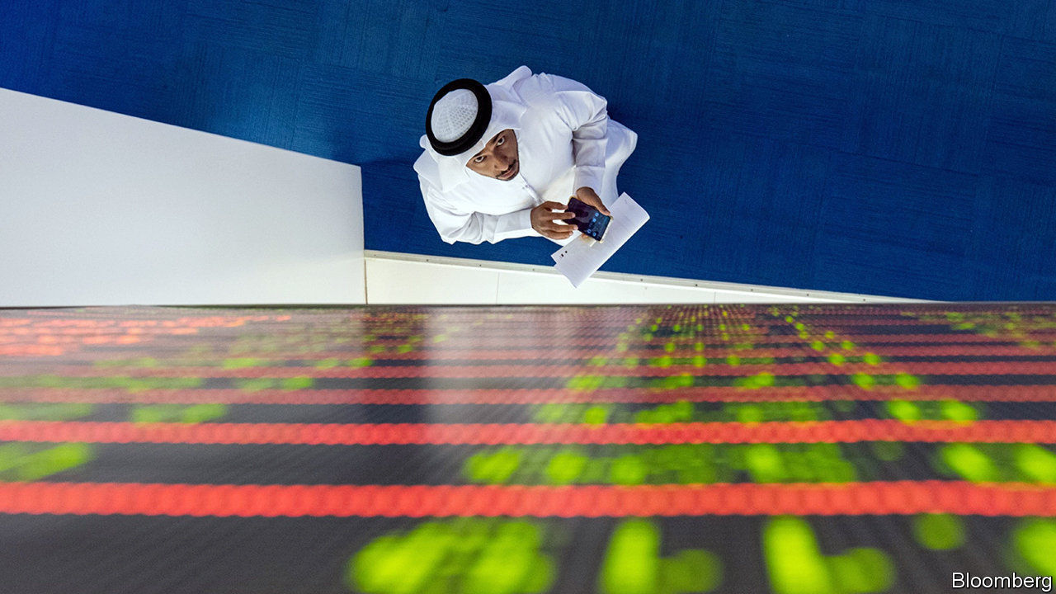

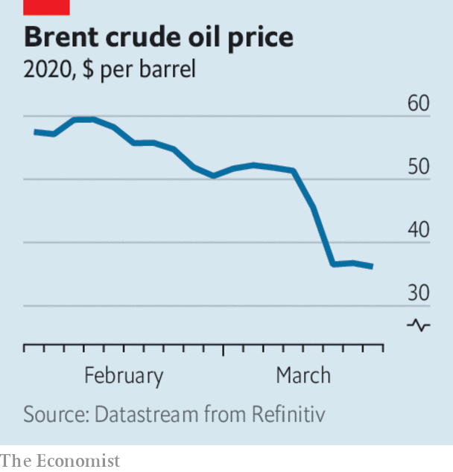

Staggering from the effects of coronavirus on business, stockmarkets were also sent reeling by Saudi Arabia’s decision to instigate an oil-price war with Russia, as the pair’s agreement over production levels broke down. Oil prices plunged in the sharpest one-day decline since 1991. Saudi Aramco, the state-controlled oil company, is increasing capacity by 1m barrels of oil a day to a record 13m, saturating an already over-supplied market. Trading remained volatile; the decade-long bull run in stockmarkets was deemed to be over. See article.

Amid the turmoil Saudi Aramco saw its stock fall below 32 riyals ($8.50) for the first time, the price at which the shares were offered when they floated on the stockmarket in December.

The Bank of England made an emergency cut to interest rates, lowering its main rate by half a percentage point to 0.25%. It also extended cheap funding to banks so that they can “bridge a potentially challenging period”. The European Central Bank prepared to ease policy and offer a range of supportive actions to companies and banks. The Federal Reserve pumped money into the short-term repo market to support the “smooth functioning of funding markets”. See article.

The aviation industry is being battered by the covid-19 outbreak. Boeing lost a fifth of its market value in a day amid reports that it would soon use the remainder of a $13.8bn loan it had only recently secured. Korean Air, which has cancelled 80% of its international flights, said that prolonged disruption threatened its survival. The suspension of many flights, and a general reluctance to travel, has already led to a collapse in bookings, which will be compounded by America’s ban on flights from Europe. Chinese airlines have been the worst affected. Chinese passenger numbers tumbled by 85% in February compared with February 2019.

China’s exports dropped sharply in January and February, and imports fell, producing a surprise trade deficit of $7.1bn. That raises questions about whether China will be able to meet its commitments under the “phase one” trade deal with America, through which it is supposed to buy more American products.

## The bank that likes to save Yes

India’s central bank stepped in to rescue Yes, the country’s fourth-largest private lender, which is grappling with high debt. The bail-out involves State Bank of India, the biggest government-owned bank, taking a stake in Yes. See article.

Jamie Dimon, the chief executive of JPMorgan Chase, had an emergency procedure on his heart, leaving two senior executives in charge until he recovers. Mr Dimon has run the company since 2005, making him the longest-serving CEO of any big American bank. See article.

Aon and Willis Towers Watson, the world’s second- and third-largest insurance brokers, agreed to combine in a $30bn deal. Separately, Tesco, one of the world’s biggest supermarket chains, said it would sell its operations in South-East Asia to Charoen Pokphand, a Thai conglomerate, for $10.6bn. It is the biggest-ever takeover in Thailand.

Twitter reached a truce with activist investors led by Elliott, a hedge fund, seeking changes at the company. Three new directors were added to the board. Jack Dorsey keeps his job as chief executive; he has been criticised by the investors for having too many outside interests. As part of the deal a committee has been tasked with evaluating a “succession plan” for Mr Dorsey.

In Britain, dozens of Conservative MPs backed an amendment to a bill that would end the involvement of Huawei, a Chinese maker of telecoms equipment, in the country’s 5G networks, on the grounds of national security. The amendment was defeated, but it was the first Tory rebellion against Boris Johnson’s government.

The Chinese owner of Grindr, the world’s most popular gay-dating app, found a buyer for the business after the American government reportedly pressed it to sell. In 2016 Beijing Kunlun Tech acquired Grindr from its American developers. But that led to concerns that China could tap into data on the app in order to blackmail American citizens.

The UN and World Meteorological Organisation released a report on the rise of carbon-dioxide emissions. “Greenhouse-gas concentrations are at the highest levels in three million years, when the Earth’s temperature was as much as three degrees hotter and sea levels some 15 metres higher,” said António Guterres, the UN’s secretary-general.

## Not business as usual

The list of events cancelled or postponed because of covid-19 mushroomed. Casualties include the rest of the NBA season in America and the Coachella festival in southern California. The Council on Foreign Relations scrapped a roundtable on “doing business under coronavirus”. See article.

This article was downloaded by calibre from <https://www.economist.com/the-world-this-week/2020/03/14/business-this-week>

|  |  |  |  |
| --- | --- | --- | --- |
| Previous | Articles | Sections | Next |

|  |  |  |  |
| --- | --- | --- | --- |
| Previous | Articles | Sections | Next |

# KAL’s cartoon

Mar 14th 2020 |

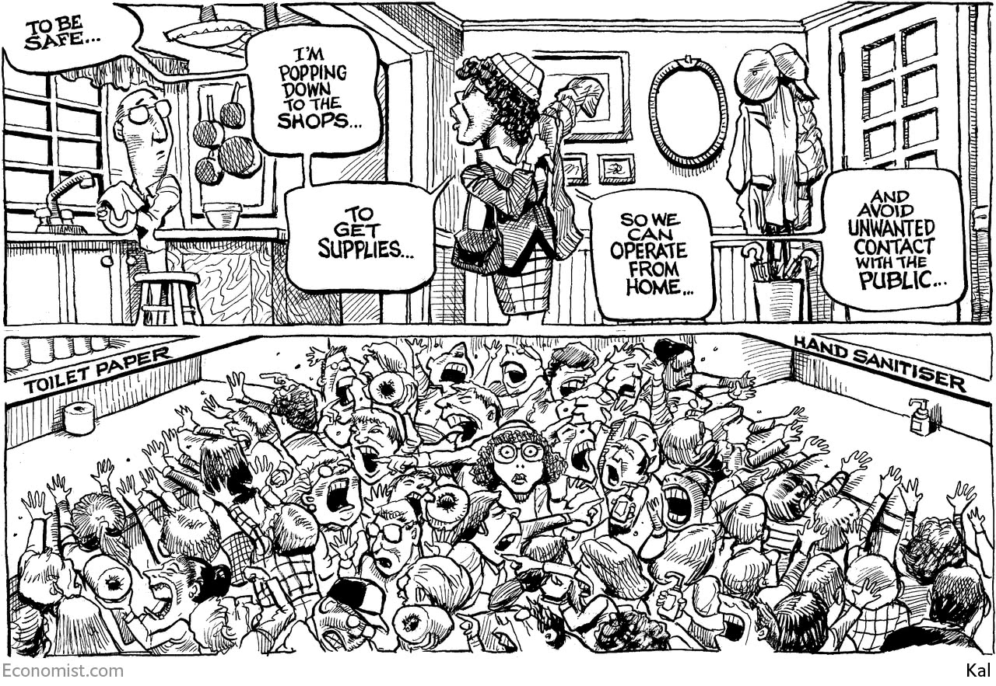

This article was downloaded by calibre from <https://www.economist.com/the-world-this-week/2020/03/14/kals-cartoon>

|  |  |  |  |
| --- | --- | --- | --- |
| Previous | Articles | Sections | Next |

|  |  |  |
| --- | --- | --- |
| The world this week | Sections | Letters |

Leaders

Covid-19: The politics of pandemics

.

Financial conditions: V is for vicious

.

Russia: Vlad the indefinite

.

Latin America: How to reform Chile

.

Succession at JPMorgan Chase: Mission accomplished

.

|  |  |  |
| --- | --- | --- |
| The world this week | Sections | Letters |

|  |  |  |  |
| --- | --- | --- | --- |
|  | Articles | Sections | Next |

#### Covid-19

# The politics of pandemics

All governments will struggle. Some will struggle more than others

Mar 12th 2020 |

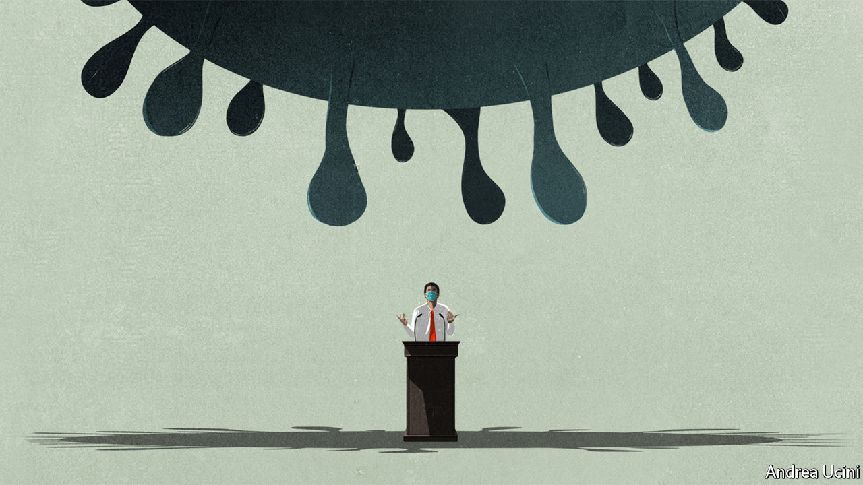

TO SEE WHAT is to come look to Lombardy, the affluent Italian region at the heart of the covid-19 outbreak in Europe. Its hospitals provide world-class health care. Until last week they thought they would cope with the disease—then waves of people began turning up with pneumonia. Having run out of ventilators and oxygen, exhausted staff at some hospitals are being forced to leave untreated patients to die.

The pandemic, as the World Health Organisation (WHO) officially declared it this week, is spreading fast, with almost 45,000 cases and nearly 1,500 deaths in 112 countries outside China. Epidemiologists reckon Italy is one or two weeks ahead of places like Spain, France, America and Britain. Less-connected countries, such as Egypt and India, are further behind, but not much. (For more coverage of covid-19 see our [coronavirus hub](https://www.economist.com/news/2020/03/11/the-economists-coverage-of-the-coronavirus).)

Few of today’s political leaders have ever faced anything like a pandemic and its economic fallout—though some are evoking the financial crisis of 2007-09 (see article). As they belatedly realise that health systems will buckle and deaths mount, leaders are at last coming to terms with the fact that they will have to weather the storm. Three factors will determine how they cope: their attitude to uncertainty; the structure and competence of their health systems; and, above all, whether they are trusted.

The uncertainty has many sources. One is that SARS-CoV-2 and the disease it causes, covid-19, are not fully understood (see article). Another is over the status of the pandemic. In each region or country it tends to proliferate rapidly undetected. By the time testing detects cases in one place it will be spreading in many others, as it was in Italy, Iran and South Korea. By the time governments shut schools and ban crowds they may be too late.

China’s solution, endorsed by the WHO, was to impose a brutal quarantine, bolstered by mass-testing and contact tracing. That came at a high human and economic cost, but new infections have dwindled. This week, in a victory lap, President Xi Jinping visited Wuhan, where the pandemic first emerged (see article). Yet uncertainty persists even in China, because nobody knows if a second wave of infections will rise up as the quarantine eases.

In democracies leaders have to judge if people will tolerate China’s harsh regime of isolation and surveillance. Italy’s lockdown is largely self-policed and does not heavily infringe people’s rights. But if it proves leakier than China’s, it may be almost as expensive and a lot less effective (see article).

Efficacy also depends on the structure and competence of health-care systems. There is immense scope for mixed messages and inconsistent instructions about testing and when to stay isolated at home. Every health system will be overwhelmed. Places where people receive very little health care, including refugee camps and slums, will be the most vulnerable. But even the best-resourced hospitals in rich countries will struggle.

Universal systems like Britain’s National Health Service should find it easier to mobilise resources and adapt rules and practices than fragmented, private ones that have to worry about who pays whom and who is liable for what (see article). The United States, despite its wealth and the excellence of its medical science, faces hurdles. Its private system is optimised for fee-paying treatments. America’s 28m uninsured people, 11m illegal immigrants and an unknown number without sick pay all have reasons to avoid testing or isolation. Red tape and cuts have fatally delayed adequate testing (see [article](https://www.economist.com/united-states/2020/03/12/covid-19-is-rapidly-spreading-in-america-the-country-does-not-look-ready)).

Uncertainty will be a drag on the third factor—trust. Trust gives leaders licence to take difficult decisions about quarantines and social-distancing, including school closures. In Iran the government, which has long been unpopular, is widely suspected of covering up deaths and cases. That is one reason rebellious clerics could refuse to shut shrines, even though they spread infection (see article).

Nothing stokes rumour and fear more than the suspicion that politicians are hiding the truth. When they downplay the threat in a misguided attempt to avoid panic, they end up sowing confusion and costing lives. Yet leaders have struggled to come to terms with the pandemic and how to talk about it. President Donald Trump, in particular, has veered from unfounded optimism to attacking his foes. This week he announced a 30-day ban on most travel from Europe that will do little to slow a disease which is already circulating in America. As people witness the death of friends and relatives, he will find that the pandemic cannot be palmed off as a conspiracy by foreigners, Democrats and CNN.

What should politicians do? Each country must strike its own balance between the benefits of tracking the disease and the invasion of privacy, but South Korea and China show the power of big data and mass-testing as a way of identifying cases and limiting their spread. Governments also need to anticipate the pandemic, because actions to slow its spread, such as banning crowds, are more effective if they are early.

The best example of how to respond is Singapore, which has had many fewer cases than expected. Thanks to an efficient bureaucracy in a single small territory, world-class universal health care and the well-learned lesson of SARS, an epidemic of a related virus in 2003, Singapore acted early. It has been able to make difficult trade-offs with public consent because its message has been consistent, science-based and trusted.

In the West covid-19 is a challenge to the generation of politicians who have taken power since the financial crisis. Many of them decry globalisation and experts. They thrive on division and conflict. In some ways the pandemic will play to their agenda. Countries may follow America and turn inward and close their borders. In so far as shortages crimp the world economy, industries may pull back from globalisation—though they would gain more protection by diversifying their supply chains.

Yet the pandemic also puts doctors, scientists and policy experts once again at the heart of government. Pandemics are quintessentially global affairs. Countries need to work together on treatment protocols, therapeutics and, it is hoped, a vaccine. Worried voters may well have less of an appetite for the theatrical wrestling match of partisan politics. They need their governments to deal with the real problems they are facing—which is what politics should have been about all along. ■

Dig deeper:

* For more coverage of covid-19 see our [coronavirus hub](https://www.economist.com/news/2020/03/11/the-economists-coverage-of-the-coronavirus)
* The science of the virus
* Fatality rates for covid-19 could vary enormously
* How to deal with a new sort of financial shock
* Should other countries copy Italy’s nationwide lockdown?

This article was downloaded by calibre from <https://www.economist.com/leaders/2020/03/12/the-politics-of-pandemics>

|  |  |  |  |
| --- | --- | --- | --- |
|  | Articles | Sections | Next |

|  |  |  |  |
| --- | --- | --- | --- |
| Previous | Articles | Sections | Next |

#### V is for vicious

# How to deal with a new sort of financial shock

The subprime crisis is not a good guide to markets today

Mar 12th 2020 |

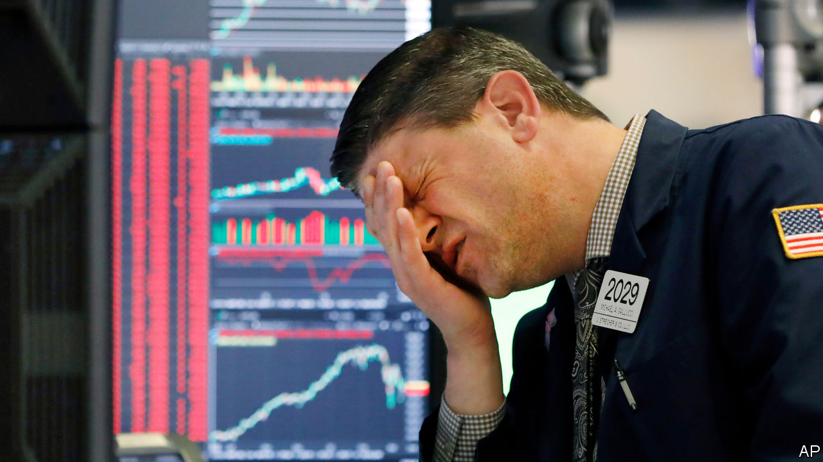

Editor’s note (March 12th 2020): This article was updated after the European Central Bank’s policy meeting on March 12th.

WHEN FACED with a bewildering shock it is natural to turn to your own experience. As covid-19 rages, investors and officials are scrambling to make sense of the violent moves in financial markets over the past two weeks. For many the obvious reference is the crisis of 2007-09. There are indeed some similarities. Stockmarkets have plunged. The oil price has tumbled below $40 a barrel. There has been a flurry of emergency interest-rate cuts by the Federal Reserve and other central banks. Traders are on a war footing—with a rising number working from their kitchen tables. Still, the comparison with the last big crisis is misplaced. It also obscures two real financial dangers that the pandemic has inflamed. (For more coverage of covid-19 see our [coronavirus hub](https://www.economist.com/news/2020/03/11/the-economists-coverage-of-the-coronavirus).)

The severity of the shock so far does not compare with 2007-09. Stockmarkets have fallen by a fifth from their peak, compared with a 59% drop in the mortgage crisis. The amount of toxic debt is limited and easy to identify. Some 15% of non-financial corporate bonds were issued by oil firms or others hit hard by the virus, such as airlines and hotels. The banking system, stuffed with capital, has yet to seize up; interbank lending rates are under control. When investors panic about the end of civilisation they rush into the dollar, the reserve currency. That has not yet happened (see article).

The nature of the shock is different, too. The 2007-09 crisis came from within the financial system, whereas the virus is primarily a health emergency. Markets are usually spooked when there is uncertainty about the outlook six or 12 months out, even when things seem calm at the time—think of asset prices dropping in early 2008, long before most subprime mortgage borrowers defaulted. Today, the time horizon is inverted: it is unclear what will happen in the next few weeks, but fairly certain that within six months the threat will have abated.

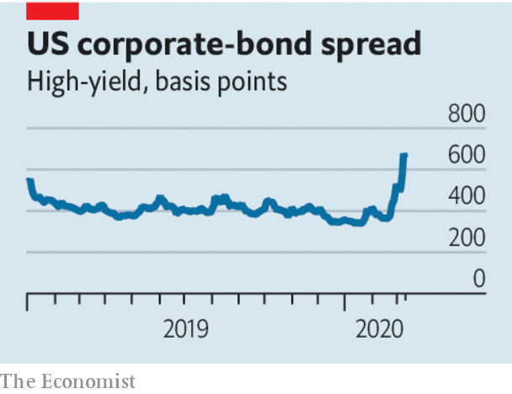

Instead of tottering Wall Street banks or defaults on Florida condos, two other risks loom. The first is a temporary cash crunch at a very broad range of companies around the world as quarantines force them to shut offices and factories. A crude “stress test” based on listed companies suggests that 10-15% of firms might face liquidity problems (see article). Corporate-bond markets, which demand precise contractual terms and regular payments, are not good at bridging this kind of short but precarious gap.

In 2007-09 the authorities funnelled cash to the financial system by injecting capital into banks, guaranteeing their liabilities and stimulating bond markets. This time the challenge is to get cash to companies. This is easy in China, where most banks are state-controlled and do as they are told. Credit there grew by 11% in February compared with the previous year. In the West, where banks are privately run, it will take enlightened managers, rule tweaks and jawboning from regulators to encourage lenders to show clients forbearance. Governments need to be creative about using tax breaks and other giveaways to get cash to hamstrung firms. While America dithered, Britain set a good example in this week’s budget (see article).

The second area to watch is the euro zone. It is barely growing, if at all. Central-bank interest rates are already below zero. Its banks are healthier than they were in 2008 but still weak compared with their American cousins. Judged by the cost of insuring against default, there are already jitters in Italy, the one big economy where banks’ funding costs have jumped. On March 12th the European Central Bank promised additional liquidity for the banking system, notably to support lending to small and medium-sized firms (but did not cut interest rates). The danger is that it, national governments and regulators fail to work together.

Every financial shock is different. In 1930 central banks let banks fail. In 2007 few people had heard of the subprime mortgages that were about to blow up. This financial shock does not yet belong in that company. But the virus scare of 2020 does create financial risks that need to be treated—fast.■

Dig deeper:

* For more coverage of covid-19 see our [coronavirus hub](https://www.economist.com/news/2020/03/11/the-economists-coverage-of-the-coronavirus)
* The science of the virus
* Fatality rates for covid-19 could vary enormously
* Should other countries copy Italy’s nationwide lockdown?

This article was downloaded by calibre from <https://www.economist.com/leaders/2020/03/12/how-to-deal-with-a-new-sort-of-financial-shock>

|  |  |  |  |
| --- | --- | --- | --- |
| Previous | Articles | Sections | Next |

|  |  |  |  |
| --- | --- | --- | --- |
| Previous | Articles | Sections | Next |

#### Vlad the indefinite

# Russia’s president reluctantly agrees to 16 more years in power

Vladimir Putin has no plans to retire. Poor Russia

Mar 14th 2020 |

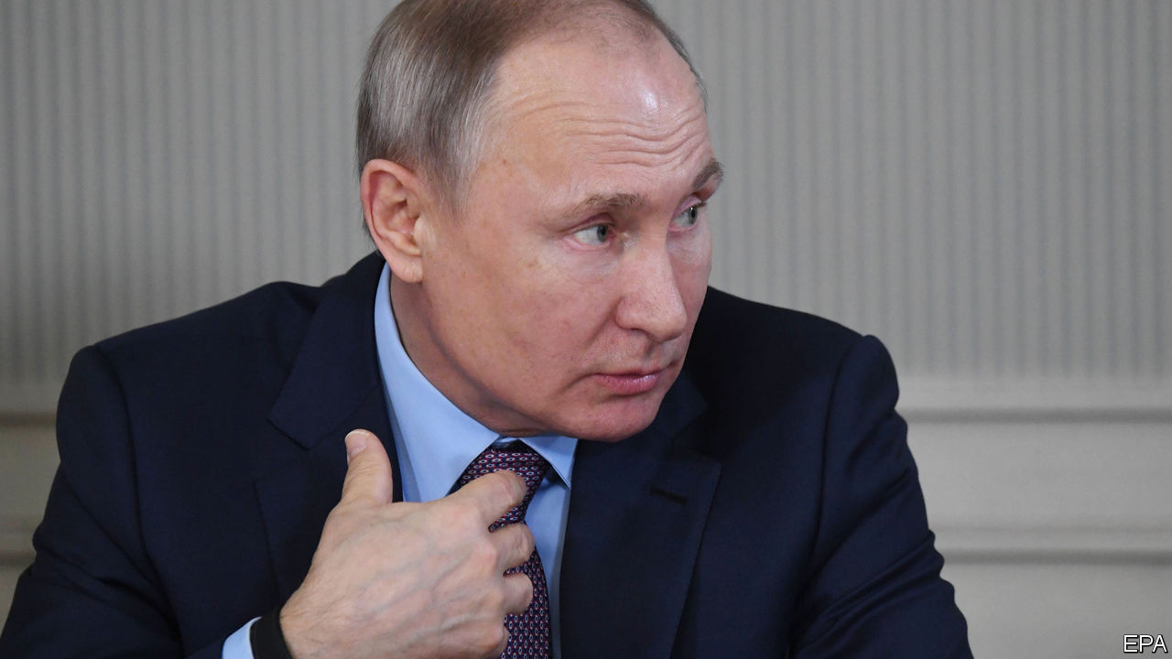

WHAT A CONVENIENT thing a tame parliament is. On March 10th, acting on a proposal from the first woman in space (now a celebrity MP), the Russian Duma approved an amendment to the country’s constitution that would reset the clock barring anyone from serving more than two consecutive terms as president. As it happens, that would allow Vladimir Putin, at present ineligible to run for another term when his current one expires in 2024, to stay on for two more six-year terms after that date, assuming he can win two more elections on top of the four he has won already. By then, in 2036, he would be 83, and would have ruled Russia for 36 years, as long as Ivan the Terrible. Two of the world’s biggest military powers, China and Russia, now have what look like presidents-for-life. Such leaders seldom improve with age.

A few technicalities remain (see [article](https://www.economist.com/node/21781330)). Russia’s Constitutional Court still has to rule on whether Mr Putin’s changes are indeed constitutional. It is a sign of how completely Mr Putin has packed and bent Russian institutions to his will that no one imagines that he will fail to get his way, just as no one imagines that Valentina Tereshkova, who took her giant leap for womankind back on June 16th, 1963, was acting off her own bat. The third hurdle is an “all-people vote” of doubtful legality on the newly adjusted constitution, which Mr Putin has scheduled for April 22nd. That, perhaps, is a little less in the bag, but the Kremlin’s operatives are dab hands at suppressing protests and neutering the press. And the rest of the changes to the constitution are designed to enhance its popularity with tradition-minded Russians, for instance by stressing that Russian law must have primacy over international law, that state pensions must be inflation-proof and that gay marriage will never be permitted.

None of this ought to come as a surprise. Mr Putin and his circle have made too many enemies and too much money for him to risk giving up power voluntarily. The real question has been how he would dress up his intention to rule indefinitely. Once before he got around the two-term rule, by taking the supposedly less powerful post of prime minister, swapping jobs with the pliable Dmitri Medvedev who served as president between 2008 and 2012. Mr Medvedev then dutifully swapped back again, allowing Mr Putin to resume being president with his clock reset and the term extended from four years to six. Mr Medvedev was dumped as prime minister earlier this year, and the Kremlin seems to have opted for an even simpler run around the rules.

The trick assumes that Mr Putin will be as weakly opposed in 2024 and 2030 as he was in 2000, 2004, 2012 and 2018. Is that plausible? The timing of the changes is ominous for him. This week’s collapse in the oil price will hurt the economy. Despite 20 years in charge and a clear global trend to find substitutes for fossil fuels, he has failed to do nearly enough to diversify Russia away from oil and gas. His government has built up enough financial reserves to last for years, but not for ever. Meanwhile, deep-rooted corruption and a lack of competition have hobbled the prospects for growth. Mr Putin’s political actions—annexing Crimea, invading eastern Ukraine, meddling in other countries’ elections and presiding over the murder of opponents on foreign soil—have made his country a pariah, subject to sanctions that show no sign of being relaxed. Import substitution since 2014 has bought him breathing space, but for ordinary Russians life is likely to get harder.

## In the hot seat until he grows cold

Mr Putin’s popularity has faltered since the election in 2018, partly because of a weak economy, but also because he tried to raise the age at which Russians receive state pensions. This was necessary but unpopular, and he watered his plans down. At municipal elections last year his United Russia party suffered heavy losses, especially in Moscow, despite efforts to keep strong opponents off the ballot. Still, by manipulating the media and electoral law, he has so far prevented any single challenger from securing broad support. Mr Putin won re-election as president in 2018 with a thumping 77% of the vote, his best result ever, helped by the fact that his most popular opponent, Alexei Navalny, was barred from the contest on trumped-up charges of fraud. No despot is immortal. But Russians have good cause to worry that their modern-day tsar has a long future on the throne. ■

This article was downloaded by calibre from <https://www.economist.com/leaders/2020/03/14/russias-president-reluctantly-agrees-to-16-more-years-in-power>

|  |  |  |  |
| --- | --- | --- | --- |
| Previous | Articles | Sections | Next |

|  |  |  |  |
| --- | --- | --- | --- |
| Previous | Articles | Sections | Next |

#### A tarnished star

# How to reform Chile

A new constitution offers the country a path out of anger and disorder

Mar 14th 2020 |

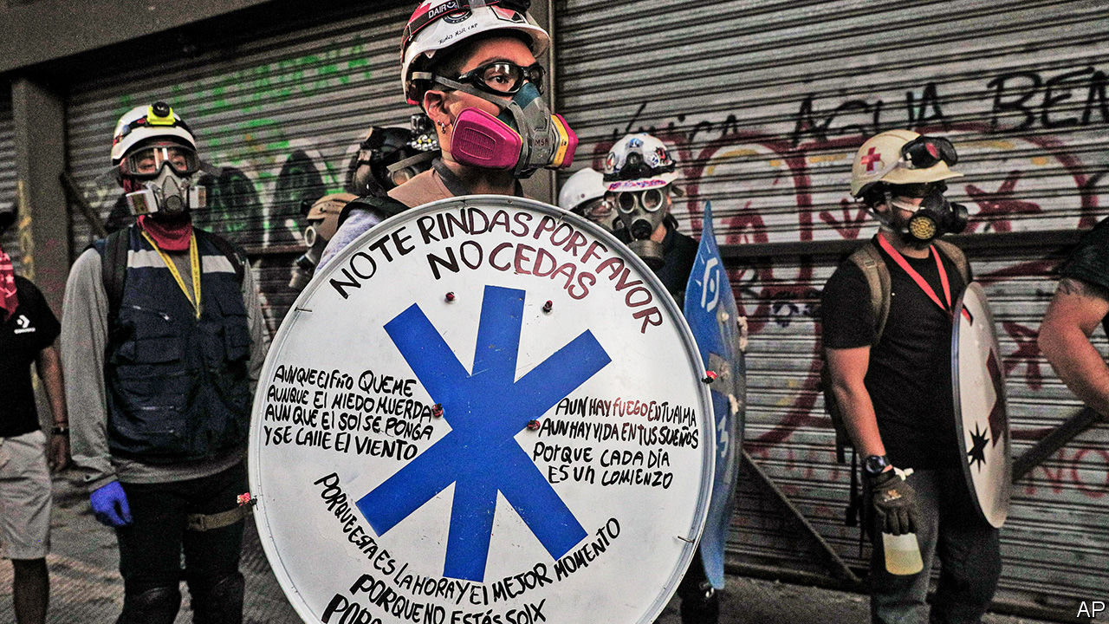

FOR MUCH of the past 30 years Chile has stood out from the rest of Latin America as a country that seemed to be doing most things right. It combined an open market economy with the rule of law, stable institutions and growing social provision. Poverty rates fell steeply and most Chileans became middle-class by official measures. The large, sustained and sometimes violent protests that have shaken the country since last October have therefore come as a shock. They have called into question the success of the “Chilean model” and its future.

What happens now in Chile matters beyond its borders. Its protests, which have resumed this month (see article), are just one manifestation of the discontent sweeping Latin America. Several other countries have also seen protests, though these have mainly been more narrowly focused. The election of contrasting populists in Brazil and Mexico in 2018 was a further sign of anger. So were opposition victories in recent presidential elections across the region.

It is not hard to divine the causes of this discontent. Latin America has seen little or no economic growth since 2013. Its new middle classes fear that they have fewer opportunities. Corruption has discredited the political class. And there is a widespread sense that democracy has not brought equal treatment and equal access to basic services for all citizens.

Several of these factors apply in Chile (see article). The right identifies the problem as slow growth combined with a more demanding middle class. For the left, the protests are a rebellion against inequality and the “neoliberal model” imposed by the dictatorship of General Augusto Pinochet.

On the face of it the left’s complaint is far-fetched. Since 1990 democratic governments have made many reforms. Yet, the main grievances really do concern legacies of the dictatorship: a private pension system that fails to offer security in old age, a segregated health system and a sense of impunity for the rich. In addition, violence and vandalism have called into question the ability of the state to maintain public order. The police, once respected and left to run themselves, have in recent years shown themselves to be corrupt, brutal and incompetent. They need to be thoroughly reformed.

In an effort to placate popular anger Sebastián Piñera, the embattled president, struck an agreement to hold a plebiscite on April 26th on whether to set up an assembly to write a new constitution. Mr Piñera, a billionaire former businessman, has veered between sounding tough and acknowledging that Chile needs big changes. As if haggling over a business deal, he offered concessions at the margin in pensions, health subsidies and so on. A bolder approach is needed. Many Chileans want the promise of a pension system with a stronger safety-net and a universal public-health system. That means allowing private insurance but abolishing health bodies known as Isapres, a Pinochet invention, which drain contributions into a high-priced private system. It also means a commitment to raise taxes, which are only 20% of GDP. Better public services must be paid for.

Is a new constitution essential to achieve these changes? It has been a device of the far left in several Latin American countries to seize control and impose a (failed) socialist model. But in this respect Chile is different. Although much-amended, its constitution is branded illegitimate by its origin under Pinochet. Polls have long shown that two-thirds of voters favour a new charter. The existing constitution is very hard to reform. Matters of routine disagreement, such as health care and education, require a supermajority to change.

That is not to deny the risks. On April 26th Chileans will vote not just on whether to set up the constitutional convention but also on whether this should be wholly elected or composed partly of existing legislators. The new body may suffer from inexperience. Many recent Latin American constitutions have been prolix and Utopian, stuffed with unaffordable “rights” and spending promises. But Chile has safeguards. Unless the new document is approved by a two-thirds vote of the assembly and then in a referendum, the existing constitution will remain.

Above all, the convention offers Chile a path out of its labyrinth. The new constitution should embody a new social contract. It should remove the obstacles to reforming the police, providing universal health care and regulating private universities. A healthier, better-educated population would be more productive. A stronger safety-net would encourage workers to be more flexible. A new basic law could give Chile a fresh start—and Latin America a new model from which to learn. ■

This article was downloaded by calibre from <https://www.economist.com/leaders/2020/03/14/how-to-reform-chile>

|  |  |  |  |
| --- | --- | --- | --- |
| Previous | Articles | Sections | Next |

|  |  |  |  |
| --- | --- | --- | --- |
| Previous | Articles | Sections | Next |

#### Mission accomplished

# Should Jamie Dimon, Wall Street’s most celebrated boss, call it a day?

A health scare puts succession in the spotlight

Mar 14th 2020 |

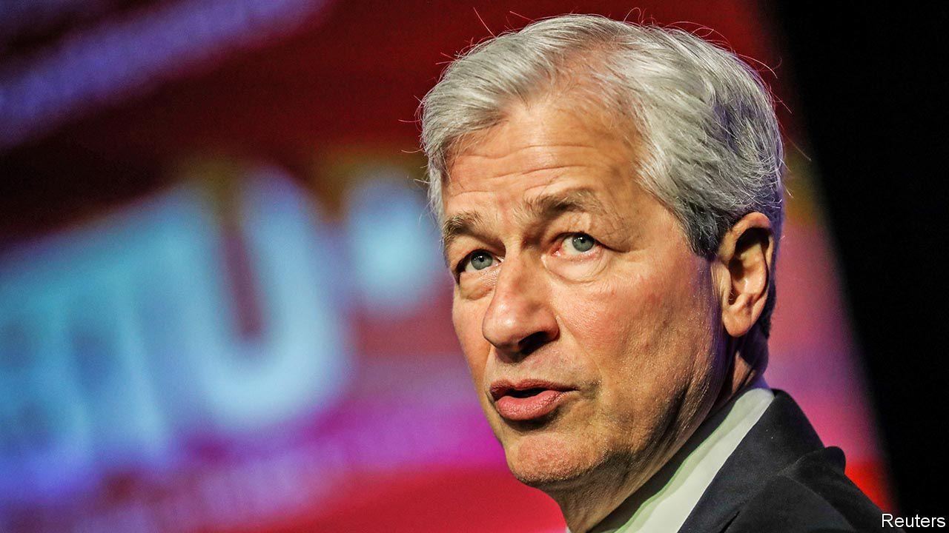

WHEN JAMIE DIMON took the reins at JPMorgan Chase in 2005 he had, at the relatively tender age of 49, already earned himself a reputation. In the 1990s he was the wunderkind sidekick to the imperial Sandy Weill, then boss of Citigroup, the world’s pre-eminent bank. Still, while some peers described Mr Dimon as brilliant, charismatic, caring and dedicated, others complained he was abrasive, foul-mouthed and unpredictable. Plenty doubted he was well suited to such a large stage.

As we explain this week (see article), Mr Dimon has put paid to these doubters. JPMorgan weathered the financial crisis well and has since become the bank that all the others want to emulate. It is big, globally active, dominant in retail and investment banking, transparent, well capitalised and admirably profitable. Last year its return on equity was a handsome 15%. Its annual profits are now double the entire current market value of Deutsche Bank, once Europe’s pretender to the global investment-banking throne.

However, another big question has remained unanswered: when Mr Dimon should leave and who will run the bank after he is gone. It has been cast in sharp relief by the recent news that Mr Dimon has undergone emergency surgery for an “aortic dissection”, a rare heart condition. The bank says he is recovering well. But investors, the board, staff and regulators have had a reminder that one day JPMorgan will have to have a different leader.

Wall Street’s biggest succession decision is tricky for several reasons. JPMorgan could benchmark itself against other banks: in 2018 the head of Goldman Sachs retired and a flurry of European banks have waved goodbye to their leaders in the past few months. But in all these cases the firms were performing below their potential. Aged 63, Mr Dimon is no geriatric—77 CEOs who are older than him are serving at firms in the S&P 500 index of America’s biggest companies. The most seasoned, Warren Buffett, is still, inadvisedly, clinging on at the age of 89.

Mr Dimon has served for longer than the typical American CEO, who lasts about a decade. Bob Iger, the boss of Disney, has just stood down after 15 years at the top. But tenure is not, in and of itself, a disqualification. There are 66 S&P 500 CEOs who have been in place longer than Mr Dimon. Reed Hastings has run Netflix for over two decades and few reckon he should press stop.

So how to make a decision? Two tests matter. The first is that Mr Dimon is not blocking the path of an entire generation of successors who might end up leaving or becoming disillusioned. Inevitably, one cohort has already departed. A JPMorgan diaspora now run financial firms all over the world, including Wells Fargo, Barclays and Standard Chartered. It would be a mistake to let another generation go, too. Mr Dimon has two co-presidents directly beneath him who are both aged about 60. Beneath them is a broader group of half-a-dozen potential successors, most of whom are in their 50s and still being battle-hardened.

The second test is the likely time horizon of the strategic threats and opportunities that the bank faces. These mainly arise from technology—the prospect that big tech firms might challenge the big banks, or that new payments firms win huge customer bases independently of the banks, as they already have in China, or that new digital currencies take the world by storm. These trends will play out over a decade or more—and no one, not even Mr Dimon, thinks that he will stay that long.

Both tests suggest that Mr Dimon should leave the stage sooner rather than later. A good option would be for him to do so at the end of next year. By then the next generation of executives will have acquired the experience necessary to run the Western world’s biggest bank at a time of technological tumult, while not being so frustrated that they quit. Even if JPMorgan and Mr Dimon follow this advice, they and the shareholders should reflect on another succession. March 2nd saw the death of Jack Welch, the former chief executive of General Electric (GE), and perhaps the most celebrated American boss of recent decades. He retired from GE in 2001 on a high, but the firm soon slipped into brutal decline, reflecting in part long-standing problems that became clear only once he had left. The best bosses face up to the reality that at some point someone else has to be in charge. But even then their legacy can only be assessed years after they have thanked their team, shed a tear and walked out the door with their head held high.■

This article was downloaded by calibre from <https://www.economist.com/leaders/2020/03/14/should-jamie-dimon-wall-streets-most-celebrated-boss-call-it-a-day>

|  |  |  |  |
| --- | --- | --- | --- |
| Previous | Articles | Sections | Next |

|  |  |  |
| --- | --- | --- |
| Leaders | Sections | Briefing |

Letters

Letters to the editor: On Bernie Sanders, green technology, Mexico, Chinese MBAs, facial expressions

.

|  |  |  |
| --- | --- | --- |
| Leaders | Sections | Briefing |

|  |  |  |  |
| --- | --- | --- | --- |
|  | Articles | Sections | Next |

#### On Bernie Sanders, green technology, Mexico, Chinese MBAs, facial expressions

# Letters to the editor

A selection of correspondence

Mar 14th 2020 |

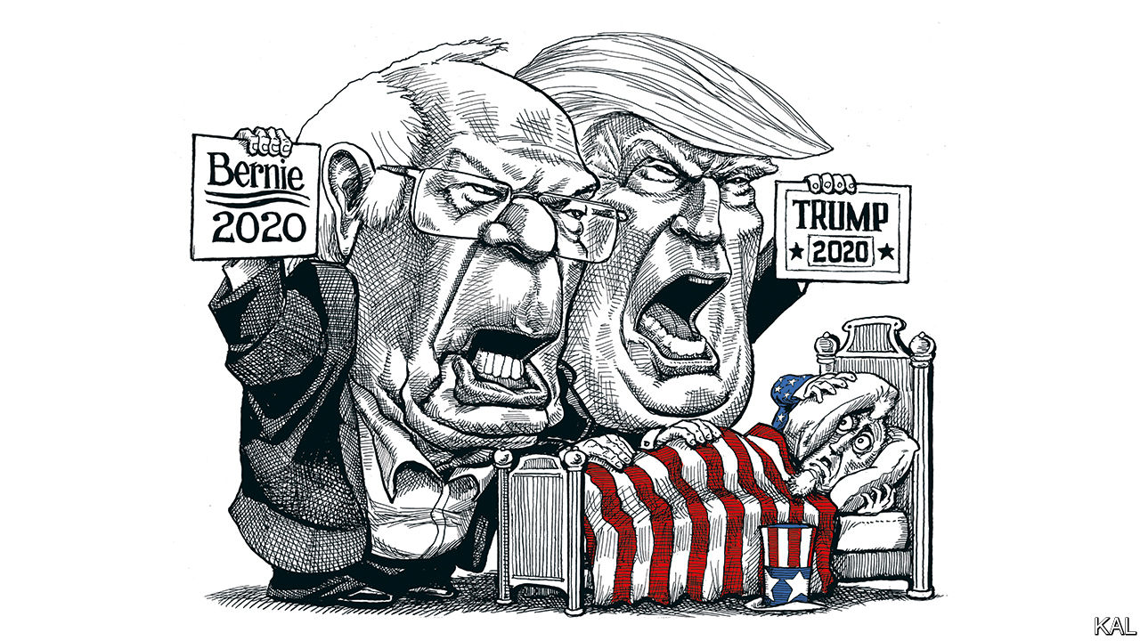

## Feeling the Bern

“It will surprise nobody”, you said, “that we disagree with a self-described democratic socialist over economics” (“[America’s nightmare](https://www.economist.com/leaders/2020/02/27/bernie-sanders-nominee)”, February 29th). But, as a 40-year subscriber to The Economist, I was indeed surprised by your leader on Bernie Sanders. I have always valued your commitment to free trade and to socially liberal policies: universal education, efficient and affordable health care, legalisation and control of drugs, workplace equality, broad immigration and integration, and so on.

Many of these social policies have been disrupted around the world by nationalist sentiments, driven by economic insecurity over rising financial inequality, which in turn is a result of corporate giveaways, trickle-down (or voodoo) economics, and outright corruption.

There are two ways of improving the situation. One is to ask corporations to share their wealth more widely with their employees and to do more for society. This doesn’t work because the benefits are spread unevenly, and it puts the civic-minded corporation at a competitive disadvantage to its less generous competitors.

The other approach is to allow corporations to go ahead and make their money, and for the government to tax them sufficiently to provide universal education and health care and other services. This was the norm under Franklin Roosevelt, Harry Truman and Dwight Eisenhower, underpins the democratic socialism of Scandinavia and other happy places, and is what Mr Sanders advocates. I fail to understand your hostility to it.

ROBIN HELWEG-LARSEN  
Governor’s Harbour, Bahamas

Starting with his campaign in 2016 Mr Sanders brought some much-needed civility to political discourse. He inspired many by talking about actual issues rather than the trash talk we have got used to over the past five years. He veers away from inane platitudes like “Hope and Change” and “Make America Great Again”. Does your newspaper really think that American capitalism is so desperate and fragile that it cannot handle a serious debate on the problems that confront the country today?

DAVID WARREN  
Berkeley, California

Mr Sanders is indeed “convinced that he is morally right”. Yet I recall that back in November 2012, Mr Sanders was one of only four senators to vote against the Magnitsky Act, which imposes sanctions on certain human-rights offenders in Russia. Notwithstanding his positions against fracking and private health insurance, or his sympathy with autocratic regimes, his vote against the Magnitsky Act alone is proof enough that he is far from being morally right.

STEVEN HONG  
North Vancouver, Canada

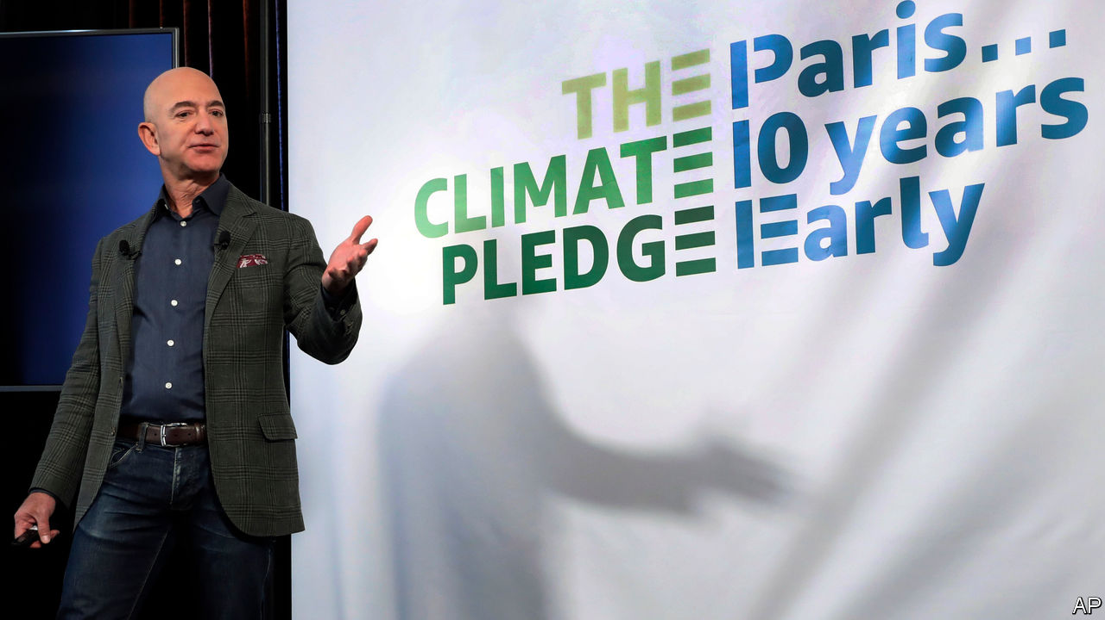

## How to spend it

Besides the political and technological, there are plenty of other ways for Jeff Bezos to spend $10bn philanthropically on solving climate change (“[The great Bezos giveaway](https://www.economist.com/leaders/2020/02/22/jeff-bezos-wants-to-help-save-the-climate-here-is-how-he-should-do-it)”, February 22nd). You have reported, for instance, on the MethaneSAT project, which will police and shut down methane leaks from oil and gas operations globally, emissions which represent several per cent of the total climate warming effect (“The methane hunters”, February 1st). Perhaps the largest problem and thus biggest opportunity of all is the scale and cost of investment in solar, wind and energy storage projects, which must be constructed in emerging economies. Around $20trn must be invested in poorer areas of the world over the next ten years. Poor countries have spotty track records of respecting the rights of foreign investors, have weaker currencies and other challenges. Innovation in financing solar, wind and energy-storage projects in the form of “blended finance” is desperately needed to make these infrastructure investments more affordable for those who have, paradoxically, the highest cost of money today. The scale of the problem requires government intervention, but philanthropy on the $10bn scale can lead the way.

ION YADIGAROGLU  
New York

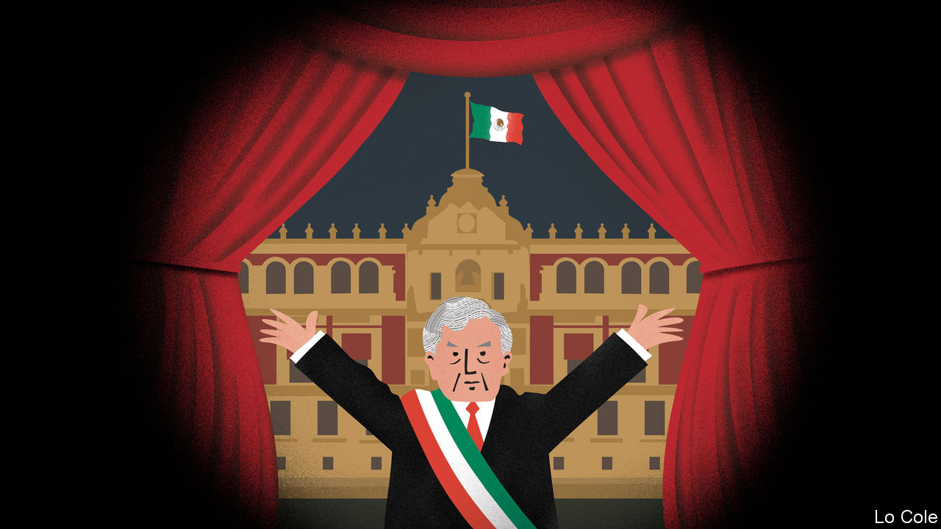

## Mexico’s government

In response to [Bello](https://www.economist.com/the-americas/2020/02/27/mexico-needs-statecraft-yet-its-president-offers-theatre)’s column on Mexico’s government, (February 29th), this administration is fighting crime on many fronts. The newly created National Guard has curbed the rise in the number of murders. Kidnappings in December 2019 were down by 31% year over year; car thefts have fallen by 12%.

On the economic front, the progress made in ratifying the new trade deal with Canada and the United States will promote investment. In 2019 foreign direct investment grew by 4.2%. The Mexican government has also invested heavily in our southern states to boost growth and address economic inequalities. Meanwhile, it has kept inflation low, even while raising the minimum wage.

The administration has a clear strategy. It is committed to eliminating inequality and violence by ending the war on drugs, strengthening the rule of law, ending impunity, and promoting inclusive development. The use of force is no longer the first option. For the first time since 2010, attacks by criminal groups on federal forces have resulted in more arrests than deaths. At the same time, more than 9.2m people have benefited from social programmes or unconditional cash transfers to vulnerable groups. The results are clear: a fifth of our poorest citizens have seen their incomes rise by 24%. The challenges that our country faces are vast, but the statecraft Mexico urgently needed is at last being delivered.

ROBERTO VELASCO áLVAREZ  
Director-general of public affairs  
Ministry of Foreign Affairs  
Mexico City

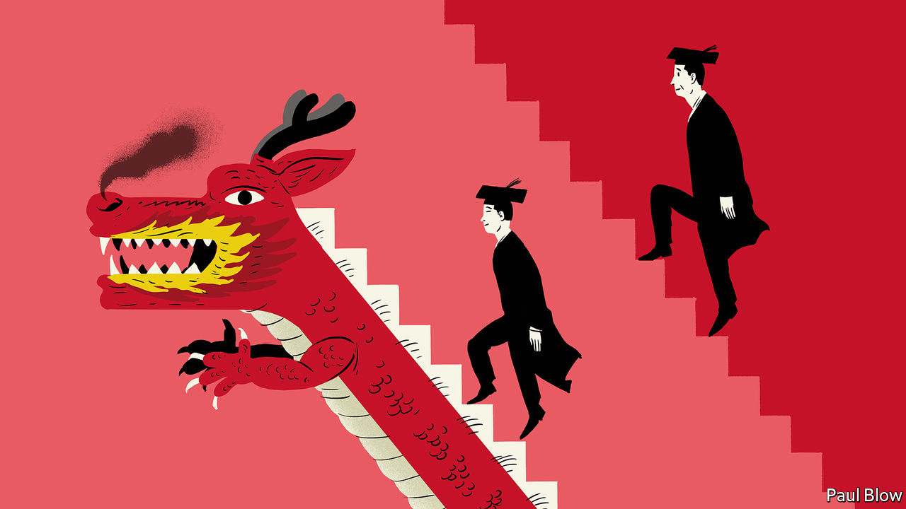

## The new masters

The history of Chinese management education starts earlier than 1994 (“[MBAs with Chinese characteristics”](https://www.economist.com/business/2020/02/13/chinese-management-schools-are-thriving), February 15th). After diplomatic relations were established, Jimmy Carter’s science adviser in 1980 urged China to start the first management education programme at Dalian, a seaport. The costs for a new building and American faculty were shared equally by the two countries. Lectures were held in summer and autumn because of the poor heating. The audience was composed of nationally selected mid-level managers, economics and management professors (universities were closed during the Cultural Revolution) and Chinese government officials. The attendees’ level of English was quite low, so lectures were prepared in advance and translation was sequential. Some resulted in books which had as many as five printings.

To learn that now China has its own executive programmes abroad in countries like Switzerland, teaching economics and management with capitalistic characteristics, reflects the miraculous changes which have occurred over 40 years.

BERTRAND HORWITZ  
Asheville, North Carolina

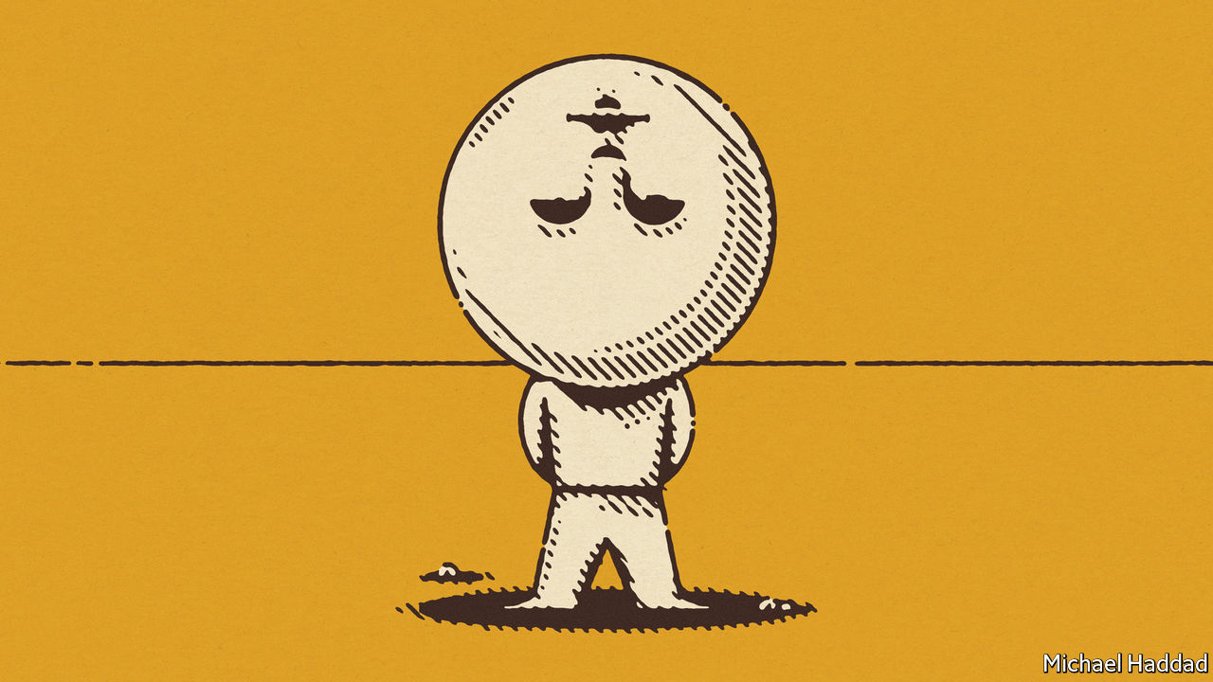

## Keeping your chin up

At last, proof that facial expressions are not an accurate guide to how someone feels (“[Face blind](https://www.economist.com/science-and-technology/2020/02/20/do-not-rely-on-facial-expressions-for-how-people-are-feeling)”, February 22nd). I tend to have a downturned mouth, more so with age, yet life is wonderful. Even more so now, since I have cut out your article, and intend to wave it at every builder or scaffolder who has the temerity to yell out, “Cheer up love, it might never happen.”

LUCY BERESFORD  
London

This article was downloaded by calibre from <https://www.economist.com/letters/2020/03/14/letters-to-the-editor>

|  |  |  |  |
| --- | --- | --- | --- |
|  | Articles | Sections | Next |

|  |  |  |
| --- | --- | --- |
| Letters | Sections | United States |

Briefing

The covid-19 virus: Anatomy of a killer

.

JPMorgan Chase: The house that Jamie built

.

|  |  |  |
| --- | --- | --- |
| Letters | Sections | United States |

|  |  |  |  |
| --- | --- | --- | --- |
|  | Articles | Sections | Next |

#### Anatomy of a killer

# Understanding SARS-CoV-2 and the drugs that might lessen its power

Modest improvements in treatment could make a big difference

Mar 12th 2020 |

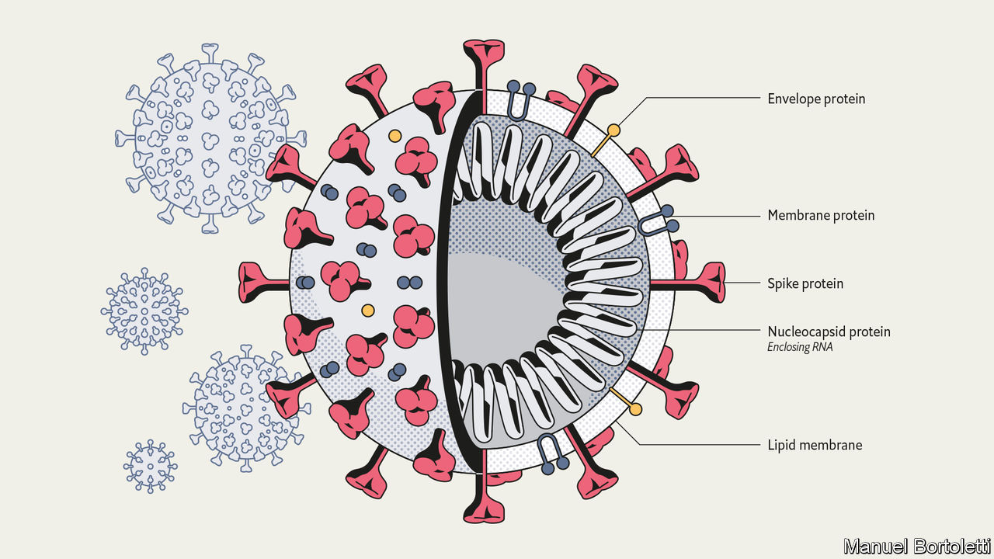

THE INTERCONNECTEDNESS of the modern world has been a boon for SARS-CoV-2. Without planes, trains and automobiles the virus would never have got this far, this fast. Just a few months ago it took its first steps into a human host somewhere in or around Wuhan, in the Chinese province of Hubei. As of this week it had caused over 120,000 diagnosed cases of covid-19, from Tromsø to Buenos Aires, Alberta to Auckland, with most infections continuing to go undiagnosed (see article).

But interconnectedness may be its downfall, too. Scientists around the world are focusing their attention on its genome and the 27 proteins that it is known to produce, seeking to deepen their understanding and find ways to stop it in its tracks. The resulting plethora of activity has resulted in the posting of over 300 papers on MedRXiv, a repository for medical-research work that has not yet been formally peer-reviewed and published, since February 1st, and the depositing of hundreds of genome sequences in public databases. (For more coverage of covid-19 see our [coronavirus hub](https://www.economist.com/news/2020/03/11/the-economists-coverage-of-the-coronavirus).)

The assault on the vaccine is not just taking place in the lab. As of February 28th China’s Clinical Trial Registry listed 105 trials of drugs and vaccines intended to combat SARS-CoV-2 either already recruiting patients or proposing to do so. As of March 11th its American equivalent, the National Library of Medicine, listed 84. This might seem premature, considering how recently the virus became known to science; is not drug development notoriously slow? But the reasonably well-understood basic biology of the virus makes it possible to work out which existing drugs have some chance of success, and that provides the basis for at least a little hope.

Even if a drug were only able to reduce mortality or sickness by a modest amount, it could make a great difference to the course of the disease. As Wuhan learned, and parts of Italy are now learning, treating the severely ill in numbers for which no hospitals were designed puts an unbearable burden on health systems. As Jeremy Farrar, the director of the Wellcome Trust, which funds research, puts it: “If you had a drug which reduced your time in hospital from 20 days to 15 days, that’s huge.”

Little noticed by doctors, let alone the public, until the outbreak of SARS (severe acute respiratory syndrome) that began in Guangdong in 2002, the coronavirus family was first recognised by science in the 1960s. Its members got their name because, under the early electron microscopes of the period, their shape seemed reminiscent of a monarch’s crown. (It is actually, modern methods show, more like that of an old-fashioned naval mine.) There are now more than 40 recognised members of the family, infecting a range of mammals and birds, including blackbirds, bats and cats. Veterinary virologists know them well because of the diseases they cause in pigs, cattle and poultry.

Virologists who concentrate on human disease used to pay less attention. Although two long-established coronaviruses cause between 15% and 30% of the symptoms referred to as “the common cold”, they did not cause serious diseases in people. Then, in 2002, the virus now known as SARS-CoV jumped from a horseshoe bat to a person (possibly by way of some intermediary). The subsequent outbreak went on to kill almost 800 people around the world.

Some of the studies which followed that outbreak highlighted the fact that related coronaviruses could easily follow SARS-CoV across the species barrier into humans. Unfortunately, this risk did not lead to the development of specific drugs aimed at such viruses. When SARS-CoV-2—similarly named because of its very similar genome—duly arrived, there were no dedicated anti-coronavirus drugs around to meet it.

## As a known enemy

A SARS-CoV-2 virus particle, known technically as a virion, is about 90 nanometres (billionths of a metre) across—around a millionth the volume of the sort of cells it infects in the human lung. It contains four different proteins and a strand of RNA—a molecule which, like DNA, can store genetic information as a sequence of chemical letters called nucleotides. In this case, that information includes how to make all the other proteins that the virus needs in order to make copies of itself, but which it does not carry along from cell to cell.

The outer proteins sit athwart a membrane provided by the cell in which the virion was created. This membrane, made of lipids, breaks up when it encounters soap and water, which is why hand-washing is such a valuable barrier to infection.

The most prominent protein, the one which gives the virions their crown- or mine-like appearance by standing proud of the membrane, is called spike. Two other proteins, envelope protein and membrane protein, sit in the membrane between these spikes, providing structural integrity. Inside the membrane a fourth protein, nucleocapsid, acts as a scaffold around which the virus wraps the 29,900nucleotides of RNA which make up its genome.

Though they store their genes in DNA, living cells use RNA for a range of other activities, such as taking the instructions written in the cell’s genome to the machinery which turns those instructions into proteins. Various sorts of virus, though, store their genes on RNA. Viruses like HIV, which causes AIDS, make DNA copies of their RNA genome once they get into a cell. This allows them to get into the nucleus and stay around for years. Coronaviruses take a simpler approach. Their RNA is formatted to look like the messenger RNA which tells cells what proteins to make. As soon as that RNA gets into the cell, flummoxed protein-making machinery starts reading the viral genes and making the proteins they describe.

First contact between a virion and a cell is made by the spike protein. There is a region on this protein that fits hand-in-glove with ACE2, a protein found on the surface of some human cells, particularly those in the respiratory tract.

ACE2 has a role in controlling blood pressure, and preliminary data from a hospital in Wuhan suggest that high blood pressure increases the risks of someone who has contracted the illness dying of it (so do diabetes and heart disease). Whether this has anything to do with the fact that the virus’s entry point is linked to blood-pressure regulation remains to be seen.

Once a virion has attached itself to an ACE2 molecule, it bends a second protein on the exterior of the cell to its will. This is TMPRSS2, a protease. Proteases exist to cleave other proteins asunder, and the virus depends on TMPRSS2 obligingly cutting open the spike protein, exposing a stump called a fusion peptide. This lets the virion into the cell, where it is soon able to open up and release its RNA (see diagram).



Coronaviruses have genomes bigger than those seen in any other RNA viruses—about three times longer than HIV’s, twice as long as the influenza virus’s, and half as long again as the Ebola virus’s. At one end are the genes for the four structural proteins and eight genes for small “accessory” proteins that seem to inhibit the host’s defences (see diagram). Together these account for just a third of the genome. The rest is the province of a complex gene called replicase. Cells have no interest in making RNA copies of RNA molecules, and so they have no machinery for the task that the virus can hijack. This means the virus has to bring the genes with which to make its own. The replicase gene creates two big “polyproteins” that cut themselves up into 15, or just possibly 16, short “non-structural proteins” (NSPs). These make up the machinery for copying and proofreading the genome—though some of them may have other roles, too.

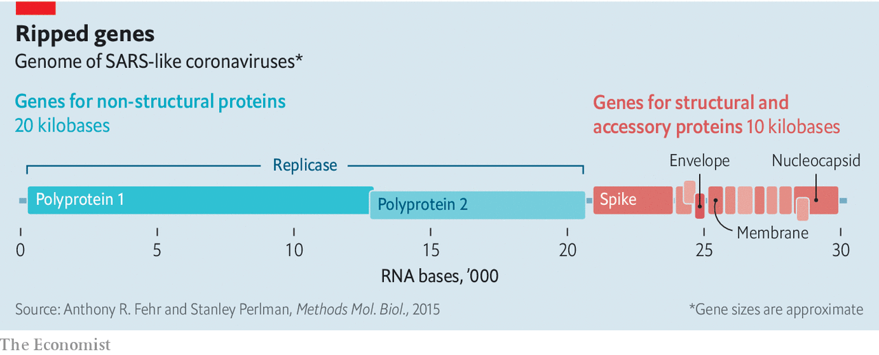

Once the cell is making both structural proteins and RNA, it is time to start churning out new virions. Some of the RNA molecules get wrapped up with copies of the nucleocapsid proteins. They are then provided with bits of membrane which are rich in the three outer proteins. The envelope and membrane proteins play a large role in this assembly process, which takes place in a cellular workshop called the Golgi apparatus. A cell may make between 100 and 1,000 virions in this way, according to Stanley Perlman of the University of Iowa. Most of them are capable of taking over a new cell—either nearby or in another body—and starting the process off again.

Not all the RNA that has been created ends up packed into virions; leftovers escape into wider circulation. The coronavirus tests now in use pick up and amplify SARS-CoV-2-specific RNA sequences found in the sputum of infected patients.

## Take your time, hurry up

Because a viral genome has no room for free riders, it is a fair bet that all of the proteins that SARS-CoV-2 makes when it gets into a cell are of vital importance. That makes each of them a potential target for drug designers. In the grip of a pandemic, though, the emphasis is on the targets that might be hit by drugs already at hand.

The obvious target is the replicase system. Because uninfected cells do not make RNA copies of RNA molecules, drugs which mess that process up can be lethal to the virus while not necessarily interfering with the normal functioning of the body. Similar thinking led to the first generation of anti-HIV drugs, which targeted the process that the virus uses to transcribe its RNA genome into DNA—another thing that healthy cells just do not do.

Like those first HIV drugs, some of the most promising SARS-CoV-2 treatments are molecules known as “nucleotide analogues”. They look like the letters of which RNA or DNA sequences are made up; but when a virus tries to use them for that purpose they mess things up in various ways.

The nucleotide-analogue drug that has gained the most attention for fighting SARS-CoV-2 is remdesivir. It was originally developed by Gilead Sciences, an American biotechnology firm, for use against Ebola fever. That work got as far as indicating that the drug was safe in humans, but because antibody therapy proved a better way of treating Ebola, remdesivir was put to one side. Laboratory tests, though, showed that it worked against a range of other RNA-based viruses, including SARS-CoV, and the same tests now show that it can block the replication of SARS-CoV-2, too.

There are now various trials of remdesivir’s efficacy in covid-19 patients. Gilead is organising two in Asia that will, together, involve 1,000 infected people. They are expected to yield results in mid- to late-April. Other nucleotide analogues are also under investigation. When they screened seven drugs approved for other purposes for evidence of activity against SARS-CoV-2, a group of researchers at the State Key Laboratory of Virology in Wuhan saw some potential in ribavirin, an antiviral drug used in the treatment of, among other things, hepatitis C, that is already on the list of essential medicines promulgated by the World Health Organisation (WHO).

Nucleotide analogues are not the only antiviral drugs. The second generation of anti-HIV drugs were the “protease inhibitors” which, used along with the original nucleotide analogues, revolutionised the treatment of the disease. They targeted an enzyme with which HIV cuts big proteins into smaller ones, rather as one of SARS-CoV-2’s NSPs cuts its big polyproteins into more little NSPs. Though the two viral enzymes do a similar job, they are not remotely related—HIV and SARS-CoV-2 have about as much in common as a human and a satsuma. Nevertheless, when Kaletra, a mixture of two protease inhibitors, ritonavir and lopinavir, was tried in SARS patients in 2003 it seemed to offer some benefit.

Another drug which was developed to deal with other RNA-based viruses—in particular, influenza—is Favipiravir (favilavir). It appears to interfere with one of the NSPs involved in making new RNA. But existing drugs that might have an effect on SARS-CoV-2 are not limited to those originally designed as antivirals. Chloroquine, a drug mostly used against malaria, was shown in the 2000s to have some effect on SARS-CoV; in cell-culture studies it both reduces the virus’s ability to get into cells and its ability to reproduce once inside them, possibly by altering the acidity of the Golgi apparatus. Camostat mesylate, which is used in cancer treatment, blocks the action of proteases similar to TMPRSS2, the protein in the cell membrane that activates the spike protein.

Not all drugs need to target the virus. Some could work by helping the immune system. Interferons promote a widespread antiviral reaction in infected cells which includes shutting down protein production and switching on RNA-destroying enzymes, both of which stop viral replication. Studies on the original SARS virus suggested that interferons might be a useful tool for stopping its progress, probably best used in conjunction with other drugs

Conversely, parts of the immune system are too active in covid-19. The virus kills not by destroying cells until none are left, but by overstimulating the immune system’s inflammatory response. Part of that response is mediated by a molecule called interleukin-6—one of a number of immune-system modulators that biotechnology has targeted because of their roles in autoimmune disease.

Actemra (tocilizumab) is an antibody that targets the interleukin-6 receptors on cell surfaces, gumming them up so that the interleukin-6 can no longer get to them. It was developed for use in rheumatoid arthritis. China has just approved it for use against covid-19. There are anecdotal reports of it being associated with clinical improvements in Italy.

While many trials are under way in China, the decline in the case rate there means that setting up new trials is now difficult. In Italy, where the epidemic is raging, organising trials is a luxury the health system cannot afford. So scientists are dashing to set up protocols for further clinical trials in countries expecting a rush of new cases. Dr Farrar said on March 9th that Britain must have its trials programme agreed within the week.

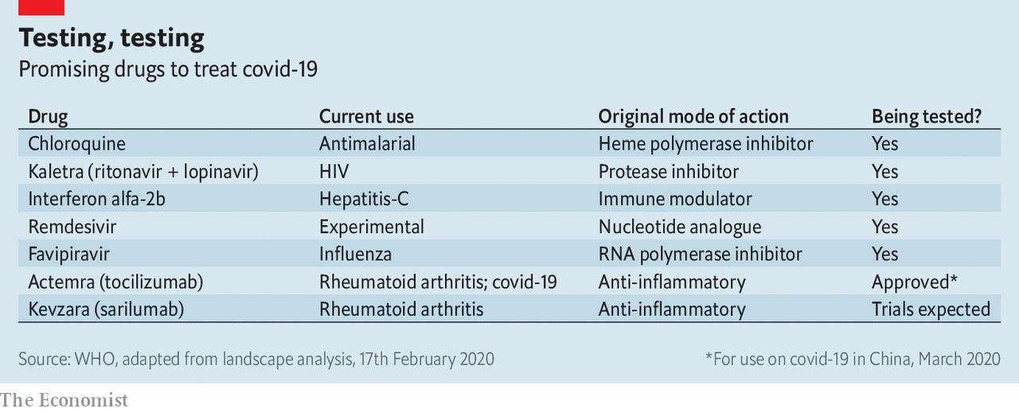

International trials are also a high priority. Soumya Swaminathan, chief scientist at the WHO, says that it is trying to finalise a “master protocol” for trials to which many countries could contribute. By pooling patients from around the world, using standardised criteria such as whom to include and how to measure outcomes, it should be possible to create trials of thousands of patients. Working on such a large scale makes it possible to pick up small, but still significant, benefits. Some treatments, for example, might help younger patients but not older ones; since younger patients are less common, such an effect could easily be missed in a small trial.

## Come as you are

The caseload of the pandemic is hard to predict, and it might be that even a useful drug is not suitable in all cases. But there are already concerns that, should one of the promising drugs prove to be useful, supplies will not be adequate. To address these, the WHO has had discussions with manufacturers about whether they would be able to produce drugs in large enough quantities. Generic drug makers have assured the organisation that they can scale up to millions of doses of ritonavir and lopinavir while still supplying the HIV-positive patients who rely on the drugs. Gilead, meanwhile, has enough remdesivir to support clinical trials and, thus far, compassionate use. The firm says it is working to make more available “as rapidly as possible”, even in the absence of evidence that it works safely.

In the lab, SARS-CoV-2 will continue being dissected and mulled over. Details of its tricksiness will be puzzled out, and the best bits of proteins to turn into vaccines argued over. But that is all for tomorrow. For today doctors can only hope that a combination of new understanding and not-so-new drugs will do some good. ■

Dig deeper:

* For more coverage of covid-19 see our [coronavirus hub](https://www.economist.com/news/2020/03/11/the-economists-coverage-of-the-coronavirus)
* Fatality rates for covid-19 could vary enormously
* How to deal with a new sort of financial shock
* Should other countries copy Italy’s nationwide lockdown?

This article was downloaded by calibre from <https://www.economist.com/briefing/2020/03/12/understanding-sars-cov-2-and-the-drugs-that-might-lessen-its-power>

|  |  |  |  |
| --- | --- | --- | --- |
|  | Articles | Sections | Next |

|  |  |  |  |
| --- | --- | --- | --- |
| Previous | Articles | Sections | Next |

#### The house that Jamie built

# Is Dimon’s work done at JPMorgan Chase?

A second health scare puts the focus on succession

Mar 14th 2020 | NEW YORK

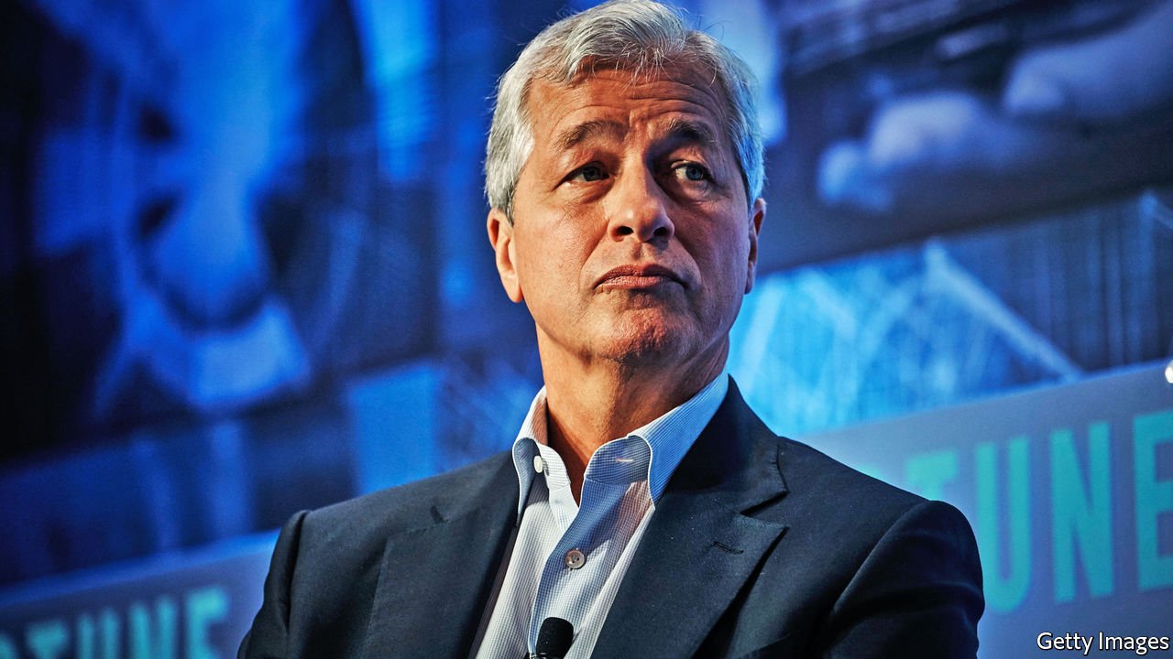

IT HAD BECOME a running joke on Wall Street that whenever Jamie Dimon was asked, after beating cancer in 2014, how much longer he intended to stay at the helm of JPMorgan Chase (JPM), he always replied: “another five years”. Sometimes he said it with a twinkle in his eye; at other times the response was tetchy. The matter became more serious after March 5th, when the 63-year-old underwent emergency surgery for a rare heart condition. The bank said afterwards that he was “recovering well”, and that two trusted lieutenants, Gordon Smith and Daniel Pinto, had stepped in to run the bank until his return. The question of how long before he steps down, and who will replace him, is now a more urgent one, though.

For a man not known to underestimate himself, even Mr Dimon cannot imagine he has much more to achieve as a banker. Over 15 years he has built JPM into the world’s most reputable bank. It is America’s biggest by assets and also its most profitable: in 2019 it broke the world record for bank earnings in a single year. It is the dominant player on Wall Street, while also running a formidable retail bank.

Mr Dimon is his firm’s best-known boss since its bulbous-nosed namesake, John Pierpont Morgan, lorded it over Wall Street in the late 19th century. The straight-talking son of second-generation Greek immigrants who settled in New York, he has brought a down-to-earth (some would say brusque) authenticity to what was once one of America’s most buttoned-up, blue-blooded financial firms. (JPM spokespeople have long joked that their main job is to make sure he doesn’t swear in public.) He is known for encouraging openness and inspiring loyalty.

Even as JPM has continued to grow into a dizzyingly sprawling financial giant, and as Mr Dimon has weighed in on a range of public-policy issues beyond his ken, from health-care reform to inequality, he has avoided much of the public vilification directed at his peers. At various times he has been touted as a possible treasury secretary, and even as a dark-horse presidential candidate. It is hard to imagine any other moneyman being in a position to consider canvassing for popular support.

Mr Dimon made arguably the most important decision of his career in his twenties, when he turned down a cushy job at Goldman Sachs to help create a vast financial firm with his mentor, Sanford Weill, then boss of American Express. Mr Dimon’s impatience to run Citigroup, the institution they built together, at the tender age of 42, ran up against Mr Weill’s unwillingness to relinquish the top job. He unceremoniously fired Mr Dimon in 1999. In the year that followed Mr Dimon turned down a raft of job offers, earning himself the moniker of “the most famous unemployed man in the country”. He was waiting for his moment. It came in 2004 when he pulled off a merger between Bank One, the Chicago-based bank he had run for four years, and the more illustrious JPMorgan Chase.

It was a sign of his steely determination to reach the top that, with a beady eye on Mr Weill, he said the merger would “give Citi a run for its money”. Under Mr Dimon, JPM has achieved far more than that. At the time Citigroup was considered the greatest American bank. It was twice as valuable as its newly merged rival; it had the biggest pile of assets of any bank globally; and it had earned an average return on equity (ROE) of 19.2% over the previous five years. JPM had registered a paltry 8.9%. It was seen as a lumbering laggard (see chart 1).

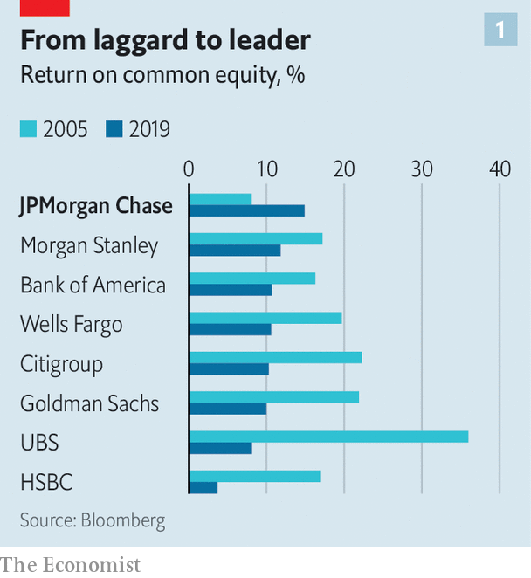

How times have changed. JPM has since become a world-beater on a wide range of metrics. In 2006 its investment bank won a fat share of the advisory fees on Wall Street but its trading business was comfortably outclassed by rivals. Today it is number one in both businesses.

Its retail bank has ballooned in size. In 2006 JPM held 3.6% of American retail deposits; it now holds 9%. The bank opened almost a quarter of all new checking (current) accounts in America last year. It has also scooped up a growing share of corporate deposits. JPM’s asset-management business runs $2.7trn-worth of investments on behalf of clients, double the amount held in 2006. Acquisitions made opportunistically during the financial crisis of 2007-09, such as Bear Stearns, an investment bank, and Washington Mutual (WaMu), a savings-and-loan institution, have helped JPM leapfrog other American and European banks in size (though a clutch of Chinese banks are still larger).

Importantly, this growth has been reflected in the bottom line. Earnings per share of $9 in 2019 were four times higher than in 2005. The bank’s ROE in 2019 was 15%, several percentage points higher than those of American and Chinese rivals and double that of the best-performing European ones. This has been achieved without relying on easy ways of boosting performance, like increasing leverage or the risk the bank takes (see chart 2).

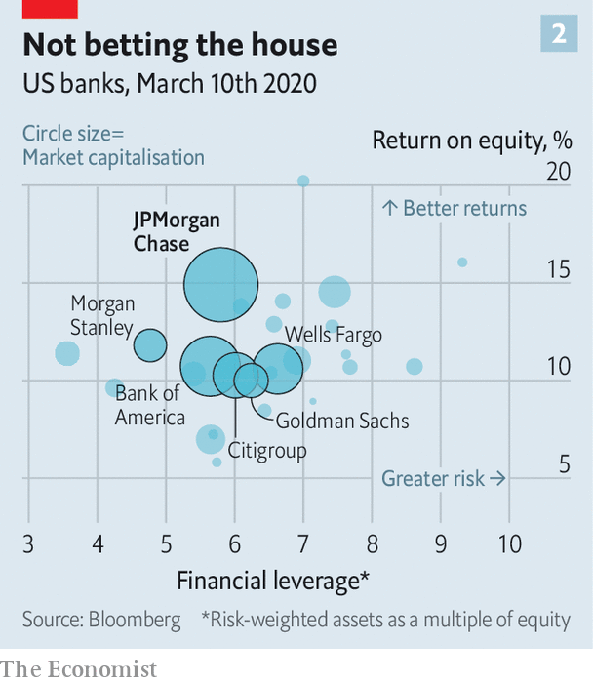

Financial markets have acknowledged the feat. JPM’s market value is 50% higher than that of its closest American rival, Bank of America, which has a balance-sheet almost as big, and more than double that of Citigroup. It beats overseas competitors too. It is, for instance, six times more valuable than Banco Santander, the biggest euro-zone bank by market value. Over the past 15 years The Economist has described an array of global banks—Citigroup, Bank of America, HSBC, Deutsche Bank—that we thought could become serious rivals to JPM. It has left them all in the dust.

What are the ingredients of Mr Dimon’s success? The best bosses are both lucky and smart, and he is no exception. European banks, which stormed into America in the 1990s, have fallen by the wayside in part owing to problems in sclerotic domestic markets where rock-bottom interest rates have crimped margins. The same is true of Japanese banks. The burgeoning Chinese lenders are kept at arm’s length by international investors, who are rightly wary of what they stuff into their loan books.

## Going with the flow

In some key businesses Mr Dimon has deftly taken advantage of the evolution of the financial system since the crisis. Take fixed-income trading. Before the meltdown, the most successful investment banks focused on complex derivatives transactions. These are much less profitable now, thanks to a thicket of post-crisis regulation, so the largest players are those that excel at “boring” flow trades (buying and selling financial instruments with clients’ funds rather than their own). This is just one market in which Mr Dimon’s bank has gobbled up market share.

But he also deserves credit for strategic thinking, which some once doubted he possessed. When he took the helm, he was already one of America’s highest-profile bank executives: precocious, telegenic and charismatic. As such, he had long attracted media attention. Some fretted about his temperament. His shouting matches with Mr Weill were infamous, and he was also considered brash. Mr Dimon’s wife once reportedly asked him why he couldn’t be as “patient” and “mature” as Bill Harrison, his predecessor at JPM.

He also had a reputation as little more than a number-cruncher and cost-cutter. The value he had created at Bank One was mostly generated by frugality, not revenue growth. Doubts lingered about his ability to pull off a similar trick on a bigger stage.

Yet in his 2005 letter to shareholders, his first as the boss of JPM, he sketched out a vision for the firm that he has stuck with through thick and thin. It registered not only his loathing of bureaucracy and bloat, but also his fondness for a “fortress balance-sheet”. He wrote of the natural connections between different parts of a large bank—between the commercial and investment banks, the credit-card business and the retail bank, and the cash-management and asset-management arms. In summary, Mr Dimon declared that “size, scale and staying power matter”.

This vision has been vindicated. First, during the pre-crisis years, he focused on ridding the bank of flab. This came naturally to him, given his experience wielding the scalpel with Mr Weill, and tidying up an ill-executed, pre-Dimon merger between Bank One and First USA. He then set about allocating costs properly, in order to cut them more effectively. Mr Dimon was perturbed, for example, that managers at Chase branches claimed they were more profitable than their Bank One counterparts when the firm did not allocate all their firmwide costs—like marketing, risk and legal—to each branch individually, as they did at Bank One. Once accounted for on a like-for-like basis, the Bank One branches made more money. He jettisoned consultants the firm had hired and trimmed benefits for executives. He declared the merger complete in January 2006, and ROE duly climbed to 13%, narrowing the gap with rivals.

But it was the financial crisis that was the making of him. It quickly became clear than JPM was better prepared to weather the storm than most. This was in part thanks to his insistence on a solid balance-sheet, but also because of his management style. As one bank analyst puts it, “Jamie is always looking from the perspective of what can go wrong.”

Such healthy paranoia forms the basis for a weekly meeting between Mr Dimon and the heads of all the main businesses. The meeting has no time limit—sometimes it takes minutes, other times all day—and he quizzes them on what the risks are in their units. It was over the course of these meetings in 2006 that problems with subprime mortgages were revealed. As a result JPM began to reduce its exposure across all its businesses, 18 months before most other banks did. While they were struggling to stay afloat, JPM was in a position to snap up Bear Stearns and WaMu for a song.

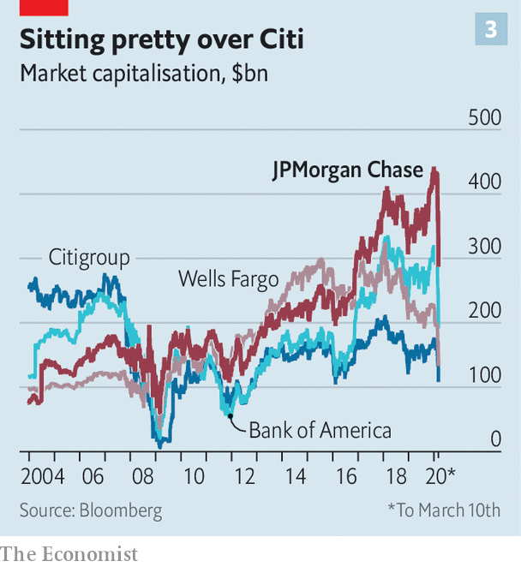

Despite navigating the crisis relatively unscathed, the bank has paid heavily for mishaps. Mortgage-related fines have cost it tens of billions of dollars—the most expensive being a $13bn bill for misleading investors over toxic securitised loans. JPM also had to cough up $2.6bn to settle allegations that it turned a blind eye to Bernie Madoff’s giant Ponzi scheme.

One blow-up in the post-crisis years made it appear that even Mr Dimon was incapable of running a bank as large as JPM had become. In 2012 it lost $6bn as a result of outsized derivatives trades by an employee known as the “London Whale”. Shareholders proposed a motion to separate the job of chief executive from chairman (though it was defeated). Politicians, pundits and analysts alike accused JPM of being both too big to fail and too big to manage. It has also faced criticism for remaining wedded to dirty industries. It is a big financier of fossil fuels—though in February it announced a partial pullback.

Throughout, however, Mr Dimon has stuck to his overarching strategy, and the economies of scale have paid off. This is clear not only from the firm’s financial results but also from the behaviour of its rivals. Goldman Sachs, whose executives once scoffed at prosaic banking businesses like taking deposits, now seek to emulate JPM’s type of full-service bank. When asked whether he feels a sense of vindication, Mr Dimon simply replies: “I always believed that scale mattered.”

What, then, is there left for the boss to do? Health permitting, he could of course find plenty of reasons to stay put. In the past three weeks alone, the bank’s share price has fallen by a third, as the covid-19 epidemic has shaken financial markets. The ship will need steadying.

In the longer term there is also a tech war to win. With fintech firms continuing to sprout, and tech giants like Amazon and Google busily experimenting in financial services, digital disruption is set to upend banking over the next decade or so. Some financial experts expect it to have the same impact on the industry as electricity did on manufacturing in the 1890s. Mr Dimon is alive to the threat. He has long endorsed enormous investment in technology. Last year JPM spent $11.5bn, more than any other American bank, on improving its systems.

Meanwhile, Mr Dimon may see scope for further expansion. Rumours have circulated that JPM is preparing to launch a British digital bank later this year, as a possible step towards taking the retail bank global. He might want to do a few more deals. At the bank’s investor day on February 25th he hinted that a fintech acquisition might look tempting.



It must, indeed, be hard to say goodbye. The decision is especially tricky for a boss who is so widely lauded, and famously dedicated to the job. Mr Dimon once insisted on keeping an appointment with The Economist despite feeling woozy after undergoing an intrusive medical procedure earlier that day.

One of the most critical roles of a CEO is to groom a successor and then to recognise when the time has come to pass the baton. Mr Dimon’s health problems will focus investors’ minds on this question. He has, however, long been accused of pushing out heirs apparent. “Jamie Dimon has only one succession plan,” quips one European bank boss, “If he sees a successor, he kills them.” The bank denies this and says those who left were not on the board’s list.

Plenty of putative successors have left during the Dimon era, including lieutenants who followed him from Citigroup, like Charlie Scharf and Mike Cavanagh (see chart 4). A JPM diaspora now run banks with $5trn-worth of assets. And Mr Dimon continues to keep the net of potential heirs wide open. At least six names are commonly mentioned: along with Messrs Smith and Pinto, Marianne Lake, who runs consumer lending; Doug Petno, head of the commercial bank; Jennifer Piepszak, the chief financial officer; and Mary Erdoes, head of wealth and asset management.

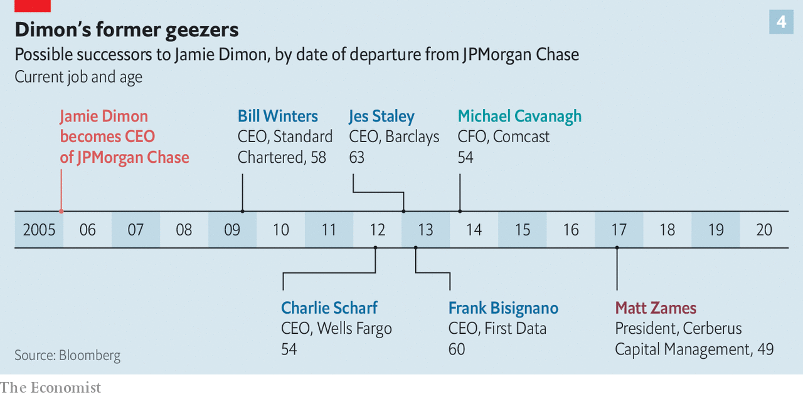

Having had two serious health scares, Mr Dimon may now be reflecting more seriously on how change at the top can reinvigorate the lower rungs. Jack Welch, a longtime boss of GE, who died on March 1st, once said that when he finally decided to leave the firm it was not because he wanted to, but “for everyone else”.

Were Mr Dimon to bow out now, his place in the pantheon of banking greats would be assured. His star has long since eclipsed Mr Weill’s. In interviews since the financial crisis his former mentor has admitted that one of his bitterest regrets was letting Mr Dimon go. Mr Weill lingered too long at Citi. It is hard to imagine any shareholder cheering Mr Dimon’s departure when it comes. But he must be careful to avoid making the same mistake. ■

This article was downloaded by calibre from <https://www.economist.com/briefing/2020/03/14/is-dimons-work-done-at-jpmorgan-chase>

|  |  |  |  |
| --- | --- | --- | --- |
| Previous | Articles | Sections | Next |

|  |  |  |
| --- | --- | --- |
| Briefing | Sections | The Americas |

United States

Public health: Dropping the ball

.

Covid-19 and the economy: Spluttering

.

The Democratic primaries: Berning out

.

Climate change: Green Texas

.

Rural policing: Country cops

.

Lexington: Digital myths and political reality

.

|  |  |  |
| --- | --- | --- |
| Briefing | Sections | The Americas |

|  |  |  |  |
| --- | --- | --- | --- |
|  | Articles | Sections | Next |

#### Uncle Sam v the coronavirus

# Covid-19 is spreading rapidly in America. The country does not look ready

There are structural reasons why America finds a response to the pandemic hard

Mar 12th 2020 | CHICAGO, NEW YORK, AND WASHINGTON, DC

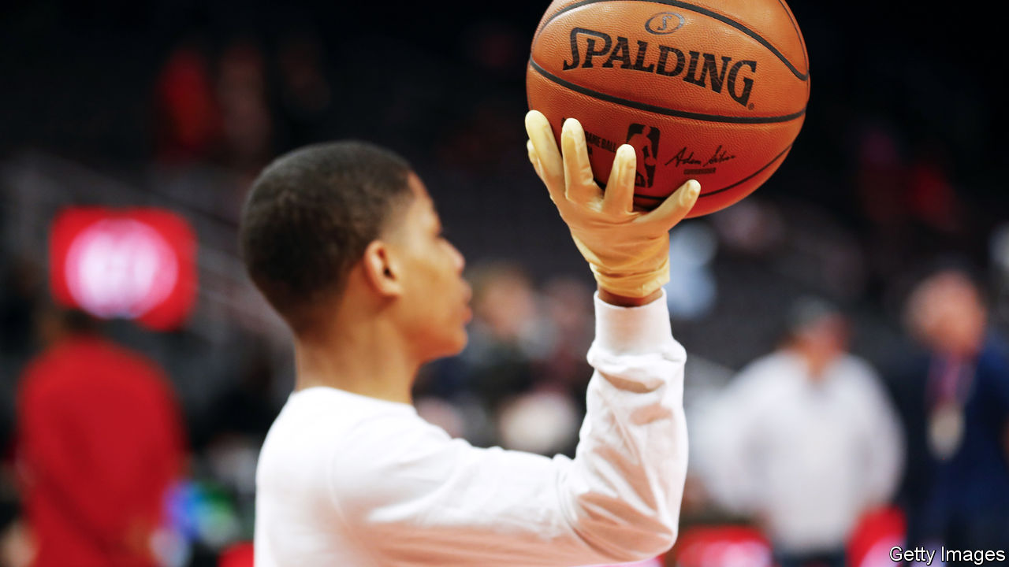

WHEN A NEW disease first took hold in Wuhan, the Chinese authorities did not have the luxury of advanced notice. Their initial strategy, in the crucial early weeks of what would become the global pandemic covid-19, was obfuscation and censorship, which did nothing to halt the spread of the virus that causes the disease. Only now, months after the first cases were reported, have new transmissions slowed to close to zero—and only after an unprecedented, draconian lockdown for hundreds of millions of citizens.

America, by contrast, had the luxury of several weeks’ notice. Yet the crucial early weeks when it could have prepared for the spread of the disease were squandered, in a country with some of the world’s best epidemiologists and physicians. As of March 11th, almost 1,300 Americans had been diagnosed with covid-19. Several times more probably have the disease undetected and are transmitting it within communities. And still the country looks behind in its preparations for what now threatens to be a bruising pandemic. (For more coverage of covid-19 see our [coronavirus hub](https://www.economist.com/news/2020/03/11/the-economists-coverage-of-the-coronavirus).)

America’s decentralised authority, expensive health care and skimpy safety-net will all make the pandemic response harder to deal with. The uncertainty is high, but a plausible scenario—one-fifth of the population falling ill, and a 0.5% fatality rate—would lead to 327,000 deaths, or nine times that of a typical flu season.

How America got here was the result of two significant failures—one technical, the other of messaging. A country of America’s size could probably not have avoided a serious outbreak of covid-19. But with enough information, the early spread of the disease could have been slowed. That lowers the peak of the outbreak, lightening the load on hospitals when they are most overstretched, thereby saving lives. It also gives the health service and the government time to prepare, and the population a chance to learn how to respond.

However, in America the testing regime has worked badly, because of faulty test-kits manufactured by the Centres for Disease Control and Prevention (CDC) and tangles in administrative red tape between the CDC and the Food and Drug Administration (FDA), another government agency. “The debacle with the tests probably reflects underlying budget cuts. You can’t have surge capacity if you’ve already been cut to the bone,” says Scott Burris, director of the Centre of Public Health Law Research at Temple University. In 2010 the CDC budget was $12.7bn in current dollars; today it is $8bn. Whether skimpy budgeting, bureaucratic blockages or both were to blame is as yet unclear and sure to be the subject of a future investigation.

When there are just a few infections, the health system has enough epidemiologists to track down and quarantine patients and their recent contacts. Without surveillance, however, small clusters rapidly become full-blown epidemics. This is where America finds itself today. The estimated doubling time of the virus is six days. If that remains constant, as is likely, the close-to-1,300 current cases are the bottom of a sickening ride up an exponential curve of infections. “In literal terms, we have no idea about the number of cases because nobody has tested to any meaningful extent,” says Marc Lipsitch, a professor of epidemiology at Harvard. “Tens of thousands of cases in the US seems plausible,” he adds.

A successful testing regime also buys time for the right messaging. But from the start, President Donald Trump has downplayed the chance of big disruption to ordinary lives and the economy. His insistence that virus hysteria was being amped up by his political enemies has distracted from the crucial message, which is to get ready. His announcement on March 11th of a ban on most travel from Europe was confused (he initially appeared to suggest it would apply to cargo), arbitrary (it excludes Britain) and accomplishes little now that the virus is spreading from within.

These mistakes cannot be undone. But what matters now is giving people the right information and reinforcing hospitals ahead of the inevitable deluge of cases. Unfortunately, the difficulties in testing and honest messaging look set to persist.

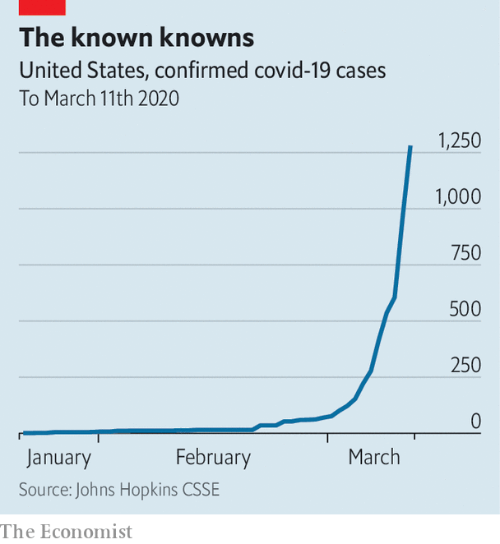

Even after the error in the test kits was detected, the increase in testing has been slow. Andrew Cuomo, the governor of New York, and Bill de Blasio, the mayor of New York City, have been begging the FDA to speed up approval for automated testing, to boost capacity from around 100 tests a day to the several thousand that are needed. A doctor at a Chicago clinic says that she has received no kits, nor guidance on when they will come. When she sees patients with covid-19-like symptoms she has to send them to be tested at a nearby hospital.

Now that kits are being delivered, researchers are reporting another problem—a shortage of the components needed to extract genetic material from samples. The White House promised capacity of 1m tests by March 6th. The CDC has stopped publishing data on the number of tests performed. But the latest cobbled-together estimates, as of March 11th, are of 7,000 tests in total, well behind almost every developed country with an outbreak.

Mr Trump has minimised the threat all the same. On March 9th he blamed the “Fake News Media” and Democrats for conspiring “to inflame the Coronavirus situation” and wrongly suggested that the common flu was more dangerous. The same day, Nancy Messonnier, an official at the CDC, was warning, correctly, that “as the trajectory of the outbreak continues, many people in the United States will at some point in time this year or next be exposed to this virus.”

Correcting the course of the outbreak is vital because America’s health infrastructure, like that of most countries, is not equipped to deal with an enormous surge in serious cases. A recent study of covid-19 in China found that 5% of patients needed to be admitted to an intensive care unit (ICU), with many needing intensive ventilation or use of a more sophisticated machine that oxygenates blood externally. America has 95,000 ICU beds and 62,000 mechanical ventilators, while only 290 hospitals out of 6,000 offer the most intensive treatment. Much of this equipment is already being used for current patients, including those with seasonal flu. Human capacity, such as the number of pulmonologists and specially trained nurses, is also a limiting factor—although in Italy, where the epidemic is raging, specialisms have begun to matter less. Mortality in overwhelmed hospitals will certainly be higher.

To reduce the chances of this happening, rates of transmission must be slowed by encouraging social distancing and telework, and cancelling large gatherings. (Sports events are already being called off: the National Basketball Association season was suspended on March 11th.) But in America authority over public health is largely delegated to the states and some cities. It is for each locality to declare a state of emergency; 13 had done so as of March 11th. The decentralised system means that containment regimes will differ.

Mr Cuomo has ordered a series of measures: a one-mile containment area in New Rochelle, site of a cluster, serviced by the National Guard; and a state-produced line of hand-sanitiser made by prisoners to ameliorate a shortage. At the same time, New York City and Chicago have so far resisted closing their public schools, noting that many poor households rely on them for meals and child care. Many private universities are cancelling classes and switching to tele-instruction (causing much difficulty for some septuagenarian professors). Harvard gave its undergraduates five days’ notice to pack their things and leave.

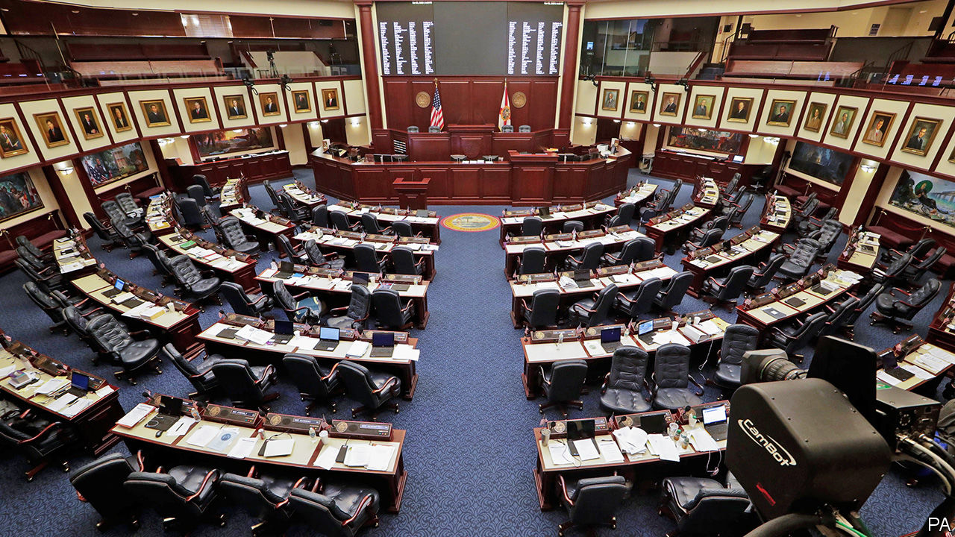

Maintaining a healthy population requires people not to spread the disease, but also to seek treatment without worrying about crippling debt. America is one of the few countries in the developed world that does not mandate paid sick leave. A mere 20% of low-paid, service-sector workers can count on it. Those without cannot stay at home, because a retail worker cannot just fire up Slack and Zoom as a white-collar office worker might.

Health care is also extraordinarily costly. People who are uninsured, underinsured (ie, liable for a high share of their treatment costs) or fearful of surcharges for using out-of-network hospitals and physicians may keep away—particularly if their pay has recently fallen or stopped altogether. “The idea that people should have skin in the game kind of doesn’t work when you’re also playing with your neighbour’s skin,” says Wendy Parmet, a professor of public-health law at Northeastern University. Some insurers, as in Illinois or in California, insist that patients will not be made to pay for testing. But as yet there is no such policy at national level.

Last week Congress passed an emergency appropriation of $8.3bn to fight the virus, which Mr Trump signed into law. Almost all that money will be devoted to front-line measures—such as test-kits, laboratory equipment and additional staff. A bigger fiscal stimulus will probably be needed. Mr Trump and Democratic leaders have sketched competing visions for what to do. The president would like to provide tax credits directly to stricken industries such as airlines, frackers and cruise-ship operators, cut payroll taxes (usually paid every two weeks) and offer paid sick leave to hourly workers. Democrats have proposed more generous paid-sick-leave rules, expanded payments for programmes like unemployment insurance and nutrition assistance, and guaranteed payment of all testing and out-of-pocket treatment costs. The need is urgent, but the haggling could drag on for some time.

Thus far in his presidency, Mr Trump has faced a few crises. Most he generated himself, including various trade wars and bouts of chest-thumping, which could generally be defused. The virus, however, will circulate no matter how much the president may wish it gone. Talking down the risks is not a winning strategy. To fight the outbreak, America needs clear, unvarnished public information and policies based on the best science. Is the president capable of endorsing that? ■

Dig deeper:

* For more coverage of covid-19 see our [coronavirus hub](https://www.economist.com/news/2020/03/11/the-economists-coverage-of-the-coronavirus)
* The science of the virus
* Fatality rates for covid-19 could vary enormously
* How to deal with a new sort of financial shock
* Should other countries copy Italy’s nationwide lockdown?

This article was downloaded by calibre from <https://www.economist.com/united-states/2020/03/12/covid-19-is-spreading-rapidly-in-america-the-country-does-not-look-ready>

|  |  |  |  |
| --- | --- | --- | --- |
|  | Articles | Sections | Next |

|  |  |  |  |
| --- | --- | --- | --- |
| Previous | Articles | Sections | Next |

#### Spluttering

# Tracking the economic impact of covid-19 in real time

It is not necessary to wait for quarterly GDP numbers to see what the virus is doing to activity

Mar 14th 2020 | SAN FRANCISCO

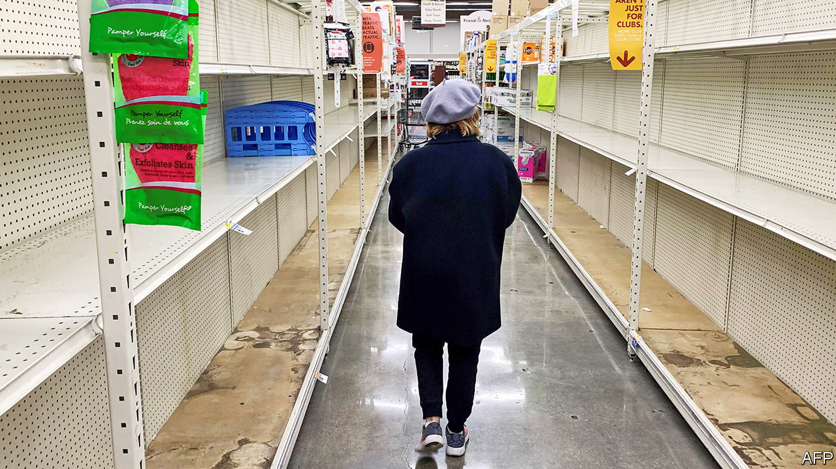

AS FEARS GROW about the impact of the covid-19 virus, financial markets have slumped. Now there are signs that the virus is moving from traders’ screens to the real economy. No one will know the true economic impact for some time, because official statistics are published with a lag: the first estimate of GDP growth in the current quarter, for instance, will not appear until April 29th. Analysts cannot wait that long. So they are turning to “real-time” data, mainly produced by the private sector, on everything from transport use to social-media activity. None of these measures is reliable by itself, but together they give a decent impression of what is going on.

It is not all doom and gloom. So far there are few indications—either from weekly jobless claims or from company announcements—that joblessness is rising. Worries that broken supply chains would stoke inflation also look overdone, for now at least. Data to the beginning of March from State Street PriceStats Indicators, which measures inflation daily, suggest that inflation has been on a steady downward trend since the beginning of the year (though in recent days food prices have inched up, perhaps pointing to the effects of stockpiling). Railway and trucking volumes appear to be holding up. There is some evidence of lower electricity demand, perhaps as people miss work, though the figures are volatile.

Household spending is taking a big hit, however. Analysis by Goldman Sachs, a bank, of Twitter posts suggests that consumer confidence has dropped. People are nervous of crowds—and some 40% of household spending is vulnerable to people shunning gatherings, according to calculations by The Economist using a methodology from an Oxford University research paper. (About 5% of consumer spending goes on dining out, for instance.)

Google searches for “restaurant reservations” are way down. The maître d’ at San Francisco’s best oyster bar was so pleased to see a customer that he offered a free plate of them when your correspondent bought a drink (the bar looked over the bay towards Grand Princess, a virus-stricken ship harboured in Oakland). A report from JPMorgan Chase, another bank, estimates that last weekend the virus reduced cinema-ticket receipts by 20%. Attendance at Broadway shows has also dropped. Data from TomTom, a location-technology firm, reveal unusually low traffic congestion in many American cities since the end of last week. Lower consumer spending points to feeble GDP growth in the first half of this year, though a recession still seems unlikely at this stage.

What happens next depends on whether America gets a handle on the outbreak. If it does not, then over time revenue-starved firms and salary-starved families will struggle. Any short-term economic boost from stockpiling would be cold comfort in the face of lower spending on services. But if America contains the virus, it can look forward to a bounceback of sorts. Real-time data in China, from traffic congestion to energy consumption, remain weak but are fast improving as the number of new infections slows. An acute economic shock does not have to turn chronic. ■

Dig deeper:

* For more coverage of covid-19 see our [coronavirus hub](https://www.economist.com/news/2020/03/11/the-economists-coverage-of-the-coronavirus)
* The science of the virus
* Fatality rates for covid-19 could vary enormously
* How to deal with a new sort of financial shock
* Should other countries copy Italy’s nationwide lockdown?

This article was downloaded by calibre from <https://www.economist.com/united-states/2020/03/14/tracking-the-economic-impact-of-covid-19-in-real-time>

|  |  |  |  |
| --- | --- | --- | --- |
| Previous | Articles | Sections | Next |

|  |  |  |  |
| --- | --- | --- | --- |
| Previous | Articles | Sections | Next |

#### Berning out

# Working-class whites deserted Bernie Sanders in the Midwest

Joe Biden will very probably be the Democratic nominee

Mar 12th 2020 | WASHINGTON, DC

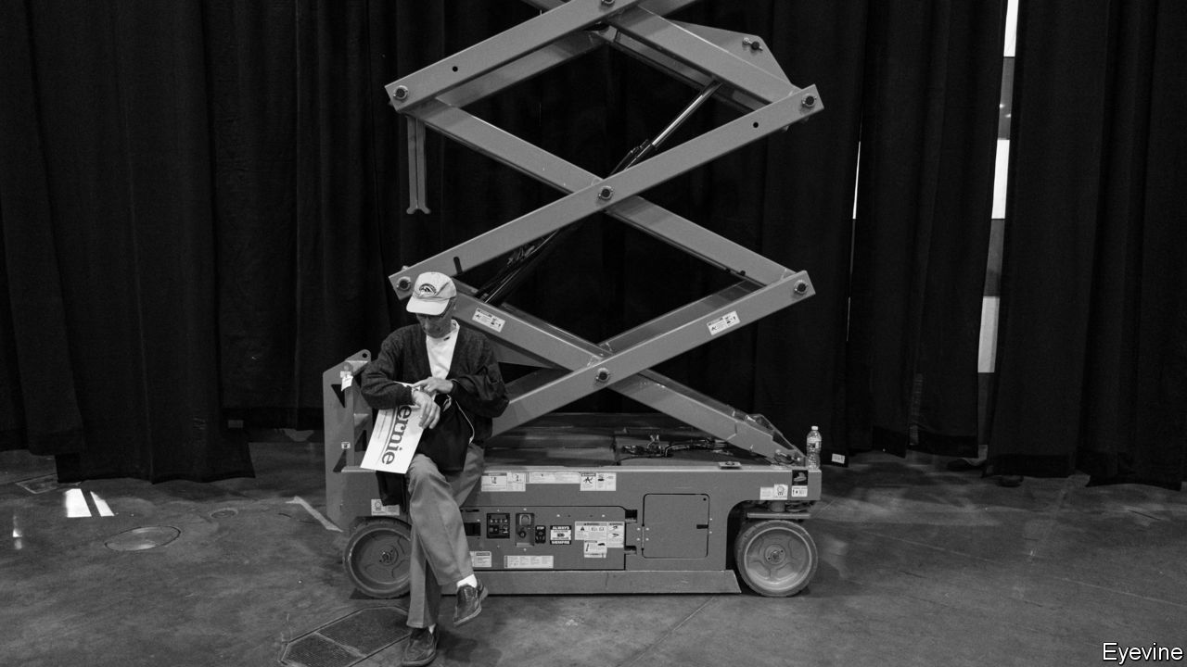

IN 1987, WHILE he was mayor of Burlington, Vermont, Bernie Sanders released an album of folk songs and poetry entitled “We Shall Overcome”. The record included anthems of Americana such as “This Land Is Your Land”, as well as civil-rights ballads like “Oh Freedom”. It became popular among Mr Sanders’s supporters during the 2016 Democratic primaries, embodying his long-standing devotion to progressive ideas about race and civil rights, along with his vintage lefty beliefs about the state’s responsibility to create equality. (His singing abilities were probably less of a factor in the album’s success.)

Despite his folksy appeal, Mr Sanders was unable to win the Democratic Party’s presidential nomination that year. Voters seem to have decided on a similar fate for him this time round. After briefly leading the primary race in February, the Vermont senator suffered a severe setback on Super Tuesday. He limped into this week trailing Joe Biden, the former vice-president, by roughly 80 delegates, according to The Economist’s projections. On March 10th Mr Biden dealt him another crushing blow. Mr Sanders lost in Michigan, where he won in 2016, by more than 15 percentage points. He also lost in Missouri and Mississippi (which he lost in 2016) and in Idaho (which he won).

The results in Michigan are particularly rough for Mr Sanders. Back in 2016 his surprise victory was an important boost for a campaign that had struggled to build a winning coalition. He had lost the majority of the primaries and caucuses held the previous week, and trailed Hillary Clinton by 156 delegates (a far worse deficit than his position this week). Yet despite the odds—polls had him down by 20 percentage points—he won the state, breathing new life into his campaign. Victory then came thanks to support from working-class whites, who favoured him by large margins over Mrs Clinton, and from young people. Mr Sanders’s protectionist trade policies may have been particularly popular in declining post-industrial cities such as Grand Rapids and Kalamazoo.

Much of that Sanders coalition from 2016 has not stuck around. In post-industrial Kent County (which surrounds Grand Rapids), his vote share fell by 18 points compared with 2016. In Kalamazoo County, it fell by 17 points.

Cracks in the base had already begun to show. Suburbanites and young voters had failed to turn out in Super Tuesday states in the revolutionary numbers that he has long promised. Until now, though, it was not clear whether rustbelt whites would give him enough support to keep his hopes alive. But across Michigan his vote share slipped by larger amounts in counties with higher concentrations of white adults without a college degree. It plunged too in the sparsely populated areas of the state (see chart).

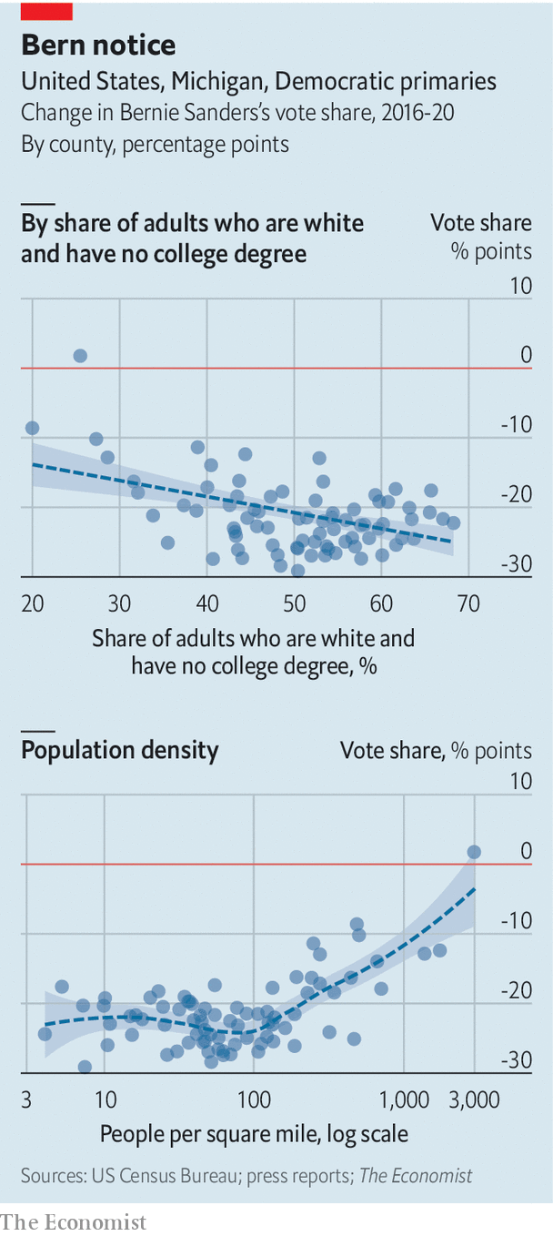

Although these voters were willing to cast their ballots for a self-described socialist in 2016, that was probably because they disliked Mrs Clinton more. Given the choice between Mr Biden and a far-left ideologue, they picked the moderate this time round.

The primaries are now all but over. Mr Biden emerges from the latest contests with a 145-delegate lead, according to our projections of how remaining delegates from partially-reporting states will be allocated. Barring disaster, Mr Biden will probably go on to win a large majority of delegates in next week’s contests. Polls put him ahead in Arizona, Florida, Illinois and Ohio—worth 577 delegates in total.

Mr Sanders’s campaign will not have been for nought; he has moved the party left on the issues he cares about most. Ultimately, though, Democrats just did not believe he could beat Donald Trump. ■

Dig deeper:

* Sign up and listen to Checks and Balance, our new [newsletter](https://www.economist.com/checksandbalance/) and [podcast](https://www.economist.com/podcasts/2020/02/21/checks-and-balance-our-new-weekly-podcast-on-american-politics) on American politics
* [Explore our guide](https://www.economist.com/united-states/2020/02/26/the-economists-guide-to-the-us-2020-elections) to the US 2020 elections

This article was downloaded by calibre from <https://www.economist.com/united-states/2020/03/12/working-class-whites-deserted-bernie-sanders-in-the-midwest>

|  |  |  |  |
| --- | --- | --- | --- |
| Previous | Articles | Sections | Next |

|  |  |  |  |
| --- | --- | --- | --- |
| Previous | Articles | Sections | Next |

#### Green Texas

# A renewable-energy boom is changing the politics of global warming

An awful lot of Republican-voting states have fallen for wind farms and solar panels

Mar 14th 2020 | TAHOKA, TEXAS

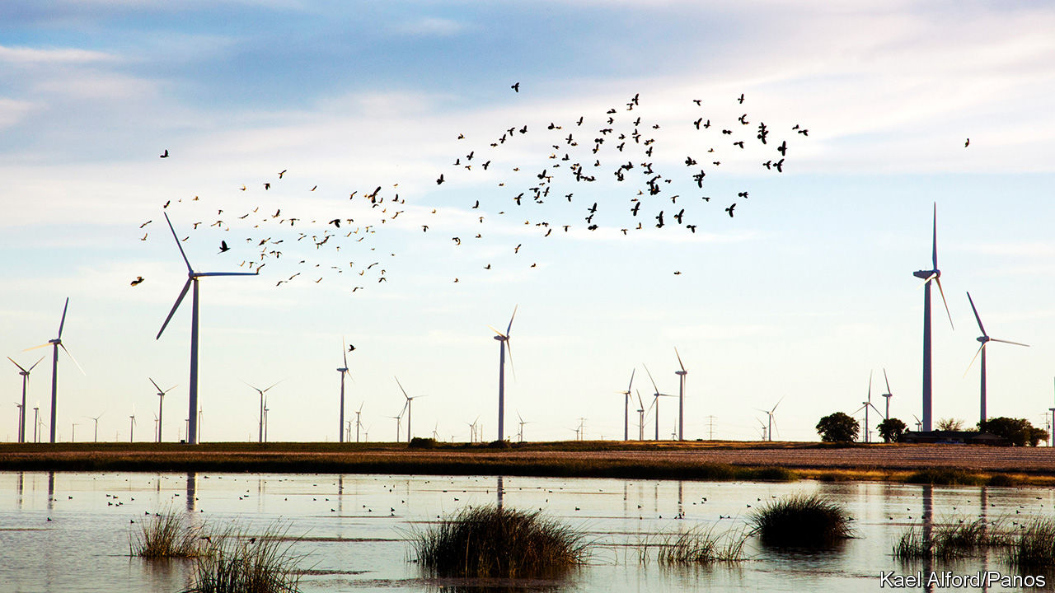

OVER THE PAST few years Dewey Engle, an 81-year-old retired highway worker who lives on the outskirts of Tahoka, a small farming town in west Texas, has acquired a new view from his back porch. Dozens of wind turbines hum 300ft over the cotton fields behind his bungalow. Some people might be disturbed by the sudden arrival of such monstrous machines practically in their garden. Mr Engle says that his only problem with them is that they are not on his modest patch of farmland, so he does not get any royalties. “I would love to have that money coming in,” he says. “I’d like to have ten of them.”

The wind farm at Tahoka is owned by Orsted, a Danish energy firm which entered the American market less than two years ago. It comprises 120 turbines, each capable of generating enough power for 1,000 homes. At next door Sage Draw, another 120 turbines are still being erected and hooked up to the Texas grid. Fracking, another industry which has transformed parts of western Texas over the past decade, is now in trouble. But turbine blades will not stop spinning. Drive from Lubbock to Sweetwater, and for almost the entire journey the horizon bristles with windmills in every direction. The vast majority were put up in the past ten years. Texas now meets 20% of its sizeable electricity demand with wind. If it were a country, the Lone Star State would be the fifth-biggest in the world in its production of wind energy.

Curiously, America’s renewable-energy boom has been strongest in Republican-controlled states like Texas. Democrat-controlled places like New York have policies intended to attract investment, for example pledges that state governments will buy only green power. But Texas has lots of wind and sun and rather fewer Nimbys. President Donald Trump, who has spent a small fortune trying to fight a wind farm within sight of his Scottish golf club, evidently cannot stand turbines. At rallies he likes to rant about how they kill birds. But for many of his supporters, particularly in rural areas, wind turbines and solar panels are a boost to ailing economies. In Lynn County, of which Tahoka is the seat, 77% of people voted for Mr Trump. Could the boom persuade Republicans that decarbonising might be an economic opportunity, not just a cost?

In recent years turbines have sprouted across the American plains; proportionately, Kansas and Oklahoma both rely on wind more than Texas does. For some years now, one of the fastest-growing job categories in America has been “wind-turbine technician”. Nor is the boom confined to wind. Investment is pouring into solar plants and battery systems, especially in the sun-soaked south-west. The growth in numbers of solar-panel installers has now overtaken that of wind-turbine technicians. Taken together, solar and wind energy make up 55% of the new electricity-generating capacity added each year, according to the Solar Energy Industries Association, an industry group. Since coal plants are shutting faster than gas ones open, overall fossil-fuel capacity is shrinking.

What precipitated this boom? Federal policies have helped—wind has benefited from a production tax credit for decades, though it will expire in the next few years. A solar-investment tax credit will continue. But local policies have helped, too. Texas has its own electricity grid, which is managed by ERCOT, a state utility. In the 2000s lobbying by politicians in the west of the state led it to create a fund to build a new network of transmission lines, which made it possible for wind producers to supply power to the grid from remote but windy parts of the state. The same lines are now helping to boost solar, says Dan Woodfin of ERCOT. He says that, ten years ago, he did not believe that the system would be able to handle as much renewable energy as it does now; at the peak, 55% of Texas’s electricity has been supplied by wind.

Yet the biggest driver has simply been low cost and high demand. The cost of wind turbines and solar panels has fallen precipitously. And in rural places like Texas (unlike more densely populated parts of the country) royalties paid for the use of land are important enough to landowners and local governments to deter opposition. Meanwhile a growing number of large firms want to buy green electricity to reduce their own carbon emissions, which means producers can package up their renewable energy to sell with virtual power-supply agreements.

Will all this growth begin to change attitudes towards climate change? For now, Texas has around 35,000 jobs in solar and wind energy. The figure has grown quickly, but ten times that number are still in fossil fuels. Texas is America’s biggest producer of carbon emissions. So it is perhaps unsurprising that its governor, Greg Abbott, has been sceptical that humankind has much to do with global warming. Plenty of Republican politicians, such as Senator Chuck Grassley of Iowa, show that it is entirely possible to be an enthusiastic proponent of green energy in your district while still denying that climate change overall requires any national policy response.

But the shift towards greener energy is changing some minds. Curt Morgan, the CEO of Vistra Energy, one of Texas’s biggest electricity firms, which both generates and sells electricity, says his firm has moved from relying on coal for around 70% of its generation to less than half that now. All of Vistra’s new investments are in renewable energy, and the firm now backs a carbon tax, which Mr Morgan says is the best way to incentivise firms like his to move away from polluting carbon. ExxonMobil, a fossil-fuel giant headquartered in the state, is another proponent of the idea.

Yet will that persuade Republicans? Mr Morgan says he thinks the party is moving in the right direction. They have moved from being a “just say no party on climate change to a party that recognises it is a problem,” he says. But, he adds, progress is slow. “The politicians have a problem—they need to get re-elected.” In February Republicans in the House of Representatives proposed to reduce emissions by creating a tax credit for carbon sequestration and encouraging the planting of trees. Despite its modesty, the plan was immediately denounced as capitulation by some groups on the right. The Republican Party risks being left behind defending old industries even as new ones sweep them away.■

This article was downloaded by calibre from <https://www.economist.com/united-states/2020/03/14/a-renewable-energy-boom-is-changing-the-politics-of-global-warming>

|  |  |  |  |
| --- | --- | --- | --- |
| Previous | Articles | Sections | Next |

|  |  |  |  |
| --- | --- | --- | --- |
| Previous | Articles | Sections | Next |

#### Country cops

# Small towns and rural parts of America have a policing problem

Difficulty recruiting and retaining officers means that the number of police departments is shrinking

Mar 14th 2020 | THOMASTON, MAINE

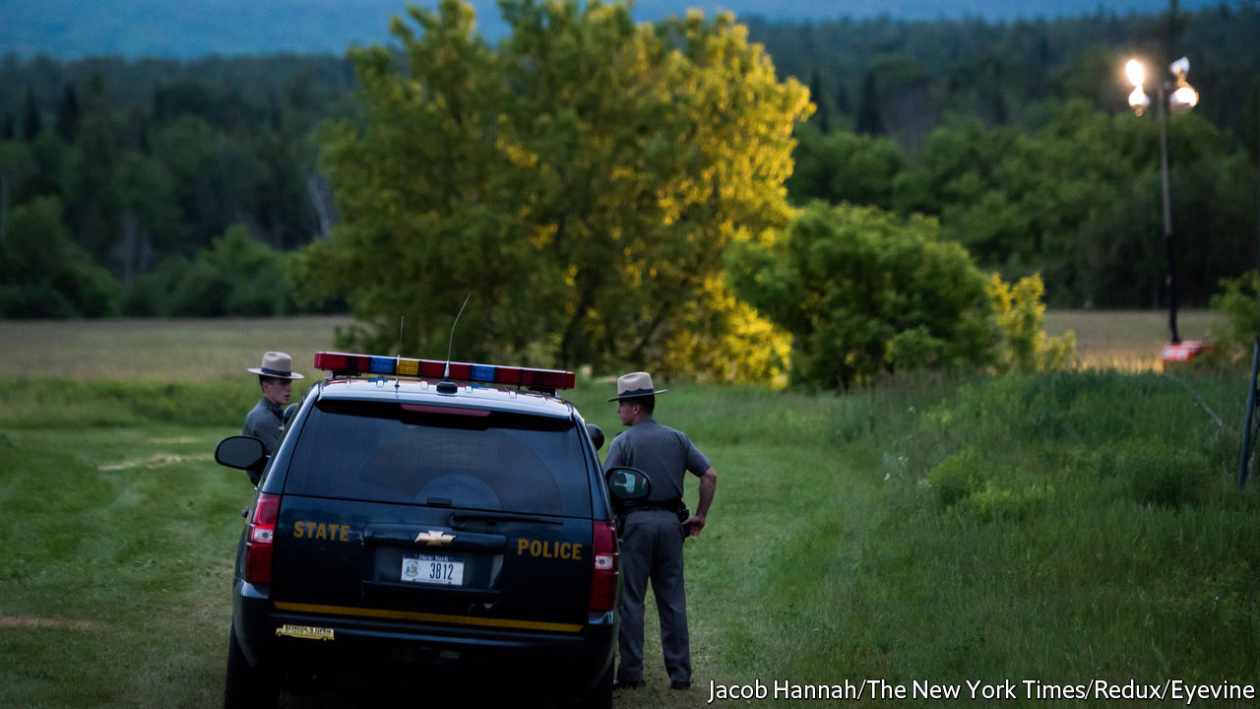

“THE ANDY GRIFFITH SHOW”, one of the most popular television programmes during the 1960s, was about a small town’s sensible and empathetic sheriff. It would be difficult to reboot today. The loyal deputy position would have a high turnover rate and the sheriff would consider resigning for a job with family health insurance. The town council, meanwhile, would debate disbanding the police department altogether.

Thomaston, a picturesque town of 2,800 people in mid-coast Maine, found itself with just one full-time police officer last year. Two officers resigned and then two more left for better-paying jobs in other law-enforcement agencies. The police department at full capacity is made up of four full-time officers, the police chief and three reserve officers. A reserve officer is a sort of apprentice cop, who works part-time and is certified to enforce the law, but has not yet gone to the police academy for training. The small department was kept busy responding to around 5,000 calls a year, ranging from barking-dog complaints to domestic violence. Much of the crime is related to opioid addiction. Keeping good cops had long been a problem. Their families were not entitled to health coverage, and working nights, weekends and holidays is not for everyone.

The exodus left just Tim Hoppe, the police chief. A referendum was held to disband the police department and contract a sheriff to patrol the town. The townspeople voted in favour of keeping its local force, even if it meant paying more in taxes. But a police department does not come cheap. Training an officer can cost $40,000-50,000. Health care can be extortionate. Equipment is pricey and must be upgraded regularly. Bulletproof vests, for instance, must be changed every few years. Many small departments make do with battered cruisers and radios which fail to work in rural dead zones. Some departments require officers to pay for their own firearms, body armour and body cameras.

About half of all local police departments have fewer than ten officers. Many are battling to keep even those. Better pay in the private sector is helping thin the ranks. The result is that the number of officers per 1,000 residents fell by 7% between 2007 and 2016, the most recent year examined by the Bureau of Justice Statistics.

Thomaston is not alone in debating the future of policing in its town hall. Rural districts from Maine to Montana are consolidating law-enforcement resources or contracting them out to the county or state. Gouldsboro, another Maine town of 1,700 people, voted to keep its department in 2019. Croydon, a small town in New Hampshire, disbanded its one-man police department last month.

Jim Burch of the National Police Foundation, a research outfit, says contract policing with a larger county agency can work well. But, he says, it comes at a cost. Response times can be slower. And local policing brings other benefits. Mr Hoppe knows everyone in Thomaston. Two people have died from opioids in the past two weeks in his town. He knew them both.

The Department of Justice recently held a series of sessions around the country to understand the troubles of local law-enforcement agencies. The hope is that the feds will adjust funding to give rural police forces some backup.■

This article was downloaded by calibre from <https://www.economist.com/united-states/2020/03/14/small-towns-and-rural-parts-of-america-have-a-policing-problem>

|  |  |  |  |
| --- | --- | --- | --- |
| Previous | Articles | Sections | Next |

|  |  |  |  |
| --- | --- | --- | --- |
| Previous | Articles | Sections | Next |

#### Lexington

# The Trump campaign

Donald Trump owes his election to the moral choices of millions of voters—not to Facebook ads

Mar 14th 2020 |

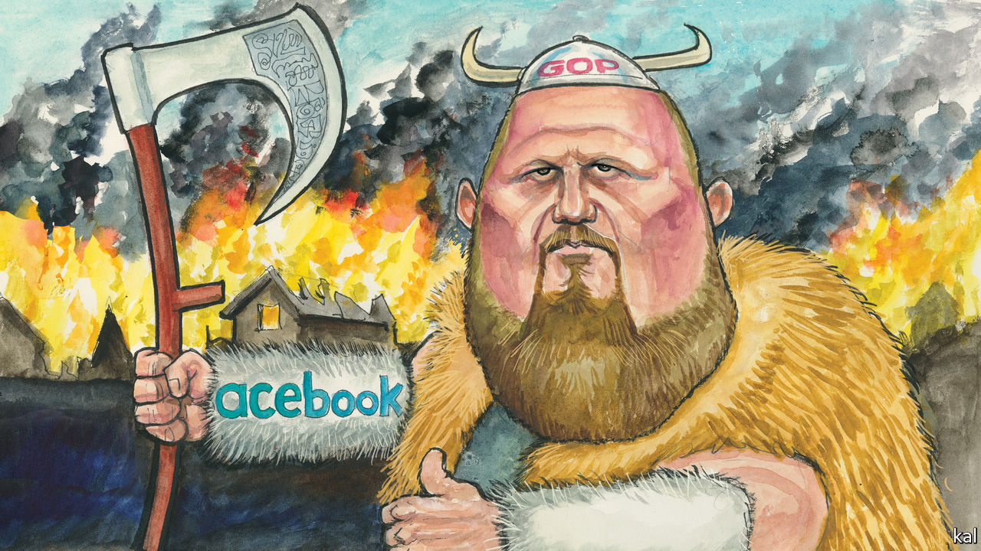

FIRST IT WAS Steve Bannon; then Jared Kushner; now it is Brad Parscale. Ever since Donald Trump began persuading millions of Americans to support him while behaving as no successful politician ever had, mainstream commentators have looked for the evil genius pulling his strings. Messrs Bannon and Kushner were both auditioned for the part, but rejected, after achieving little in office besides notoriety. Now, as Mr Trump’s re-election campaign starts going full tilt, Mr Parscale is being considered.

Tremulous profiles of the Trump campaign’s manager are the latest thing in political reporting. They typically start by noting his intimidating height, bullish demeanour and “Viking beard” (“I get the Viking thing often,” Mr Parscale has acknowledged). Such attributes are on-brand with a president fixated on central casting—as are other features of the 44-year-old Mr Parscale’s rise from obscurity in San Antonio, Texas, where he worked as an online marketer, to command the heights of the politics business.

Like Mr Trump—who launched Mr Parscale by paying him $1,500 to design his first campaign website—he is a political gadfly, rabble-rouser and dissembler. A sometime libertarian, who has rarely voted, he is now a staple warm-up act at Trump rallies: praising the president and attacking his enemies. A self-described “farm boy from Kansas”, he in fact grew up in suburbia, the son of a wannabe Democratic politician. But, again like Mr Trump, he has a reputation for native cunning and outlandish success that can make such foibles seem colourfully additive or irrelevant.

Mr Pascale’s reputation is based on Mr Trump’s 2016 digital campaign, which he led. A Facebook executive described it as “the single best digital ad campaign I’ve ever seen”. Heavily focused on Facebook advertising, it was credited with micro-targeting thousands of Trump voters in swing states with the half-truths and xenophobic messaging that Mr Parscale has a gift for turning from Mr Trump’s lips into ad copy. And sometimes the other way round: he is also credited with persuading the president to swap “illegal immigrants” for “illegal aliens”, a more stimulating phrase.

The liberal commentariat fears Mr Parscale is about to repeat his electoral feat. Mr Trump’s campaign is now awash with cash and even more ambitiously digitised than it was in 2016. It also stands to benefit disproportionately from his incumbency, because digital campaigning is based on data-gathering, which he has been doing non-stop. Perhaps a million people have attended the hundred-odd rallies he has held since his election, and many more provided their names and phone numbers to register for one. At a rally in South Carolina last month one attendee, with phone in hand, showed your columnist what happens next.

Every few hours she had received a text message, purportedly from one of Mr Trump’s sons, demanding cash. “My father asked me to reach out personally, friend…Don’t disappoint him,” ran the latest from Eric Trump. By such means Mr Trump and his proxies have raised over $200m, far more than their Democratic rivals.

That sort of money buys impunity as well as advertising. Though Facebook has tried to impose a code of conduct on political advertisers—for example, it vowed to block content ruled untrue by a third-party fact-checker—the Trump campaign has often violated its terms. And in response the platform has backed down; for example, although the campaign recently pushed a lie linking Joe Biden to corruption in Ukraine, Facebook decided to make political campaigns exempt from its fact-checking rule.

This is a promise of yet more disinformation and divisiveness. Yet whether Mr Parscale’s digital knavery will affect Mr Trump’s chances of re-election is moot. Academic studies of political advertising suggest it reinforces existing biases but is almost useless at changing voters’ minds. Americans’ partisan affiliations and familiarity with advertising are too strong. “The best estimate of the effects of campaign contact and advertising on Americans’ candidate choices in general elections is zero,” concluded the authors of a recent meta-study of electoral research. Mike Bloomberg spent half a billion dollars proving the same point in a primary contest. It bought him some decent poll numbers, but the moment he faced critical coverage after a bad debate performance, they collapsed.

Digital campaigning is fast-evolving. But, notwithstanding the fears he is inspiring, there is little reason to think Mr Parscale has anything up his sleeve that could alter this reassuring picture. His main ploy in 2016 was to use Facebook technology to raise money, according to David Karpf of George Washington University, an expert on disinformation. Mr Parscale was told how to do so by Facebook staffers loaned to the campaign. Otherwise, the Trump campaign’s digital strategy was not fundamentally different from Hillary Clinton’s. Her campaign also spent heavily on Facebook.

The mystique surrounding Mr Parscale and his digital arts appears to be largely a product of vested interests. Political operatives revere ads in part because many have got rich on them, including Mr Parscale. One of his many firms has charged the Trump campaign and related organisations nearly $35m since 2017, mostly to pay for ads it has commissioned. This has also given Facebook, the main beneficiary of Mr Parscale’s strategy, an obvious incentive to talk up his genius and the potency of digital advertising—though there is no compelling evidence for either claim.

## Look at the data

Journalists who covered the 2016 election also have reasons to buy the myth of Mr Trump’s digital mastery. It allows them to downplay their own responsibility for his win by providing blanket coverage of the Republican candidate and the many slanders he levelled at Mrs Clinton, concerning her emails, alleged corruption and so forth. It is also a means to avoid confronting the uncomfortable fact that 63m Americans heard who Mr Trump was from his own mouth, unfiltered, and still voted for him. That is a better explanation for his success than Mr Parscale’s dark arts.■

Dig deeper:

* Sign up and listen to Checks and Balance, our new [newsletter](https://www.economist.com/checksandbalance/) and [podcast](https://www.economist.com/podcasts/2020/02/21/checks-and-balance-our-new-weekly-podcast-on-american-politics) on American politics
* [Explore our guide](https://www.economist.com/united-states/2020/02/26/the-economists-guide-to-the-us-2020-elections) to the US 2020 elections

This article was downloaded by calibre from <https://www.economist.com/united-states/2020/03/14/the-trump-campaign>

|  |  |  |  |
| --- | --- | --- | --- |
| Previous | Articles | Sections | Next |

|  |  |  |
| --- | --- | --- |
| United States | Sections | Asia |

The Americas

Chile: A model country in need of remodelling

.

|  |  |  |
| --- | --- | --- |
| United States | Sections | Asia |

|  |  |  |  |
| --- | --- | --- | --- |
|  | Articles | Sections | Next |

#### Remodelling the model

# Can Chile reinvent itself?

Why the country’s citizens are so angry

Mar 14th 2020 | SANTIAGO

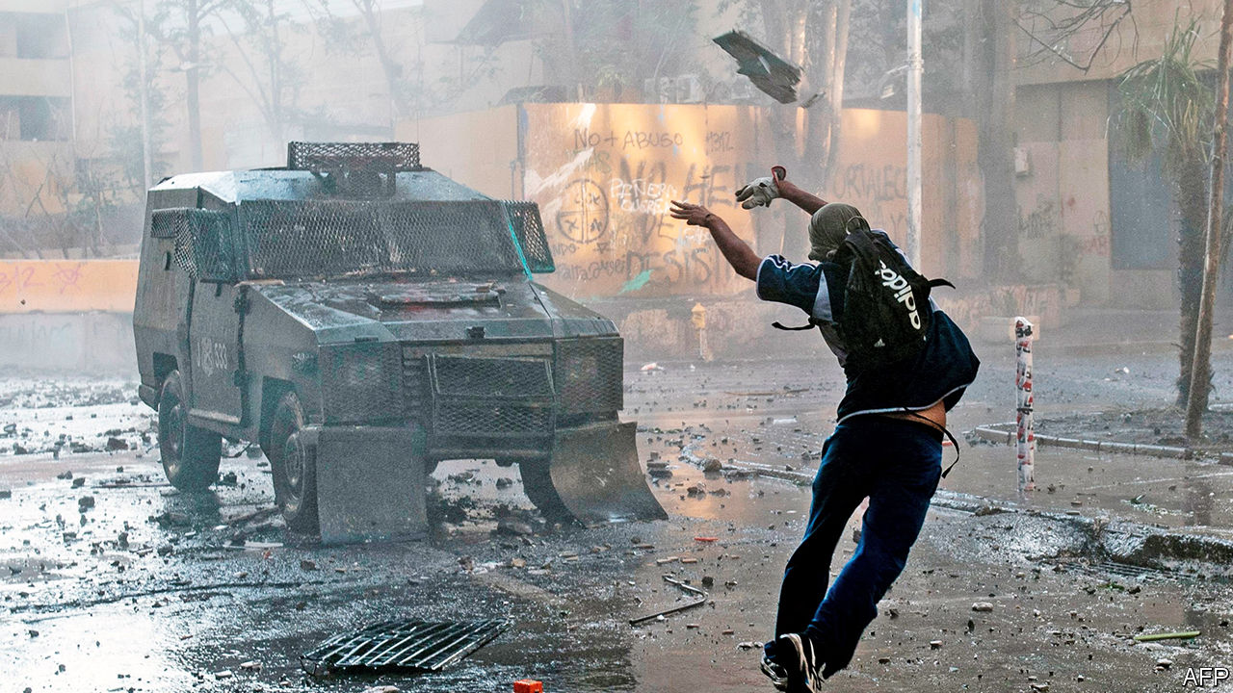

WALK NORTH-EAST along the Alameda, the main avenue of Chile’s capital, Santiago, to the well-heeled neighbourhood of Providencia, and for several miles the scene on either side is one of desolation. Hundreds of businesses are boarded up, some operating through doors between shutters. The Baquedano metro station and a large hotel next to it are partly burned out. Pavements have been ripped up, leaving earth and rubble. Traffic lights are disabled. Walls and statues are plastered with graffiti. Many denounce as “murderers”, variously, Sebastián Piñera, Chile’s centre-right president, the Carabineros (the national police force), the state and capitalism. Others hail a coming revolution, or at least a new constitution.

The trouble began on October 6th with a 30-peso (four-cent) rise in the price of peak-hour metro tickets. That set off mass fare-dodging by school pupils. Days later much of the metro in Santiago suffered arson attacks (by foreign agitators, claimed the government, without evidence). Declaring that Chile was “at war”, Mr Piñera imposed a state of emergency for ten days and sent the army on to the streets for only the second time since the dictatorship of General Augusto Pinochet (1973-90). That prompted peaceful protests, including a march in Santiago of perhaps 1m people—in a metropolitan area of 7m. At the same time, supermarkets and pharmacies were looted and several churches and public buildings burned. Much of the damage was in poorer areas on the periphery of Santiago and other cities. At least 30 people died. The economy was hurt, too: growth last year was barely above 1%. The government had forecast 2.6%.

The malcontents are a loose confluence of young people. In the capital nearly 200,000 neither work nor study. Chile has an intellectual proletariat of graduates from low-grade private universities, many of whom have large student debt. Over the past decade anarchist groups that specialise in attacking the police have grown in Santiago. Then there are football hooligans and the footsoldiers of the drug trade, who operate in poor barrios. The fact that many of these people are outside the political system has made it harder for the government to know whom to negotiate with.

Things came to a head on November 12th when, some Chileans feared, the country faced a choice between anarchy and martial rule. “Many people called me, desperate, saying ‘They are burning the city’,” Mr Piñera said in an interview in late January. “I had two choices: to call on the armed forces again, or give another opportunity for peace, dialogue and agreements. It was a very difficult decision.”

According to several sources, this time the military commanders balked at intervening without immunity from prosecution. “The armed forces would have obeyed a presidential order,” insists Mr Piñera. For whatever reason, he drew back. The government swiftly negotiated cross-party agreements for a plebiscite, to be held on April 26th, on whether to set up an assembly to write a new constitution. It rushed through an increase in pensions for the poorest and a tax increase on the better-off, and promised other measures.

All this released some of the tension. The protests faded during the southern-hemisphere summer holidays. But now they have resumed, while vandalism never really stopped.

Several other countries in Latin America saw street protests last year, though not on the same scale. But Chile? Over the past 30 years it came to be viewed as the one country in Latin America on the path to developed-country status. The protests are a big blow to that confidence, and threaten to halt Chile’s progress. But they might also be the spur by which it finally joins the global top tier.

Chile “could become a country with a more solid and sustainable social contract that resolves the legacy issues [left by the Pinochet dictatorship],” as Mario Marcel, the president of the Central Bank, puts it. He notes that those obstacles have contributed to what economists call the middle-income trap, in which sociopolitical shortcomings slow growth and prevent countries reaching developed status.

But if violence continues and the state is unable to contain it by democratic means, and if conservatives block change, others fear a darker future. Chile could face “a classic Peronist moment in which a country successful in growth has contradictions it can’t manage”, says Óscar Landerretche, an economist aligned with the Socialist Party, referring to the period in the 1940s in which Argentina embraced populism and dictatorship.

## Middle-of-the-road rage

In many respects Chile has been a success story since democracy returned in 1990. Governed by the centre-left for 24 of those years, it has combined economic growth, political stability, fairly strong institutions and expanding social services. Those below the official poverty line (of $206 per month) fell from 45% of the population in the mid-1980s to 9% in 2017. Some 65% of Chileans are middle-class, up from 24% in 1990, according to the World Bank’s income criteria. Since Chile joined the OECD, a club of mainly rich countries, in 2010, its elites have taken to suggesting that it has little in common with its neighbours.

What, then, prompted the social explosion? “There are many theories,” says Mr Piñera, a billionaire businessman. “I agree with all of them, and they are contradictory, which means we lack a shared diagnosis.” The first theory, favoured on the right, is the slowing of economic growth since 2014. In Mr Piñera’s first term (from 2010 to 2014) growth averaged 5.3% a year, boosted by reconstruction after an earthquake. He won his second term in 2017 by promising a repeat but failed to deliver it. A second, related theory concerns rising expectations. It sees discontent as the consequence of Chile’s success in creating a middle class that demands more of government.

A third view, common on the left, is that the country is rebelling against inequality, which, it is claimed, is entrenched by Pinochet’s “neoliberal” economic “model”. This gave private enterprise free rein and confined the state to a subsidiary role, even in providing social services. By OECD standards, though not those of Latin America, income inequality is indeed wide (see chart 1). “You can’t go through a process of rapid growth and capitalist modernisation and persist with pre-capitalist levels of inequality and absence of meritocracy and social mobility,” says Mr Landerretche. Yet income distribution has improved this century.

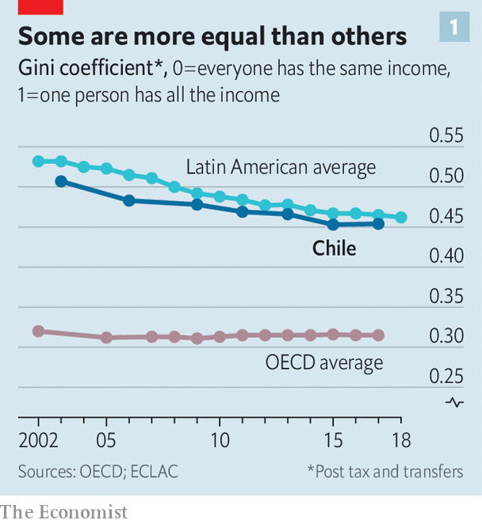

A fourth theory highlights political failures. During the second government in 2014-18 of Michelle Bachelet, a Socialist, much of the left disowned its own past work of gradual, consensual reform, propagating the view that it was a failure. As for Mr Piñera, he and his team, who come from a privileged slice of society, lack political skills and empathy with the masses. In their first 18 months in office, they failed to get promised tax and pension reforms through Congress, where the opposition has a majority. Polls now put the president’s popularity at 6-12%. But they reveal a broader abyss between the people and the system: trust in institutions, from the police to the press and the politicians to the churches, has evaporated (see chart 2).

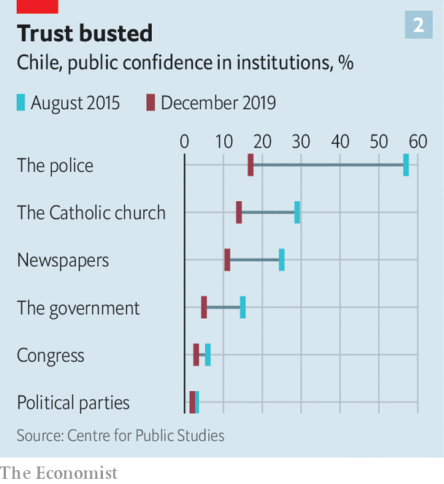

“It’s not [about] 30 pesos, it’s about 30 years of abuses,” goes a popular slogan. Considered more broadly, inequality is indeed at the heart of the matter. It “isn’t just about income, it’s about place, gender, skin colour, where you live, what school you went to, what surname you have,” says Heraldo Muñoz, who leads the centre-left Party for Democracy. “The explosion is against the arrogance of the elite.” More concretely, discontent is focused on pensions, health care and the privileges of a small minority (see chart 3). These mean that being “middle-class” in Chile often means receiving second-class services.

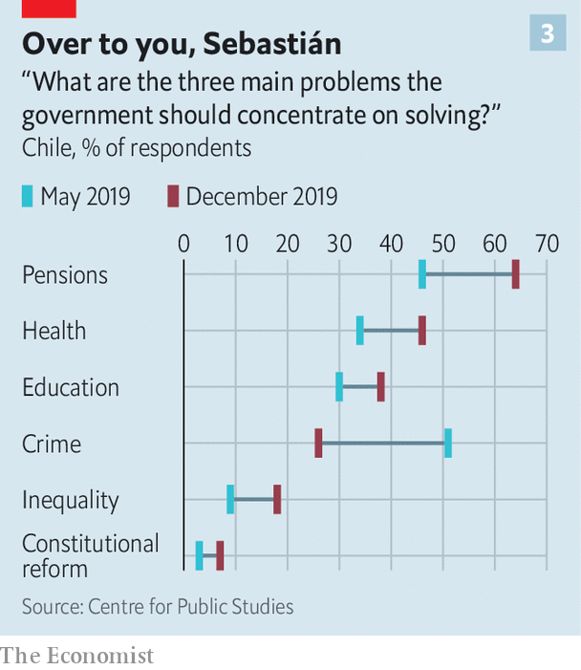

One of the trademarks of Pinochet’s model was a pension system of individual savings accounts in private funds known as AFPs, with no contributions by employers or governments. It was imposed in 1981 by José Piñera, the current president’s (estranged) brother, who calculated that it should deliver pensions averaging 70% of final salary. Widely praised and copied, the system provided Chile with a deep capital market and cheap financing for big firms.

Andrés Uthoff, a member of a consultative committee on pensions under Ms Bachelet, points out that José Piñera’s calculation depended on three conditions being met: continuous employment with a steady income, interest rates above 5% and no increase in life expectancy. None has been: Chile’s labour market is Latin American, not European, featuring low wages, high churn and, for about a third of the labour force, informal work. For every ten people in the workforce, only four pay into their AFP for their whole working life, according to Ignacio Briones, who became finance minister in October. In recent years millions of Chileans have reached retirement age. Four-fifths of all pensions are less than the minimum wage (301,000 pesos per month, or $378) and 44% are below the poverty line, according to Mr Uthoff.

Ms Bachelet introduced a safety net in the form of a basic pension for the poor of 110,000 pesos. Following the protests, the government has raised this to 160,000 pesos. That does not help middle-class retirees. Significantly, Pinochet did not require the armed forces to join AFPs. The government spends more on pensions for the security forces and on those who remained in the pre-1981 system (more than 2% of GDP) than it does for the whole of the rest of the population (less than 1%), points out Roberto Zahler, a former Central Bank president. Government and opposition are close to an agreement that would add employer contributions to pension accounts.

The dictatorship set up a segregated health service. All those in jobs pay a contribution of 7% of salary for health care. In theory, they are free to use that to join private health schemes (with no waiting lists) known as Isapres. But these demand often large additional payments. The Isapres cream off people “with better health and more money”, according to Carolina Velasco of the Centro de Estudios Públicos, a think-tank. Some 77% of the population relies on the public system (known as Fonasa). This is short of money and doctors, so waiting lists are long. “In Chile 25,000 people a year die while waiting for medical treatment,” says Germán Codina, the mayor of Puente Alto, a poor district in Santiago, who is from President Piñera’s National Renovation party.

Then there is the problem of medicines. Fonasa provides some free but there are “queues of up to eight hours to get them, and sometimes they don’t have it”, says Ms Velasco. In 2009 the three main pharmacy chains, which control 90% of the market, were found guilty of price collusion. Even today, prices of over-the-counter drugs are wildly inflated. To take one example, a steroid nasal spray costs $51 in Santiago, compared with $22 in Lima and $13 in Madrid.

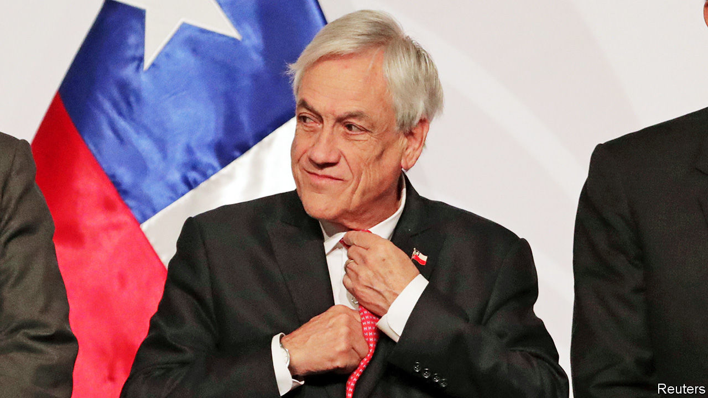

President under pressure

This price-gouging is part of a wider pattern of abuse by businesses. Water and fishing rights are held as private property, in practice in perpetuity. Until recently cartels flourished in industries ranging from toilet paper to buses and chickens. Many of the rich avoid taxes. The top 1% pay no more than 15% of their income, according to Rodrigo Valdés, who was finance minister under Ms Bachelet. “Tax lawyers in Chile have helicopters, a sign that we are in trouble,” he says.

Successive governments have tried to deal with these problems, but not fast enough. They faced obstinate resistance from the right and business lobbies. Congress approved a tough competition law in 2009 that makes price fixing a criminal offence. But it is not retroactive. “Many people won’t think anything has changed until someone is in prison,” says Eduardo Engel, an economist at the University of Chile.

“Those who refused to listen or who blocked change are complicit in what happened,” says Mr Codina in Puente Alto. The constitution, drawn up by the dictatorship, has been amended more than 40 times and now carries the signature of Ricardo Lagos, a Socialist president. But it still gives undue protection to vested interests. A score of “organic laws” can only be changed with a four-sevenths majority of Congress. The Constitutional Tribunal, which has a conservative bias, has shielded the Isapres from price regulation, for example.

When Ms Bachelet proposed a new constitution to overcome such resistance in 2015 this was greeted with a collective yawn. Now it has been seized on as a way out of the troubles. Opponents fear that a new charter will lead to the creation of “rights” that are impossible to fulfil and to fiscal irresponsibility. But the law for the April plebiscite on setting up a constitutional convention stipulates that the new document must command two-thirds support in that body, as well as approval in a second referendum in which voting will be compulsory. “The mechanism requires reaching agreements,” says Giorgio Jackson, a left-wing legislator. “So there’s not much time for radicalisation or space for polarisation.” There is little demand to weaken the Central Bank’s independence or Chile’s strict fiscal rules.

The proposal for a new constitution has split the right. Some who were initially panicked into backing it no longer do. Despite such resistance, Eugenio Tironi, a political consultant who ran the campaign that defeated Pinochet’s attempt to stay in power through a plebiscite in 1988, thinks that if turnout in April is at least 60% the convention will be approved by 60% or more of those voting.

Mr Piñera has seemed to veer between the demand for order from his own political base and for change from much of the country. Both are necessary. The scale of the protests and violence spread fear among business folk. “We have a very basic concern,” says Bernardo Larraín of Sofofa, a business lobby. “Does the Chilean state have the ability to maintain public order, so that people can get to work and companies can operate normally?” The Carabineros were once respected. They have been tarnished by recent corruption scandals in a country with much less graft than many of its Latin American peers. In the face of sometimes extreme provocation, they have been exposed as incompetent as well as brutal. Almost 1,900 people were hurt by plastic bullets or buckshot, including 445 with eye injuries, according to the National Human Rights Institute. At 60,000, the force is too small. “The police police themselves,” says Lucía Dammert, a political scientist at the University of Santiago. “The political world hasn’t put any limits on them.” Reforming the police is now widely seen as essential, but will take years.

Because of its macroeconomic prudence, Chile has money to respond to some of the demands for more public spending. This will rise by 9% this year, though much of that will go on repairing the damage. In addition, Mr Briones is preparing a plan for “a gradual and moderate” increase in taxes and permanent spending. “The list of demands is infinite, we have to prioritise,” he says. “We are Chile, not Sweden.”

Will that be enough? Much will depend on whether the constitutional convention takes off, on whether large-scale violence resumes and on how quickly the economy hits its stride again. “Of course there’s more uncertainty and investment decisions are being postponed,” says Mr Larraín. Nevertheless, at least before factoring in covid-19, the Central Bank thinks Chile will avoid recession and that the economy will grow by around 1% this year, helped by fiscal and monetary stimulus.

As with the student rebellion in France in May 1968, Chile’s events have shaken a country that seemed to be progressing, placing both the survival of its president and its political stability in doubt. Mr Piñera says he has been reading a new biography of General Charles de Gaulle, who weathered the 1968 protests as France’s president but bowed out shortly afterwards. Mr Piñera insists he will soldier on to the end of his term in 2022.

“We don’t yet know whether this crisis will be a way of improving Chile or whether it will get worse,” he admits. The country lacks a recent populist tradition, but some of the elements are there. “The people, united, functions without parties”, proclaims a large graffito. The next few months will determine whether Chile seeks a saviour or follows a path of improving its institutions. Time alone will not heal: there is no going back to the country of October 5th.■

This article was downloaded by calibre from <https://www.economist.com/the-americas/2020/03/14/can-chile-reinvent-itself>

|  |  |  |  |
| --- | --- | --- | --- |
|  | Articles | Sections | Next |

|  |  |  |
| --- | --- | --- |
| The Americas | Sections | China |

Asia

Myanmar’s army: Making war and law

.

Traffic on Everest: High and climbing

.

Politics in Afghanistan: Twin peaks

.

Sectarianism in India: First the mob, then the law

.

Banyan: Apocalypse, but no deliverance

.

|  |  |  |
| --- | --- | --- |
| The Americas | Sections | China |

|  |  |  |  |
| --- | --- | --- | --- |
|  | Articles | Sections | Next |

#### Making war and law

# Myanmar’s army blocks constitutional reforms

The civilian government had been seeking to limit the generals’ political power

Mar 14th 2020 | YANGON

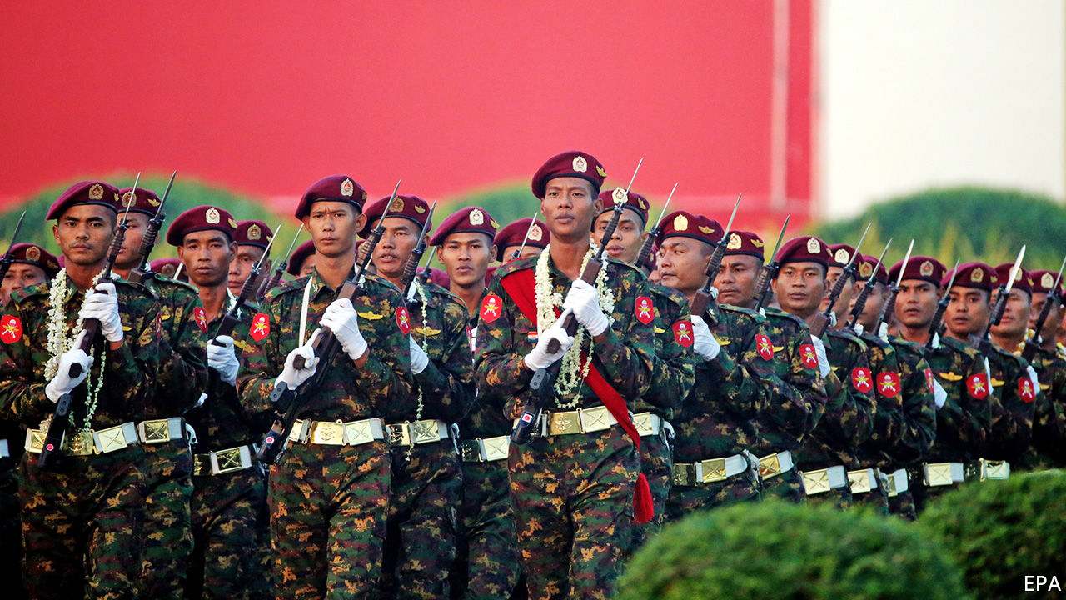

AS THE SHOUTING slalomed around the chamber, Myanmar’s parliamentarians stiffened in shock. They had only just begun debating a number of proposed amendments to the constitution, and tempers were already fraying. One MP, Major-General Tin Swe Win, bellowed repeatedly at the speaker of the house. The ruling National League for Democracy (NLD) was hoping to reduce the army’s big role in government, by gradually trimming the number of seats in the national and regional parliaments filled by military appointees like the major-general, among other things. He was not in favour.

Tension continued to crackle in the chamber for another two weeks, but on March 10th and 11th, General Tin Swe Win got his way. Although the NLD’s amendments won support from a majority of MPs, they did not reach the necessary threshold of more than three-quarters, thanks to opposition from the quarter of seats reserved for serving military officers. The soldiers rejected all substantive changes, including a proposal to strip the army of its majority on a committee empowered to declare a state of emergency and thus hand power to the army chief. An amendment to make it easier to change the constitution in future by reducing the required threshold from three-quarters to two-thirds of MPs was also knocked back.

The army even rejected symbolic concessions to the NLD and its leader, Aung San Suu Kyi. It blocked the party’s bid to change the constitution’s description of Myanmar from a “disciplined democracy” to a “democracy” plain and simple, as well as its effort to remove the clauses of the constitution that have prevented Miss Suu Kyi from becoming president. (She runs the civilian part of the government anyway, with the title “state counsellor”, having installed a loyal ally as president.)

The intransigence of the army, or Tatmadaw, as Burmese call it, is no surprise. The constitution, which the generals drew up towards the end of the 50-odd years they ran the country, deliberately avoids giving civilian politicians unfettered control not only of the army itself, but also of government more broadly. Instead, it was carefully crafted to maintain the generals’ “iron grip on the security sector”, says Thant Myint U, the author of “The Hidden History of Burma”. In addition to appointing members of parliament and the emergency-declaring committee, the army commander can name his own notional boss, the minister of defence, as well as the ministers of the interior and border control. That gives him control over the police, intelligence services and border guards, as well as the armed forces.

The Tatmadaw sees itself as the guardian of the nation, and has never distinguished between its military and political roles, writes Andrew Selth of Griffith University in Australia. The long period of military rule in effect fused the army with the rest of the state, says Marco Bünte of Friedrich-Alexander University in Germany. Although the NLD took charge of the civilian bit of the government in 2016, after a 25-year stand-off with the Tatmadaw, former military officers and officials first appointed under military rule continue to serve in every branch of government, including the judiciary. Members of political parties, in contrast, have been allowed to work as civil servants only since this week, as a result of one of the few constitutional amendments that parliament did approve.

The courts and bureaucrats side instinctively with the Tatmadaw. Two journalists from Reuters, a news agency, who exposed a massacre in which an army unit killed ten villagers, spent more time behind bars for revealing “official secrets” than did the soldiers who slaughtered innocent civilians. What is more, the massacre is the only incident for which soldiers have been punished during a months-long, army-led pogrom in 2017 that sent more than 750,000 Rohingyas, a Muslim minority, fleeing to neighbouring Bangladesh. This week the police said the army was seeking a criminal prosecution of Reuters and an MP quoted in a Reuters report, for claiming that shelling by the army had killed two Rohingya civilians. Neither the police nor the army seem to have investigated the shelling itself.

As if its weapons and its constitutional powers do not give the Tatmadaw enough power, it also has huge economic clout. It owns two big conglomerates, Myanmar Economic Holdings Limited (MEHL) and Myanmar Economic Corporation (MEC), which benefited from lucrative monopolies under military rule. An American diplomatic cable from 2009 stated that MEHL and MEC are “key components of the elaborate system of patronage the [army] uses to maintain power”. In recent years they have lost some of their monopolies and have had to start paying taxes. But MEHL and its subsidiaries, Myawaddy Bank and Myawaddy Trading, remain among the country’s biggest businesses.

The civilian government has reduced expenditure on the Tatmadaw, from 4.3% of GDP in 2015, just before the NLD took office, to 3.3% in 2017. But according to the UN, “The Tatmadaw’s ability to draw upon alternative sources of revenue, outside the military budget, enables it to operate without effective oversight.”

Miss Suu Kyi has seldom dared to confront the Tatmadaw directly. Indeed, she has leapt very publicly to its defence over its treatment of the Rohingyas, arguing before the International Court of Justice last year that its abuses were neither systematic nor widespread. Behind the scenes, however, she has on occasion subtly foiled the generals. They do not appear to have anticipated her invention of the job of state counsellor. She has also appointed her own national security adviser, instead of relying on the men in uniform. And although the army dominates the committee that can declare a state of emergency, it is the president who convenes it. Neither of the two NLD loyalists who have held the job since 2016 has seen fit to do so. Most notably, at the end of 2018, in what looked like an anodyne restructuring of the bureaucracy, her government moved the powerful General Administration Department, which controls all bureaucrats in state and local government, from the army-run Ministry of the Interior to a department under civilian control. This put “the backbone of public administration” in the NLD’s hands for the first time, writes Matthew Arnold of the Asia Foundation, an NGO.

In theory, Miss Suu Kyi and the NLD will not always need to resort to bureaucratic subterfuge to get their way. The Tatmadaw claims that it will relinquish its role in politics once democracy has “matured”. But with their churlish refusal to countenance even modest constitutional reforms, it is the generals, not the civilian politicians, who are behaving immaturely. ■

This article was downloaded by calibre from <https://www.economist.com/asia/2020/03/14/myanmars-army-blocks-constitutional-reforms>

|  |  |  |  |
| --- | --- | --- | --- |
|  | Articles | Sections | Next |

|  |  |  |  |
| --- | --- | --- | --- |
| Previous | Articles | Sections | Next |

#### High and climbing

# New rules to limit numbers on Everest are delayed

Getting people up the world’s tallest mountain is a big industry for Nepal

Mar 14th 2020 |

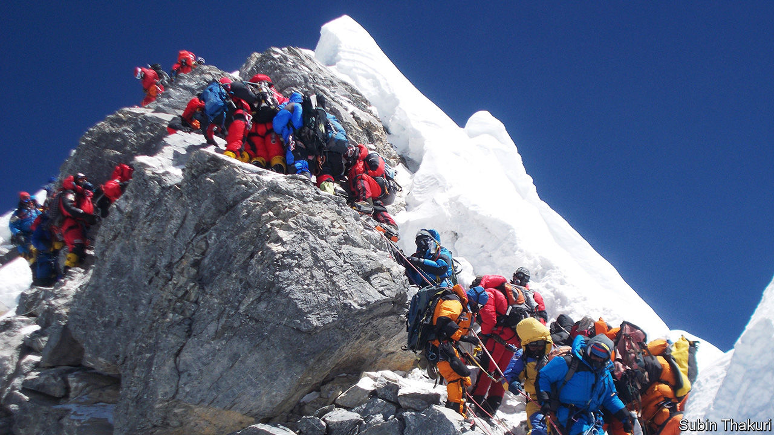

LIKE BEADS on a slender string, a long queue of mountaineers clings to a single safety rope. They are waiting to ascend to the icy peak of the world’s tallest mountain: Everest. The climbers and their guides have braved sheer rock, avalanches and wild winds. But the crowds that await interludes of good weather to rush for the summit can be just as deadly. Climbers jostle and bicker; long delays deplete supplies of oxygen. Last year four of the 11 deaths on the mountain during the spring climbing season were blamed on overcrowding.

“It is quite a commotion up there,” says Jeremy Tong of JTRACE, a trekking firm, who had to queue to reach the summit last year. The Nepalese government had promised new rules to thin out the mob. (Because of coronavirus the Chinese government has called off all ascents this year on the northern face of the mountain, which is in its territory.) It came up with a series of new requirements to obtain a permit to make an attempt on the peak. Applicants should have successfully climbed another Nepalese mountain of at least 6,500 metres (Everest is 8,848 metres). They should provide documentation certifying their physical fitness for the challenge and employ experienced guides. The authorities are also considering raising the cost of a permit from $11,000 to $35,000. Yet this week they announced that they would not put these changes into effect this year, since there had not been sufficient consultation on them within the government.

Mountaineers are far less likely to die on Everest than they were just a few decades ago. Rescue teams and helicopters stand ready to help those in need, which is not always the case with other Himalayan peaks. But there are many more climbers than there used to be (see chart).

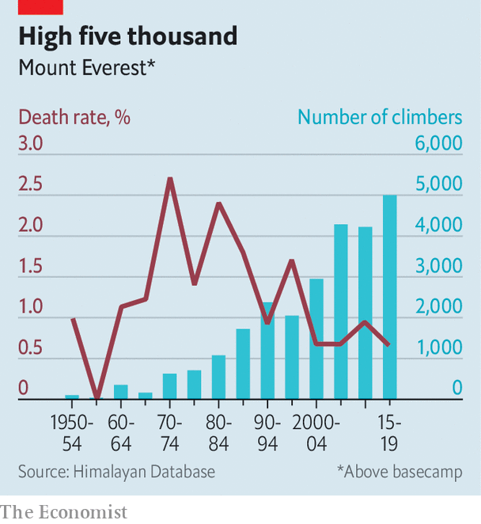

The Nepalese authorities handed out 381 permits to teams of mountaineers last year, generating a welcome dollop of cash. They are presumably keen to ensure that stricter rules do not shrink revenues. Even if the government comes out ahead, with extra income from higher fees offsetting any decrease in the number of permits issued, an entire industry depends on Everest. Nepal is among Asia’s poorest places: about half of its 30m people subsist on less than $3.20 a day, according to the World Bank. Guides risk their lives because they can earn perhaps $5,000 a season working at the highest altitudes, more than seven times the average annual wage. With last year’s bad publicity and the impending tightening of the rules, their earnings may have peaked.■

This article was downloaded by calibre from <https://www.economist.com/asia/2020/03/14/new-rules-to-limit-numbers-on-everest-are-delayed>

|  |  |  |  |
| --- | --- | --- | --- |
| Previous | Articles | Sections | Next |

|  |  |  |  |
| --- | --- | --- | --- |
| Previous | Articles | Sections | Next |

#### Twin peaks

# Two different people are sworn in as president of Afghanistan

The electoral farce is distracting from peace talks with the Taliban

Mar 14th 2020 |

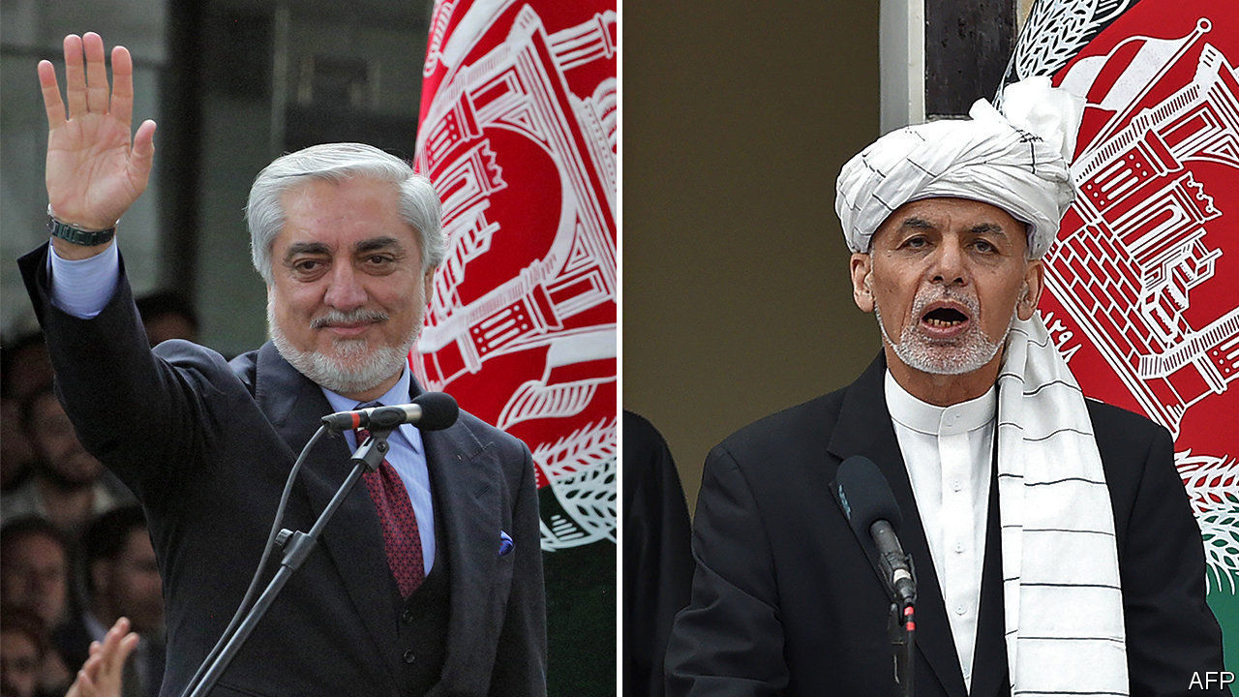

AFGHANISTAN WAITED five months for a president and then two came along at once. An election was held in September, but the results were not announced until last month. Although the electoral commission said the incumbent, Ashraf Ghani, had won, his main electoral rival, Abdullah Abdullah, dismissed its tally as fraudulent and declared himself the winner. On March 9th both men had themselves sworn in, in competing inauguration ceremonies held just metres apart in the capital, Kabul.

Afghans watched split-screen news coverage of the events and wearily shook their heads. Satirists seized on the farce. The two could each rule for eight hours a day, with a third shift going to the leader of the Taliban insurgency, suggested Afghan Onion, a parody site. Residents in one Kabul neighbourhood reportedly held their own spoof swearing-in. Yet for all the gallows humour, there was unease. The squabble conjures memories of the 1990s, when warlords who are still on the political stage fought for power. A salvo of rockets that landed close to Mr Ghani’s ceremony, without causing casualties, did not stem the foreboding.

The election and subsequent dispute have a familiar ring. In the previous vote, in 2014, Mr Ghani also defeated Dr Abdullah, only to have him cry fraud. That time, America ended the stand-off by persuading Mr Ghani to create an important-sounding job, chief executive, for Dr Abdullah. But both ruled out a repeat of this awkward power-sharing government before the latest vote and, so far, American diplomats have been unable to change their minds.

Donald Trump’s pointman for Afghanistan, Zalmay Khalilzad, spent the day before the inaugurations shuttling between the opposing camps. Western countries signalled support for Mr Ghani by sending delegations to his swearing-in, but they still would like him to find a way to include Dr Abdullah. Yet it is rumoured that Dr Abdullah has rejected an offer to name two-fifths of cabinet posts and take a leading role in peace talks with the Taliban, which are supposed to start imminently.

Mike Pompeo, America’s secretary of state, said he hoped for an inclusive government “which unifies the country and prioritises peace”. “It is serious, but not terminally so—having multiple poles of power is hardly new here,” says a diplomat in Kabul. “Afghans will work it out. They’ll have to. It is their problem to fix.”

The horse-trading distracts from a harder and more important task for the Afghan political elite: bargaining with the Taliban. Talks between the militants and Afghan leaders had been due to start on March 10th. But the Taliban insisted that the Afghan government should release 5,000 prisoners first—something Mr Ghani has refused to do. On March 11th, however, he announced he would release 1,500 Taliban detainees in the coming weeks. Each fighter would have to give a written guarantee he would not return to the battlefield. If talks progress, Mr Ghani promised, a further 500 Taliban prisoners would be freed each fortnight, up to a total of 5,000.

The Taliban immediately rejected the offer. Perhaps they were hoping for a better one from Dr Abdullah.■

This article was downloaded by calibre from <https://www.economist.com/asia/2020/03/14/two-different-people-are-sworn-in-as-president-of-afghanistan>

|  |  |  |  |
| --- | --- | --- | --- |
| Previous | Articles | Sections | Next |

|  |  |  |  |
| --- | --- | --- | --- |
| Previous | Articles | Sections | Next |

#### First the mob, then the law

# Victims of rioting in India are bashed by the police and courts, too

Judges who decry anti-Muslim bias find themselves overruled or transferred

Mar 14th 2020 | DELHI

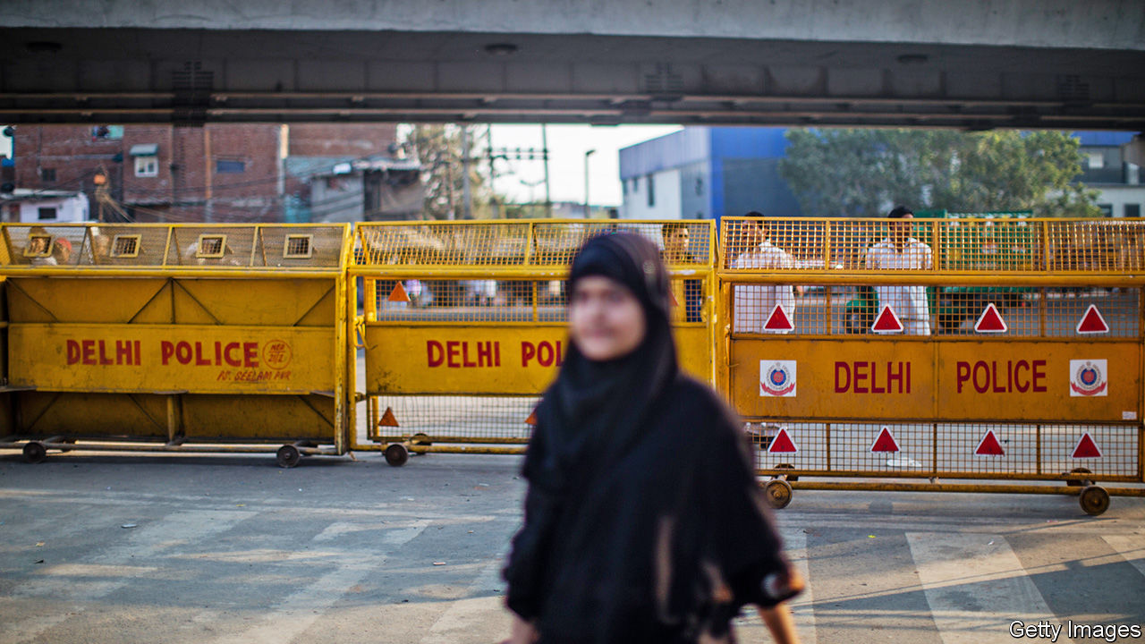

LAST MONTH a judge in Mangaluru, in the southern state of Karnataka, did something increasingly unusual in an Indian court. Not only did he grant bail to 21 Muslim men charged with joining a riot, he also roundly condemned the police for fabricating evidence against them. They had failed to establish a link between the accused and any crime, he said. They had also failed to register even a single case on behalf of multiple witnesses who claimed that it was the police themselves who had shot dead two people in the city in December during a protest against controversial new citizenship rules. There appeared to have been “a deliberate attempt to cover up police excesses”, he concluded. Two weeks later, in much more typical fashion, the Supreme Court struck down the ruling, sending the men back to prison.

Since the Hindu nationalist government of Narendra Modi changed the laws on citizenship in a way that discriminated against Muslims, at least 80 people have died in related protests, including 53 in riots that engulfed parts of Delhi, the capital, in February. And although it is Muslims, both protesters and bystanders, who have borne the brunt of the violence and vandalism, the government, the agencies of the state and much of the press have persisted in blaming the victims.

In one of many such cases, for instance, a court elsewhere in Karnataka rejected a plea for bail by three students from Kashmir, charged with sedition for singing “Long live Pakistan” in a video on Facebook. Indian legal precedent defines sedition as the direct instigation of violence against the state, yet the judge found it sufficient that the students had “created unhealthy atmosphere”. In Uttar Pradesh, the most populous state, where police were repeatedly caught on film vandalising private property during the protests, the state is fining not the errant officers, but lawyers and human-rights activists who have supposedly damaged public property. The police even erected giant billboards with the photos, names and addresses of several dozen people from whom it is seeking damages. The state’s highest court did order a stop to the legally groundless public shaming campaign, but the state government, which happens to be run by Mr Modi’s Bharatiya Janata Party (BJP), has appealed to the Supreme Court.

It is likely to get a sympathetic hearing. During the riots in Delhi, it was only after the high court ordered police to help evacuate wounded people to hospital that the city’s 80,000-person police force began to intervene, after 48 hours of arson and murder. The same bench also demanded that the police register cases against members of the BJP for hate speech, which they had refused to do despite copious footage of politicians calling for protesters to be shot. Hours later the Supreme Court transferred one of the troublesome judges out of Delhi. The next day the high court postponed all hearings about hate speech to April.

As the bodies were fished out of Delhi’s fetid canals, it became clear that some three-quarters of the victims had Muslim names. Most of the homes and businesses damaged in the riots belonged to Muslims. Yet the police seem to think that Muslims orchestrated it all. Hundreds have been rounded up for questioning on flimsy pretexts, say locals. In one example, a Muslim local councillor who owns a tall building near the scene of some of the worst violence repeatedly called the police to plead for help, warning that his building was being invaded by a mob. He has since been charged with the murder of an undercover policeman whose body was found nearby.

On the night of February 24th, witnesses say, a mob surged into a neighbourhood called Shiv Vihar, systematically targeting Muslim property. Wasiq Khan, a lawyer trying to help victims claim compensation, says the police have made no effort to investigate, not even to note the telltale serial numbers of cooking gas canisters used to firebomb shops and homes. He suspects they are “hoping that renovations overtake the evidence”. Once residents clear away the ashes or haul away the carcasses of torched vehicles, there will be nothing to show what happened. ■

This article was downloaded by calibre from <https://www.economist.com/asia/2020/03/14/victims-of-rioting-in-india-are-bashed-by-the-police-and-courts-too>

|  |  |  |  |
| --- | --- | --- | --- |
| Previous | Articles | Sections | Next |

|  |  |  |  |
| --- | --- | --- | --- |
| Previous | Articles | Sections | Next |

#### Banyan

# How two Korean cults measure up against covid-19

The “promised pastor” v the god-king of Pyongyang

Mar 14th 2020 |



CULTS AND coronavirus to do not mix—or perhaps mix only too well. Take South Korea which, until recently overtaken by Italy, had the highest number of covid-19 infections outside China. Of 7,869 diagnosed cases, three-fifths trace back to a sect called the Shincheonji Church of Jesus.

Shincheonji’s 88-year-old founder, Lee Man-hee, is said to descend from ancient Korean kings. As the “Promised Pastor”, he is uniquely able to interpret the Book of Revelation and to foresee the apocalypse it describes. He will take 144,000 followers with him to Heaven on the Day of Judgment, apparently.

Other Christian leaders call Shincheonji a cult. Many of its 245,000 adherents hide their membership from family and workmates. At church they worship sitting on the ground in serried ranks, are not allowed to wear glasses—or, at least until recently, face masks—and are encouraged to attend even when ill. In February one congregant with undiagnosed covid-19 infected dozens of worshippers in Daegu, a southern city.

Mr Lee, who has a taste for videos of white chargers and for mass games performed by his followers in stadiums, has become the butt of nationwide invective. He has therefore had to abase himself. Not long ago he blamed the epidemic on evil types jealous of Shincheonji’s success. But at a press conference last week he was on his knees apologising for his church’s role in spreading the virus. Shincheonji, he said, would do everything to help the authorities check its spread. Meanwhile, politicians are grandstanding. The mayor of Seoul wants prosecutors to investigate Mr Lee for murder through negligence. A provincial governor and presidential hopeful showed up with 40 officials at Shincheonji’s headquarters demanding a full list of members.

What of that other cult leader, North Korea’s Kim Jong Un? He also goes in for white chargers, mass games and dodgy family mythology, but is far swifter at spotting threats. In January, soon after reports surfaced of a growing epidemic in China, North Korea slammed its borders shut. The country responded similarly to China’s outbreak of SARS in 2003 and even to the outbreak of Ebola in West Africa in 2014. The measures were much more comprehensive this time. All travel in and out of the country was stopped. Foreigners already in the country, notably diplomats and aid workers, were put in quarantine. Trade across the border with China, three times higher than in 2003, has ground to a halt, including (to judge by rising domestic prices for staples) the huge, officially sanctioned smuggling rackets that get around UN sanctions. North Korea has even refused to take back defectors rounded up by Chinese authorities.

A nasty virus is yet another foreign threat—like Japanese or American imperialism—against which a loving leader must guard his pure, vulnerable people. The response includes the mobilisation of tens of thousands of “disease-control workers” and the production of “our-style” disinfectants. Vagrants are being rounded up to stop them bringing illness into the capital, Pyongyang. In official pictures Mr Kim, who this week fired off another round of missiles, is the only North Korean not wearing a mask.

The question is whether the “super-special” quarantine measures are working. North Korea supposedly has not a single infection. Perhaps its extreme quarantine has worked. As Andrei Lankov of Kookmin University puts it, the regime is readier to see tens of thousands of already malnourished citizens starve to death, as the price of staple foods rises sharply, than it is to let the virus take hold. Mr Lankov predicts pockets of hunger in remoter rural areas and among groups deemed to be disloyal.

But with so much cross-border activity before the clampdown, it seems implausible that the virus has been kept wholly at bay. It is impossible to know for sure. One report claims that 200 North Korean soldiers have died from covid-19. If that is true, and anything like the typical ratio of infections to deaths holds true, then tens of thousands of North Koreans have the virus—and the chances of keeping it away from the well-fed elites in Pyongyang are close to zero.

If the new coronavirus does take hold, it will ravage the malnourished (including many army conscripts) before anyone else. To Mr Kim, these people are expendable. Nonetheless, the ferocity of his response suggests he is terrified of the virus. A big epidemic would make him look ineffective—something no all-powerful god-king can afford.

Dig deeper:

* For more coverage of covid-19 see our [coronavirus hub](https://www.economist.com/news/2020/03/11/the-economists-coverage-of-the-coronavirus)
* The science of the virus
* Fatality rates for covid-19 could vary enormously
* How to deal with a new sort of financial shock
* Should other countries copy Italy’s nationwide lockdown?

This article was downloaded by calibre from <https://www.economist.com/asia/2020/03/14/how-two-korean-cults-measure-up-against-covid-19>

|  |  |  |  |
| --- | --- | --- | --- |
| Previous | Articles | Sections | Next |

|  |  |  |
| --- | --- | --- |
| Asia | Sections | Middle East and ... |

China

Politics and the coronavirus: A gesture to the sequestered

.

Covid-19 and farmers: The other 40%

.

Chaguan: When nationalism bites back

.

|  |  |  |
| --- | --- | --- |
| Asia | Sections | Middle East and ... |

|  |  |  |  |
| --- | --- | --- | --- |
|  | Articles | Sections | Next |

#### A gesture to the sequestered

# China appears confident that its coronavirus epidemic has abated

Many citizens are not yet celebrating

Mar 12th 2020 | BEIJING

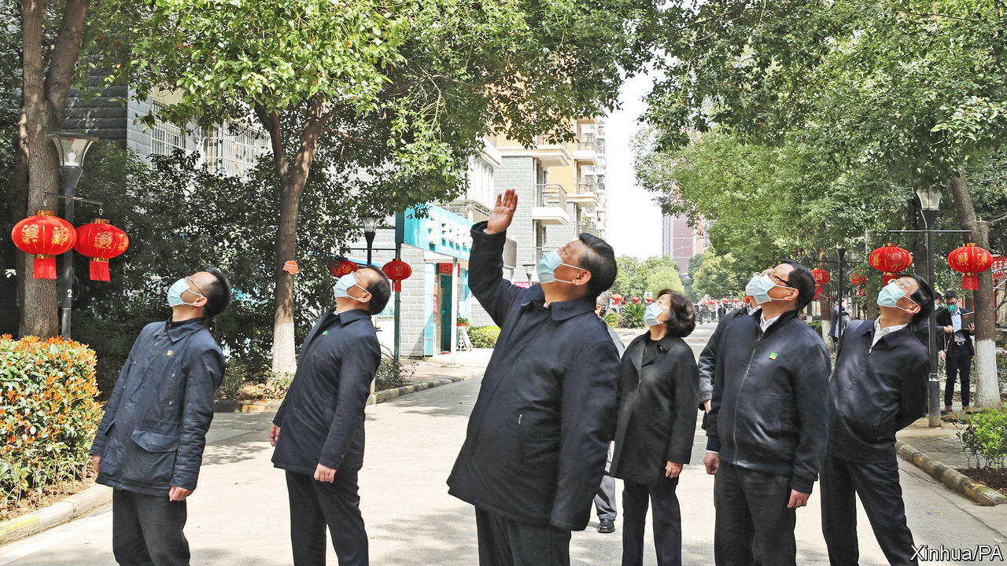

SEVEN WEEKS after cordoning off Hubei, the Communist Party is itching to declare victory over the novel coronavirus that has swept across the country from that central province. On March 10th the country’s leader, Xi Jinping, visited Hubei’s capital, Wuhan, for the first time since the lockdown. He spoke by videolink to patients at an army-run hospital there. He also visited a residential area (see picture) to see how Wuhan’s citizens—most of whom are still under orders to stay at home—are coping with quarantine. Mr Xi said the spread of the virus had been “basically” curbed.

Official figures are certainly encouraging. On the day of Mr Xi’s trip only 19 confirmed new infections were recorded in China, down from thousands at the peak of the outbreak in February. About three-quarters of the 80,000 or so people known to have caught the virus in China are now said to have recovered from it. Officials in Wuhan have closed makeshift wards in public buildings such as sports centres and exhibition halls. Local governments in less-affected parts of Hubei say they are beginning to relax travel restrictions in the hope that people can get back to work. China is now stressing the importance of making sure that travellers from countries where infections are rising do not bring the pathogen with them. On March 11th city officials in Beijing said passengers flying into the capital’s airports from abroad must spend 14 days in self-quarantine.

China’s growing confidence in its struggle with the epidemic is evident in its propaganda. State media increasingly crow about the party’s strengths in handling the crisis. Their editorials marking Mr Xi’s visit to Wuhan proclaimed the success of China’s anti-virus measures, which have required hundreds of millions of people to submit to quarantine, and gave the credit to China’s political system. People who use the crisis to “smear” the country’s politics are “immoral and despicable” said Xinhua, a state news agency. With the virus now threatening to damage the health and livelihoods of people globally, the party appears keener than ever to deflect criticism of its own bungling in the early days of the outbreak when news of its spread was suppressed. On March 10th a Chinese magazine, Renwu, published an interview with Ai Fen, one of several doctors in Wuhan who are known to have been muzzled by officials for discussing the virus online soon after its discovery. Censors quickly pulled the story from Renwu’s website.

Ordinary Chinese are relieved by the sharp drop in daily numbers of confirmed new infections. Many show remarkable tolerance for the lengthy quarantines they have had to suffer. But there is much grumbling online about the behaviour of some officials during the outbreak, and less full-throated praise for the merits of one-party rule than officials would like to see. Tensions have been particularly evident in Wuhan. In early March quarantined residents in one housing complex shouted down from their windows as Sun Chunlan, a deputy prime minister, was being shown round. They warned her that officials in their neighbourhood were putting on a “fake” show of relief efforts in order to impress her. The hecklers explained that they were having problems getting deliveries of groceries, among other difficulties. Videos of the incident spread online. Unusually, state media broadcast footage of the incident, perhaps to show that the authorities are heeding complaints. During his trip to Wuhan, Mr Xi also made a rare nod to public anger. “The masses in Hubei, Wuhan and other areas hard-hit by the epidemic have been in self-isolation for a long time,” he said. “They have some emotions to vent. We must understand this and be tolerant and forgiving. We must continue to step up the intensity of our work in all aspects.”

Mr Xi may have had in mind an eruption of emotion on March 6th, when Wuhan’s recently appointed party boss, Wang Zhonglin, told officials that a campaign of “gratitude education” was needed to make sure local people understood the important role that Mr Xi and the party had played in their deliverance. His words, carried in local newspapers, provoked outrage on social media and were swiftly deleted from websites. The party chief of Hubei, Ying Yong, also newly appointed, made a statement clarifying that “Wuhan people are heroes” and that he was sincerely grateful to them. The party probably hopes that Mr Xi’s visit will help to assuage some of the public’s anger.

There is plenty of it bubbling up online, and not always about the government’s handling of the epidemic. People have been fuming about officials’ lax controls over construction projects, after the collapse on March 8th of a hotel in the coastal province of Fujian that had been requisitioned for use as a quarantine centre. Around 30 people died. The victims were travellers who had returned from other parts of the country and who were being kept in precautionary isolation for 14 days. Many people have also been venting about a proposed regulation that would make it easier for certain foreigners to gain permanent residency (see article).

Mr Xi may find it hard to choose his moment to declare complete success. As people gradually get back to work, there is a risk that the virus may begin to spread more widely again in China. That may lead to renewed lockdowns. The party appears to remain intent on treating the virus as something that can be conquered, rather than—as some other governments are handling it—something that can only be hindered from spreading too rapidly.

In Wuhan, Mr Xi was careful not to sound triumphant. “Through arduous efforts, there has been a positive turn for the better in epidemic containment in Hubei and Wuhan. Important interim results have been achieved,” he said. But he also said there should be “no slackening at all” in anti-virus work. That will not be music to the ears of people in Wuhan and many other parts of China where draconian quarantine measures may have helped to curb the epidemic, but at no small cost, not least for firms and people in need of medical care unrelated to covid-19. ■

Dig deeper:

* For more coverage of covid-19 see our [coronavirus hub](https://www.economist.com/news/2020/03/11/the-economists-coverage-of-the-coronavirus)
* The science of the virus
* Fatality rates for covid-19 could vary enormously
* How to deal with a new sort of financial shock
* Should other countries copy Italy’s nationwide lockdown?

This article was downloaded by calibre from <https://www.economist.com/china/2020/03/12/china-appears-confident-that-its-coronavirus-epidemic-has-abated>

|  |  |  |  |
| --- | --- | --- | --- |
|  | Articles | Sections | Next |

|  |  |  |  |
| --- | --- | --- | --- |
| Previous | Articles | Sections | Next |

#### Planters, plagued

# Covid-19 is making it harder to grow food in China

The government is straining to get supplies to farmers

Mar 14th 2020 | ZHAOQUANYING

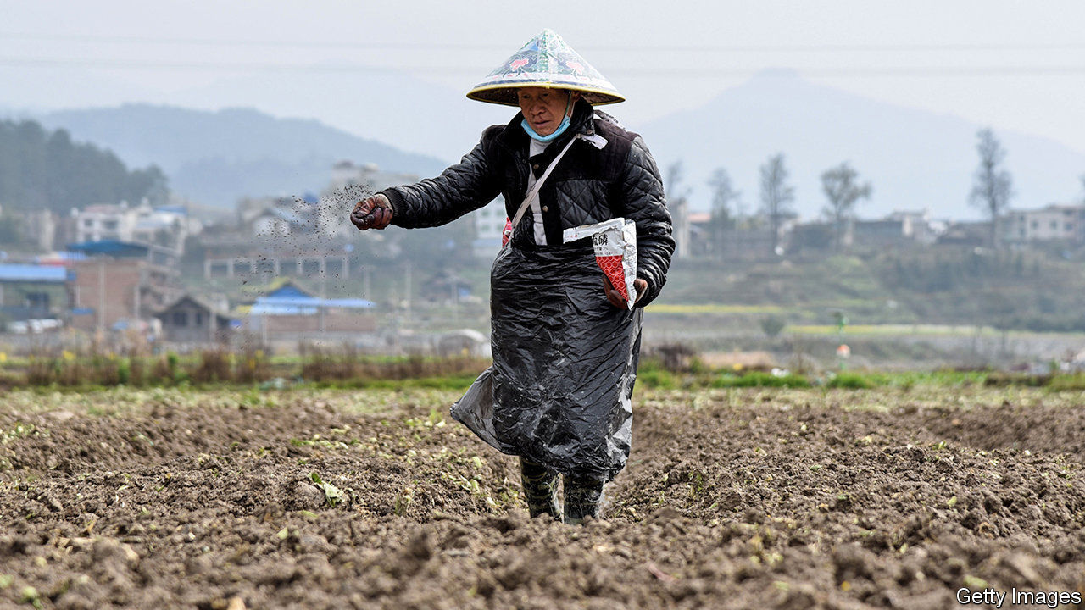

NEXT TO A row of idle tractors on the edge of a field in Zhaoquanying, a village on the outskirts of Beijing, sits a row of wheat farmers. Like almost all Chinese when outdoors these days, they are wearing face masks because of the epidemic of covid-19. Their gaze is fixed on their smartphones because, they say, there is not much else to do. “The ground is still too hard,” says one. “But we’re ready to plant when the time is right.” As the weather warms, that day is imminent. It is one that they, and many government officials, have been worrying about.

In mid-February, at the peak of the coronavirus outbreak, some of China’s agricultural experts said it was “unclear” whether spring planting could happen on time. They worried that massive disruptions to transport caused by virus-containment measures could affect the delivery of inputs such as fertiliser on which farmers rely (see chart). They also feared that quarantine controls would prevent seasonal workers from getting to farms where their labour is needed for planting. On February 25th China’s president, Xi Jinping, and the prime minister, Li Keqiang, issued instructions on the need to “stabilise” agriculture. They called for an “all-out effort” to ensure that the epidemic did not affect the planting of vital crops.

Much of China’s economy shudders with uncertainty about the damage caused by covid-19. But many firms still hope they can recoup at least some of their losses. Some cancelled events will be rescheduled. Some of the cars or refrigerators that were not sold during the shutdown will be snapped up when things return to normal. Farmers, however, cannot accept any disruption. To avoid a total loss for the season, they must start their spring planting soon. At stake is not only the welfare of the 40% of China’s people who live in the countryside and depend on agriculture, but the stability of the national food supply.

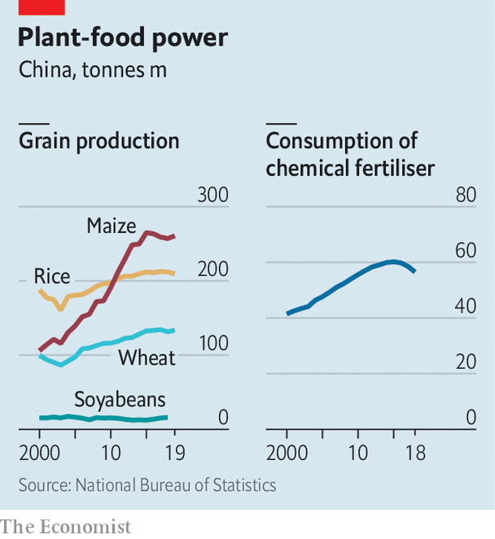

In the two months since the outbreak began, China has already felt covid-19’s impact on supplies of some food. Restrictions on the movement of people have left labour-intensive slaughterhouses understaffed, squeezing meat production. This follows the severe damage already done to pork supplies by an outbreak of African swine fever, an animal disease that struck China in 2018 and led to the loss of 40% of China’s pigs. Pork prices have tripled since early last year.

## Fertiliser freeways

In response to the leadership’s calls, local officials have been pulling out the stops to ensure planting proceeds. They have set up “green channels” for lorries carrying agricultural necessities so they do not get delayed at checkpoints and toll booths (tolls have been waived on all highways since February 15th). Bureaucrats have a strong incentive: promotions, they have been told, will depend on how effectively they ensure that farmers can do their work this spring. Officials have been trying to make life easier for farmers in other ways, too, such as by reducing land-use fees and directing state-owned banks to give them loans on easy terms.

In Zhaoquanying, together with a faint scent of manure, there is a hint of optimism in the air. The farmers say their wheat planting will go ahead as usual. In the nearby village of Hongtongying, some vegetable farmers have just taken delivery of several lorry-loads of plastic film for use on the greenhouses they erect over their fields. The shipment arrived on time from the eastern city of Hangzhou, some 1,300km (800 miles) away. Everything else they need is already in place, they say. Still missing, however, are migrant workers from other provinces, who have been held up by epidemic-related travel restrictions. “They’ll get here when they can, but until then we will manage,” says one of the men.

Recovery will be slower in Hubei, the province hardest hit by covid-19, and that is no small matter. It is one of the country’s main sources of chemical fertiliser. Last year it produced nearly a tenth of China’s rice. But agricultural experts say most of China’s farmers are likely to muddle through the busy season ahead. The government has made clear that spring planting must be carried out without delay, says Thomas Luedi of Bain & Company, a consultancy. “They built two hospitals in about a week,” he notes, so they can probably get the grains sown on time, too. ■

Dig deeper:

* For more coverage of covid-19 see our [coronavirus hub](https://www.economist.com/news/2020/03/11/the-economists-coverage-of-the-coronavirus)
* The science of the virus
* Fatality rates for covid-19 could vary enormously
* How to deal with a new sort of financial shock
* Should other countries copy Italy’s nationwide lockdown?

This article was downloaded by calibre from <https://www.economist.com/china/2020/03/14/covid-19-is-making-it-harder-to-grow-food-in-china>

|  |  |  |  |
| --- | --- | --- | --- |
| Previous | Articles | Sections | Next |

|  |  |  |  |
| --- | --- | --- | --- |
| Previous | Articles | Sections | Next |

#### Chaguan

# A proposal to help a few foreigners settle in China triggers a furore

Several women vow to leap off the Great Wall rather than marry a foreigner

Mar 12th 2020 |

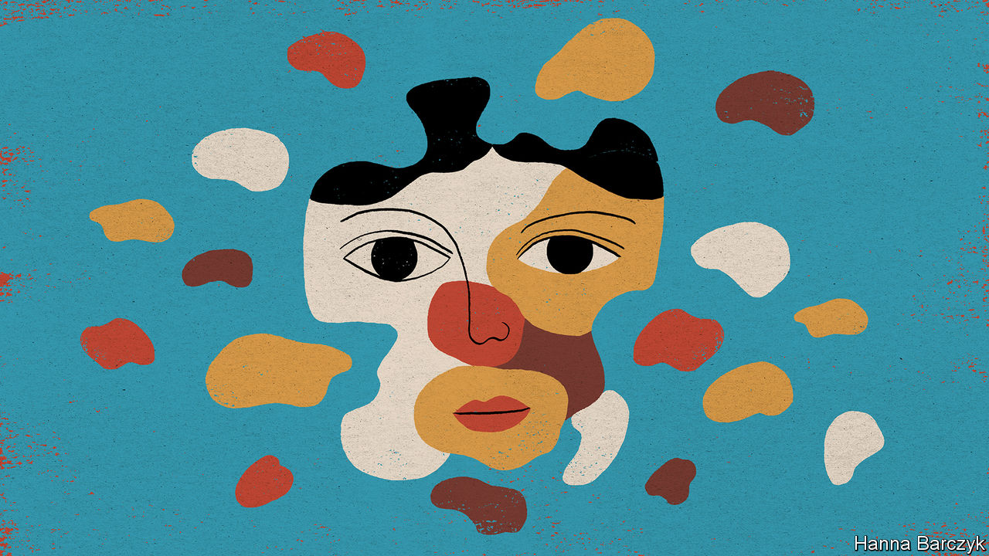

CHINA’S LEADERS have pulled off a remarkable feat. They have joined the long list of governments humbled by a populist revolt over immigration—though there are hardly any immigrants in China, and political opposition is banned. The revolt’s cause is also a surprise: a consultation exercise by the justice ministry, inviting comments on a proposal to make it slightly easier for rich or highly skilled foreigners to become permanent residents. This expands a scheme begun in 2004. On March 7th, after days of online fury, officials took the proposal back for revisions. Soon afterwards censors moved to shut down the debate. By then a related hashtag on Weibo, a Twitter-like service, had been viewed more than 5bn times. A dismaying number of comments betrayed racial and sexual panic, with men vowing to defend Chinese women from immigrants, notably from Africa. Several young women vowed to leap from the Great Wall rather than marry a foreigner.

Some anger is understandable. Foreign permanent residents may have as many children as they wish, and bring them up and educate them in any city in China. Bossy family-planning and residency rules deny Chinese citizens such freedom. Some indignation reflects a trend seen in other countries: a distrust of technocrats who defend migration as an economic necessity. Wang Huiyao heads a think-tank, the Centre for China and Globalisation, which promoted the permanent-residency scheme. For his pains he has been vilified online as a traitor. Mr Wang calls some suggestions helpful, such as requests for clarification of which PhD subjects earn a green card. Defending the scheme, he says: “China has been a giant exporter of talent for the 40 years of reform and opening. Why can’t China now seek to import some global talents?”

Some online panic is more difficult to understand. China is hardly poised to become an immigrant melting-pot. In 2016 it issued just 1,576 permanent-residency permits. In the same year America granted permanent residency to over 1m foreigners—roughly equivalent to China’s entire foreign-born population. Unlike American green cards, China’s residence permits are not considered a pathway to citizenship. William Rosoff is an American corporate lawyer turned academic. He teaches law at Tsinghua and other universities in Beijing, and secured permanent residency in 2018. Chinese colleagues see his status as a tribute to their homeland, not a new identity, he says. “My Chinese friends and students are all really pleased, not because it makes me Chinese but because it shows that I love China, otherwise why would I want it?”

Yet questions of identity have stoked the most online outrage in recent days. China must not become multicultural, social-media users wrote. Accused of taking foreign nationality, a film actress, Ning Jing, assured fans that she had never swayed “for even half a second” and remained a “child of the Flame Emperor and the Yellow Emperor”. That slogan, claiming descent from two mythological founders of China, is telling, for it draws on claims of Chinese racial purity peddled by nationalists for well over a century.

More than 90% of modern Chinese hail from the Han nationality. Han chauvinism helped topple the last imperial dynasty, the Qing, whose emperors were called impure outsiders on account of their Manchurian origins. With the Qing safely gone, nationalists reversed course and claimed the nations making up their new republic—Han, Manchu, Mongolian, Muslim Hui and Tibetan—as branches of one Chinese bloodline. Twentieth-century nationalists embraced Western racial theories and asserted the superiority of “yellow” and “white” races over the “brown” and “black”. In Communist times, state-backed scientists have sought proof, whether genetic or archaeological, that China’s ethnic groups share a common origin. President Xi Jinping calls China’s recorded history unique for its continuous transmission over 3,000 years by yellow-skinned, black-haired “descendants of the dragon”.

In much of the West arguments about racial superiority are taboo, and should be, thanks to shared guilt about the horrors of slavery, colonialism, the Holocaust and segregation. That taboo is weaker in China, where schools drum into students that their country is a victim of racist, imperialist bullying, and a benefactor to the developing world. As one netizen wrote during this immigration row, when the Chinese express dislike of Africans that cannot be racism, because “China never oppressed black people.”

## Blood, soil and flags: a combustible mix

Though China is ageing fast and its working-age population is shrinking, the country does little to help immigrants who have neither a small fortune to invest nor a spare PhD in nuclear physics, and so may not seek a green card. Joseph Matanda, a 43-year-old from Zimbabwe, came to China in 2008 to teach English. Three years later he married Run Qi, a 36-year-old computer-network engineer from the northern province of Inner Mongolia. Mr Matanda lives in China on a spouse’s visa that does not allow him to work. He helps bring up his eight-year-old son and new baby, both of whom have Chinese passports. When ordinary Chinese shrink from him on the bus or in a lift, he engages with them in cheerful Mandarin. “I carry myself in such a way that people don’t look down on me,” he says. He dreams that his sons will grow up to be bilingual bridges between high-tech China and developing Africa: “The world is becoming smaller. I want them to be constructive.”

Still, neighbours do not consider their sons Chinese, sighs Ms Run. “In their eyes, they will always be ‘of mixed blood’.” She has learned to tolerate hearing casual assertions that mixed-race children are clever and good-looking. She cannot abide the usual follow-up, namely: “It’s good that they are not too black.” The family recently moved to Changping, a bustling outer suburb of Beijing, filled with migrants from other Chinese regions. It should be a fine place to start a new life. But this bicultural couple plan to move to a country where both are allowed to work. Online nationalists may cheer their departure, but it will be China’s loss. ■

This article was downloaded by calibre from <https://www.economist.com/china/2020/03/12/a-proposal-to-help-a-few-foreigners-settle-in-china-triggers-a-furore>

|  |  |  |  |
| --- | --- | --- | --- |
| Previous | Articles | Sections | Next |

|  |  |  |
| --- | --- | --- |
| China | Sections | Europe |

Middle East and Africa

The politics of cheap oil: The big squeeze

.

Tanzania and the World Bank: Bankrolling bigotry

.

Traffic in Nigeria: Two wheels bad, four wheels better

.

Iran and covid-19: Sickly state

.

Lebanon: Resilient no more

.

|  |  |  |
| --- | --- | --- |
| China | Sections | Europe |

|  |  |  |  |
| --- | --- | --- | --- |
|  | Articles | Sections | Next |

#### The big squeeze

# The low price of oil will test governments in the Middle East and Africa

With less cash to bribe the people, some strongmen will resort to repression

Mar 14th 2020 | ABU DHABI

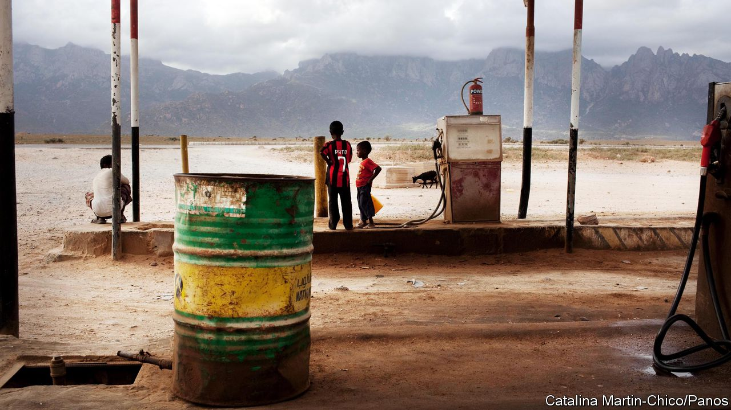

“IN THE HISTORY of any nation there are special moments and seminal events,” said President Uhuru Kenyatta in August. He was celebrating Kenya’s entry to the club of oil producers with a symbolic shipment of 200,000 barrels. “The first export of crude oil by our nation...marks a special moment in our history,” he declared.

Politicians love oil. Selling it generates easy money for governments; much easier than taxing citizens, who might then demand services, democracy and good governance. Petrodollars also lubricate patronage networks. They can be used to buy votes, silence rivals or, if that fails, fund a comfortable retirement abroad.

So when the price of oil fell by about 30% on March 9th, to below $32 a barrel (see article), many politicians were aghast. Oil prices crashed because covid-19 cut global demand and Saudi Arabia opened its taps to crush high-cost producers. The consequences for other oil-pumping nations will be economic pain and hard choices. The pain will be felt in broad swathes of the Middle East and Africa.

A rehearsal took place in 2014, when oil prices fell by more than half. This time will be tougher, since countries burned through many of their cash reserves during that crash. The most immediate impact will be on government budgets.

Start in Nigeria, where oil accounts for roughly 90% of exports and two-thirds of government revenue. The finance minister has already called for a review of the budget, which was based on an oil price of $57 a barrel. Yet austerity will prove difficult in an economy so lethargic that it is barely keeping pace with population growth. There is little space for borrowing: 65% of government revenues go to servicing existing debt. Nonso Obikili, a Nigerian economist, assumes that the government will simply print money to pay civil servants, which would stoke inflation.

The price war will make a mess of public finances in parts of the Gulf, too. Oman’s 2020 budget predicted a deficit of 8% of GDP even with oil at $58 a barrel. Prices at $30 would send the deficit as high as 22%. Bahrain, a middling producer that nonetheless relies on oil for around 75% of public revenue, had hoped to balance its budget by 2022. Both will probably have to cut spending and borrow money. Their debt loads have soared since 2014, when years of $100-a-barrel oil came to an end. Oman now owes more than 60% of GDP, up from 5% in 2014, while Bahrain’s debt load jumped from 44% to 105%.

Wealthier countries can muddle through for years. Saudi Arabia had budgeted for a $50bn deficit in 2020. Goldman Sachs, a bank, thinks it could now surpass $80bn; other economists put the hole at $100bn. But the kingdom has about $500bn in the central bank, and it can borrow cheaply, with ten-year bonds trading at yields of less than 4%. Saudi debt is 24% of GDP, low by global standards. However, it is a marked increase from 2014, when the kingdom owed less than 2% of GDP.

Much of this debt is unproductive: Gulf states are borrowing to sustain current, bloated levels of spending. The new sultan of Oman, Haitham, who took power in January after his cousin’s death, would like to dole out largesse. Dubai, part of the United Arab Emirates (UAE), has an expansionary budget meant to kick-start a weak economy. Some of this will have to be scaled back. Expats in Dubai are already being hit by lay-offs and salary cuts. Contractors in Saudi Arabia worry that the government will start delaying payments, as it did during the last oil-price slump.

Low oil prices will be even more painful in Iraq, which relies on the black stuff for 90% of government revenue. The country is gripped by political paralysis. Months of protests brought down the government in October, and the prime minister-designate, Muhammad Tawfiq Allawi, failed to form a new one. His predecessor raised public spending by 45% last year and doubled the deficit. Almost half its spending is on public-sector wages and pensions; with oil cheap, the state cannot make payroll.

In the long term, a sustained fall in the price of oil may not be a bad thing for states in the Middle East and Africa if it pushes them to diversify. Though oil makes up a huge proportion of exports and government revenue in countries such as Angola and Nigeria, neither is a big producer when measured per person. Nigeria needs to “get out of oil dependency”, says Charlie Robertson of Renaissance Capital, an investment bank. He recommends investing in education, health and infrastructure. President João Lourenço of Angola, who took over in 2017, has focused on lowering the costs for producers. But producing oil in Angola is still far from cheap.

The Gulf states talk a lot about diversification, but their business cycles are still hostage to oil prices. Muhammad bin Salman, the crown prince and de facto ruler of Saudi Arabia, has ambitious plans to invest in everything from tourism to tech. Foreign direct investment in the kingdom, though, was already weak, partly due to worries about Prince Muhammad’s arbitrary rule. Confidence will not be boosted by his surprise oil-price war. In the UAE, perhaps the most successfully diversified oil economy, the main alternative to crude is tourism, which provides 12% of GDP. But the covid-19 outbreak has scared off visitors.

With less oil money around, African and Middle Eastern leaders may find it harder to keep the masses placid. In Angola elections are due in 2022 and the MPLA, which has ruled since independence in 1975, may face a genuine challenge. In Nigeria, the emir of Kano, who is a former central bank governor and critic of President Muhammadu Buhari’s economic policies, was dethroned on March 9th for showing “insubordination” to local authorities. Just before the oil price crashed, the authorities in Saudi Arabia arrested several influential royals, including Ahmed bin Abdel-Aziz, the king’s brother. In the absence of black gold, some strongmen will no doubt resort to the iron fist. ■

This article was downloaded by calibre from <https://www.economist.com/middle-east-and-africa/2020/03/14/the-low-price-of-oil-will-test-governments-in-the-middle-east-and-africa>

|  |  |  |  |
| --- | --- | --- | --- |
|  | Articles | Sections | Next |

|  |  |  |  |
| --- | --- | --- | --- |
| Previous | Articles | Sections | Next |

#### A Tanzanian trilemma

# Should the World Bank fund schools that expel pregnant girls?

Bankrolling bigotry is bad. So is cutting aid to the needy

Mar 14th 2020 | DAR ES SALAAM

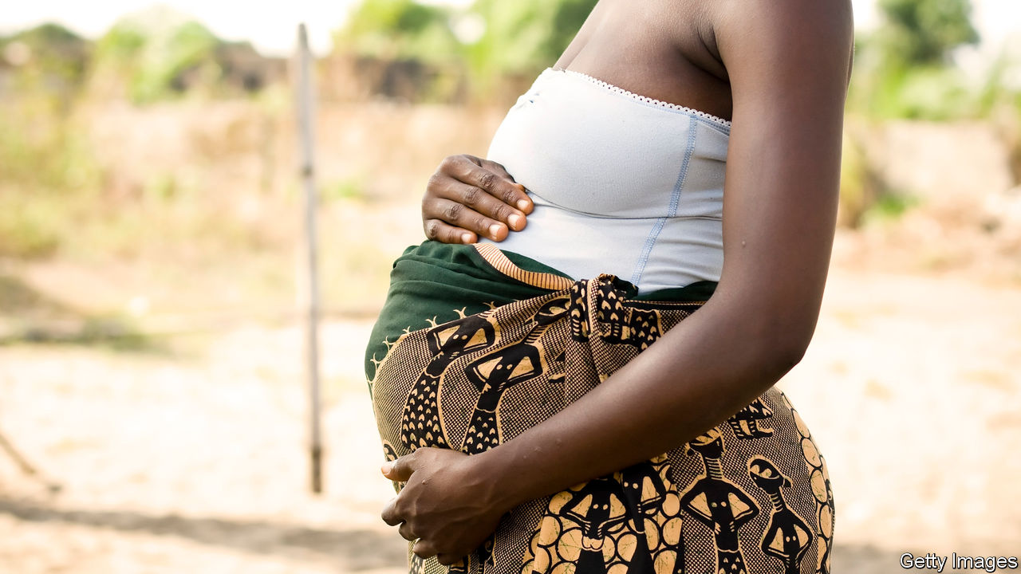

TANZANIA’S PRESIDENT, John Magufuli, has little sense of irony. He marked International Women’s Day by tweeting that his government wants to help women “fulfil [their] responsibilities effectively”. Those responsibilities evidently do not require an education: his government expels girls from school if they become pregnant. Mr Magufuli sounds less than empathetic when discussing the matter. “After calculating some few mathematics, she’d be asking the teacher in the classroom: ‘Let me go out and breastfeed my crying baby’,” he once complained.

Aghast, the World Bank withheld a $300m loan in 2018 that was intended to fund secondary education. After some toing and froing, Mr Magufuli promised to expand a programme to teach young mothers. The bank once again offered a loan, this time of $500m.

Many people think it was wrong to do so. One pundit dubbed the new deal “separate but equal”, in a nod to the era when schools for blacks and whites were segregated in America. The analogy holds. There are not always enough places for young mothers in Tanzania’s parallel schooling programme, which, moreover, teaches an outdated curriculum and is staffed by ill-prepared teachers.

Under pressure from Tanzanian campaigners, the World Bank again delayed issuing the loan in January. Yet the controversy also illustrates a quandary often faced by donors trying to help poor people ruled by unpleasant governments.

Some activists argue that the bank should simply withdraw the loan. But that would mean hobbling the education of about 6.5m children in an attempt to protect a much smaller number. (Some 5,500 pregnant girls were expelled in 2017.)

A second option would be for it to offer the loan with strings attached. But such “conditionality” is often ineffective, in part because donors fail to enforce it, notes Haley Swedlund of the Centre for International Conflict Analysis and Management at Radboud University in the Netherlands. “The incentive is always to disburse,” she says. Aid programmes take time and effort, and next year’s budget allocation often depends on whether this year’s was used. So donors often push the money out of the door regardless of whether conditions are met. Some worry that if they press too hard, recipients will just walk away.

Then there is the problem of fungibility. Aid for schools does not automatically raise spending on schools. The government may react by diverting the money it was going to spend on schools to another purpose, such as weapons or presidential palaces. Even attempts to fund worthwhile projects can facilitate repugnant ones.

The availability of Chinese financing further complicates things. Mr Magufuli says he prefers Chinese aid because it comes with fewer conditions. This is not quite true. Chinese loans often have higher interest rates and must be spent with Chinese firms. However, China never fusses about human rights—and this forces other lenders to adjust. One study found that the World Bank offered loans with fewer conditions to African countries if they were also assisted by China.

A third option is for donors simply to give money without any strings. But this is unpopular with taxpayers in donor countries, who do not like their cash being spent on things they find appalling.

Many aid programmes face similar quandaries, and there is no easy answer. In this case, though, the World Bank could be firmer. It is the only consistent funder of secondary schooling in Tanzania, and standing up to Mr Magufuli has worked before. Last year, after being criticised by donors, Tanzania amended a law that made it a crime to dispute official statistics. Another firm nudge might get him to let teenage mothers back into school. ■

This article was downloaded by calibre from <https://www.economist.com/middle-east-and-africa/2020/03/14/should-the-world-bank-fund-schools-that-expel-pregnant-girls>

|  |  |  |  |
| --- | --- | --- | --- |
| Previous | Articles | Sections | Next |

|  |  |  |  |
| --- | --- | --- | --- |
| Previous | Articles | Sections | Next |

#### War on wheels

# A ban on motorcycle taxis is causing chaos in Lagos

It was supposed to ease gridlock, but made it worse

Mar 14th 2020 | LAGOS

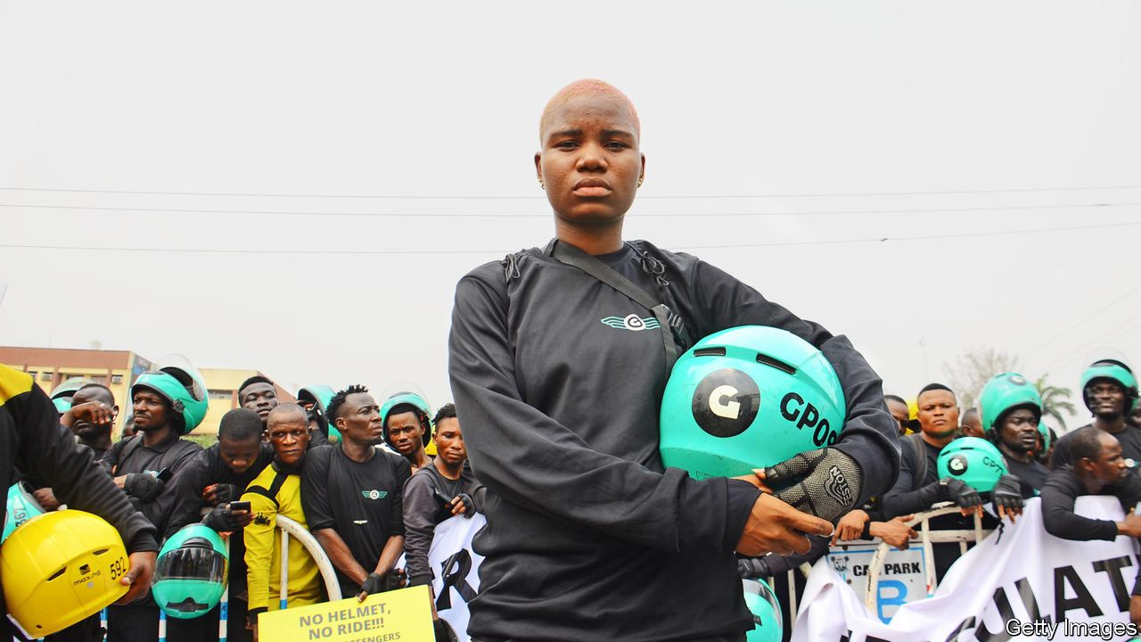

ON A BUSY street in Lagos, Nigeria’s business centre, the usual horde of motorbike-taxis jolting passengers through evening gridlock is palpably absent. The men who used to ride them sit idly. “How do we feed our families?” asks Stanley, a former rider.

The authorities confiscated his motorbike after suddenly banning two- and three-wheeled taxis, known as okadas (after a now-defunct airline, for their ability to soar over traffic) and kekes. The ban, which was imposed on February 1st across big parts of the city, was intended to make commuting safer. City authorities absurdly blame the motorbikes for congestion and, somewhat more plausibly, for being involved in accidents. Further issues, they said, were that motorbikes are used by criminals and have no place in the master plan they have drawn up to improve the city.

Instead of ushering in modernity, the ban has wrought chaos. Riders have clashed with police and burned tyres in the neighbourhood of Alimosho, west of the city centre. Commuters have suffered. At dawn thousands of people trek by foot through inner-city streets. Those able to take cars have done so, adding to the city’s already insufferable gridlock: one study before the ban found that residents spent almost as much time commuting to work (30 hours a week) as they spent once they got there. To fill the gap the government has laid on an extra 65 buses. That is roughly one bus for every 300,000 residents.

Another effect of the ban may be to deter investment. Nigeria already has a reputation for arbitrary governance; making gridlock worse won’t help. Among the worst-hit firms are Gokada, a sort of Uber for motorcycle taxis, and Max, a motorcycle courier business. Both had attracted millions of dollars from foreign investors. Valuations of both have slumped. Lagos without okadas may be both less liveable, and poorer.

This article was downloaded by calibre from <https://www.economist.com/middle-east-and-africa/2020/03/14/a-ban-on-motorcycle-taxis-is-causing-chaos-in-lagos>

|  |  |  |  |
| --- | --- | --- | --- |
| Previous | Articles | Sections | Next |

|  |  |  |  |
| --- | --- | --- | --- |
| Previous | Articles | Sections | Next |

#### Sickly state

# Iran has let its covid-19 outbreak get out of hand

A slow response and unreliable numbers are making matters worse

Mar 12th 2020 |

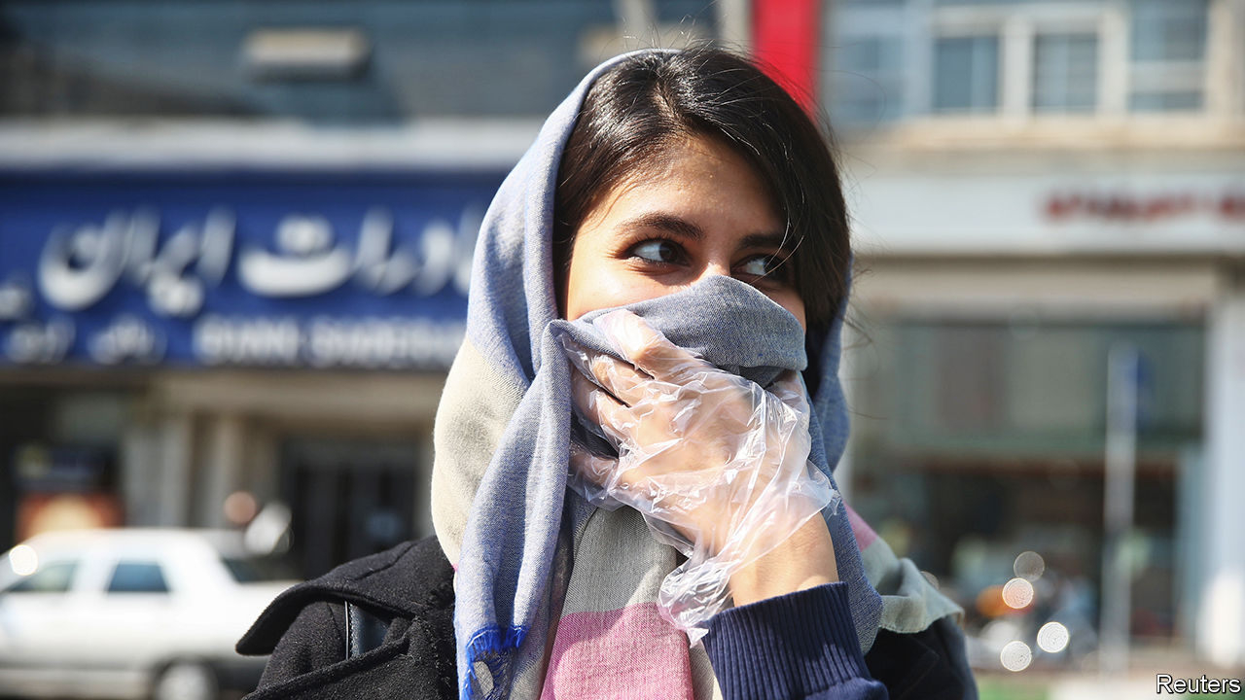

NOWHERE HAS covid-19 hit a country’s leaders harder than in Iran. Two vice-presidents, ministers and 24 members of parliament (almost 10% of the total) have contracted the virus. Two of those parliamentarians, as well as two former high-ranking diplomats and a member of an advisory council to Iran’s supreme leader, have been killed by it. Hassan Rouhani, the president, now hosts sparsely attended cabinet meetings, as questions mount about the absence of other senior officials.

According to the government, the virus has infected 9,000 people and killed over 300. That would make it the second-biggest outbreak outside China (see chart). But no one believes the government’s numbers. The outbreak is probably much worse than it is letting on.

Trust in the regime was already low as a result of its killing of protesters in November and its attempt to cover up the downing of a Ukrainian passenger plane over Tehran in January. When the virus struck, officials hid news of it so that voters would turn out for a rigged parliamentary election on February 21st. Visibly sick, the deputy health minister denied a cover-up on February 24th. He tested positive for the virus a day later. The number of infected officials alone suggests an enormous outbreak. So do public surveys and other indicators. Some in the government think the actual number of cases is closer to 100,000. Outside estimates go even higher.

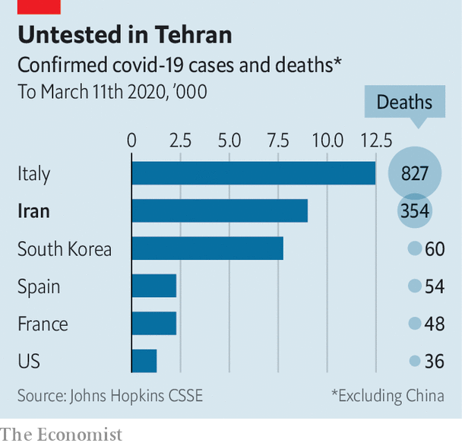

The government has closed schools, universities and theatres, and told people not to attend large gatherings. Some 300,000 soldiers and volunteers have been mobilised to fight the disease. But these measures have come late and are incomplete. There was no thought of quarantining the holy city of Qom, where the outbreak started. As fear of the virus grew, sick residents fled to other parts of the country, spreading it to every province. Hospitals, dubbed “virus factories” by locals, are overloaded. Yet the mullahs still refuse to close the popular (and lucrative) holy shrines in Qom and elsewhere. Two men even filmed themselves licking the shrines (and were arrested). By contrast Saudi Arabia, with many fewer cases, has banned foreign pilgrims from its holy sites.

Before the virus, Iran’s economy was largely isolated, thanks to American sanctions. Now it is even more cut off. Neighbours including Iraq, its main trading partner, are restricting the passage of people and goods. Religious, medical and leisure tourism, worth almost $12bn last year, has dried up. Iranians themselves are not spending ahead of Nowruz, the new-year festival on March 21st. Restaurants, concert halls and hotels have shut for want of business. Shopping malls and bazaars are empty. Some businesses have cut the work week in half, but many employees are not showing up at all. March 8th was the Tehran metro’s quietest day in a decade.

As imports become harder to get, inflation is likely to rise. The collapsing price of oil has cut into the profits of smugglers. With little hard currency entering the country, market-watchers expect another run on the rial, whose value has plummeted over the past year. Jamshid Edalatian, an economist, thinks GDP could shrink by 25-30% as a result of the virus.

In February the government said it would punish anyone spreading rumours about a serious outbreak. Officials have blamed America for fearmongering. But the regime’s own ailing members have made the scale of the crisis impossible to conceal. And it could get worse for Iran’s rulers. Many of them are old, infirm and especially at risk of dying from covid-19. ■

Dig deeper:

* For more coverage of covid-19 see our [coronavirus hub](https://www.economist.com/news/2020/03/11/the-economists-coverage-of-the-coronavirus)
* The science of the virus
* Fatality rates for covid-19 could vary enormously
* How to deal with a new sort of financial shock
* Should other countries copy Italy’s nationwide lockdown?

This article was downloaded by calibre from <https://www.economist.com/middle-east-and-africa/2020/03/12/iran-has-let-its-covid-19-outbreak-get-out-of-hand>

|  |  |  |  |
| --- | --- | --- | --- |
| Previous | Articles | Sections | Next |

|  |  |  |  |
| --- | --- | --- | --- |
| Previous | Articles | Sections | Next |

#### Resilient no more

# For the first time, Lebanon defaults on its debts

Restructuring will be a struggle. Fixing the country’s rentier economy will be even harder

Mar 14th 2020 | BEIRUT

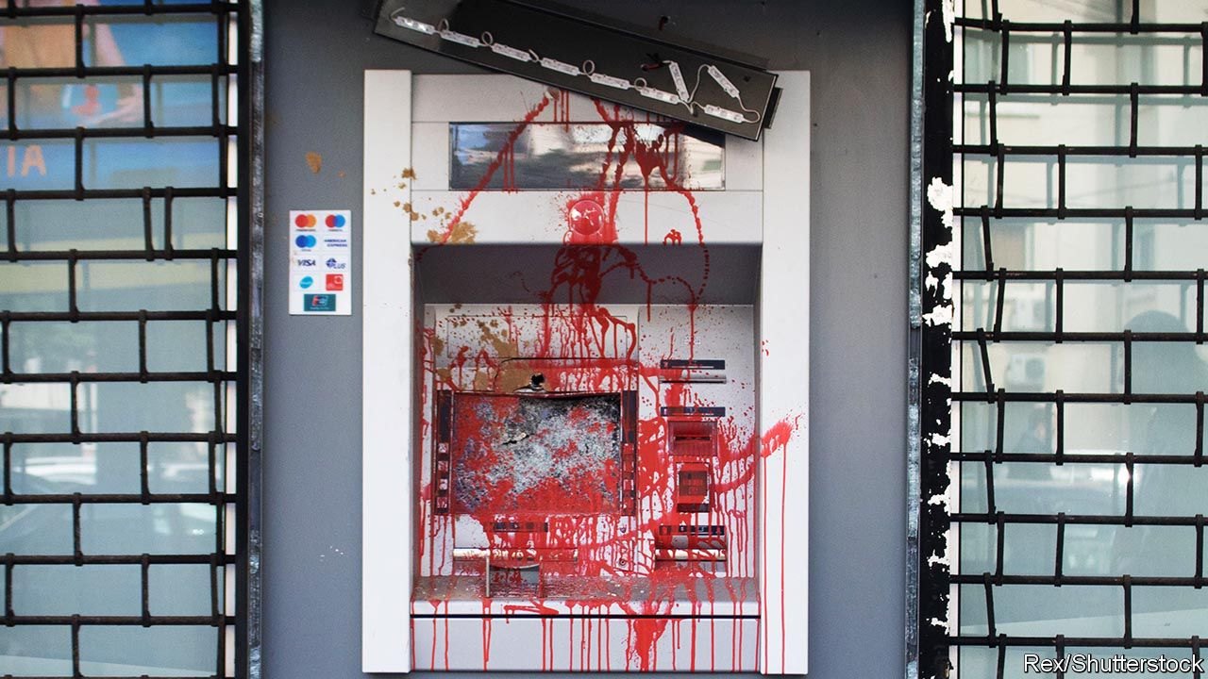

A CURRENCY CRISIS has done what years of sectarian bloodletting could not. On March 9th Lebanon did not repay a $1.2bn Eurobond, the first sovereign default in the country’s history. Even during the darkest days of its civil war in the 1980s, the state met its obligations. But Lebanon must now choose between honouring its debts and providing the most basic services to its citizens. “How can we pay the creditors while there are people in the streets without the money to buy a loaf of bread?” said Hassan Diab, the prime minister.

Lebanon has spent months slipping towards an economic abyss. Its currency, the pound, is officially pegged to the dollar, but has lost more than 40% of its value on the black market. Banks are imposing ever-stricter capital controls because they lack the hard currency to repay depositors. Big protests in October, against the corruption and incompetence that led Lebanon to crisis, brought down the previous government. Mr Diab, an academic, inherited a mess when he took over in January. Many Lebanese support his decision to default. But it is only a first step—and it is not clear that his government has a plan.

Start with restructuring. About two-thirds of government debt (which, in total, is more than 150% of GDP) is held by local banks. They argued for months against a default, because they fear even a modest haircut would wreck their balance-sheets. As default grew more likely, the banks dumped some of their holdings to outside investors that were willing to gamble. Officials believe foreigners now hold more than 25% of some bond issues—enough to block any restructuring deal.

The problems do not end there. For years the central bank, the Banque du Liban (BdL), borrowed dollars from commercial banks to sustain the currency peg and cover big fiscal and current-account deficits (in 2018 they were 11% and 26% of GDP, respectively). In return, the banks received above-market interest rates on what seemed like a risk-free investment.

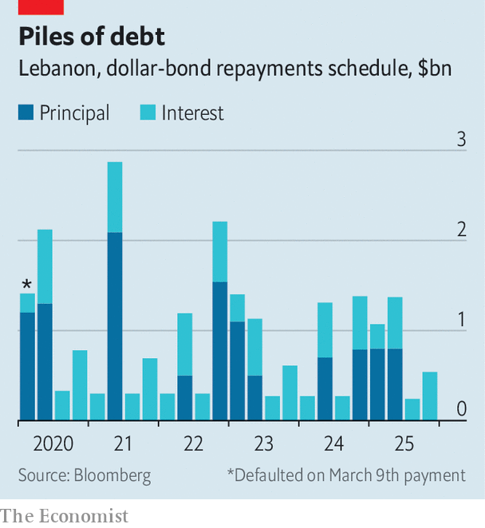

But this state-sanctioned pyramid scheme no longer has enough new money to sustain itself. Bank deposits, which grew at a healthy clip for years, levelled off in 2018 and have started to decline. Commercial banks had 247trn pounds ($160bn, at the official rate) in deposits in December, an 8% drop from a year earlier. The central bank does not have enough dollars to repay what it owes. At the end of January it had a healthy $37bn in gross foreign-currency reserves—but an eye-watering $52.5bn in liabilities, mostly owed to local banks, estimates Fitch, a ratings firm.

Lebanon may thus have to negotiate a deal not only on its bonds, but also on deposits held by the BdL. If the central bank defaulted on deposits, it would be a death blow to the financial sector, which has 55% of its assets tied up there. A haircut of just 18% would leave commercial banks insolvent and require a recapitalisation worth at least 25% of GDP, estimates IHS Markit, a research firm.

The dollar shortage has sent the pound into a spiral. On March 6th the central bank told money-changers not to buy dollars for more than 30% above the official rate. But supply and demand dictate that the edict will merely create a new black market.

Money has become a daily fixation for many Lebanese. ATMs no longer spit out dollars. To obtain them, customers trudge to the bank each week, often queuing for hours, to withdraw whatever pittance their branch allows, sometimes just $50 a week. Paying with plastic is also fraught—some businesses have stopped accepting cards.

Banks still honour cheques, which has led to an odd boomlet in luxury goods as clients snap up tangible assets. Khoury Home, a household-goods store, advertises new washing machines as a way to “survive the haircut”. But cheques simply move inaccessible money from one account to another. Sellers have begun to demand at least partial payment in cash.

On February 15th the national carrier, Middle East Airlines, announced that it would stop accepting Lebanese pounds the next day. The decision, later reversed, was striking, because the airline is majority-owned by the BdL. Such is the state of Lebanon’s economy: a firm controlled by the central bank no longer wants to accept the currency issued by the central bank.

With money scarce, the economy is frozen. Even before the crisis, unemployment was thought to be as high as 25%. Perhaps 40% of Lebanese are now poor, and the number could soon rise to 50%, according to the World Bank.

No one is lining up to help Lebanon: neither its Western partners nor the Gulf states that have bailed it out in the past. It will probably have no choice but to seek an IMF loan. The fund will insist on painful reforms. There is already talk of raising the value-added tax and fuel prices. Lebanon will also have to find a new economic model. Mr Diab rightly points out that it is a rentier state, too reliant on finance and inflows from a sprawling diaspora. “We don’t need a banking sector four times the size of our economy,” he said. Last year Lebanon exported just $3.7bn-worth of goods.

Though it will never be an industrial powerhouse, businessmen point to opportunities for growth. With an educated, multilingual workforce, Lebanon could be a hub for tech companies and high-end manufacturing. Agriculture has room to grow. So does tourism, which already contributes 19% of GDP. All these, however, need big investment in new infrastructure. Electricity is spotty, internet speeds are glacial and roads are clogged. The country’s natural beauty has been spoiled by heedless development. But the coffers are bare. Restructuring the debt will be easier than restructuring a country blighted by decades of bad government. ■

This article was downloaded by calibre from <https://www.economist.com/middle-east-and-africa/2020/03/14/for-the-first-time-lebanon-defaults-on-its-debts>

|  |  |  |  |
| --- | --- | --- | --- |
| Previous | Articles | Sections | Next |

|  |  |  |
| --- | --- | --- |
| Middle East and ... | Sections | Britain |

Europe

Russia: The prisoner in the Kremlin

.

French local elections: A kicking on the way

.

Women and work: Why Germany’s pay gap is so large

.

Charlemagne: Pour décourager les autres

.

|  |  |  |
| --- | --- | --- |
| Middle East and ... | Sections | Britain |

|  |  |  |  |
| --- | --- | --- | --- |
|  | Articles | Sections | Next |

#### Prisoner in the Kremlin

# Why Vladimir Putin cannot retire

He has too many enemies, and too many cronies who depend on him

Mar 14th 2020 |

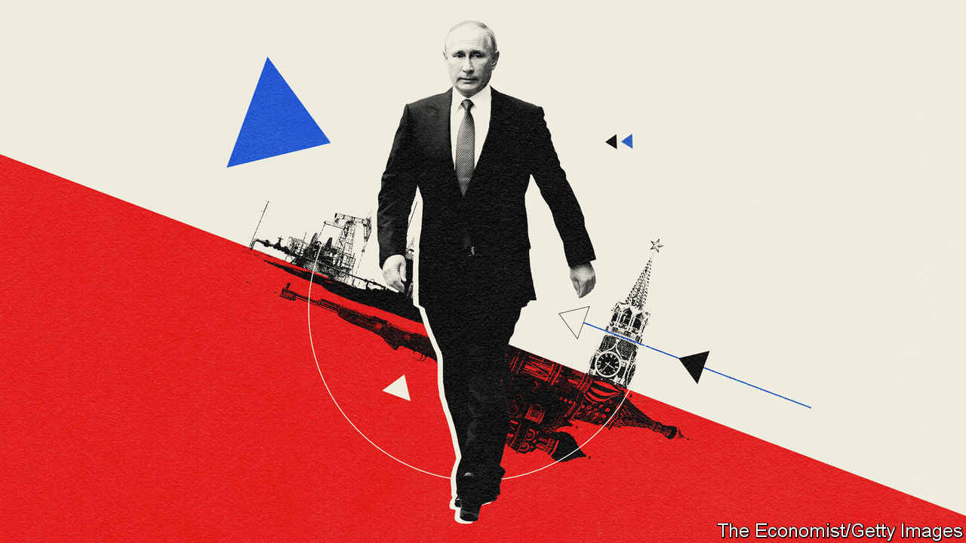

SHORTLY AFTER becoming president in 2000, the 48-year-old Vladimir Putin pondered how he would one day leave office. Riding in a presidential limousine through Moscow at night, he confided to an interviewer: “I very much hope that one day I will manage to go back to a normal life and that I will have some private future. I can’t say that the life of a monarch inspires me. A democracy is much more viable.”

Twenty years on, Mr Putin is further away from a peaceful post-presidential life than ever. On March 10th the Duma, Russia’s parliament, voted to approve constitutional changes proposed by Mr Putin, and added one that resets the number of terms he can serve. Under the current system, he would have had to stand down in 2024; now, he could go on until 2036, and perhaps longer.

Mr Putin has pondered various methods of retaining power for some time: merging Russia with Belarus to create a new country to rule over; presiding over an all-powerful Supreme State Council; or becoming prime minister in a new parliamentary system. In the end, he chose the crudest, but perhaps simplest, method—changing the constitution and giving himself an option to stay on. In this, he is following in the footsteps of several post-Soviet central Asian despots, observes Kirill Rogov, a political analyst.

Mr Putin’s other amendments curb the power of parliament and courts and position him as “not only the head of the state but the head of the executive branch as well, attributing to him the co-ordination of all public authorities and affirming his dominance in the judiciary”, as Mr Rogov explains. The power-grab is shrouded in the language of God, tradition, heterosexual families and Russia’s great victory in the second world war (the 75th anniversary of which Russia will mark on May 9th).

Like many autocrats, Mr Putin suggests that he needs to remain in power to ensure stability. This week he invoked the turbulence in the oil market, the new coronavirus and threats from enemies within and outside. “They are waiting for us to make a mistake or to slip up, losing our bearings or, worse still, getting bogged down in internal dissent, which is sometimes fanned, fuelled and even financed from abroad,” he told the Duma.

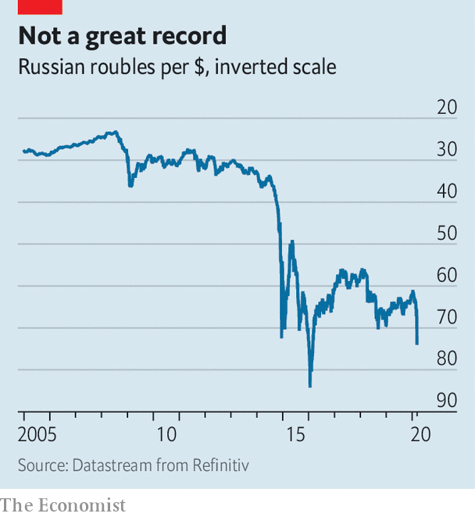

The collapse in the oil price, which at one point this week was down by 30%, added drama to his words. Oil and gas are most of Russia’s exports and generate a third of GDP. That Russia remains so reliant on hydrocarbons is largely Mr Putin’s fault. On his watch attempts to diversify the economy have failed to achieve as much as they should have.

Mr Putin implied that the world was too stormy a place for him to abandon his position. A former KGB agent, he defined his role not merely as the defender of the constitution (which he is busily rewriting), but “the guarantor of the country’s security, domestic stability and evolutionary development”—evolutionary because “Russia had its share of revolutions.” It hardly needed saying that he was the only man capable of averting such mortal dangers. Still, it was said, and by none other than Valentina Tereshkova, a famous Soviet cosmonaut who is now an MP aged 83. She was given the role of voicing the reset proposal, which was promptly approved by the president and the Duma.

All of this was part of a special operation that Mr Putin launched in mid-January when he first announced plans for constitutional changes. The process was murky and abrupt. So it was in keeping with the style of a former KGB man whose own ascent to power was a special operation plotted in the corridors of the Kremlin. “A group of FSB agents assigned to work undercover in the government of the Russian Federation is successfully fulfilling its task,” he quipped in his speech to the FSB (the successor to the KGB) in December 1999 upon being made prime minister. He became president the following year.

Since then he has conducted other special operations, such as the annexation of Crimea and invasion of Ukraine in 2014, not to mention the expropriation of the oil-and-gas firm Yukos in 2004-06. Each of these operations was dressed up in legal procedure, be it a referendum in Crimea or a show trial in the case of Yukos. The constitutional change is no different.

Mr Putin says that the changes will come into effect only with the endorsement of the Constitutional Court (which he controls), and with the approval of the Russian people. They will vote, as it happens, on April 22nd—the birthday of Lenin, the founder of the Soviet state who still lies in a mausoleum in Red Square. The vote is neither a referendum nor an election, and the whole process is as legally dubious as the referendum staged in Crimea. The fact that Mr Putin is expected to sign his constitutional amendment on March 18th, the sixth anniversary of the illegal annexation of Crimea, is revealing.

While Mr Putin’s intention of staying in power was never much in doubt, the timing and the rush with which the changes to the constitution have unfolded have been striking. Ekaterina Schulmann, a political scientist, attributes this in part to the mood of Russia’s elite, who were feeling nervous about their own future. Mr Putin’s cronies depend on him for their positions. Uncertainty about his plans makes them fearful of losing their money, status and possibly their freedom.

The aim of Mr Putin’s move, she reckons, is to eliminate the risk that the elite might agree on a successor. Such an agreement would turn Mr Putin into a lame duck. Sergei Sobyanin, the mayor of Moscow, noted on his personal website that “a president who cannot run for another term cannot be a strong figure by definition. A ban on the incumbent being re-elected is a destabilising factor both in domestic and foreign policy.”

But Mr Putin’s erratic and unconvincing performance over the past few months risks alienating the public. The fact that he wants to impose his plan on the Russian people does not mean he will succeed. Few countries are as capable of delivering surprises as Russia. His power-grab is taking place against the background of a stagnating economy and rampant corruption.

In the two years since Mr Putin’s most recent election in March 2018, trust in him has fallen from 60% to 35%. His foreign adventures no longer thrill the public. Even anti-Americanism, one of the staples of his ideology, is going stale. This is why the promised vote on April 22nd is likely to be a fraudulent affair. Rallies against the changes are likely to be banned, thanks to the convenient coronavirus.

Ella Paneyakh, a Russian sociologist, argues that the Kremlin has lost touch with society. Its channels of communication have been reduced to broadcasting propaganda, which is losing its effect. Even bribing people with their own money does not seem to work any more.

The only instrument left is repression, which the government has already shown a willingness to use. “The state has plenty of potential for repression and it can be used again and again, until it encounters a problem that cannot be resolved by force,” Ms Paneyakh says. Mr Putin’s constitutional coup and his growing reliance on repression rather than patronage or propaganda raises the cost of challenging him, reduces the chances of an orderly transfer of power and increases the risk of violence in Russia. All this in the name of stability. ■

This article was downloaded by calibre from <https://www.economist.com/europe/2020/03/14/why-vladimir-putin-cannot-retire>

|  |  |  |  |
| --- | --- | --- | --- |
|  | Articles | Sections | Next |

|  |  |  |  |
| --- | --- | --- | --- |
| Previous | Articles | Sections | Next |

#### Marine’s mayors multiply?

# Emmanuel Macron’s party braces for a kicking in mayoral elections

Terrible results are expected

Mar 14th 2020 | AVIGNON AND CARPENTRAS

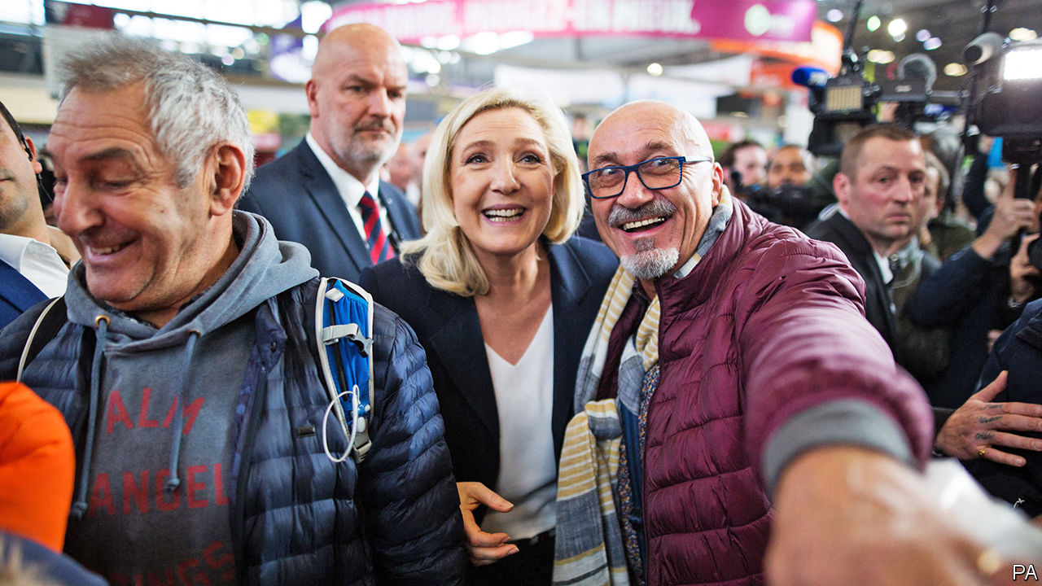

DRESSED IN A Barbour coat and clutching a NATO-embossed umbrella, the retired general strides down the streets as if into battle. “I’m not a politician,” declares Bertrand de la Chesnais as he knocks vigorously on doors, which are opened cautiously, if at all: “But I know how to run an organisation.” Dividing Carpentras into eight districts, he has chalked up 5,000 doors in this Provençal town of 29,000 people since last August. The general’s aim: to raise his profile as a candidate for mayor—backed by Marine Le Pen (pictured).

On March 15th and 22nd the French go to the polls for two rounds of voting for mayors of the country’s 35,000 towns and villages. At the previous elections, in 2014, Ms Le Pen’s populist party, National Rally (RN, formerly the National Front), won a record 11 town halls. It hopes to beat that this time. In Carpentras, with its 15th-century cathedral, shaded fountains and plentiful kebab shops, her candidate lost by just 306 votes after a three-way run-off against the Socialists and Republicans. Now the 62-year-old general, who led a United Nations battalion during the siege of Sarajevo, is hoping to take the town.

During an evening of canvassing, Mr de la Chesnais is mostly greeted as a candidate like any other. Inside a small flat, a man wearing a tracksuit and crucifix welcomes him in for a chat. A discussion ensues about the “Muslim vote”. “They are manipulated,” suggests his wife. Back out in the street, a woman parking her car smiles in recognition: “I know you from Sunday mass!” “Ah non, not you!” calls out another from the second-floor window of a shuttered town-house. “The bourgeois are often against us,” shrugs the general, marching off to the next door.

The campaign in southern France suggests three points with wider political resonance. The first is what the French call the “banalisation” of the RN vote. Mr de la Chesnais refuses to be labelled “Ms Le Pen’s candidate”. Yet he posed unapologetically for a campaign photo with her, and has splashed her party’s label on his official poster, alongside that of other right-wing fringe parties. The RN is not expected to do well in big cities. But in small and mid-sized towns it could build on its successes. Many are in Provence-Alpes-Côte d’Azur, the surrounding region. At the first round of the presidential election in 2017, Ms Le Pen came top in Carpentras.

This near-normalisation has led to a “porosity” between the right-wing and far-right vote in the region, says Christèle Marchand-Lagier, a political scientist at the University of Avignon. Carpentras was where Marion Maréchal, Ms Le Pen’s niece and a champion of Catholic right-wing politics, was once elected deputy. Thierry Mariani, another former deputy from the region and ex-Republican government minister, last year defected to the RN. So far, both locally and nationally, the Republicans have refused to contemplate alliances of any sort with Ms Le Pen. But the search for second-round backing in three-way contests could strain such principles.

A second feature is the local resilience of mainstream parties, despite Mr Macron’s crushing of them at the national level at a parliamentary election in 2017. French mayors have a strong link to voters, incumbency helps, and parochial issues prevail. In the nearby walled city of Avignon, home to 14th-century popes and 21st-century yoga studios, the talk at the Green party office is all about making public transport free and contesting the construction of a new motorway link. In 2014 Jean-Pierre Cervantes, the Green candidate, who wears a pea-green scarf knotted around his neck, was on the victorious Socialist list. Today, going it alone, he hopes the “green awakening” will make Avignon one of the Greens’ national successes.

The third point is the chronic local weakness of President Emmanuel Macron’s La République en Marche (LREM). The party he founded in 2016 did not exist at the previous local elections, and has struggled to put down roots. Across France, Ms Le Pen is running more party lists than Mr Macron. In Carpentras, in line with LREM’s policy of supporting friendly incumbents in many places, it does not have its own candidate. Frédéric Tacchino, the LREM candidate in Avignon, says that, unlike him, many of his fellow candidates in the region have not even put Mr Macron’s party name on their flyers. At Paris headquarters, the party says it will ask its candidates who come third in the first round to stand down, or merge with either the left or the right, in order to keep the RN out.

Focused on managing the coronavirus crisis, Mr Macron insists that this election is a local matter, not a referendum on him. Up to a point this may be true. Yet the dismal results that even his own party now expects will nonetheless be seen as further evidence of his lack of personal popularity, as well as the failure of his party to build up countrywide the sort of local networks it needs if it is ever to become a lasting force in French politics. ■

This article was downloaded by calibre from <https://www.economist.com/europe/2020/03/14/emmanuel-macrons-party-braces-for-a-kicking-in-mayoral-elections>

|  |  |  |  |
| --- | --- | --- | --- |
| Previous | Articles | Sections | Next |

|  |  |  |  |
| --- | --- | --- | --- |
| Previous | Articles | Sections | Next |

#### From peer to maternity

# Why the pay gap in Germany is so large

Women are more likely to work part-time—except in the east

Mar 14th 2020 | BERLIN

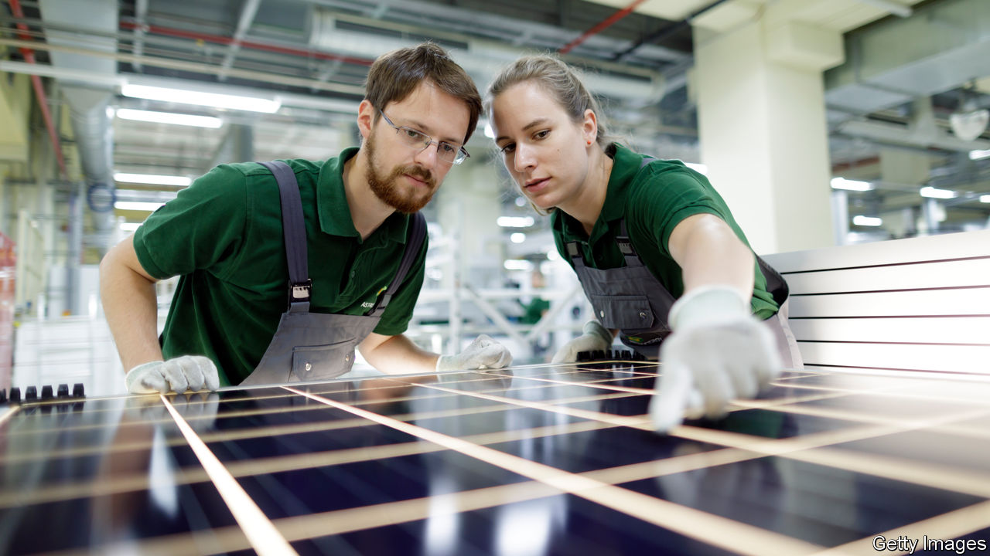

“REVOLUTIONARY” IS not a word that often escapes Angela Merkel’s lips. Yet on March 8th, international women’s day, that was how Germany’s chancellor described the change she had observed in men’s attitudes to balancing work and family. This matters in a country that can still deride Rabenmütter (“Raven mothers”), women who supposedly neglect children for career. But on another measure of equality—pay—Germany is lagging.

The median hourly wage for German women is €17.09 ($19.31), 21% less than men’s €21.60. In the European Union, only Estonia has a wider gap. But the raw numbers can mislead. Adjust for sector, skills, age and other factors, and the gap plummets to 6-7%. Women are likelier than men to work in badly paid service jobs; two-thirds of shop assistants are female. Almost half of working women are part-time (compared with 9% of men) and so tend not to climb the career ladder as fast. Katharina Wrohlich at the German Institute for Economic Research notes that some countries with lower pay gaps, such as Italy, have far fewer women working. Women who earn low wages drag down the average; those who earn nothing are not counted.

Yet the adjusted figures leave something out, too. Which career to follow, and whether to work part-time, are individual choices. Yet they are influenced by tax and benefit rules, education and child-care policy, and social norms. Ensuring equal pay for equal work would not, in itself, make Germany’s boardrooms less male, or get more women into well-paid sectors.

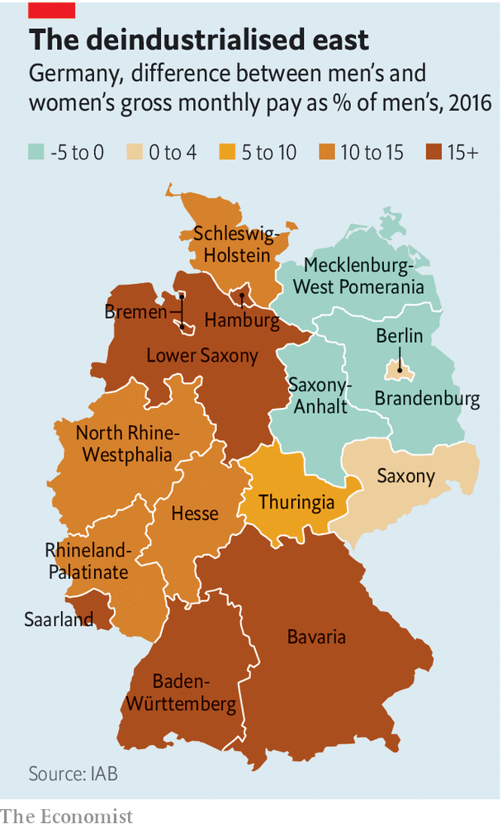

In the former East Germany, the unadjusted pay gap between men and women is minuscule. In some areas, women earn more. This is partly explained by the lack of industrial giants in the east. Germany’s pay gap yawns widest in the humming southern states of Bavaria and Baden-Württemberg, where men dominate lucrative technical and manufacturing jobs. In the east the public sector, where women do better, employs more people. History counts, too. The old communist regime cajoled women to work outside the home, and started a tradition of state-backed child care that persists. East German women have long been more likely to work than westerners, although the figures are converging.

The pay gap has almost vanished for full-time workers under 30, the average age for new mothers, but for those over 40 it has barely budged for three decades. The motherhood wage penalty is higher in Germany than in many rich countries; ten years after giving birth the average German mother earns almost two-thirds less than before, a far more precipitous drop than in countries with better child-care provision, such as Sweden or France. Tax rules and education practices, including schools that can close as early as noon, nudge large numbers of women into part-time work.

Germany is changing. Since 2013 the state has guaranteed day care for children over 12 months (though finding a spot can be nightmarish). The minimum wage, which was introduced in 2015, disproportionally helped women. New transparency rules oblige big firms to explain pay decisions to curious staff. But much remains to be done, including chivvying men to take on more of the duties of parenting; just 36% of German fathers take paternity leave. The revolution is incomplete. ■

This article was downloaded by calibre from <https://www.economist.com/europe/2020/03/14/why-the-pay-gap-in-germany-is-so-large>

|  |  |  |  |
| --- | --- | --- | --- |
| Previous | Articles | Sections | Next |

|  |  |  |  |
| --- | --- | --- | --- |
| Previous | Articles | Sections | Next |

#### Charlemagne

# Europe hopes brutality at the border will keep refugees away

That is why other countries are supporting Greece

Mar 12th 2020 |

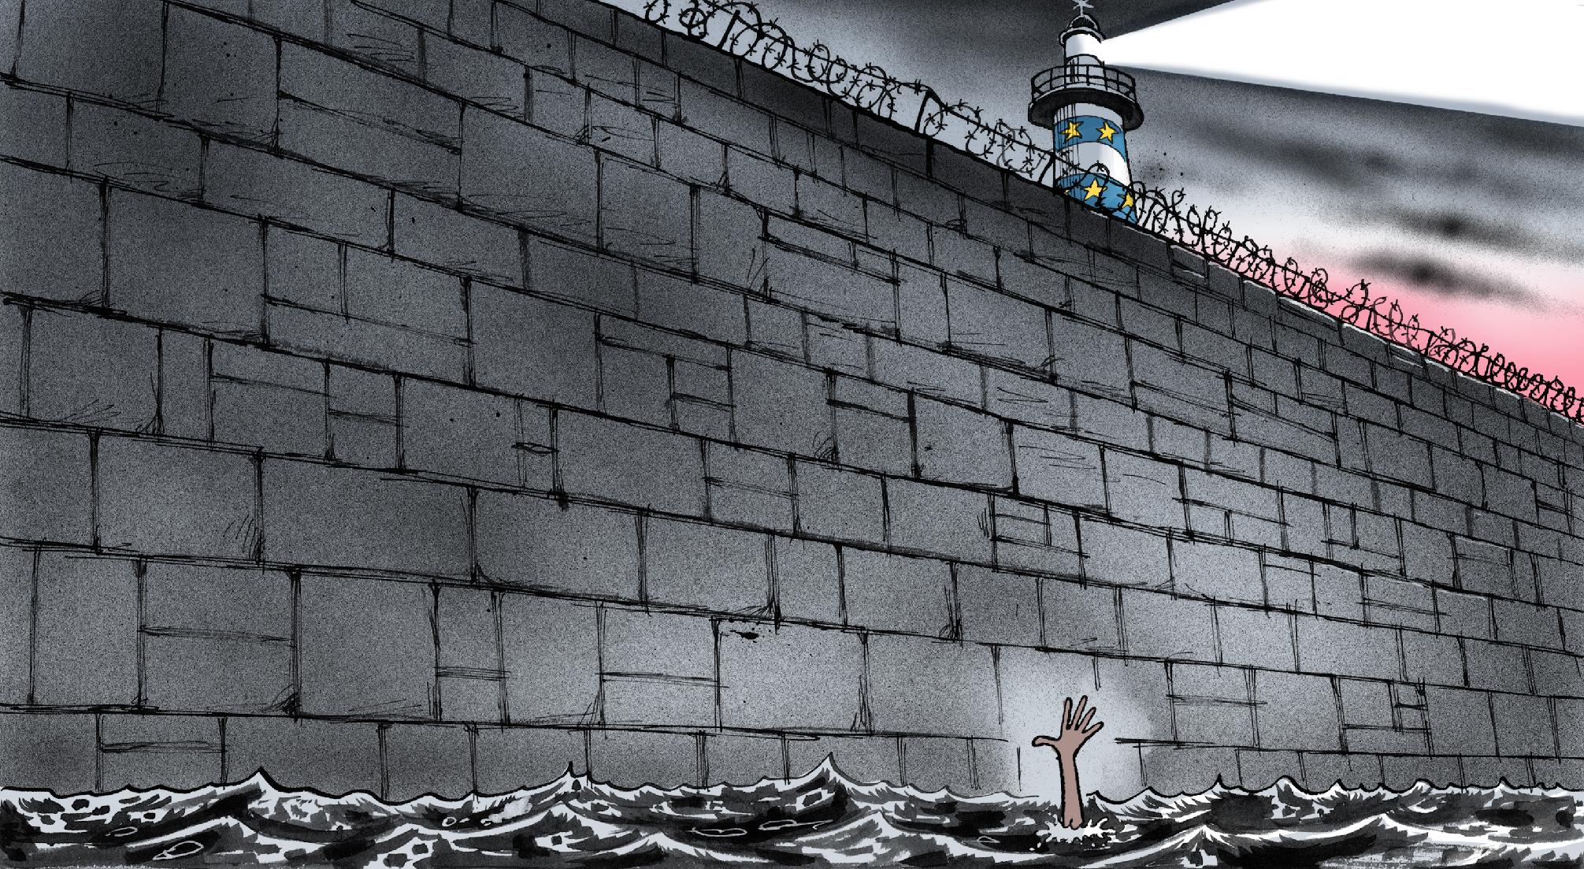

COMPARE AND contrast. In 2015 thousands of irregular migrants and asylum-seekers entered Hungary, en route to Germany. Hungary’s prime minister, Viktor Orban, built a fence along the country’s southern border to stop them. The European Commission chided Mr Orban. “We have only just torn down walls in Europe; we should not be putting them up,” tutted a flack for the European Commission. Fast forward five years, and ugly scenes erupted at the EU’s borders once again. Migrants trying to reach Europe on a dinghy were greeted by a Greek vessel, whose crew hit the boat with sticks and fired warning shots at them. This time the commission had a different response. “I thank Greece for being our European aspida [shield] in these times,” said Ursula von der Leyen, the president of the European Commission. What changed?

Two visions of the EU competed during the migration crisis of 2015 and 2016, when more than 2m people flooded into the bloc. On one side stood the humanitarians, who viewed the EU as a normative power, a shining light on a hill. For them, the response was a moral question with a simple answer: Willkommenskultur. On the other side were the hardliners. Their argument for stiff, brutal measures at the border was based on practicality (a state can only feed and house so many refugees at once) and politics (voters will kick out anyone who allows too large and sudden an influx, sharpish). After five years of wrestling, the humanitarians have been routed. Now the hardliners reign supreme.

Brutality at the border is now a central feature of European migration policy. The misery is no coincidence. Anyone who makes it to Greece faces dreadful conditions. On the Greek island of Lesbos 20,000 people are stuck in a camp designed for a seventh of that number. The Greek government is building new facilities, but these will come with strict rules on when asylum-seekers may come and go. Anyone who makes it out of Greece is liable to be beaten up by police at the Croatian border, who have been accused of pummelling and robbing migrants before dumping them back into neighbouring Bosnia. Deterrence trumps principle or, in some cases, the law. (Greece has suspended asylum applications for a month, arguing with some justification that the recent influx of people is being orchestrated by the Turkish government, which wants the EU to give it more money.) Officials are eager to focus on what has become the EU’s guiding philosophy on migration: pour décourager les autres.

Tactics that were once the demands of a nationalist fringe have been adopted by mainstream governments. NGO vessels operating in the Mediterranean have been impounded and their crews harassed. Those who help people making the trip to Europe, by organising food and water along migratory routes, face charges of people-smuggling. Mediterranean patrols have been scaled back lest they act as a pull factor, encouraging people to brave choppy waters in the hope of being rescued by the coastguard.

Morality still sometimes rears its head. European leaders are not always comfortable with their choice. They grab policy figleaves to hide their shame whenever possible. Leaders from a handful of states this month cooked up a scheme to relocate minors abandoned in miserable camps on Greek islands. Legally, refugee status has nothing to do with virtue. Being a refugee is not about the content of your character but the misery of your circumstance. But politically it is far easier to move women and children than 25-year-old single blokes, even if all are in danger.

Though some wrestle with the hardline turn, most officials are happy to justify it. Ugly scenes at the frontier are a necessary evil for convenience in the interior, goes one argument. Border control is never pretty. A strong external border is required if Europeans are to zip between Schengen countries with nary a flick of a passport. The situation in 2015, when the EU’s frontier was patently not secure, was untenable. At the moment, the main threat to Schengen is coughing Italians or sneezing Germans. Poland has introduced health checks for arrivals from Germany, and Slovenia has closed some of its border-crossings from Italy. Freedom of movement is fragile, even without a refugee crisis.

The most persuasive justification for all this is that hard borders may allow political space for softer measures, such as resettling refugees directly from trouble spots. Unfortunately, that is not how it seems to be working: only 65,000 refugees have been resettled in the EU since 2015. Another possible excuse is that a second refugee crisis might help far-right parties win elections, just as the first one helped trigger Brexit and the rise of Italy’s Matteo Salvini. Consequently, governments seem happy to do nearly anything to keep asylum-seekers at bay, even if that means aping the parties they are determined to keep out of power.

## Good walls and good neighbours

A tough border is something with which all European leaders agree. What happens if people breach it is another matter. Reforms to EU laws on how to share responsibility for asylum-seekers and irregular migrants have made little progress in four years. If Greece fails to control the situation, as in 2015 and 2016, things could turn ugly quickly. Other EU countries would have few qualms about pushing on with plans for a much smaller Schengen area, consisting mainly of rich, prosperous countries in the bloc’s north, far from awkward external borders. A renewed crisis would potentially be even more bitter than the first. Keeping people out by any means necessary keeps this existential problem for the EU at bay.

In 2015 Jean-Claude Juncker, then president of the commission, declared that Europe was “the baker in [the Greek island of] Kos who gives away his bread to hungry and weary souls”. In 2020 Europe is the Greek ship attempting to capsize a dinghy full of people. It is an ugly situation, which undermines the EU’s pretensions to moral leadership. But to avoid another refugee crisis, this is a price the EU’s leaders seem willing to pay. ■

This article was downloaded by calibre from <https://www.economist.com/europe/2020/03/12/europe-hopes-brutality-at-the-border-will-keep-refugees-away>

|  |  |  |  |
| --- | --- | --- | --- |
| Previous | Articles | Sections | Next |

|  |  |  |
| --- | --- | --- |
| Europe | Sections | International |

Britain

The NHS and covid-19: Is it ready?

.

The Budget: Economic medicine

.

Scottish politics: Sturgeon at bay

.

House names: Dun Namin’

.

Technology startups: Unicorn lead

.

Policing the police: Watchdogs without bite

.

Looking for gardeners: Green gods

.

Bagehot: The meaning of conservatism

.

|  |  |  |
| --- | --- | --- |
| Europe | Sections | International |

|  |  |  |  |
| --- | --- | --- | --- |
|  | Articles | Sections | Next |

#### Is it ready?

# Britain’s NHS is well suited to dealing with crises

But it is overstretched and faces an enormous task

Mar 12th 2020 |

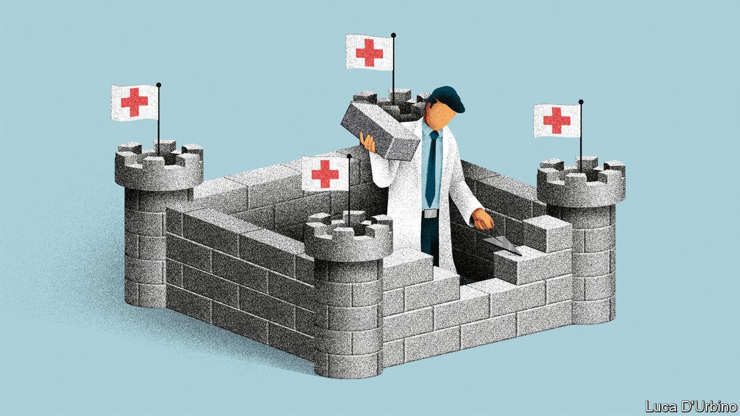

WHEN BORIS JOHNSON addresses the nation about the threat posed by covid-19, he likes to be flanked by a Praetorian Guard of mild-mannered scientific advisers. Chris Whitty, the government’s chief medical adviser, and Sir Patrick Vallance, the chief scientific officer, have become unlikely stars thanks to their calm bedside manner. The prime minister’s aim is to show that the government is following the best available advice—in part to offer reassurance and in part, surely, for insurance if things do not go according to plan.

Over the past few weeks, the advice has mainly been about how to stop the spread of the virus, with Britain taking a more laissez-faire approach than some other countries (see article). More than 27,000 tests have been carried out, with 459 positive results and eight deaths. Attention is now turning to the NHS. International comparisons made before the current threat suggest that Britain is among the best prepared countries for a pandemic, thanks to its testing infrastructure and contingency planning. But some have also pointed to the health system as a relative weak point. In his budget on March 11th, Rishi Sunak announced £5bn ($6.4bn) extra for the health service to help deal with the virus, with more to come if needed. It will have as many “millions…or billions” as it requires, the chancellor assured MPs (see article).

Whether more money will be enough is not yet clear. The NHS is far from the monolithic organisation, caring for people from “cradle to grave”, of popular imagination. In reality, it is an enormously complex network of intertwined and sometimes competing bodies. Yet at times of crisis there are well-established lines of instruction, and hospitals are used to working together. “There are many disadvantages to centrally organising a health-care system for 60m-plus people,” says Helen Buckingham of the Nuffield Trust, a health think-tank. “An advantage is that, when you need to do command-and-control, you can, and you can do it quickly.”

NHS England has established a dedicated team to handle its response to the virus. It is in daily contact with all 223 NHS providers, which range from ambulance to mental-health services, keeping tabs on such things as levels of protective equipment and whether providers have enough space to quarantine those who are infected. An advisory group for emergencies, made up of various experts, provides ministers with a single source of information. Across the country local resilience forums, which include representatives from health services, local authorities, the army and others, meet in peacetime, meaning that connections are already established. “We know each other’s faces, we know each other’s foibles,” says one attendee.

Their task would be easier if the NHS were not already so stretched. In January just 82% of people requiring emergency treatment were seen within four hours, against a target of 95%. A report last year estimated that there were some 100,000 vacancies across the health service. Staff shortages could quickly be exacerbated by covid-19. If schools are closed, lots of workers will have to stay at home to look after children. The government is preparing emergency legislation to protect the employment of those who volunteer to help out. Recently retired medics may be brought back and trainees brought in. The majority of covid-19 patients will be asked to recover at home.

Two areas are of particular concern. Alison Pittard, dean of the Faculty of Intensive Care Medicine, notes that Britain has historically spent relatively little on intensive care. It has fewer beds than other countries in Europe, with just 4,048 in England, of which three-quarters are already full. The NHS hopes vastly to increase capacity. But doing so will require looser rules on staff numbers and lots of new equipment, which there is limited time to buy. “You can’t share a monitor, you can’t share an oxygen pipe,” says Dr Pittard. The other worry among health wonks is social care, which is already running on empty. If lots of carers are unable to work, it will be even more difficult to get people out of hospital. If conditions deteriorate in care homes, there could be more hospitalisations.

Officials hope the health service will be able smoothly to reallocate resources. Most people are not aware of the “degree to which hospital capacity can be flexed pretty significantly,” says Chris Hopson, chief executive of NHS Providers, a membership group. Lots of hospital traffic is either elective surgery, which can be delayed, or people who have had surgery and can be discharged rapidly if necessary, he adds. So far, NHS England has not said when or if it will consider such moves, although it has put in place measures to reduce workload. Health-care leaders have also asked the government to consider whether they might adopt more radical measures, like not allowing those blocking beds a choice of care home, to free up space in a worst-case scenario.

Speaking on March 5th, Dr Whitty, the chief medical officer, said that “depending on how high the peak is, this could be anything from a rather bad winter but in spring and summer...to huge numbers way overtopping the ability of the NHS realistically to put everyone in beds.” Vigorous tracing of those who potentially contracted the virus in its early stages was put in place partly to push the peak back to a time when the NHS is not under typical winter pressure. The weeks and months ahead will push an already stretched health service to its limits. Officials will be praying that their preparations are enough to ensure it is not pushed beyond them. ■

Dig deeper:

* For more coverage of covid-19 see our [coronavirus hub](https://www.economist.com/news/2020/03/11/the-economists-coverage-of-the-coronavirus)
* The science of the virus
* Fatality rates for covid-19 could vary enormously
* How to deal with a new sort of financial shock
* Should other countries copy Italy’s nationwide lockdown?

This article was downloaded by calibre from <https://www.economist.com/britain/2020/03/12/britains-nhs-is-well-suited-to-dealing-with-crises>

|  |  |  |  |
| --- | --- | --- | --- |
|  | Articles | Sections | Next |

|  |  |  |  |
| --- | --- | --- | --- |
| Previous | Articles | Sections | Next |

#### Economic medicine

# Anti-covid-19 measures mask a shift in Britain’s budget strategy

A shock-and-awe response to the virus

Mar 12th 2020 |

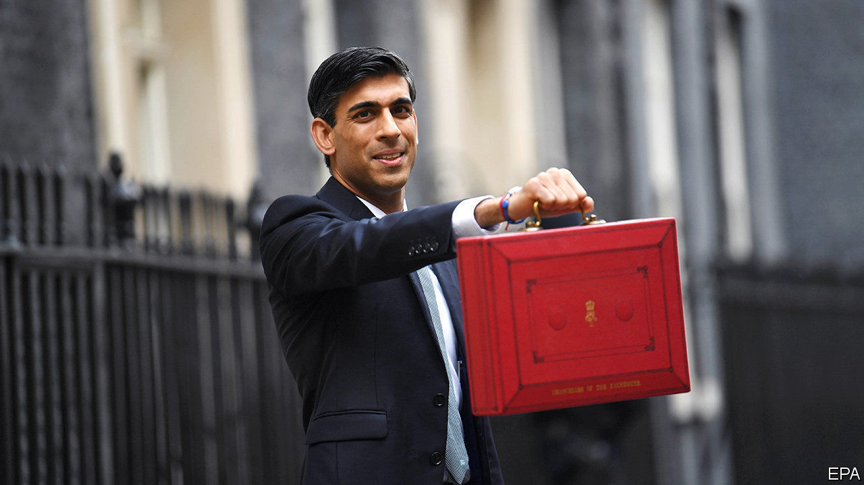

ON MARCH 11TH policymakers took decisive action to inoculate the economy from the effects of covid-19. The Bank of England eased monetary policy. And Rishi Sunak, the chancellor, unveiled the largest sustained fiscal loosening since the early 1990s. He announced a £30bn ($39bn), or 1.3% of GDP, giveaway for the coming year, made up of £12bn of immediate virus-related spending and £18bn of other measures. Fiscal prudence would appear to have been an early casualty of this government—and of the virus.

In his budget speech Mr Sunak noted that one in five workers may be simultaneously absent in the coming weeks, creating a concurrent shock to both supply and demand. He argued that, because the hit to supply was likely to be transitory, the best response was a “temporary, targeted and timely” boost to support demand in the short run and try to stop hard-hit firms going out of business. The mutation of covid-19 from a Chinese crisis into a global one came too recently for it to be reflected in the forecasts of the Office of Budget Responsibility, the fiscal watchdog. So policymakers are, to a greater extent than usual, flying blind.

The bank reduced base rates by 50 basis points back to the post-crisis low of 0.25%, a bigger cut than investors had expected. It also introduced a new facility to give banks access to cheap liquidity to sustain lending for small- and medium-sized businesses and it cut capital requirements. City economists were quick to note that, although interest rates cannot be reduced much further, the bank could still choose to restart its programme of quantitative easing should the outlook darken.

The real action came on the fiscal side. Mr Sunak outlined a three-pronged strategy to cushion the blow from the virus on the public services, on households and on businesses. For the first he essentially wrote a short-term blank cheque, pledging to give the NHS whatever financial resources it required. Some £5bn has been set aside as an emergency-response fund. Support for households will take the form of early entitlement to sick pay for those required to isolate themselves and easier access to welfare payments for the self-employed and those working in the gig economy.

The support for businesses, especially smaller ones, was the most substantial element. The main goal was to ease potential cashflow problems. Firms with fewer than 250 employees will have any statutory sick pay picked up by the government. The “time to pay” scheme, which lets firms restructure tax payments, will be extended. Business rates, a property tax, will be cut to zero for the coming year for most small firms in industries such as retailing, hospitality and leisure. Some 700,000 especially tiny firms eligible for small-business-rate relief will receive a one-off payment of £3,000 to help them manage.

The reaction from the main business lobbies was positive. The British Chambers of Commerce welcomed the chancellor’s efforts to help firms manage their cashflow. Ian Stewart, chief economist of Deloitte, a professional-services firm, hailed the Treasury’s and the bank’s actions as “a forceful and convincing response to the crisis”. According to one corporate restructuring specialist, easier credit conditions and a delayed schedule of tax payments should help to prevent “thousands of insolvencies over the next few months. There are firms that would have gone to the wall that now won’t.”

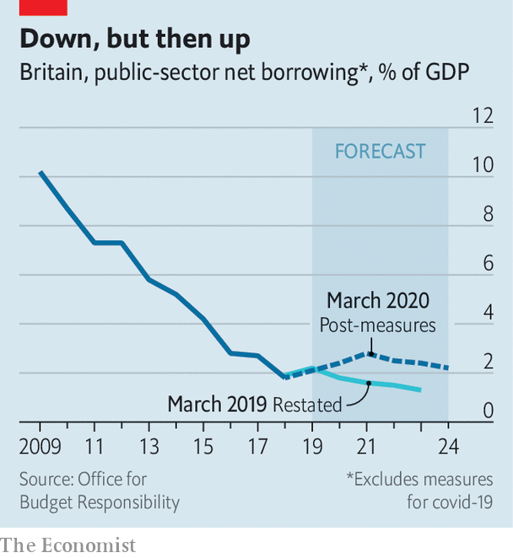

Whether these measures will prove sufficient will depend as much on epidemiology as on economics. The ultimate impact of the virus is still impossible to quantify. But the emergency measures masked a wider shift in the government’s fiscal strategy. Even excluding any covid-19 related economic slowdown, as well as the £12bn response package announced so far, the government is set to borrow significantly more in the next five years than it had previously planned (see chart). The deficits planned in 2019 for the years from 2021 to 2024 have all been revised up by more than 1% of GDP.

For the past decade British fiscal policy has aimed at reducing the ratio of public debt to GDP over the medium term. This target has been quietly dumped in favour of stabilising the debt ratios. Such a long-term shift in policy may ultimately matter more than any emergency medicine.■

Dig deeper:

* For more coverage of covid-19 see our [coronavirus hub](https://www.economist.com/news/2020/03/11/the-economists-coverage-of-the-coronavirus)
* The science of the virus
* Fatality rates for covid-19 could vary enormously
* How to deal with a new sort of financial shock
* Should other countries copy Italy’s nationwide lockdown?

This article was downloaded by calibre from <https://www.economist.com/britain/2020/03/12/anti-covid-19-measures-mask-a-shift-in-britains-budget-strategy>

|  |  |  |  |
| --- | --- | --- | --- |
| Previous | Articles | Sections | Next |

|  |  |  |  |
| --- | --- | --- | --- |
| Previous | Articles | Sections | Next |

#### Sturgeon at bay

# The fallout from Alex Salmond’s trial will damage the SNP

Splits between fundamentalists and gradualists are growing wider

Mar 14th 2020 | EDINBURGH

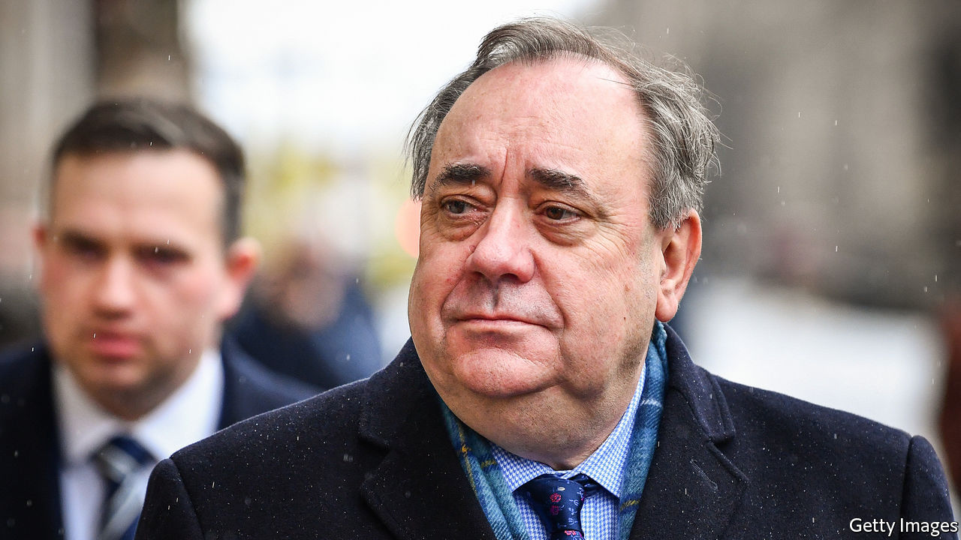

JUST A FEW years ago, in 2014, he came within a whisker of realising his dream of leading Scotland out of the United Kingdom. The former leader of the Scottish National Party, Alex Salmond, transformed the politics of his homeland, dragging the SNP from the fringes to the centre-ground, from where it now dominates elections to both the Westminster and the Edinburgh parliaments. Today, Mr Salmond’s public appearances are from the dock at Edinburgh’s High Court, where he is on trial in a series of sexual-offence charges. The trial, which began on March 9th, is expected to last for four weeks.

Mr Salmond’s relationship with Nicola Sturgeon, his former protégé and successor as both SNP leader and Scotland’s first minister, has been badly damaged by the allegations against him. But in truth the two had been growing apart for some time, with the strategy for how best to achieve independence lying at the heart of their differences. And the division between them now extends right through the party, with members tending to cleave to one side or the other.

As first minister from 2007 to 2014, Mr Salmond backed a slow and steady approach to the question of Scotland’s independence. This culminated in the September 2014 referendum, which he lost by 55-45%. Ms Sturgeon, who took over soon afterwards, has been similarly cautious, rejecting suggestions by some colleagues that she should mount a legal challenge to the right of the British government to decide whether to allow a referendum, or perhaps even (like Catalonia) attempt to call one unilaterally.

But since he stepped down, Mr Salmond has become more radical. And he has wilfully ignored the convention that former bosses should keep their views to themselves and allow their successors freedom to follow their own path. Mr Salmond’s frequent interjections on the question of whether and when a second independence referendum should be held have, at times, undermined Ms Sturgeon. Her patience with her former leader had worn tissue-thin even before his arrest.

Mr Salmond remains a hugely popular figure among many in the party. There are those who would have him back as leader in an instant. Hardliners in the party see him, even now, as the true standard-bearer for the cause of Scottish independence. To such acolytes, Ms Sturgeon seems too cautious, too managerial. She lacks the swagger that was a part of Mr Salmond’s appeal to ordinary Scottish voters.

Historians of Scottish politics say that, until Mr Salmond began his second stint as the party’s leader in 2004, the SNP was perpetually split. On one side were the gradualists, who favoured a cautiously drawn-out campaign for independence. On the other were fundamentalists, who wanted a more swashbuckling approach, including such options as a unilateral declaration of independence.

Mr Salmond’s achievement was to bring these two warring factions together, instilling a discipline that was crucially important for the SNP’s victory in the 2007 Scottish parliamentary election. In effect, he brought the fundamentalists to heel behind a gradualist strategy. But now he has become a figurehead for those who favour a more radical approach.

It is difficult to see how what emerges from the trial in the weeks ahead will help Ms Sturgeon to repair the split. Her reputation may suffer from persistent claims that she mishandled the allegations against Mr Salmond when they first surfaced. And whatever the outcome, she leads a party that now looks more divided than it was when she took it over.■

This article was downloaded by calibre from <https://www.economist.com/britain/2020/03/14/the-fallout-from-alex-salmonds-trial-will-damage-the-snp>

|  |  |  |  |
| --- | --- | --- | --- |
| Previous | Articles | Sections | Next |

|  |  |  |  |
| --- | --- | --- | --- |
| Previous | Articles | Sections | Next |

#### Dun Namin’

# Why Britons’ house names reflect their class anxieties

British houses are often given names like Belle Vue or Dunroamin

Mar 14th 2020 |

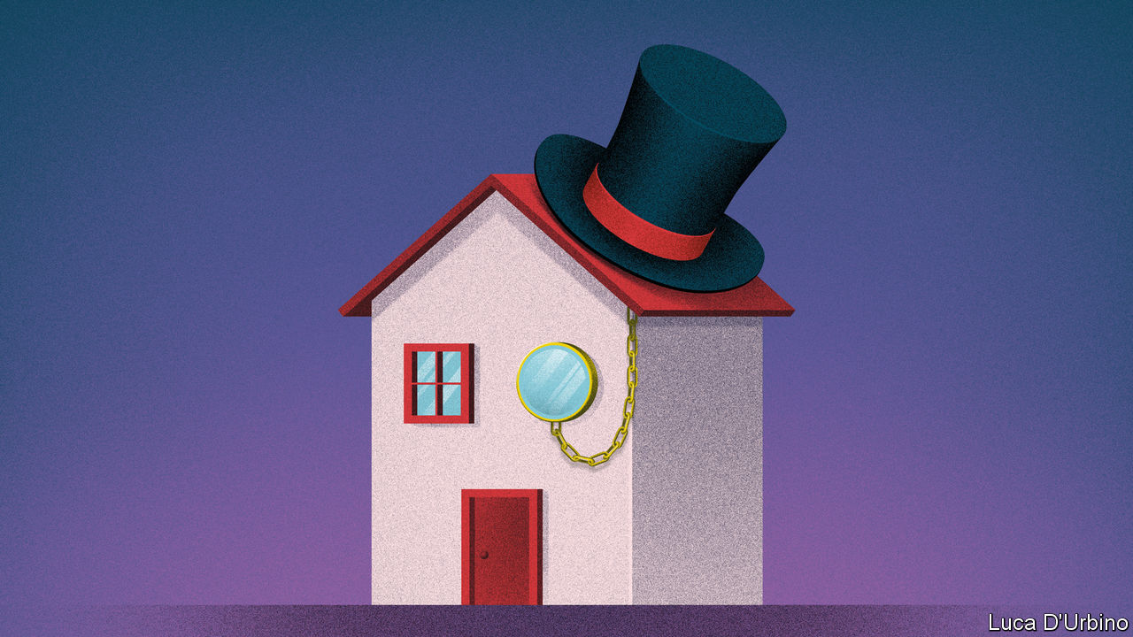

IN GEORGE ORWELL’S “Coming Up For Air” (1939), a novel about a middle-aged, middle-class Englishman bitter about the destruction of good old-fashioned English values, the lead character complains about his area, where the homes are “alike as council houses and generally uglier. The stucco front, the creosoted gate, the privet hedge, the green front door. The Laurels, the Myrtles, the Hawthorns, Mon Abri, Mon Repos, Belle Vue.”

House names in Britain are held in low esteem. They are either sneered at or ignored by current residents, who often prefer numbers. A citation in the Oxford English Dictionary for the word “naff” says “it is naff to call your house The Gables, Mon Repos, or Dunroamin’.” Yet no such embarrassment surrounds smart people’s houses: Buckingham Palace is not 1 The Mall. The reason, argues Laura Wright, a linguist at Cambridge University, in a new book, “Sunnyside: a sociolinguistic history of British house names”, is, as ever, class.

House names were rare until late Victorian times because single-family homes were exceptional. Even a century ago, nine in ten homes were privately rented. A post-war housing boom created hundreds of thousands of homes. By 1939 a quarter of homes were owner-occupied. With the surge in homeowners came a rise in home-namers.

Ms Wright classifies these into five groups: the transferred place name (Hanover Lodge); the nostalgically rural (Orchard House); commemorative (Albert Villa); names linked to nobility (Grosvenor House); and fads (Dunroamin’). All show a striving to talk up the owner’s social standing. A Royal Mail survey in 2015 found 230 homes named Clarence, 133 Sandringhams and 67 Balmorals.

In London, fancy apartment buildings were named So-and-so Court in the early 20th century as a signifier of luxury. That spread to blocks of flats and council-built towers after 1945. Names started by denoting sophistication until they were adopted by enough people to become, well, a bit naff. (Something similar happened with garden gnomes, which Dr Wright says were first installed in Long Island in 1924 to commemorate a visit by the Prince of Wales.)

House names are less common today. Address conventions have been standardised and few people build their own homes. Those that remain are no less imbued with class connotations. In 2017 Savills, an estate agent, saw interest in a new country house grow when its name changed from a “farm” to a “manor”.

This article was downloaded by calibre from <https://www.economist.com/britain/2020/03/14/why-britons-house-names-reflect-their-class-anxieties>

|  |  |  |  |
| --- | --- | --- | --- |
| Previous | Articles | Sections | Next |

|  |  |  |  |
| --- | --- | --- | --- |
| Previous | Articles | Sections | Next |

#### Technology startups

# Britain is ahead of many of its competitors in technology startups

Unicorn lead

Mar 14th 2020 |

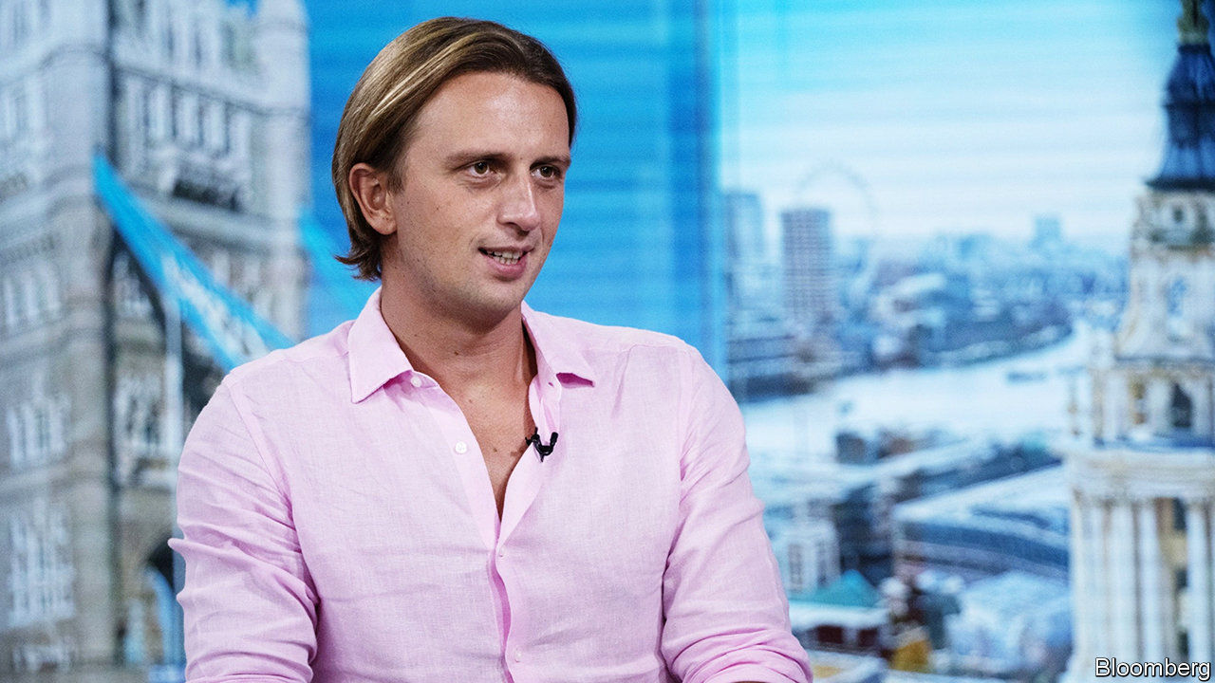

AS A DERIVATIVES trader with Credit Suisse, Nikolay Storonsky was used to gambling, but his riskiest bet was to quit the markets in 2013 and set up Revolut, a fintech startup. It paid off. Last month Revolut raised $500m, becoming Europe’s most highly valued fintech company, with a valuation of $5.5bn.

Revolut’s rise mirrors Britain’s unicorn scene. A unicorn is defined as a privately held startup valued at more than $1bn in a financing round, initial public offering or acquisition. According to Dealroom.co, a data-analytics firm, Britain has created 63 such companies in the past ten years. That is still far behind the giants, America and China, which have added 820 and 224 respectively, but it is more than twice as many as Germany’s 29 and almost five times as many as France’s 13 (see chart).

More interesting than these numbers is a step-change in the rate of growth. Between 2009 and 2013, Britain averaged about two new unicorns a year. Since then the figure has quadrupled. Part of that may be down to overall market optimism in recent years around anything tech-related. But investors may also have worked out how to navigate the “valley of death”, in which promising innovations would either disappear without being commercialised, or end up being swallowed by dragons. That was the fate of DeepMind, an artificial-intelligence startup, when Google bought it in 2014.

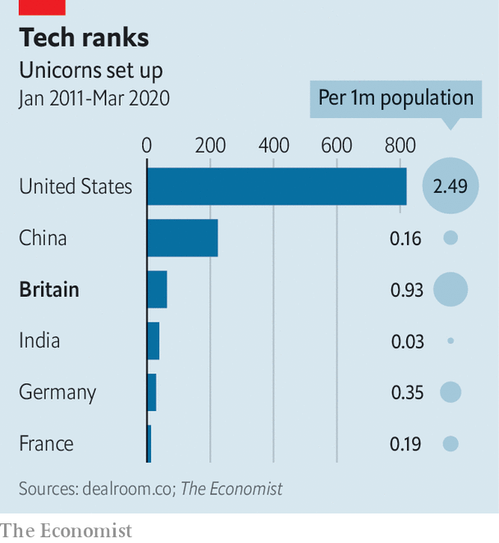

A few British unicorns, such as Graphcore, which designs specialised chips for artificial intelligence, are pure tech companies. But for most, computing is not the product, even if tech is central to the process. Finance, making up nearly a third of Britain’s unicorns, is the biggest sector, with companies like Revolut, Monzo and OakNorth (all upstart banks) and TransferWise (a money-transfer service). Retail, with ten unicorns (such as, Deliveroo and Ocado, which deliver cooked and supermarket food, respectively) and health (such as Oxford Nanopore, a gene-sequencing company) are also success stories. Some, such as BrewDog, a beer-maker, have nothing to do with technology at all.

The financial crisis may have been partly responsible for the uptick in unicorn production, particularly in finance, because it pushed talent out of established City banks and into entrepreneurship. When Zar Amrolia and Alex Gerko, two maths PhDs at Deutsche Bank, realised the bank’s spending on compliance would dwarf that on research, they left. In 2015 they set up XTX markets, an algorithmic foreign-exchange company that is now the first non-bank to make the list of the ten largest currency houses by trading volume. Mr Storonsky decided to give up the trading floor to start Revolut because it “just wasn’t as fun as it used to be”. In 2013 tech overtook finance as the preferred destination of MBA graduates from London Business School.

The government has tried to help as well. David Cameron, prime minister from 2010 to 2016, was keen to increase incentives and cut regulatory burdens for startups. The enterprise investment scheme (EIS), which was introduced in 1994 to give startup investors tax rebates and loss reliefs if investments fail, was extended from companies with fewer than 50 employees to those with fewer than 250, and from investments of £2m ($2.6m) to £10m. A new seed EIS offered larger tax relief for smaller companies. Nick Jenkins, founder of Moonpig, an online greeting-card firm, says the EIS incentives served as a catalyst, getting enough startups going to persuade venture-capital firms to pay attention to what was going on in Britain. In 2019 firms in London received $9.7bn in venture-capital funding, more than Berlin, Paris, Amsterdam and Madrid combined.

It was also Mr Cameron who called the referendum that led to Britain’s decision to leave the European Union. That dismayed many startups, since the EU’s freedom-of-movement rules make it easy to attract workers from across the continent. TechUK, a trade body, has given a cautious welcome to the government’s plans for a new, “points-based” system, announced last month and due to launch next year. Ministers hope it will maintain Britain’s attractiveness to the sorts of skilled workers that startups need. Tech firms also worry that vital data flows between Britain and Europe could be hampered if a trade deal is not negotiated by the end of the year.

There are other clouds on the horizon. Even before the covid-19 outbreak crashed the markets, investors had been cooling on unicorns, many of which have posted persistent losses as they have tried to boost customer numbers. Financial startups in particular could suddenly find life much harder if any of the big incumbent banks can manage to create similarly slick services or apps.

One question is how large British startups can become. In “The Social Network”, a film depicting the rise of Facebook, Sean Parker, Facebook’s first president, tells the site’s founder, Mark Zuckerberg, that “a million dollars isn’t cool—you know what’s cool?” The answer is a billion dollars. That was ten years ago. Today, quite a lot of British unicorns are billion-dollar cool. But America’s and China’s home-grown champions are bigger still (AirBnB, for instance, was valued at $35bn in 2019; Didi Chuxing, a Chinese ride-hailing service, hit $62bn in the same year).

Britain has a long way to go before it can boast of any startups approaching that size. But the past five years have demonstrated that the country can indeed breed unicorns. The next challenge is to turn them into dragons—and to keep other dragons from gobbling them all up.■

This article was downloaded by calibre from <https://www.economist.com/britain/2020/03/14/britain-is-ahead-of-many-of-its-competitors-in-technology-startups>

|  |  |  |  |
| --- | --- | --- | --- |
| Previous | Articles | Sections | Next |

|  |  |  |  |
| --- | --- | --- | --- |
| Previous | Articles | Sections | Next |

#### Watchdogs without bite

# Why Britain’s police commissioners are not living up to their promise

David Cameron hoped “big local figures” would apply to police the police. They haven’t

Mar 14th 2020 |

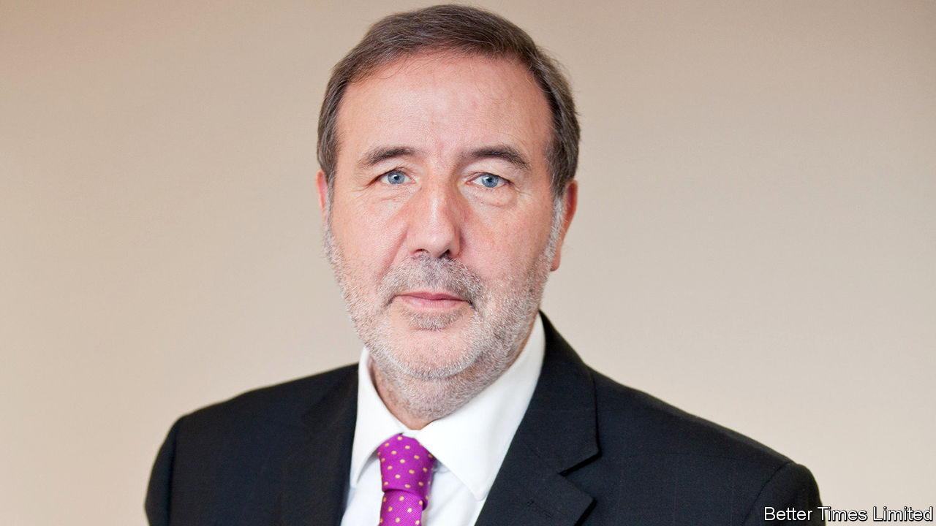

AS EVERY ENGLISH child knows, the Sheriff of Nottingham is always the baddie. His tyrannical rule is tempered only by Robin Hood, with a little help from his band of merry men. These days, Nottinghamshire’s law-and-order supremo is up for election every four years. And Paddy Tipping—properly known as the county’s police and crime commissioner (PCC)—can hardly be said to possess overweening ambition. One of his innovations is a “pension” for police dogs, so that their handlers do not pick up vet’s bills when the mutts are too old to work. “I can’t tell people what to do, by any means,” says the 70-year-old, an ex-Labour MP for Sherwood. “But I can change things.”

That is what David Cameron hoped. The then prime minister introduced PCCs in 2012 as part of his attempt to shake up the police, which he saw as the “last great unreformed public service”. Instead of answering to police authorities (bodies of councillors and other local worthies), the chief constables of most of the 43 police forces in England and Wales would be held to account by a directly elected PCC. The new watchdogs have power to hire and fire chief constables, to write policing plans for the force to follow and to set local taxes to pay for policing. Voters will go to the polls in May to pick a PCC for the third time.

The first generation of PCCs have confounded critics who feared the possible politicisation of policing. To be sure, they have ruffled a few feathers. Lincolnshire’s chief constable was reinstated in 2013 after a court ruling that the PCC’s decision to suspend him had been “irrational and perverse”. But most have struck up good relations with chiefs and recognise that they cannot interfere in police inquiries. “They have kept to strategy and financing,” says Rick Muir of the Police Foundation, a think-tank. “They are not gung-ho, locking people up.”

Two other problems have emerged. The first concerns what they do. Tackling organised crime and “county lines” drug-dealing—city kingpins sending go-betweens to provincial users—requires national co-ordination. Getting 43 chief constables to agree on a strategy was tricky enough, grumbles a senior official. Adding PCCs makes it harder: “These people couldn’t agree on what they’d had for lunch.” Since they are meant to respond to local demands, their priorities are often parochial. There is no electoral incentive to pool resources such as computer systems and specialist surveillance units, points out Harvey Redgrave of Crest Advisory, a criminal-justice consultancy.

The second problem is who they are. Mr Cameron billed the role as a “big job for a big local figure”. He wanted bosses and “pioneers of all sorts” to become PCCs, as well as politicians. Yet only three of the current crop of 40 stood as independents. Most of the rest are stalwarts of Britain’s two dominant political parties. A salary ranging from £65,000 ($84,000) to £100,000 makes for a plum job for those who have spent years delivering party leaflets. The plans they have produced are stuffed with “value-free rhetorical cliches” not analysis of local crime patterns, says a study by John McDaniel of Wolverhampton University. Voters do not appear to find them inspiring. Only 27% of eligible electors cast a ballot in 2016.

The government has promised more power for PCCs. That might help. Elected mayors in London and Manchester act as PCCs, but with more power to co-ordinate initiatives with councils and local health services. A handful of powerful regional mayors might be more effective than diffuse PCCs. And a beefier role might attract a higher calibre of candidate. Two of the current big-city mayors are former ministers; a third is an ex-boss of John Lewis, a big retailer. The answer to a flawed reform may be further reform. ■

This article was downloaded by calibre from <https://www.economist.com/britain/2020/03/14/why-britains-police-commissioners-are-not-living-up-to-their-promise>

|  |  |  |  |
| --- | --- | --- | --- |
| Previous | Articles | Sections | Next |

|  |  |  |  |
| --- | --- | --- | --- |
| Previous | Articles | Sections | Next |

#### Looking for gardeners

# Finding a great gardener can be a challenge in Britain

Green gods

Mar 14th 2020 |



MARCH IS WHEN the clocks change in the northern hemisphere. Spring is sprung, tulip bulbs put forth shoots and garden proprietors think about hiring. Anders Holch Povlsen, a Danish clothing billionaire, is advertising for a head gardener for his Aldourie Estate along the shores of Loch Ness in Scotland. The successful candidate will be in charge of 200 hectares of parkland, including a formal castle garden, an arboretum and a recently planted walled garden with glasshouses. Closing date: March 30th. “It’s all flat-out at the moment,” says Mark Read, a recruitment adviser at English Country Gardeners, “with estate owners realising that spring is around the corner.”

Gardening has never been so popular. The Royal Horticultural Society welcomed its 500,000th member in 2019, the same year that saw the number of jobbing gardeners in Britain grow by more than 5% to 157,000, according to Statista, a business data platform. But finding the right head gardener is a delicate business. One proprietress likens it to trying to recruit a lover and hairdresser in one, calling both for deep professional acumen and exquisite fingers. Many head gardeners are delicate flowers—creative loners who are easily bored. The best are inevitably already employed, but poaching is deeply frowned upon, especially within the same county.

Robert and Nicky Wilson, the owners of Jupiter Artland, a popular contemporary sculpture park outside Edinburgh, changed their job specification completely when they met Thomas Unterdorfer, a gifted Austrian gardener who trained at Kew and spent seven years helping the Keswick family develop the walks and herbaceous borders of their Gloucestershire garden at Rockcliffe. The Wilsons had advertised both for an estate manager and a head gardener. But Mr Unterdorfer knew he did not want an office job, and he worried about losing interest if all he had to do was to maintain an established garden. So the Wilsons created a new position for him: senior head gardener in charge of all Jupiter’s green spaces, which was a challenge on a different scale.

Their adaptability paid off. Mr Unterdorfer created a magnificent green backdrop to the brightly coloured tiled pool that the Wilsons had commissioned from Joana Vasconcelos, a Portuguese artist, which opened last July. Pruned in undulating waves, the 3,000 Portuguese laurels, beeches and boxwoods make an impressive showcase to set off Ms Vasconcelos’s spirited creation (pictured).

Mr Unterdorfer switched jobs for the opportunity rather than for money, he says, though it never pays to be tight if you are trying to recruit a head gardener. One British entrepreneur who wanted to transform his country seat in the Surrey Hills into an oasis of niwaki—Japanese cloud pruning—thought he might economise last year by proposing that his head gardener should do a job-share with a neighbouring family. Within months the man was off, lured by the offer of £50,000 a year and his own cottage. “I’m just too cheap, I now realise,” wails the entrepreneur, who is looking for a new head gardener.

This article was downloaded by calibre from <https://www.economist.com/britain/2020/03/14/finding-a-great-gardener-can-be-a-challenge-in-britain>

|  |  |  |  |
| --- | --- | --- | --- |
| Previous | Articles | Sections | Next |

|  |  |  |  |
| --- | --- | --- | --- |
| Previous | Articles | Sections | Next |

#### Bagehot

# The meaning of conservatism

Nick Timothy offers an answer to a question the government has fumbled: what is it for?

Mar 14th 2020 |

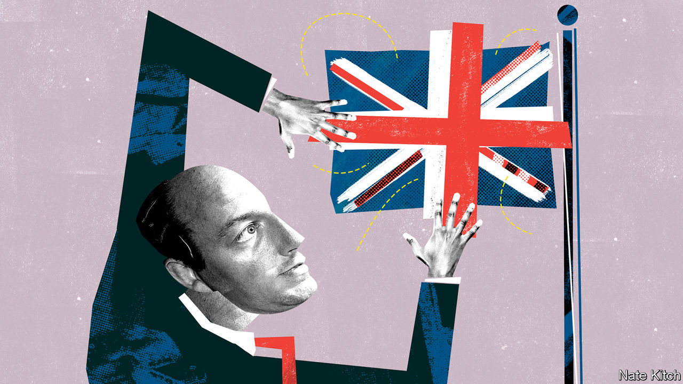

BRITISH CONSERVATISM is in an odd state: politically triumphant but intellectually dazed. A hundred days after the election the Conservative Party is still far ahead of Labour in the polls. But it has not provided a clear sense of what it stands for. Going back to the good old days of blue passports and royal yachts? Perpetual war on the liberal elite? Cutting red tape and unleashing business?

Such confusion is understandable. The Brexit explosion blew apart David Cameron’s post-Thatcherite synthesis of free markets with progressive values. But having been in power since 2010 the party hasn’t had time for a rethink. The default contender to fill the vacuum is the populism that drove the Brexit revolution. Alas, such populism is an unstable mixture of emotions not a coherent philosophy, consisting in part of rage at the liberal elites, in part celebration of the noble savage in the form of the northern working class and in part nostalgia for national greatness. The party has failed to take on the biggest issue it faces: can it cleave to free-market orthodoxy (as it did when allowing the Flybe regional airline to go bust), while still catering to its new voters in the north?

Here Nick Timothy has an advantage. He was at the heart of government for over a decade, first as Theresa May’s adviser at the Home Office and then as her co-chief of staff in Downing Street. He was hurled into the wilderness after the election debacle in 2017 and given plenty of time to think, not least about his own mistakes. These were numerous. He alienated many colleagues with his abrasive management style and he was the principal author of the party’s disastrous manifesto. Yet his “northern strategy” of winning Brexit-inclined Labour voters bore fruit in 2019, suggesting that the problem lay in its execution not its design. His conduct in Downing Street was a model of restraint compared with that of Dominic Cummings, Boris Johnson’s chief adviser. And unlike Mr Cummings, Mr Timothy is a conservative with both a small and a large “c”. His new book, “Remaking One Nation: Conservatism in an Age of Crisis”, provides something that the Johnson government conspicuously lacks: an answer to the question of what conservatism is now for and a blueprint for translating philosophical principles into detailed policy.

Mr Timothy argues that, since the French revolution, the role of conservatism has been to act as a corrective to the extremes of liberalism. Today those extremes come in two forms: neo-liberalism, which sees markets as the solution to all problems, and woke liberalism, which sees the world through the prism of minority rights and all-pervasive oppression. Many see these two liberalisms as polar opposites. But for Mr Timothy they are both degenerate versions of classical liberalism. The first undermines markets by failing to see that they require popular legitimacy and the second sacrifices what is best in liberalism (pluralism, scepticism, individualism) on the altar of group rights.

Mr Timothy presents a dismal picture of the consequences. Bosses have seen their compensation more than quadruple while the value of their companies has hardly risen at all. The largest demographic group—the white working class—has seen incomes stagnate for over a decade. Britain has the highest level of regional inequality in Europe. It also has one of the worst systems of vocational education, with 80 undergraduate degrees awarded for every post-secondary technical qualification. Woke liberals are increasingly willing to no-platform or shout down opponents because they see their objectives as quasi-sacred and their critics not just as wrong-headed folk needing to be reasoned with but as evil-minded enemies who must be destroyed.

Rather than using its power to mitigate inequality the government has directed resources at the country’s most prosperous region. Transport subsidies are twice as high per person in London as elsewhere. London and Oxbridge get almost half of national R&D spending. Far from reviving vocational education, the government has poured money into universities which, as well as failing to defend free speech, load up students with debt at the same time as too often failing to provide them with any significant return on their investment.

## Solutions, solutions

Mr Timothy presents an ideologically eclectic list of solutions to Britain’s problems. They are reminiscent of John Ruskin’s description of himself as both “a violent Tory of the old school” and “the reddest also of the red”. But two ideas give his arguments organising force: the nation-state and civic capitalism. A long-standing Brexiteer, Mr Timothy argues that the nation-state has been uniquely successful in holding global elites accountable to voters while also giving citizens a sense of common purpose. He points out that the welfare state was constructed after the second world war, when the sense of common purpose was at its height. A proud citizen of Birmingham, he champions the sort of civic capitalism practised by Joseph Chamberlain, a local businessman who looked after his workers and went on to be a reforming mayor.

There are problems with Mr Timothy’s argument. He sees the upside of nationalism without the downside, such as the beggar-thy-neighbour policies of the 1930s. He sees the downside of lifestyle liberalism without the upside: two decades ago advocates of gay marriage were self-righteous extremists. But his book should be a jolt of electricity to a moribund debate in the Conservative Party. He makes a powerful case against the libertarian right, which sees Brexit as an excuse to shrink the state and liberalise further. And he presents a blueprint very different from the one that has ruled the right since the 1970s. This is a conservatism which celebrates the power of the state to achieve collective ends by dealing with regional and inter-generational inequalities; which challenges the self-dealing of business elites by rewiring the rules of corporate governance; and which puts a premium on rebuilding local communities and reigniting civic capitalism.■

This article was downloaded by calibre from <https://www.economist.com/britain/2020/03/14/the-meaning-of-conservatism>

|  |  |  |  |
| --- | --- | --- | --- |
| Previous | Articles | Sections | Next |

|  |  |  |
| --- | --- | --- |
| Britain | Sections | Technology ... |

International

Covid-19: All’italiana

.

Deaths from covid-19: Where will it be worst?

.

|  |  |  |
| --- | --- | --- |
| Britain | Sections | Technology ... |

|  |  |  |  |
| --- | --- | --- | --- |
|  | Articles | Sections | Next |

#### All’italiana

# Should other countries copy Italy’s nationwide lockdown?

The government’s response to covid-19 is unprecedented in modern-day Europe

Mar 12th 2020 | ROME AND SEOUL

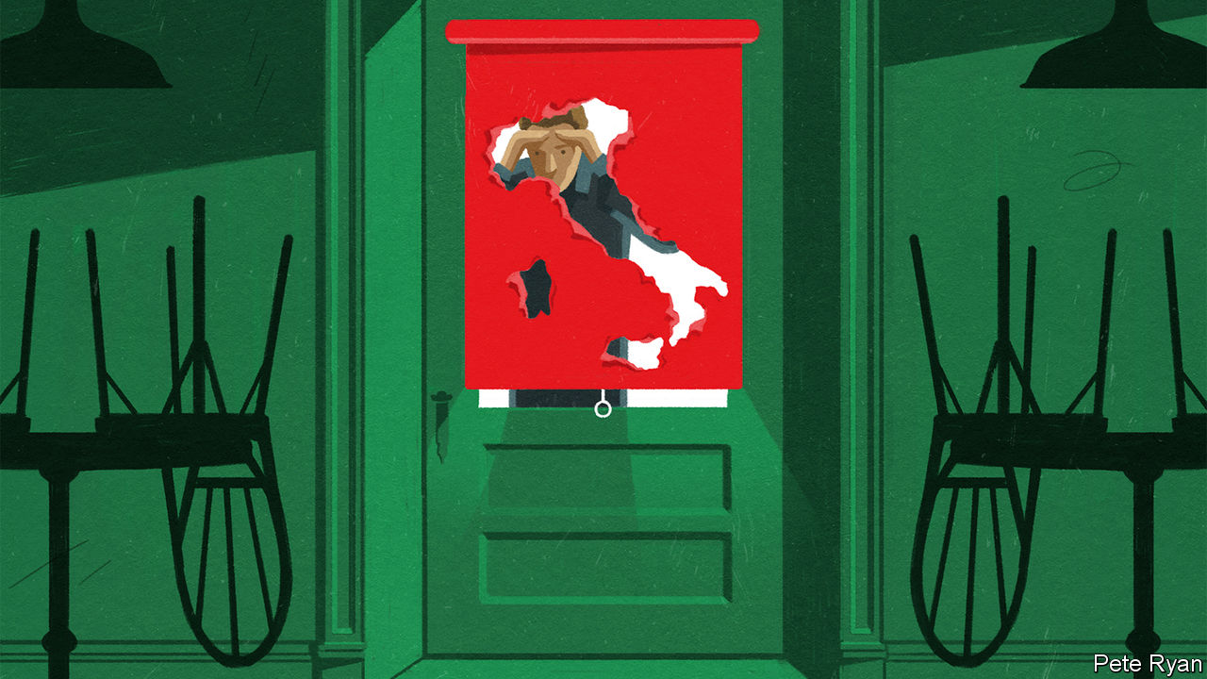

GIOVAMBATTISTA PRESTI, a psychologist at the Kore University of Enna in Sicily, is an adviser to the Policlinico, Milan’s oldest hospital, which is at the centre of Italy’s covid-19 epidemic. Of great concern now, says Mr Presti, is staff burnout. He is particularly worried about post-traumatic stress disorder among some medics. If hospitals reach the point at which they no longer have the capacity to treat every patient, some of them “will be forced to decide who should go into intensive care and who should be left to die”.

Similar accounts are emerging elsewhere. Daniele Macchini is a doctor at the Humanitas Gavazzeni hospital in nearby Bergamo. It has been overwhelmed by covid-19 patients. “Cases are multiplying. We are getting 15-20 admissions a day,” he wrote on Facebook. “The results of the swabs come in one after another: positive, positive, positive. All of a sudden, accident and emergency is collapsing.” Nurses, he added, have been reduced to tears “because we cannot save everyone”.

These reports are coming out of Lombardy, a wealthy region whose health service is judged to be among the best in a country that last year came second in Europe in a health-care efficiency ranking by Bloomberg. On March 10th Antonio Pesenti, the intensive-care co-ordinator for Lombardy’s crisis unit, told journalists that the region’s health system was “one step from collapse”.

Italy’s epidemic, which is still concentrated in Lombardy, spread rapidly. On February 25th the country’s health authorities had detected 322 cases of covid-19. Two weeks later that number had passed 10,000. Deaths have risen even more steeply as the virus, which is disproportionally lethal to the elderly, has attacked Europe’s oldest population. By March 11th, more than 800 of those infected had died.

The crisis in Italy is sending shivers down spines in Europe and America. In many countries the number of cases being detected is rising on a trajectory that will soon bring them to the point at which Italy currently finds itself (see chart). Governments elsewhere are watching to see whether Italy’s efforts slow its epidemic, spreading infections out over time and giving its hospitals some breathing room.

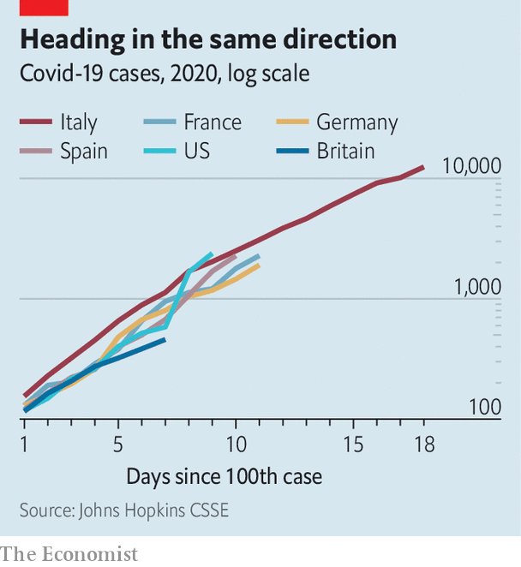

On March 8th the Italian government imposed nationwide curbs on large gatherings. Big weddings and funerals were banned; museums, cinemas and theatres were closed. Nationwide travel restrictions followed a day later. Italians are not allowed to leave—or travel within—the cities and towns where they live, except for work or emergencies. Restaurants, bars and all shops except foodstores and pharmacies were told to close entirely from March 12th. Europe has not seen controls on this scale since the second world war.

Other European countries have, for the moment, opted for less restrictive measures. Like Italy, several countries including France, Spain and Greece have closed schools and universities. Some have banned big public gatherings. In America variations on these themes are being imposed at county or state level. A growing number of universities, including Harvard and Princeton, are switching to remote teaching or simply sending their students home. But if these limitations fail to slow rapidly and substantially the rate at which infections are increasing, Italy may become a role model.

Italy’s national lockdown was prompted by its apparent success using comparable measures on a regional level. The government tested similar restrictions in two “red zones” around a handful of small towns in the northern part of the country where, in late February, it found its first big clusters of covid-19 cases. On March 8th Silvio Brusaferro, the president of Italy’s national public health institute, said the number of new infections in both areas was falling.

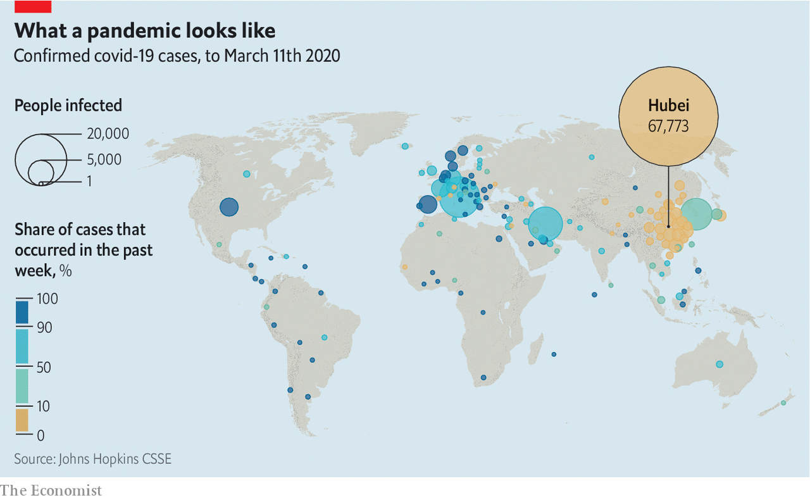

But that is no guarantee the national quarantine will lead to similar results. The efficacy of the shutdown depends on two things: the extent to which people comply with the rules; and the length of time the rules can be left in place, given their vast social and economic costs. For those watching Italy, the crucial question is whether they need to go to similar lengths, or whether a more modest set of restrictions will slow the epidemic.

Italy is following the example set by China, which got a raging covid-19 epidemic in Hubei province under control and prevented outbreaks elsewhere by imposing stringent mass quarantines. Millions have been mostly stuck inside for weeks. In some cities, such as Wuhan, where the outbreak began, people have been prevented from leaving their homes for more than a month. The lockdown has been strictly enforced by neighbourhood committees and building managers, though restrictions are now being loosened as China’s new cases have dwindled. In Italy, by contrast, the implementation of the travel restrictions depends on the public’s co-operation. Authorities and doctors are imploring people to stay at home. But at checkpoints drivers need only show a self-certified form stating their reasons for travelling.

So far Italians seem to be adhering to the new rules. There have been exceptions. A hospital porter who tested positive for the virus and should have been in self-quarantine was found shopping in a supermarket at Sciacca in Sicily. He risks being charged with spreading an epidemic, which carries a maximum penalty of 12 years in jail. People were still gathering in bars and clubs—in at least one case, to watch a football match—before the strictest measures came into effect. But in Caserta near Naples, where a handful of infractions were reported on the first full day of police checks, a senior officer said: “Members of the public are starting to be aware that it’s in the interests of their health to keep their movements to a minimum.”

The extent to which people continue to comply with demands that they keep their distance from friends, colleagues and the general public depends in large part on how long they are required to do so. Social-distancing measures work best when they are put in place early, before an epidemic takes off, says Elias Mossialos from the London School of Economics. In China cities that imposed restrictions on mass gatherings and transport before identifying their first covid-19 case had fewer infections in the first week after that milestone than places that acted later.

In Britain, however, the government is worried about introducing such restrictions too soon. The country, which is at an earlier stage of its covid-19 outbreak than many others, has not yet banned mass gatherings, nor has it closed schools or instructed people to work from home. The scientists advising the government are concerned that if such measures come now, compliance fatigue may set in just as the epidemic is taking off. But tougher restrictions are almost certainly on the way. Sometime in the next two weeks everyone with symptoms of a cold will be asked to stay at home for seven days because at that point many such cases will be assumed to be covid-19 infections.

The experience of South Korea, which has seen one of the largest outbreaks of covid-19, suggests that scientists in Britain may be right to worry. Outside the city of Daegu, where most of the country’s covid-19 cases have been identified, the government has not introduced any mandatory restrictions—hoping instead that people will voluntarily follow advice to stay at home and to take precautions during gatherings that they cannot avoid. In Gyeonggi province, which surrounds Seoul, mourners at funerals have been told to co-operate with temperature checks before writing their names in visitors’ books. They have also been ordered to minimise contact and conversation with others in attendance (including relatives of the deceased). Across the country guests attending weddings must wear masks—as must the happy couples, prompting many to postpone their nuptials.



Restaurants and bars in Seoul were noticeably quieter for a few days during the peak of the government’s official social-distancing campaign, which began in the capital on March 2nd. But that has changed in recent days. Seoul’s popular nightspots are once again seeing long queues forming. Trains are filling up and people are getting laxer about wearing masks. The shift is probably the result of officials saying that, based on a steep fall in new cases in recent days, they hope that the country has passed the peak of its epidemic.

But on March 11th a new cluster of infections was discovered in a call centre in an office building in Seoul that sits next to one of the city’s busiest subway interchanges. The outbreak may prompt people to stay at home once again. And the government may start enforcing its rules more strictly if the voluntary approach proves inadequate. On March 11th Park Won-soon, the mayor of Seoul, said that he may consider forcing call centres to shut down if they do not follow recommendations to keep their employees at a distance from each other.

As countries employ varying intensities of measures to battle their covid-19 epidemics, it should become clearer which work best—and whether the most drastic are the most effective. Gabriel Leung, an epidemiologist from Hong Kong University who was part of a World Health Organisation team that examined China’s efforts to contain its epidemic, says nobody knows yet what combination of controls works best against covid-19. “Do you need to do everything that the Chinese have done to control it?” he says, or is it enough to copy only certain elements. “That”, says Mr Leung, “is really the big question.” ■

Dig deeper:

* For more coverage of covid-19 see our [coronavirus hub](https://www.economist.com/news/2020/03/11/the-economists-coverage-of-the-coronavirus)
* The science of the virus
* Fatality rates for covid-19 could vary enormously
* How to deal with a new sort of financial shock

This article was downloaded by calibre from <https://www.economist.com/international/2020/03/12/should-other-countries-copy-italys-nationwide-lockdown>

|  |  |  |  |
| --- | --- | --- | --- |
|  | Articles | Sections | Next |

|  |  |  |  |
| --- | --- | --- | --- |
| Previous | Articles | Sections | Next |

#### Where will it be worst?

# Fatality rates for covid-19 could vary enormously

It is too soon to know how many will die from covid-19

Mar 12th 2020 |

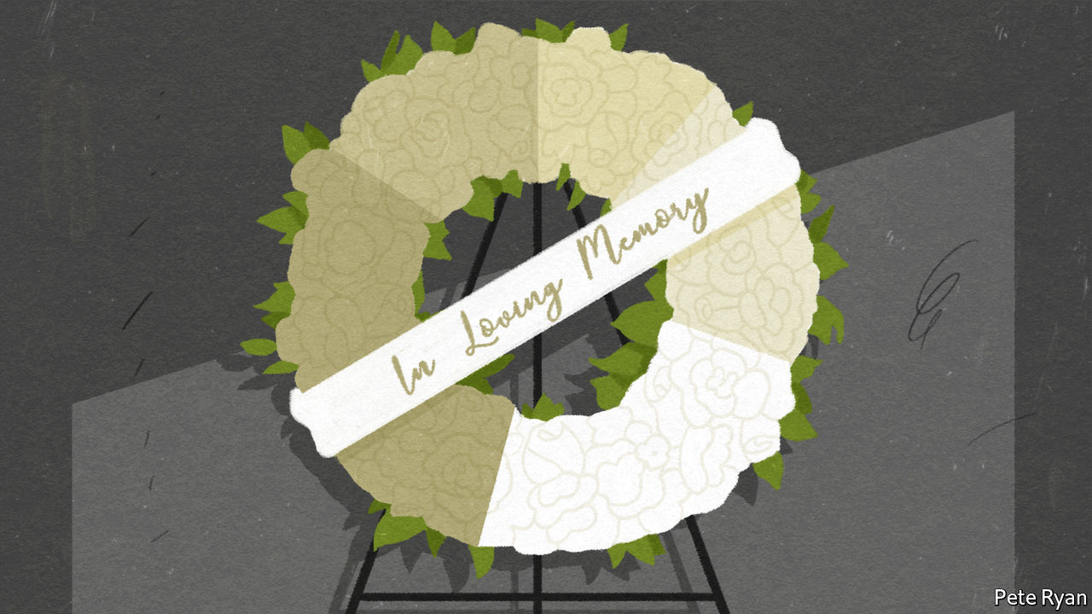

AS THE NUMBER of deaths among people infected by the new coronavirus mounts, it is tempting to divide that figure by the number of reported cases and conclude that the result is the fatality rate. Apply such maths to the world’s total of confirmed cases and deaths on March 11th and you get a fatality rate of 3.6%. But this figure, which epidemiologists call the “naive” case fatality rate, may be wrong in two different ways. First, many of the infections detected at this early stage of the epidemic are recent, so some will eventually result in deaths. That will push the fatality rate up. Second, many infections have not been spotted because testing for the virus has been patchy. Lots of mild cases of the disease have gone unnoticed. If all infections were actually counted, the result would be a bigger denominator. That would push the fatality rate down. As China began to trace infections more carefully, its fatality rate fell (see chart 1).

A conclusive measure of the denominator requires testing for antibodies against the virus in a large sample of people in a place which an outbreak has already swept through. Such studies are under way in China. In the meantime, researchers have estimated the fatality rate for covid-19 using a cohort of people for whom there is a full count of infections and deaths: passengers on the Diamond Princess cruise ship. A bungled quarantine on board led to nearly 700 cases of covid-19. Eight people have died so far. A working paper published on March 5th by Timothy Russell at the London School of Hygiene and Tropical Medicine and an international team of researchers estimates that the fatality rate among infected passengers will end up being 1.2%.

The researchers applied the results from the ship to data on covid-19 cases and deaths in China. They conclude that the fatality rate for covid-19 in the country’s outbreak was 0.5%. For comparison, that is five times the fatality rate for the seasonal flu in America.

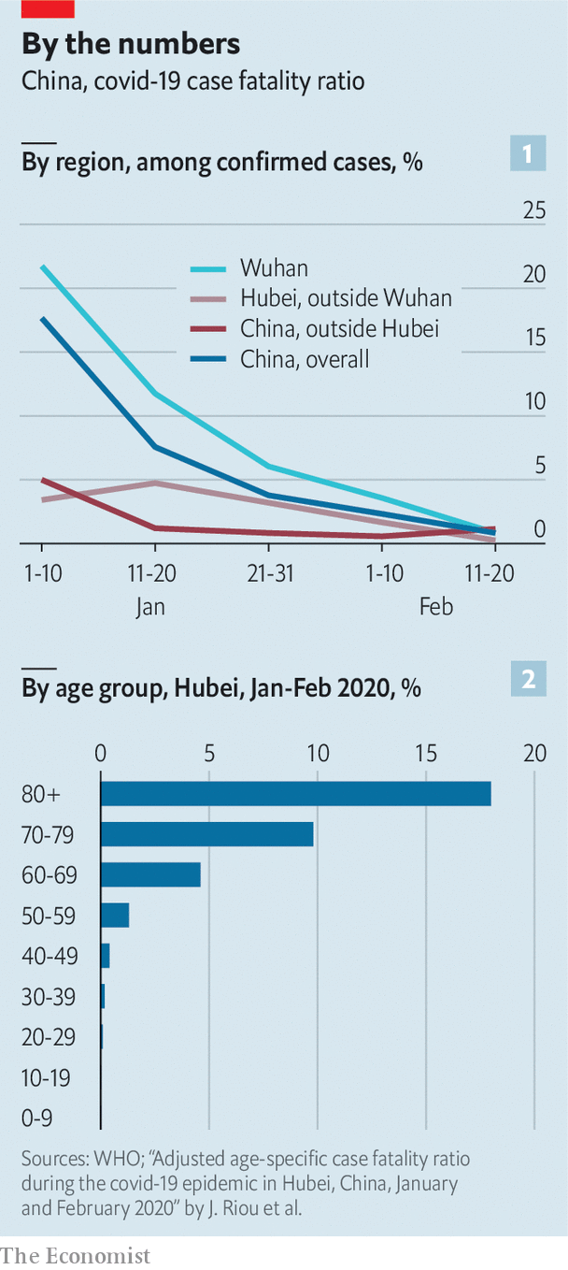

The covid-19 fatality rate among those on the Diamond Princess was higher partly because their average age was 58, older than the general population in any country. At the same time, they are probably in fairly good shape. They must be healthy enough to embark on an extended holiday. People who go on cruises tend to be richer. So the fatality rate among these passengers may be lower than it would be among people of a similar age in their home countries.

A recent study by researchers at the University of Bern, in Switzerland, sheds more light. It provides estimates of covid-19 fatality by age group in Hubei, the province in China with the worst outbreak of the disease (see chart 2). Fatality is dramatically higher among people older than 60, rising to 18% among those in their 80s or older.

But covid-19 may prove no less devastating for poor countries, which tend to have younger populations. The disease is more severe in people whose immune systems are weakened by chronic diseases, so those who are malnourished or have HIV/AIDS will probably be hit hard.

The fatality rate in any country will depend primarily on the quality of care it can provide—and how many people have access to it. About 5% of people diagnosed with covid-19 in China have needed intensive care, which is in short supply or non-existent in most hospitals in developing countries. A surge in cases even in rich countries can soon overwhelm hospitals and result in higher fatality rates. ■

Dig deeper:

* For more coverage of covid-19 see our [coronavirus hub](https://www.economist.com/news/2020/03/11/the-economists-coverage-of-the-coronavirus)
* The science of the virus
* How to deal with a new sort of financial shock
* Should other countries copy Italy’s nationwide lockdown?

This article was downloaded by calibre from <https://www.economist.com/international/2020/03/12/fatality-rates-for-covid-19-could-vary-enormously>

|  |  |  |  |
| --- | --- | --- | --- |
| Previous | Articles | Sections | Next |

|  |  |  |
| --- | --- | --- |
| International | Sections | Business |

Technology Quarterly

Personalised medicine: Populations of one

.

The human genome project: Welcome to you

.

Genes and treatment: Side-effects include death

.

Congenital disease: Broken

.

The pharmaceutical industry: Kill or cure?

.

The sum of all lives: The coming of the datome

.

|  |  |  |
| --- | --- | --- |
| International | Sections | Business |

|  |  |  |  |
| --- | --- | --- | --- |
|  | Articles | Sections | Next |

#### Personalised medicine

# Medicine is getting to grips with individuality

Their genes, environments and activities all make people different

Mar 12th 2020 |

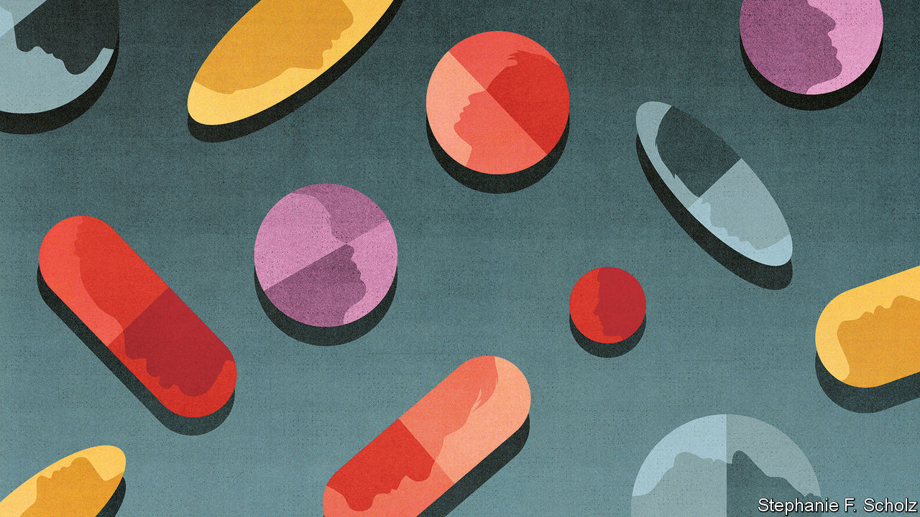

NEENA NIZAR is 42 years old, a professor of business studies and just 122cm tall. The ends of her bones are soft and pliable: on an x-ray they look frayed, like old paintbrushes. During her childhood and adolescence in Dubai she was operated on 30 times. The source of her problem remained a mystery. In 2010, after three decades of wondering, she finally received a diagnosis: Jansen’s Metaphyseal Chondrodysplasia, a condition first recognised in the 1930s. Her problems stem from a broken copy of just one of her 20,000 genes.

Dr Nizar is in some ways very unusual. Fewer than one in 200m people have the mutation to the PTH1R gene that causes Jansen’s disease. In other ways she is like everyone else. Although few people have a defect as debilitating, everyone’s health, and ill-health, is tied to the contents of their genomes. All genomes contain arrangements of genes that make psychological disorders, cancers, dementias or circulatory diseases either more of a problem or less of one. Everyone has genes that make them better or worse at metabolising drugs, more or less likely to benefit from specific forms of exercise, better able to digest some foods than others.

The same arrangement will never be seen twice. Though for identical twins the differences are the height of subtlety, each of the 7.5bn human genomes sharing the planet is unique. That irreducible diversity represents a challenge to many of the 20th century’s greatest medical advances, which were based on a one-size-fits-all approach. Personalising medicine is an enticing opportunity for improvement.

Good doctors have always treated their patients as individuals. In the 20th century blood tests, X-rays, body scans and other diagnostic tools made the specifics of each patient’s particular problems ever more visible. A spectacular reduction in the cost of reading, or sequencing, the DNA “bases” that make up human genetic information is adding a new level of individuality. It is now possible to inspect genetic differences with an ease previously unimaginable, and thus to know something about propensities to disease well before any symptoms show up.

Nobody knows exactly how many human genomes have been fully sequenced, and different sequencing procedures read the genome to different degrees—there are quick skims and painstaking philological studies. But the number is in the millions (see chart). By the 2030s genome sequencing is likely to be as routine in some places as taking a pin-prick of blood from a baby’s heel is today—it may even be part of the same procedure. Genome science is becoming a matter of practical medicine. New therapies that make it possible to adjust or edit this genetic inheritance are coming to market.

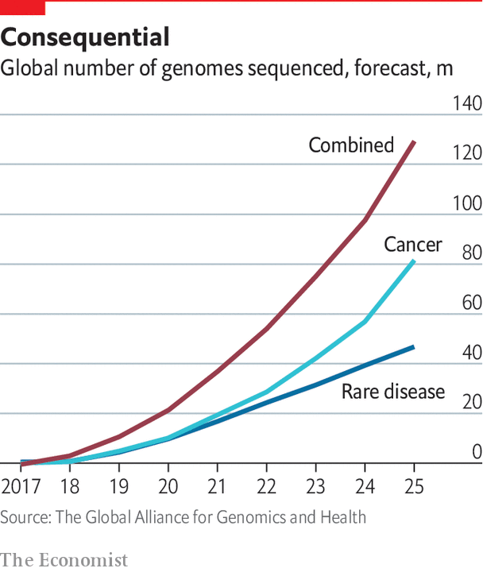

This flood of data is allowing medicine to become more precise and more personal—in many ways, the p-words are two sides of the same coin. Previously recognised genetic diseases, such as Jansen’s, have been traced to specific genes and can be connected to defects in the proteins they create (almost all genes describe proteins, and proteins do almost all the body’s chemical work). Most of these diseases are rare, in that they typically affect no more than one person in 2,000 in the general population. But with over 6,000 such rare diseases now recognised, this means they are common in the aggregate. In Britain one in 17 people can expect to suffer from a rare disease at some point.

Studies of genetic diseases are not just a worthwhile end in themselves. Understanding what goes wrong when a specific protein is out of whack can reveal basic information about the body’s workings that may be helpful for treating other ailments. And the growing understanding of how large sets of genes may contribute to disease is making it possible to pick out the patients most at risk from common diseases like diabetes, heart conditions and cancer. That will help doctors personalise their interventions. In theory, the rise in access to personal genetic information allows individuals to better calculate these risks and to take pre-emptive action. In practice, so far, few people seem to do so.

Genomics is not the only source of new personal-health data. Just as all genomes are unique, so are the lives that all those genome-carriers lead. The increase in other forms of data about individuals, whether in other molecular information from medical tests, electronic health records, or digital data recorded by cheap, ubiquitous sensors, makes what goes on in those lives ever easier to capture. The rise of artificial intelligence and cloud computing is making it possible to analyse this torrent of data.

Almost 4bn people carry smartphones that can monitor physical activity. It is estimated that by 2022, 1bn people may be wearing a device such as a smart watch that can monitor their heart rate. The data-driven giants and startups of Silicon Valley are eager to help. Consumers no longer need to go to a doctor for a genome scan or to engage with a wide range of opinion about what ails them, or will ail them. The pharmaceutical companies used to dominating medicine are working hard to keep up. So are doctors, hospitals and health systems.

## Move freely, but don’t break things

These possibilities are not without their risks, drawbacks and potential for disappointment. The ability to pinpoint what has gone wrong in a genome does not make it easy to fix. Moreover, as technology helps people monitor themselves in more ways, the number of the “worried well” will swell and unnecessary care will grow. Many could be done real harm by an algorithmic mirage.

Beyond this, the “move fast and break things” attitude common in tech companies sits uneasily with “first, do no harm”. And the untrammelled, unsupervised and unaccountable means of data accrual seen in other industries which have undergone digital transformations sits uneasily with concerns over medical privacy.

The very nature of medicine, though, means that the future will not just be a matter of business goals, research cultures, technological prowess, wise practice and well-crafted regulations. It will also be subject to the driving interests of particular individuals in ways never seen before. The development of gene-based medical research in Britain was deeply affected by the short, difficult life of Ivan Cameron, whose father, David Cameron, did much to build up genomics when he was prime minister. Many of those working in this field are impelled by personal loss.

And then there are those whose interests stem from the way in which their own genes shape their lives. People like Dr Nizar, who is now crafting a new research agenda for Jansen’s disease. There may only be 30 people in the world who suffer from it. But two of them are her children, and they are in ceaseless pain. Science knows why; medicine cannot yet help. “We believe in miracles,” she says. She is also working to make one happen. ■

This article was downloaded by calibre from <https://www.economist.com/technology-quarterly/2020/03/12/medicine-is-getting-to-grips-with-individuality>

|  |  |  |  |
| --- | --- | --- | --- |
|  | Articles | Sections | Next |

|  |  |  |  |
| --- | --- | --- | --- |
| Previous | Articles | Sections | Next |

#### The human genome project

# Genomics took a long time to fulfil its promise

Getting really cheap helped

Mar 12th 2020 |

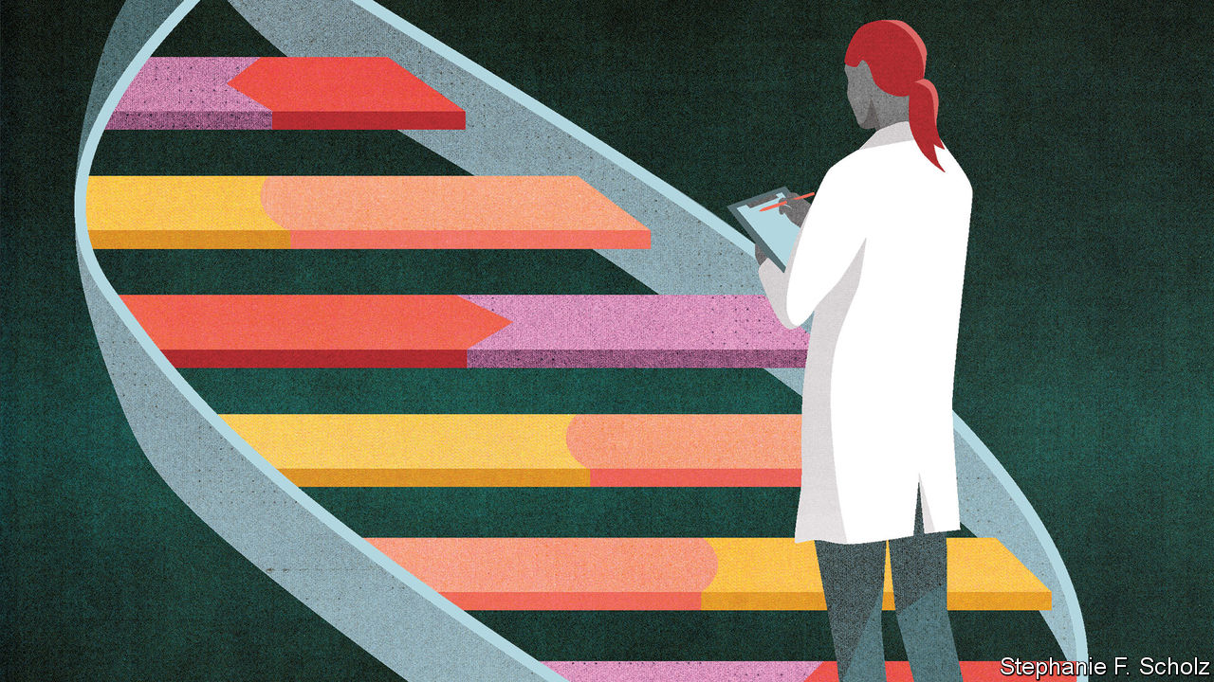

THE ATOMIC bomb convinced politicians that physics, though not readily comprehensible, was important, and that physicists should be given free rein. In the post-war years, particle accelerators grew from the size of squash courts to the size of cities, particle detectors from the scale of the table top to that of the family home. Many scientists in other disciplines looked askance at the money devoted to this “big science” and the vast, impersonal collaborations that it brought into being. Some looked on in envy. Some made plans.

The idea that sequencing the whole human genome might provide biology with some big science of its own first began to take root in the 1980s. In 1990 the Human Genome Project was officially launched, quickly growing into a global endeavour. Like other fields of big science it developed what one of the programme’s leaders, the late John Sulston, called a “tradition of hyperbole”. The genome was Everest; it was the Apollo programme; it was the ultimate answer to that Delphic injunction, “know thyself”. And it was also, in prospect, a cornucopia of new knowledge, new understanding and new therapies.

By the time the completion of a (rather scrappy) draft sequence was announced at the White House in 2000, even the politicians were drinking the Kool-Aid. Tony Blair said it was the greatest breakthrough since antibiotics. Bill Clinton said it would “revolutionise the diagnosis, prevention and treatment of most, if not all, human diseases. In coming years, doctors increasingly will be able to cure diseases like Alzheimer’s, Parkinson’s, diabetes and cancer by attacking their genetic roots.”

Such hype was always going to be hard to live up to, and for a long time the genome project failed comprehensively, prompting a certain Schadenfreude among those who had wanted biology kept small. The role of genetics in the assessment of people’s medical futures continued to be largely limited to testing for specific defects, such as the BRCA1 and BRCA2 mutations which, in the early 1990s, had been found to be responsible for some of the breast cancers that run in families.

To understand the lengthy gap between the promise and the reality of genomics, it is important to get a sense of what a genome really is. Although sequencing is related to an older technique of genetic analysis called mapping, it produces something much more appropriate to the White House kitchens than to the Map Room: a recipe. The genes strung out along the genome’s chromosomes—big molecules of DNA, carefully packed—are descriptions of life’s key ingredients: proteins. Between the genes proper are instructions as to how those ingredients should be used.

If every gene came in only one version, then that first human genome would have been a perfect recipe for a person. But genes come in many varieties—just as chilies, or olive oils, or tinned anchovies do. Some genetic changes which are simple misprints in the ingredient’s specification are bad in and of themselves—just as a meal prepared with “fuel oil” instead of “olive oil” would be inedible. Others are problematic only in the context of how the whole dish is put together.

The most notorious of the genes with obvious impacts on health were already known before the genome was sequenced. Thus there were already tests for cystic fibrosis and Huntington’s disease. The role of genes in common diseases turned out to be a lot more involved than many had naively assumed. This made genomics harder to turn into useful insight.

Take diabetes. In 2006 Francis Collins, then head of genome research at America’s National Institutes of Health, argued that there were more genes involved in diabetes than people thought. Medicine then recognised three such genes. Dr Collins thought there might be 12. Today the number of genes with known associations to type-2 diabetes stands at 94. Some of these genes have variants that increase a person’s risk of the disease, others have variants that lower that risk. Most have roles in various other processes. None, on its own, amounts to a huge amount of risk. Taken together, though, they can be quite predictive—which is why there is now an over-the-counter genetic test that measures people’s chances of developing the condition.

In the past few years, confidence in science’s ability to detect and quantify such genome-wide patterns of susceptibility has increased to the extent that they are being used as the basis for something known as a “polygenic risk score” (PRS). These are quite unlike the genetic tests people are used to. Those single-gene tests have a lot of predictive value: a person who has the Huntington’s gene will get Huntington’s; women with a dangerous BRCA1 mutation have an almost-two-in-three chance of breast cancer (unless they opt for a pre-emptive mastectomy). But the damaging variations they reveal are rare. The vast majority of the women who get breast cancer do not have BRCA mutations. Looking for the rare dangerous defects will reveal nothing about the other, subtler but still possibly relevant genetic traits those women do have.

Polygenic risk scores can be applied to everyone. They tell anyone how much more or less likely they are, on average, to develop a genetically linked condition. A recently developed PRS for a specific form of breast cancer looks at 313 different ways that genomes vary; those with the highest scores are four times more likely to develop the cancer than the average. In 2018 researchers developed a PRS for coronary heart disease that could identify about one in 12 people as being at significantly greater risk of a heart attack because of their genes.

## Hop, SNP and jump

Some argue that these scores are now reliable enough to bring into the clinic, something that would make it possible to target screening, smoking cessation, behavioural support and medications. However, hope that knowing their risk scores might drive people towards healthier lifestyles has not, so far, been validated by research; indeed, so far things look disappointing in that respect.

Assigning a PRS does not require sequencing a subject’s whole genome. One just needs to look for a set of specific little markers in it, called SNPs. Over 70,000 such markers have now been associated with diseases in one way or another. But if sequencing someone’s genome is not necessary in order to inspect their SNPs, understanding what the SNPs are saying in the first place requires that a lot of people be sequenced. Turning patterns discovered in the SNPs into the basis of risk scores requires yet more, because you need to see the variations in a wide range of people representative of the genetic diversity of the population as a whole. At the moment people of white European heritage are often over-represented in samples.

The first genome cost, by some estimates, $3bn

The need for masses of genetic information from many, many human genomes is one of the main reasons why genomic medicine has taken off rather slowly. Over the course of the Human Genome Project, and for the years that followed, the cost of sequencing a genome fell quickly—as quickly as the fall in the cost of computing power expressed through Moore’s law. But it was falling from a great height: the first genome cost, by some estimates, $3bn. The gap between getting cheaper quickly and being cheap enough to sequence lots of genomes looked enormous.

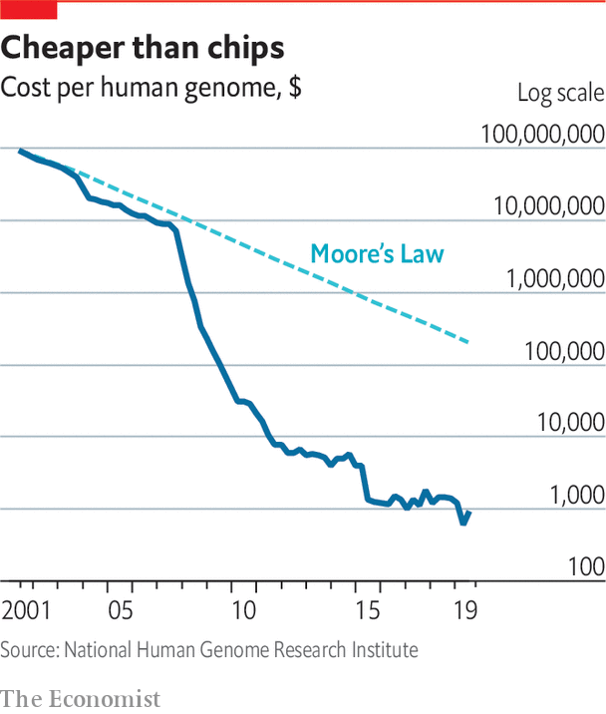

In the late 2000s, though, fundamentally new types of sequencing technology became available and costs dropped suddenly (see chart). As a result, the amount of data that big genome centres could produce grew dramatically. Consider John Sulston’s home base, the Wellcome Sanger Institute outside Cambridge, England. It provided more sequence data to the Human Genome Project than any other laboratory; at the time of its 20th anniversary, in 2012, it had produced, all told, almost 1m gigabytes—one petabyte—of genome data. By 2019, it was producing that same amount every 35 days. Nor is such speed the preserve of big-data factories. It is now possible to produce billions of letters of sequence in an hour or two using a device that could easily be mistaken for a chunky thumb drive, and which plugs into a laptop in the same way. A sequence as long as a human genome is a few hours work.

As a result, thousands, then tens of thousands and then hundreds of thousands of genomes were sequenced in labs around the world. In 2012 David Cameron, the British prime minister, created Genomics England, a firm owned by the government, and tasked initially with sequencing 100,000 genomes and integrating sequencing, analysis and reporting into the National Health Service. By the end of 2018 it had finished the 100,000th genome. It is now aiming to sequence five million. China’s 100,000 genome effort started in 2017. The following year saw large-scale projects in Australia, America and Turkey. Dubai has said it will sequence all of its three million residents. Regeneron, a pharma firm, is working with Geisinger, a health-care provider, to analyse the genomes of 250,000 American patients. An international syndicate of investors from America, China, Ireland and Singapore is backing a €365m ($405m) project to sequence about 10% of the Irish population in search of disease genes.

Genes are not everything. Controls on their expression—epigentics, in the jargon—and the effects of the environment need to be considered, too; the kitchen can have a distinctive effect on the way a recipe turns out. That is why “biobanks” are being funded by governments in Britain, America, China, Finland, Canada, Austria and Qatar. Their stores of frozen tissue samples, all carefully matched to clinical information about the person they came from, allow study both by sequencing and by other techniques. Researchers are keen to know what factors complicate the lines science draws from genes to clinical events.

## It’s in the post

Today various companies will sequence a genome commercially for $600-$700. Sequencing firms such as Illumina, Oxford Nanopore and China’s BGI are competing to bring the cost down to $100. In the meantime, consumer-genomics firms will currently search out potentially interesting SNPs for between $100 and $200. Send off for a home-testing kit from 23andMe, which has been in business since 2006, and you will get a colourful box with friendly letters on the front saying “Welcome to You”. Spit in a test tube, send it back to the company and you will get inferences as to your ancestry and an assessment of various health traits. The health report will give you information about your predisposition to diabetes, macular degeneration and various other ailments. Other companies offer similar services.

Plenty of doctors and health professionals are understandably sceptical. Beyond the fact that many gene-testing websites are downright scams that offer bogus testing for intelligence, sporting ability or wine preference, the medical profession feels that people are not well equipped to understand the results of such tests, or to deal with their consequences.

An embarrassing example was provided last year by Matt Hancock, Britain’s health minister. In an effort to highlight the advantages of genetic tests, he revealed that one had shown him to be at heightened risk of prostate cancer, leading him to get checked out by his doctor. The test had not been carried out by Britain’s world-class clinical genomics services but by a private company; critics argued that Mr Hancock had misinterpreted the results and consequently wasted his doctor’s time.

23andMe laid off 14% of its staff in January

He would not be the first. In one case, documented in America, third-party analysis of genomic data obtained through a website convinced a woman that her 12-year-old daughter had a rare genetic disease; the girl was subjected to a battery of tests, consultations with seven cardiologists, two gynaecologists and an ophthalmologist and six emergency hospital visits, despite no clinical signs of disease and a negative result from a genetic test done by a doctor.

At present, because of privacy concerns, the fortunes of these direct-to-consumer companies are not looking great. 23andMe laid off 14% of its staff in January; Veritas, which pioneered the cheap sequencing of customers’ whole genomes, stopped operating in America last year. But as health records become electronic, and health advice becomes more personalised, having validated PRS scores for diabetes or cardiovascular disease could become more useful. The Type 2 diabetes report which 23andMe recently launched looks at over 1,000 SNPs. It uses a PRS based on data from more than 2.5m customers who have opted to contribute to the firm’s research base.

As yet, there is no compelling reason for most individuals to have their genome sequenced. If genetic insights are required, those which can be gleaned from SNP-based tests are sufficient for most purposes. Eventually, though, the increasing number of useful genetic tests may well make genome sequencing worthwhile. If your sequence is on file, many tests become simple computer searches (though not all: tests looking at the wear and tear the genome suffers over the course of a lifetime, which is important in diseases like cancer, only make sense after the damage is done). If PRSs and similar tests come to be seen as valuable, having a digital copy of your genome at hand to run them on might make sense.

Some wonder whether the right time and place to do this is at birth. In developed countries it is routine to take a pinprick of blood from the heel of a newborn baby and test it for a variety of diseases so that, if necessary, treatment can start quickly. That includes tests for sickle-cell disease, cystic fibrosis, phenylketonuria (a condition in which the body cannot break down phenylalanine, an amino acid). Some hospitals in America have already started offering to sequence a newborn’s genome.

Sequencing could pick up hundreds, or thousands, of rare genetic conditions. Mark Caulfield, chief scientist at Genomics England, says that one in 260 live births could have a rare condition that would not be spotted now but could be detected with a whole-genome sequence. Some worry, though, that it would also send children and parents out of the hospital with a burden of knowledge they might be better off without—especially if they conclude, incorrectly, that genetic risks are fixed and predestined. If there is unavoidable suffering in your child’s future do you want to know? Do you want to tell them? If a child has inherited a worrying genetic trait, should you see if you have it yourself—or if your partner has? The ultimate answer to the commandment “know thyself” may not always be a happy one.■

This article was downloaded by calibre from <https://www.economist.com/technology-quarterly/2020/03/12/genomics-took-a-long-time-to-fulfil-its-promise>

|  |  |  |  |
| --- | --- | --- | --- |
| Previous | Articles | Sections | Next |

|  |  |  |  |
| --- | --- | --- | --- |
| Previous | Articles | Sections | Next |

#### Genes and treatment

# Pharmacogenomics can show what your body makes of a drug

That provides safer, more effective prescriptions

Mar 14th 2020 |

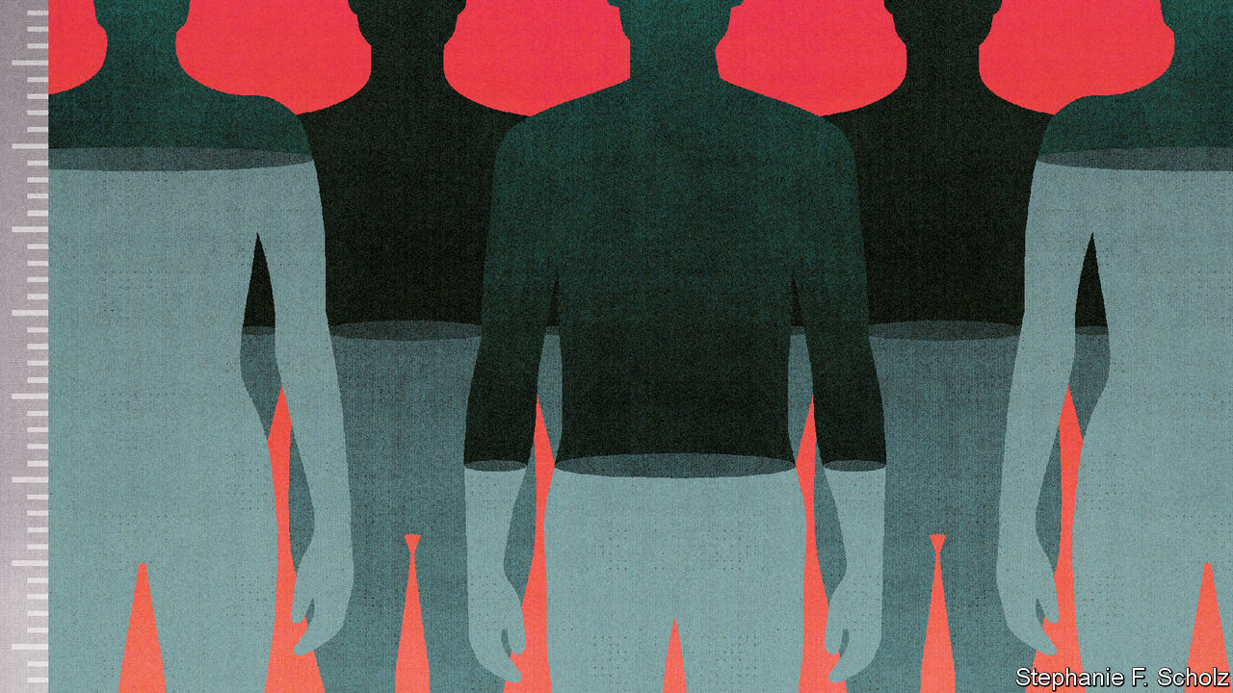

DOCTORS HAVE long appreciated that the same dose of medicine will not necessarily have the same effect on different patients. Today they are able to predict how patients will respond to hundreds of drugs. One of the ways in which people differ biologically is in how they metabolise drugs, a process largely dependent on enzymes in the liver that can vary a lot from person to person, and which are genetically determined. Differences in enzymes can lead two patients with the same disease, and the same treatment, to end up with a five-fold difference in the amount of working drug molecules in their blood.

Sometimes such differences will mean that the drug is not circulating at a high enough level to work. Sometimes it is circulating at too high a level and causing toxic side-effects. Though side-effects sound peripheral they are a huge medical problem. In Britain 6.5% of hospital admissions are related to adverse drug reactions.

The study of how genes affect an individual’s response to drugs is known as pharmacogenetics, and it is flourishing. The NHS in Britain is looking at applying pharmacogenetic tests to the treatment of 65 different medical conditions within the next few years.

One example of the technique’s potential is found with warfarin, a commonly used blood thinner that has what doctors call a “narrow therapeutic window”: the distance between a level in the blood too low to do good and a level too high for safety is small. Variations in an enzyme gene called CYP2C9, which allow warfarin to stay in the blood for longer, are quite common in white Europeans and Americans. This makes it harder to find the best therapeutic dose and increases the likelihood of adverse effects such as bleeding on the brain. Complications with warfarin cause about one-third of emergency hospital visits for older Americans.

Part of the problem with warfarin is that for a long time there was no real substitute, so it was used despite its drawbacks. The various selective serotonin-reuptake inhibitors used to treat depression offer a different challenge. Both their effectiveness and their side-effects are influenced by enzymes produced in the liver. A test produced by Myriad, a genetic-testing company, makes it possible to look at the genes for such enzymes before an antidepressant is prescribed and appears to limit side-effects and improve clinical outcomes.

In chemotherapy, too, genetics can guide the choice of treatment in ways that other indicators cannot. That matters since the drugs are so powerful. Some are so toxic that four patients in 100 will die from treatment, says David Kerr, a professor at Oxford University. Keith Gadd, an English farmer, died five weeks after a successful operation to remove a tumour from his bowel, because he was unable to metabolise the chemotherapy he had been given to lower the risk of his cancer returning.

This article was downloaded by calibre from <https://www.economist.com/technology-quarterly/2020/03/14/pharmacogenomics-can-show-what-your-body-makes-of-a-drug>

|  |  |  |  |
| --- | --- | --- | --- |
| Previous | Articles | Sections | Next |

|  |  |  |  |
| --- | --- | --- | --- |
| Previous | Articles | Sections | Next |

#### Congenital disease

# Congenital diseases reveal a lot about human biology

And some can be treated—even if there is only one patient

Mar 12th 2020 |

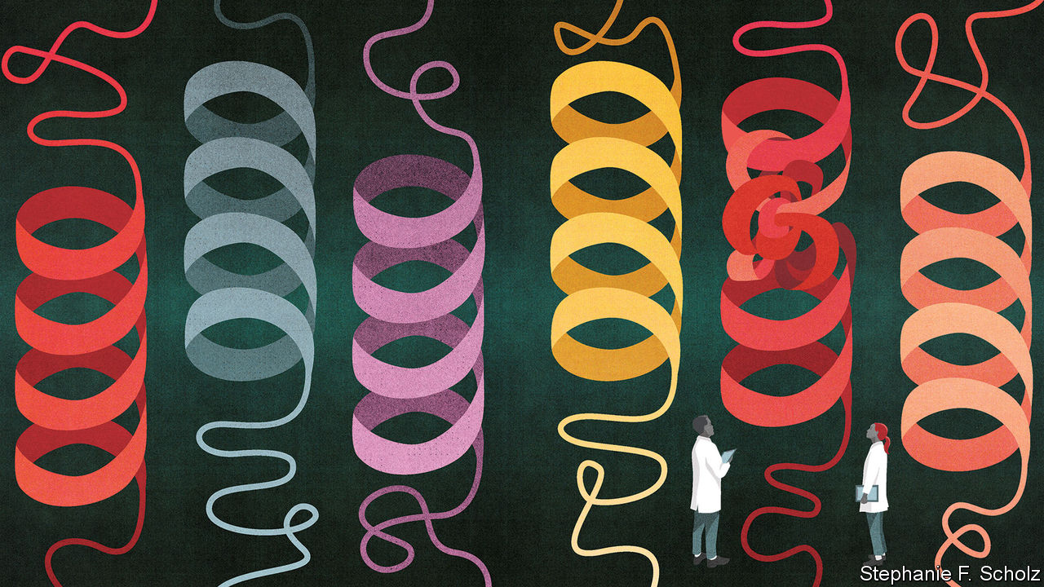

WHEN A CLINICIAN showed Dr Nizar’s sons a pain chart, they asked her what the smiley face at one end of the scale meant. The boys do not know, Dr Nizar says, what it is like to live without pain. Not all the diseases caused by calamitously failed single genes are quite that awful. But unlike the more generalised genomic influences on health—those to which everyone is heir, but few know about—people with serious congenital diseases have no escape or respite; their symptoms are inescapable. And so, too, for the most part, are their diseases. Genomics makes the diagnosis of such diseases, especially the rare ones, easier and more precise, and it has revealed what is going on in some of them in useful ways. It has not yet, though, provided much by way of cures. Now this is beginning to change.

Those who deal with rare genetic diseases talk of the “diagnostic odyssey”. This is the process, familiar to viewers of “House”, a television show, of repeatedly suggesting a cause for a rare disease, testing, ruling out and suggesting again. In real life such odysseys do not to fit into a tense hour of screentime; until recently they used drag themselves out for five years or so, according to Mark Caulfield of Genomics England. Dr Nizar’s took even longer, largely because only a handful of doctors on the planet have any experience with Jansen’s disease. Even over eight seasons, Dr House and his team never saw a single case.

In Britain and many other rich countries, genomic testing has the length of the odyssey down to months or even weeks, says Dr Caulfield. This matters because, even when genetic diseases cannot be cured, knowing the precise nature of the defect often matters—and the earlier it is known, the better. When a Mexican clinic for children with birth defects had 60 of its patients sequenced, subsequent changes in diagnosis led to revisions in the care given to almost half of them.

Sometimes the correct care has dramatic results. Jessica was four years old when sequencing showed that the disease affecting her movement and development stemmed from a misprint in a gene called SLC2A1. This meant her cells did not make enough of a protein that transports sugar into the brain, thus leaving it chronically underpowered. Giving Jessica a carefully tailored low-carbohydrate diet activated an alternative way of getting calories to herbrain. Another situation in which knowledge gives huge power is Brown-Vialetto-Van Laere disease, a rare form of motor-neurone disease that strikes in childhood. Faults in the genes SLC52A2 and SLC52A3 reduce the body’s stocks of a protein that transports riboflavin (vitamin B2) from the gut into the blood stream. High doses of riboflavin can provide great benefits to many such patients—but they will not get them if they do not know they need them.

Most of those with rare diseases cannot be provided with such a positive outcome on the basis of knowledge alone. But a secure diagnosis still helps. For one thing, the diagnostic odyssey is ended: no need for further invasive inquiry. And then there is support, which matters a lot. Accurate diagnosis lets people find others in similar straits to exchange advice, sympathy—and plans.

A genetic understanding of rare diseases also provides valuable insights into common ones. If drug developers have a target with a well defined causal role in some sort of disease, their studies are twice as likely to lead to a working drug than if they do not. The study of rare diseases provides insights of that sort which can be used to develop treatments that are much more widely applicable. That is why it continues to matter to more than just the families suffering from them.

## Start making antisense

Studies of two rare genetic disorders in which bones grow too eagerly, sclerosteosis and van Buchem’s disease, revealed that both involved mutations in SOST, a gene that describes a protein now called sclerostin. When expressed in bone-building cells, sclerostin turned out to suppress bone growth—hence the bone overgrowth problems when the gene is faulty. This opened up the possibility that patients without enough bone growth might benefit from a drug that inhibited sclerostin. That has led to the development of antibodies against sclerostin as a new strategy for treating osteoporosis. Van Buchem’s disease is almost as rare as Jansen’s; but in ageing populations osteoporosis is a public-health scourge.

Similarly, studies of a Chinese family with a rare form of erythromelalgia, which causes burning pain and redness in the feet, are driving the development of new painkillers. Studies of the faulty PCSK9 gene found in families with a genetic disorder that gives them poor coronary health inspired a whole class of new anti-cholesterol drugs that are more effective than statins.

A wrinkle on this approach is to find people with disease-causing mutations who stay healthy, or whose disease progresses slowly. These people contain genes that may protect them from harm, which might be useful in creating new therapies for others. Maze Therapeutics, based in San Francisco, is looking for “genetic modifiers” that alter the course of conditions like ALS (also known as Lou Gehrig’s disease). This disease is normally fatal within a couple of years. But in some sufferers, such as the late physicist Stephen Hawking, it develops much more slowly.

Yet as humanity’s knowledge of disease mechanisms has grown dramatically through the study of rare inherited diseases, the development of treatments for those diseases themselves has failed to keep pace. Conditions that blight lives by the dozen or hundred are not big markets.

Many hope that various new technologies could drastically reduce the costs of bespoke treatments for at least some congenital diseases. Most drugs today work by targeting a protein—either one of the body’s proteins that is misbehaving, or a protein in a pathogen that is achieving its goals all too well. The drug has to be tailored to the shape and activity of the protein it targets, while not messing up the workings of other inoffensive proteins that are doing vital work. That isn’t easy.

What, though, if you could stop a problematic protein from being made in the first place? For a cell to make a protein, it first needs to make a copy of the gene sequence that describes that protein. This copy is called a messenger RNA, or mRNA. If you know the sequence of the gene, it is easy to work out the sequence of its mRNA, and from that design a short strand of DNA that, by dint of its own sequence, will stick to that mRNA, thus rendering it useless (see diagram).

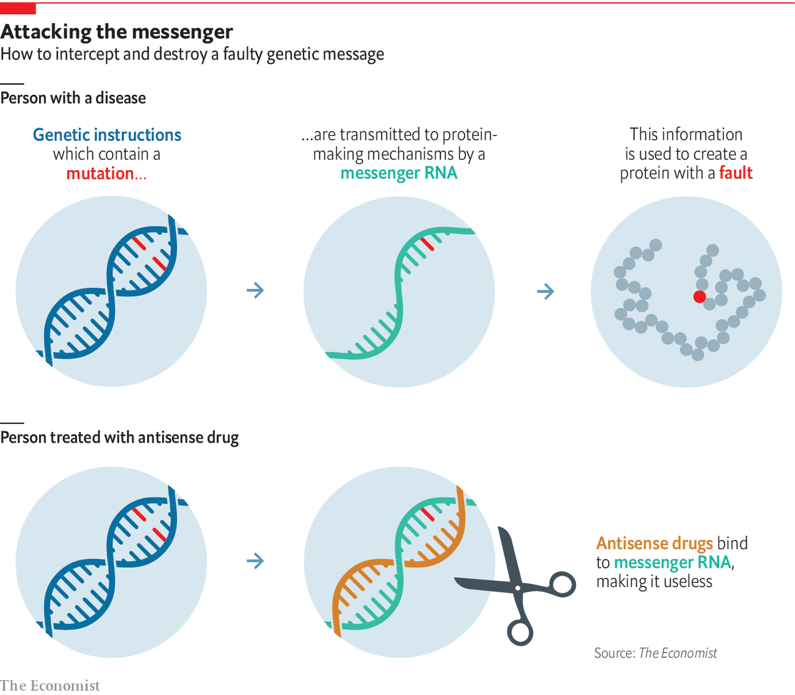

Such DNA-based saboteurs are called “antisense oligonucleotides” (ASOs). They are now being used to treat various faulty-gene diseases, including a particular form of spinal muscular atrophy (SMA), some types of Duchenne muscular dystrophy and familial hypercholesterolemia—the disease that led to the design of new anti-cholesterol drugs. There are trials under way to see if an ASO can slow the progression of Huntington’s disease, a lethal degenerative disease which affects from five to 10 people per 100,000.

Antisense drugs are particularly exciting to patients with rare congenital diseases because they can be easily tailored. Once the sequence of the gene for the protein at fault is established, an ASO can be ready in under a year, says Art Krieg, the boss of Checkmate Pharmaceuticals, a biotech company. The fact that ASOs are based on sequences means that they can be “programmed” to inhibit the synthesis of a wide range of proteins. An ASO can also be designed and used to treat a disease unique to a single patient—what doctors call an n-of-1 trial.

When she was six, Mila Makovec was diagnosed with Batten disease, in which a defect in a gene called CLN3 causes proteins and lipids to build up in the brain. That build-up was progressively robbing her of movement, sight and thought. It was eventually going to kill her. In 2017, though, sequencing showed that Mila’s version of Batten disease was not down to a good protein not being made, as most cases are, but an unhelpful version of another protein. Tim Yu, a neurologist at Boston Children’s Hospital who knew about the ASO being used to stop harmful proteins being made in SMA, realised that a similar approach might work for Mila.

The girl’s parents raised $3m dollars through crowdfunding to create Mila’s Miracle Foundation. With some of that Dr Yu designed an ASO tailored directly to Mila’s genome and got it produced. The molecule, called milasen, seems to have helped. The foundation is now trying to get the same thing done for hundreds of other very rare diseases.

A lot of charities are doing similar things. Some are big: the Chan Zuckerberg Initiative has kick-started work on various other rare diseases with its Rare As One Network. The n-Lorem Foundation, launched this year, also aims to make the development of ASOs easier. Some are small, like the one Rohan Seth, an entrepreneur, started for his six-month-old daughter Lydia. An ASO to deal with the mutation in KCNQ2 that is making her progressively more disabled cannot come soon enough. Dr Nizar watches approvingly. The disease which afflicts her family is not yet amenable to this particular approach. But there may be more miracles on the way.

This article was downloaded by calibre from <https://www.economist.com/technology-quarterly/2020/03/12/congenital-diseases-reveal-a-lot-about-human-biology>

|  |  |  |  |
| --- | --- | --- | --- |
| Previous | Articles | Sections | Next |

|  |  |  |  |
| --- | --- | --- | --- |
| Previous | Articles | Sections | Next |

#### The pharmaceutical industry

# New drugs are costly and unmet need is growing

The pharmaceutical industry needs new ways of doing things

Mar 12th 2020 |

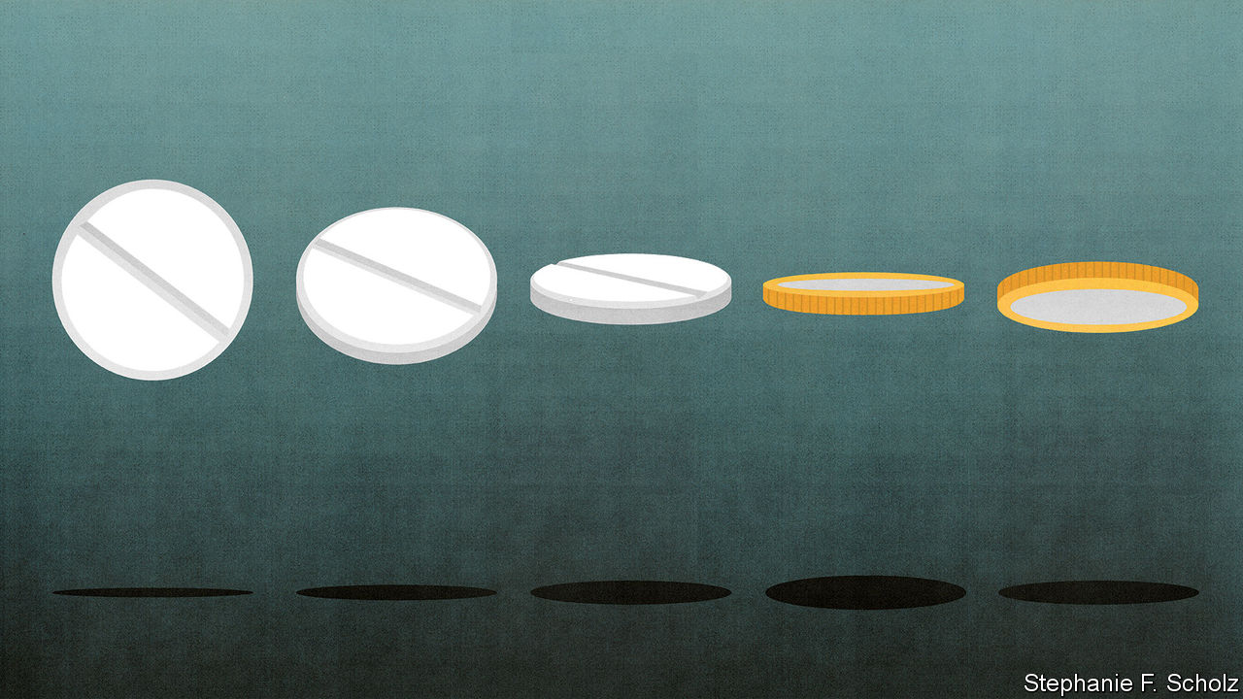

BEING ABLE to see all the details of the genome at once necessarily makes medicine personal. It can also make it precise. Examining illness molecule by molecule allows pharmaceutical researchers to understand the pathways through which cells act according to the dictates of genes and environment, thus seeing deep into the mechanisms by which diseases cause harm, and finding new workings to target. The flip side of this deeper understanding is that precision brings complexity. This is seen most clearly in cancer. Once, cancers were identified by cell and tissue type. Now they are increasingly distinguished by their specific genotype that reveals which of the panoply of genes that can make a cell cancerous have gone wrong in this one. As drugs targeted against those different mutations have multiplied, so have the options for oncologists to combine them to fit their patients’ needs.

Cancer treatment has been the most obvious beneficiary of the genomic revolution but other diseases, including many in neurology, are set to benefit, too. Some scientists now think there are five different types of diabetes rather than two. There is an active debate about whether Parkinson’s is one disease that varies a lot, or four. Understanding this molecular variation is vital when developing treatments. A drug that works well on one subtype of a disease might fail in a trial that includes patients with another subtype against which it does not work at all.

Thus how a doctor treats a disease depends increasingly on which version of the disease the patient has. The Personalised Medicine Coalition, a non-profit advocacy group, examines new drugs approved in America to see whether they require such insights in order to be used. In 2014, it found that so-called personalised medicines made up 21% of the drugs newly approved for use by America’s Food and Drug Administration (FDA). In 2018 the proportion was twice that.

Two of those cited were particularly interesting: Vitrakvi (larotrectinib), developed by Loxo Oncology, a biotech firm, and Onpattro (patisiran), developed by Alnylam Pharmaceuticals. Vitrakvi is the first to be approved from the start as “tumour agnostic”: it can be used against any cancer that displays the mutant protein it targets. Onpattro, which is used to treat peripheral-nerve damage, is the first of a new class of drugs—“small interfering RNAs”, or siRNAs—to be approved. Like antisense oligonucleotides (ASOs), siRNAs are little stretches of nucleic acid that stop proteins from being made, though they use a different mechanism.

Again like ASOs, siRNAs allow you to target aspects of a disease that are beyond the reach of customary drugs. Until recently, drugs were either small molecules made with industrial chemistry or bigger ones made with biology—normally with genetically engineered cells. If they had any high level of specificity, it was against the actions of a particular protein, or class of proteins. Like other new techniques, including gene therapies and anti-sense drugs, siRNAs allow the problem to be tackled further upstream, before there is any protein to cause a problem.

Take the drugs that target the liver enzyme PCSK9. This has a role in maintaining levels of “bad” cholesterol in the blood; it is the protein that was discovered through studies of families in which congenitally high cholesterol levels led to lots of heart attacks. The first generation of such drugs were antibodies that stuck to the enzyme and stopped it working. However, the Medicines Company, a biotech firm recently acquired by Novartis, won approval last year for an siRNA called inclisiran that interferes with the expression of the gene PCSK9—thus stopping the pesky protein from being made in the first place. Inclisiran needs to be injected only twice a year, rather than once a month, as antibodies do.

New biological insights, new ways of analysing patients and their disease and new forms of drug are thus opening up a wide range of therapeutic possibilities. Unfortunately, that does not equate to a range of new profitable opportunities.

Thanks in part to ever better diagnosis, there are now 7,000 conditions recognised as “rare diseases” in America, meaning that the number of potential patients is less than 200,000. More than 90% of these diseases have no approved treatment. These are the diseases that personalised, precision medicine most often goes after. Nearly 60% of the personalised medicines approved by the FDA in 2018 were for rare diseases.

Zolgensma is the most expensive drug ever brought to market.

That might be fine, were the number of diseases stable. But precision in diagnosis is increasingly turning what used to be single diseases into sets of similar-looking ones brought about by distinctly different mechanisms, and thus needing different treatment. And new diseases are still being discovered. Medical progress could, in short, produce more new diseases than new drugs, increasing unmet need.

Some of it will, eventually, be met. For one thing, there are government incentives in America and Europe for the development of drugs for rare diseases. And, especially in America, drugs for rare diseases have long been able to command premium prices. Were this not the case, Novartis would not have paid $8.7bn last year to buy AveXis, a small biotech firm, thereby acquiring Zolgensma, a gene therapy for spinal muscular atrophy (SMA). Most people with SMA lack a working copy of a gene, SMN1, which the nerve cells that control the body’s muscles need to survive. Zolgensma uses an empty virus-like particle that recognises nerve cells to deliver working copies of the gene to where it is needed. Priced at $2.1m per patient, it is the most expensive drug ever brought to market. That dubious accolade might not last long. BioMarin, another biotech firm, is considering charging as much as $3m for a forthcoming gene therapy for haemophilia.

Drug firms say such treatments are economically worthwhile over the lifetime of the patient. Four-fifths of children with the worst form of SMA die before they are four. If, as is hoped, Zolgensma is a lasting cure, then its high cost should be set against a half-century or more of life. About 200 patients had been treated in America by the end of 2019.

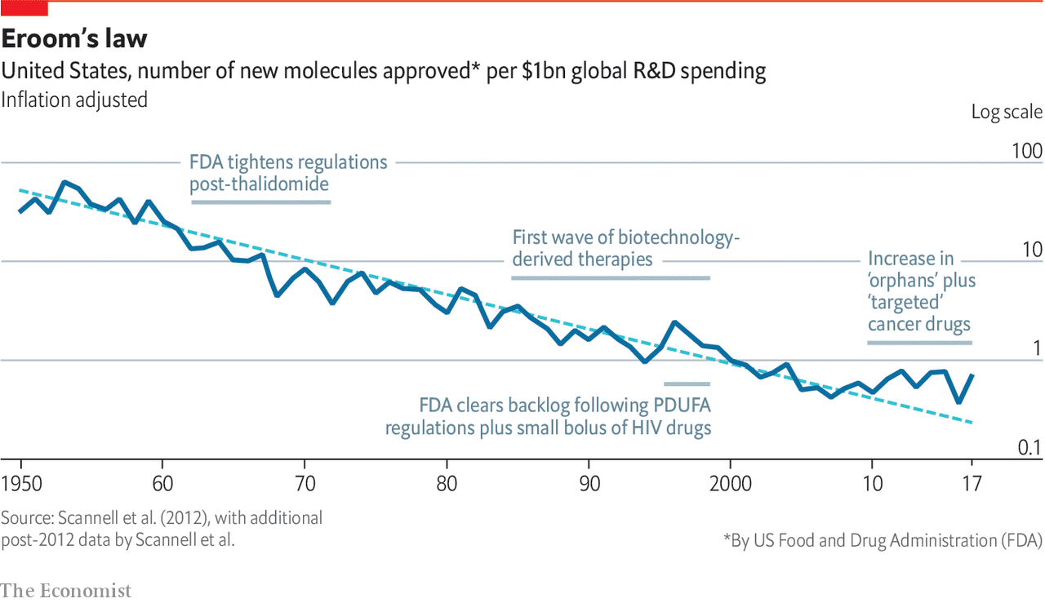

But if some treatments for rare diseases may turn a profit, not all will. There are some 6,000 children with SMA in America. There are fewer than ten with Jansen’s disease. When Dr Nizar asked companies to help develop a treatment for it, she says she was told “your disease is not impactful”. She wrote down the negative responses to motivate herself: “Every day I need to remind myself that this is bullshit”.

A world in which markets shrink, drug development gets costlier and new unmet needs are ceaselessly discovered is a long way from the utopian future envisaged by the governments and charities that paid for the sequencing of all those genomes and the establishment of the world’s biobanks. As Peter Bach, director of the Centre for Health Policy and Outcomes, an academic centre in New York, puts it with a degree of understatement: if the world needs to spend as much to develop a drug for 2,000 people as it used to spend developing one for 100,000, the population-level returns from medical research are sharply diminishing.

## Moore is less

And it is not as if the costs of drug development have been constant. They have gone up. What Jack Scannell, a consultant and former pharmaceutical analyst at UBS, a bank, has dubbed Eroom’s law—Eroom being Moore, backwards—shows the number of drugs developed for a given amount of R&D spending has fallen inexorably, even as the amount of biological research skyrocketed. Each generation assumes that advances in science will make drugs easier to discover; each generation duly advances science; each generation learns it was wrong.

For evidence, look at the way the arrival of genomics in the 1990s lowered productivity in drug discovery. A paper in Nature Reviews Drug Discovery by Sarah Duggers from Columbia University and colleagues argues that it brought a wealth of new leads that were difficult to prioritise. Spending rose to accommodate this boom; attrition rates for drugs in development subsequently rose because the candidates were not, in general, all that good.

Today, enthused by their big-science experience with the genome and enabled by new tools, biomedical researchers are working on exhaustive studies of all sorts of other ‘omes, including proteomes—all the proteins in a cell or body; microbiomes—the non-pathogenic bacteria living in the mouth, gut, skin and such; metabolomes—snapshots of all the small molecules being built up and broken down in the body; and connectomes, which list all the links in a nervous system. The patterns they find will doubtless produce new discoveries. But they will not necessarily, in the short term, produce the sort of clear mechanistic understanding which helps create great new drugs. As Dr Scannell puts it: “We have treated the diseases with good experimental models. What’s left are diseases where experiments don’t replicate people.” Data alone canot solve the problem.

Daphne Koller, boss of Insitro, a biotech company based in San Francisco, shares Dr Scannell’s scepticism about the way drug discovery has been done. A lot of candidate drugs fail, she says, because they aim for targets that are not actually relevant to the biology of the condition involved. Instead researchers make decisions based on accepted rules of thumb, gut instincts or a “ridiculous mouse model” that has nothing to do with what is actually going on in the relevant human disease—even if it makes a mouse look poorly in a similar sort of way.

But she also thinks that is changing. Among the things precision biology has improved over the past five to 10 years have been the scientists’ own tools. Gene-editing technologies allow genes to be changed in various ways, including letter by letter; single-cell analysis allows the results to be looked at as they unfold. These edited cells may be much more predictive of the effects of drugs than previous surrogates. Organoids—self-organised, three-dimensional tissue cultures grown from human stem cells—offer simplified but replicable versions of the brain, pancreas, lung and other parts of the body in which to model diseases and their cures.

Insitro is editing changes into stem cells—which can grow into any other tissue—and tracking the tissues they grow into. By measuring differences in the development of very well characterised cells which differ in precisely known ways the company hopes to build more accurate models of disease in living cells. All this work is automated, and carried out on such a large scale that Dr Koller anticipates collecting many petabytes of data before using machine learning to make sense of it. She hopes to create what Dr Scannell complains biology lacks and what drug designers need: predictive models of how genetic changes drive functional changes.

There are also reasons to hope that the new “upstream” drugs—ASOs, siRNAs, perhaps even some gene therapies—might have advantages over today’s therapies when it comes to small-batch manufacture. It may also prove possible to streamline much of the testing that such drugs go through. Virus-based gene-therapy vectors and antisense drugs are basically platforms from which to deliver little bits of sequence data. Within some constraints, a platform already approved for carrying one message might be fast-tracked through various safety tests when it carries another.

One more reason for optimism is that drugs developed around a known molecule that marks out a disease—a molecular marker—appear to be more successful in trials. The approval process for cancer therapies aimed at the markers of specific mutations is often much shorter now than it used to be. Tagrisso (osimertinib), an incredibly specialised drug, targets a mutation known to occur only in patients already treated for lung cancer with an older drug. Being able to specify the patients who stand to benefit with this degree of accuracy allows trials to be smaller and quicker. Tagrisso was approved less than two years and nine months after the first dose was given to a patient.

With efforts to improve the validity of models of disease and validate drug targets accurately gaining ground, Dr Scannell says he is “sympathetic” to the proposal that, this time, scientific innovation might improve productivity. Recent years have seen hints that Eroom’s law is being bent, if not yet broken.

If pharmaceutical companies do not make good on the promise of these new approaches then charities are likely to step in, as they have with various ASO treatments for inherited diseases. And they will not be shackled to business models that see the purpose of medicine as making drugs. The Gates Foundation and America’s National Institutes of Health are investing $200m towards developing treatments based on rewriting genes that could be used to tackle sickle-cell disease and HIV—treatments that have to meet the proviso of being useful in poor-country clinics. Therapies in which cells are taken out of the body, treated in some way and returned might be the basis of a new sort of business, one based around the ability to make small machines that treat individuals by the bedside rather than factories which produce drugs in bulk.

## Run, rabbit, run

There is room in all this for individuals with vision; there is also room for luck: Dr Nizar has both. Her problem lies in PTH1R, a hormone receptor; her PTH1R gene makes a form of it which is jammed in the “on” position. This means her cells are constantly doing what they would normally do only if told to by the relevant hormone. A few years ago she learned that a drug which might turn the mutant receptor off (or at least down a bit) had already been characterised—but had not seemed worth developing.

The rabbit, it is said, outruns the fox because the fox is merely running for its dinner, while the rabbit is running for its life. Dr Nizar’s incentives outstrip those of drug companies in a similar way. By working with the FDA, the NIH and Massachusetts General Hospital, Dr Nizar helped get a grant to make enough of the drug for toxicology studies. She will take it herself, in the first human trial, in about a year’s time. After that, if things go well, her children’s pain may finally be eased. ■

This article was downloaded by calibre from <https://www.economist.com/technology-quarterly/2020/03/12/new-drugs-are-costly-and-unmet-need-is-growing>

|  |  |  |  |
| --- | --- | --- | --- |
| Previous | Articles | Sections | Next |

|  |  |  |  |
| --- | --- | --- | --- |
| Previous | Articles | Sections | Next |

#### The sum of all lives

# The way people live their lives can be mined, too

But there will be setbacks and privacy problems along the way

Mar 12th 2020 |

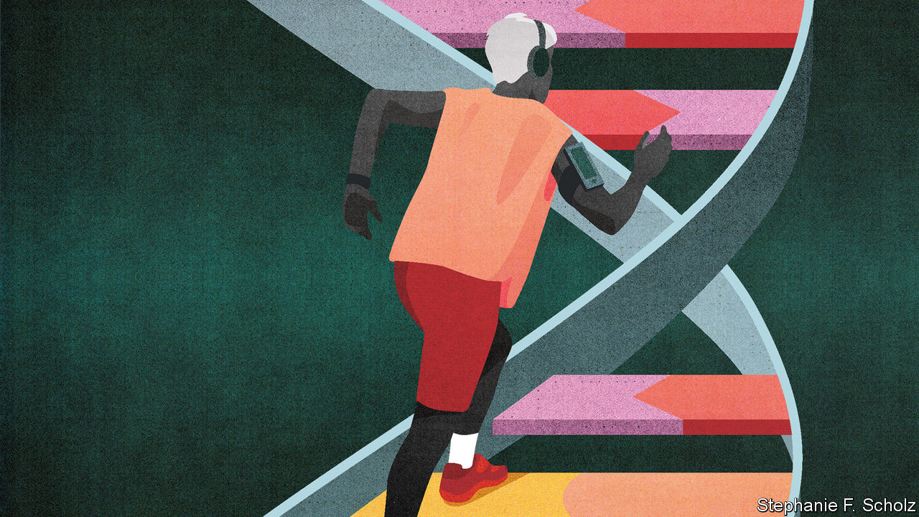

THREADWORMS ARE trending, according to the app on Johannes Schildt’s phone. The app was created by Kry, the Swedish digital health-care firm Mr Schildt runs. It offers information on the sicknesses for which people are currently booking doctor’s appointments, as well as on things specifically important to its user—it keeps Mr Schildt, who suffers from hay fever, up to date with the pollen count. It lets him book an appointment with a family doctor or a specialist, and indeed to have such an appointment by phone. None of this sounds particularly stretching. But in health care, it counts as radical.

According to the Organisation for Economic Co-operation and Development (OECD), a club of richer nations, the world creates 2.5 exabytes of data a day—thousands of times what even the grandest sequencing centre can produce in a month. Of those which get stored, 30% pertain to health. The trove contains insights into the health of populations and of individuals, the efficacy of drugs and the efficiency of health-care systems, the failings of doctors and the financial health of insurers. But OECD countries typically spend less than 5% of their health budgets managing these data, much less than is the norm in other areas. By failing to make the most of their potential, these countries are wasting $600bn a year—roughly the GDP of Sweden.

This underutilised resource has attracted the attention of a panoply of private companies, from minnows like Kry to giants like Amazon, Apple, Facebook and Google. Governments, hospitals and insurers, they think, will pay for what they glean from it. So will individuals—who will often pay for the privilege of supplying yet more data off their own bat. Mobile phones log their users’ physical activity, creating records used by many of the billions of health-related smartphone apps downloaded globally every year (1.7bn in 2013, 3.7bn in 2017). Make sense of all this data for them, the argument goes, and you can make money helping people stay healthy and warning them of disease.

As with the genome twenty years ago, some scepticism is warranted. But in time a picture of a life built up from the genome’s underlying recipe, from medical histories and tests that profile specific bodily functions, and from the monitoring of every step and heartbeat, will allow personalised, preventive medicine to be rolled out across entire populations. “All these layers define the medical essence of a human being,” says Eric Topol, head of the Scripps Research Translational Institute in La Jolla, California.

Adding real-world data to genome-based profiles would undoubtedly be useful. Michael Joyner of the Mayo Clinic in Rochester, Minnesota, and Nigel Paneth at Michigan State University argue that characteristics such as family history, neighbourhood, socioeconomic circumstances, height and girth still outperform genetic profiling as predictors for all sorts of health outcomes. This does not mean genetic information is without value; it means it needs context.

Various new frontiers in diagnosis are being explored. Firms across the world are competing to develop “liquid biopsies” that can detect and characterise cancers by means of fragments of DNA in the blood; other molecular markers could reveal other diseases. But so could the digital footprints people leave when they decide whether to leave the house, what to buy, what to search for or what to stream.

## Not-yet-dead men walking

Sometimes the footprints may be just that. Dan Vahdat, who runs Medopad, a health-technology firm in London, says conditions as varied as Parkinson’s disease, depression and breast cancer can all have a distinctive effect on a patient’s gait. He speculates that with enough data covering different behaviours it will be possible to identify “digital biomarkers” capable of predicting the risk of Alzheimer’s or a heart attack. Work by Dr Topol has already shown that spikes in resting heart rate—more common when people have an infection—allow someone with access to lots of fitbits to see when flu is breaking out in the population.

The recognition of such patterns is clearly a job for the machine-learning techniques driving the current expansion of AI. These techniques are already being used to interpret diagnostic tests, sometimes with real success. An AI system for prostate cancer diagnosis developed by the Karolinska Institute in Stockholm has held its own against a panel of 23 international experts; a nine-country trial is now assessing how much it can reduce the workload of doctors. But recent research published in The Lancet Digital Health, a journal, suggests some caution is advisable. Looking at around 20,000 studies of medical AI systems that claimed to show that they could diagnose things as well as health-care professionals, it found that most had methodological flaws.

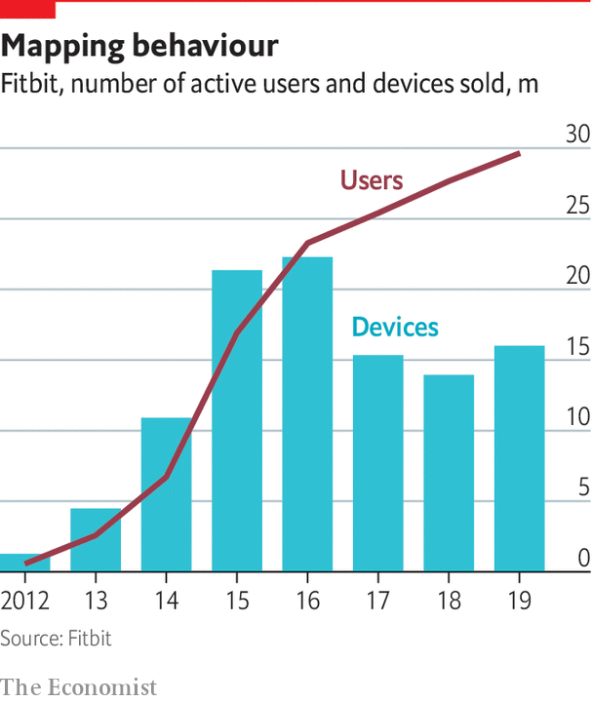

One particular worry with machine learning in general is that bias in the “training sets” from which the computers learn their stuff can mean that the algorithms do not work equally well for all members of the population. Medical research has a poor historical record on such matters, for example when it does not match clinical-trial populations to the population at large, or excludes women of child-bearing age from trials. Machine learning could bake in such biases, and make them invisible.

Excessive optimism that edges into barefaced hype is just one cause for concern about datomics. Privacy is, as always, an issue. The amount of data that parts of the NHS have shared with Google has worried some Britons. Conversely, some researchers feel hampered by constraints such as those of Europe’s General Data Protection Regulation, says Claire Gayrel of the EU’s data protection authority. They see it as an obstacle to innovation. Ms Gayrel treats that with equanimity: “I don’t think it is a bad thing to think slower, especially in health.”

As well as worries over what researchers or companies might do with personal data, there are reasonable concerns over how safe they can keep it. A cyberattack on Premera Blue Cross, an American insurer, may have exposed the medical data of 11m customers in 2015.

There is also the challenge of cost. Whatever claims are made early on and whatever benefits they may demonstrate, new technologies have a marked, persistent tendency to drive up spending on health in rich countries. There is no obvious reason to think that, just because sequencing, data processing and some forms of machine learning are getting cheaper, their ever greater application to health care will drive down costs.

One reason is that, although knowledge may be power, it may also be a needless worry. A DNA test that seems to tell you some of your future, or a watch that can pick up atrial fibrillation, may seem great to users; they are less enticing to health systems that have to deal with diagnoses which are not, in themselves, clinically relevant. Last year the New York Times reported that a period-tracking app which also evaluated women’s risk of polycystic-ovary syndrome, a hormonal problem, was recommending that an improbably large number of its users see their doctors.

Trustable intermediaries—such as government health-care systems, regulators and reputable insurers—will help consumers to know what works best. They should also be able to help each other. Not everyone is motivated to improve their health, and even avid consumers of health data will rarely have the same sense of common cause as people with congenital diseases and their families. But health concerns bring people together, and through supporting each other they may develop new mechanisms for change.

Because health systems look to the needs of the many, personalised medicine will hit its stride only when it can show that its approaches work in the round. But as people get more used to customising their lives through online services that know what they want, health care will get pulled along. There will be many false correlations, privacy violations, and errors along the way. But in the end, people of all sorts will benefit from being understood as unique. ■

This article was downloaded by calibre from <https://www.economist.com/technology-quarterly/2020/03/12/the-way-people-live-their-lives-can-be-mined-too>

|  |  |  |  |
| --- | --- | --- | --- |
| Previous | Articles | Sections | Next |

|  |  |  |
| --- | --- | --- |
| Technology ... | Sections | Finance and ... |

Business

Technology in India: Silicon subcontinent

.

Coronavirus and business: The anti-covid industrial complex

.

Bartleby: In sickness and in health

.

Cloud business: Altocumulus

.

Corporate purpose: Going in circles

.

Schumpeter: The rise and rise of Accenture

.

|  |  |  |
| --- | --- | --- |
| Technology ... | Sections | Finance and ... |

|  |  |  |  |
| --- | --- | --- | --- |
|  | Articles | Sections | Next |

#### Silicon subcontinent

# India’s booming startup scene is showing signs of trouble

A decade of phenomenal growth has created 80,000 tech firms—and mounting losses

Mar 14th 2020 | DELHI, MUMBAI AND SINGAPORE

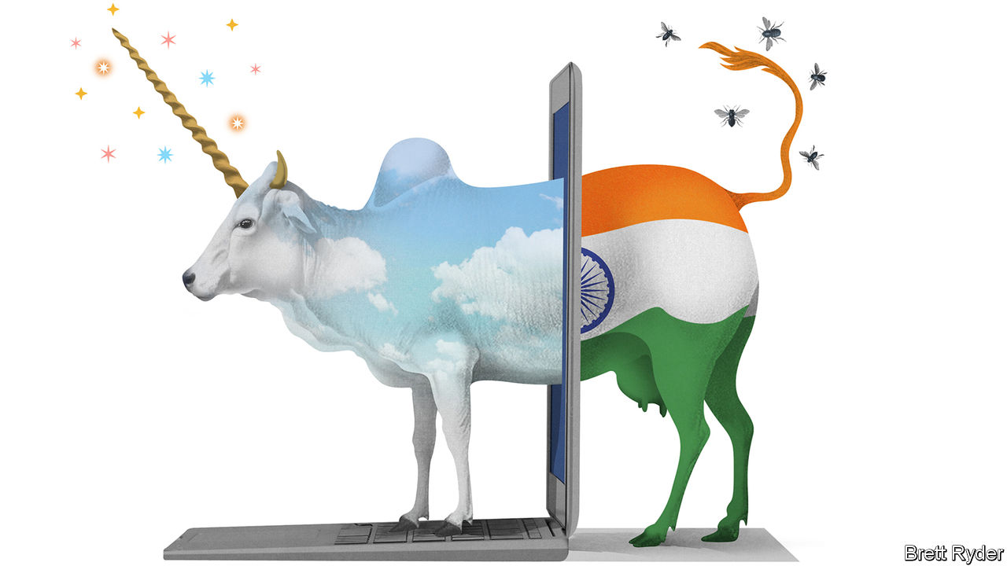

WHEN ITINERANT venture capitalists land at Delhi airport, many head straight to Aerocity, a new development of glass, steel and Starbucks next door that would not look out of place in Silicon Valley, Singapore or Shanghai. Cyber City, another tech enclave 20 minutes away by Uber (traffic permitting), swarms with young programmers in T-shirts and jeans not unlike the Stanford students plotting the next disruptive app at Philz Coffee in Palo Alto. Many are one and the same.

What Delhi’s tech parks lack in the splendour of India’s historic business hub, in south Mumbai, they make up for in unpotholed roads, uninterrupted mobile connections and stable broadband. Between 2017 and 2019 the capital spawned 2,562 startups, according to Tracxn Technologies, a data provider. Other clusters, notably in Bengaluru, Mumbai, Hyderabad, Pune and Chennai, added a further 4,500 or so between them. India now has 80,000 startups (see chart 1). They raised $10bn in 2019, up from $3.1bn in 2012 (see chart 2). That puts India’s venture capital (VC) activity behind America ($114bn) and China ($34bn) but ahead of larger economies such as Germany or France.

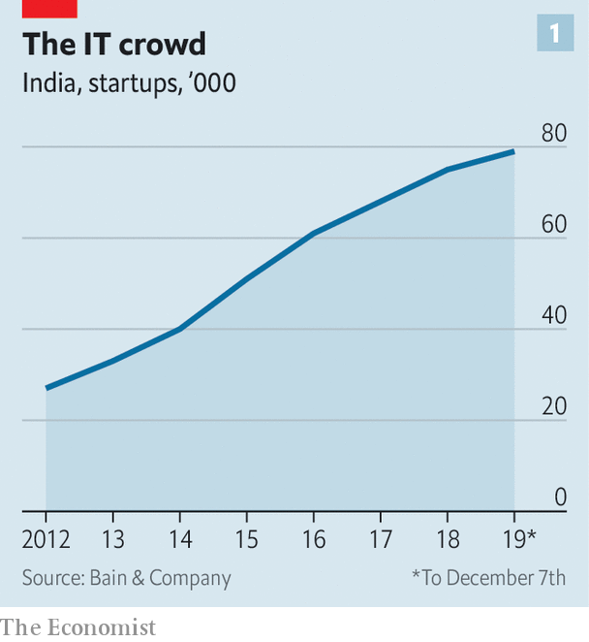

PitchBook, a research firm, counts 18 unlisted “unicorns”, valued at more than $1bn apiece, grazing in India. They are worth a combined $72bn. Bright engineers and managers now aspire to work for them—or their VC backers—rather than settle for safe careers at a multinational, a bank or a state-run firm. Another 150-odd “soonicorns” may reach the $1bn mark shortly. They promise free cappuccinos, excitement—and, for a lucky few, riches. They may reconfigure parts of the national economy. Mohandas Pai, a VC-wallah and former finance chief of Infosys, a local tech giant, predicts that within a decade India’s startups will help triple its GDP.

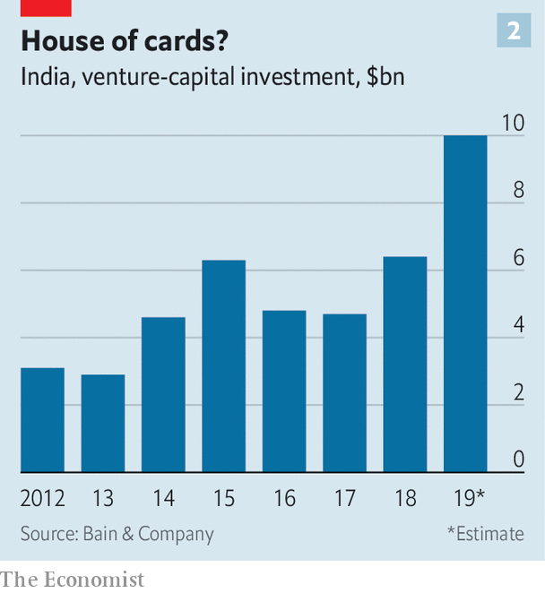

Mr Pai is not alone in his bullishness. India’s business press revels in tales of startup wonder. Foreign VC firms have piled in. They hope to ape the success of Flipkart, an e-commerce platform in which Walmart bought a majority stake for $16bn in 2018. Yet despite startup India’s indisputable promise, pitfalls await the unwary.

The Indian VC scene has come a long way. In 2005, when Rajan Anandan, a partner at Sequoia Capital, a Silicon Valley VC titan, returned to India after a spell in America, all-important early-stage VC was close to non-existent. Foreign firms began to fill the gap. Californian stalwarts, including Accel, Matrix, Lightspeed, Bessemer and Norwest, have since set up mostly autonomous Indian offices. So have Singaporean sovereign-wealth funds, Temasek and GIC; Chinese tech giants, Tencent and Alibaba; and, inevitably given its startup covetousness, SoftBank of Japan. They have been joined by powerful local firms such as Blume Capital. Giant Indian conglomerates such as Tata, Reliance and Mahindra have launched VC arms. VC types say they get more than 5,000 pitches a year.

Most of the money has gone into familiar platforms: ride-hailing (Ola), food delivery (Swiggy, Zomato), online grocers (bigbasket), car rental (Zoomcar), online education (Byju’s). The first new unicorn of 2020, HighRadius, offers software-as-a-service (SaaS), another tested business model which provides companies with things like accounting or customer support via the computing cloud.

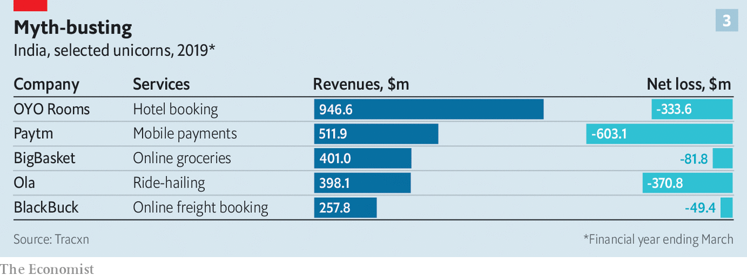

This penchant for the familiar is understandable. And the platforms work in India—just about—without the need to fix its rickety physical and digital infrastructure. But their growth is limited in a country rich in people but poor in disposable income. And, like counterparts in the West, few of them make any money (see chart 3). The reasons—and justifications—are the same, too: heavy investments are necessary to acquire new customers and achieve scale.

## Bharat biltzscaling

The success of this strategy is hard to gauge. Information on realised returns—the cash VCs get from their investments as opposed to unrealised capital gains from swelling valuations—remains scant. What little there is suggests a near absence of cash returns. People who have reviewed pitch books used to raise money say as much. True, only a few funds have been around the decade or so required for investments to ripen. But it may have something to do with weak operating performance. Oyo Rooms, a seven-year-old firm which sells tech-infused budget-hotel franchises and has expanded furiously across 800 cities in India and abroad, has had to sack workers and faces questions about its viability.

Individual companies’ valuations—including Oyo’s, long put at $7.5bn-10bn—are thus increasingly viewed with suspicion. Many are “marked to myth” rather than to market, as local wags put it. That in turn helps explain why clean exits, through a public listing or a private sale, are rare. Walmart’s Flipkart deal accounted for 80% of the ten biggest exits in 2018, according to Bain, a consultancy. Last year’s top ten raked in just $4bn. Half were sales of secondary stakes by one VC firm to another. Only one, of a 24-year-old e-merchant called Indiamart, was a public offering.

Investor-unfriendly bureaucracy presents more hurdles to divestment. A term sheet related to incorporating in India, from the Indian branch of an American VC firm, can run to 12 pages, remembers an executive at a hot startup; one from its American office related to incorporating in America took up a single page. Some of those who invested in Flipkart are enmeshed in a fight with the government to recover a withholding tax imposed on their returns.

To list on India’s main exchanges firms must demonstrate a few years of profits. Laws impede those whose management is based in India from floating overseas (the approach of many successful Israeli startups) without first going public at home. Complex and mutable levies on shares handed to investors and staff in effect give the government first dibs on a firm’s cash.

Despite its pro-business rhetoric, the nationalist government of Narendra Modi has made life harder for startups in other ways. Like all of India Inc they contend with complex and constantly changing rules. Some are draconian and indiscriminate. In December the government blocked digital-payments providers from collecting fees from merchants who use their services, hurting the business model of Paytm, India’s biggest unicorn. It also launched a public payments system that competes with private providers. Flipkart has found itself facing restrictions on warehousing and discounting, slapped with a complex transaction tax, and under investigation by the competition authorities for long-standing sales arrangements.

The cost, complexity and chaos of India’s VC world is prompting many startups to try to incorporate elsewhere while they remain small. An analysis by Tracxn shows that of 73 SaaS firms that have received at least $20m each in funding, 50 have headquarters outside India. Many flee to Singapore, where expatriate managers can catch a six-hour flight to Delhi or Mumbai, which plenty do on a weekly basis. America is luring them with its vast market, better protection of intellectual property, lower taxes and a deep network of analysts, VC firms, lawyers and bankers. If India is to unleash its huge startup potential, it must first ask itself why some of its entrepreneurs and venture capitalists are so eager to leave. ■

This article was downloaded by calibre from <https://www.economist.com/business/2020/03/14/indias-booming-startup-scene-is-showing-signs-of-trouble>

|  |  |  |  |
| --- | --- | --- | --- |
|  | Articles | Sections | Next |

|  |  |  |  |
| --- | --- | --- | --- |
| Previous | Articles | Sections | Next |

#### The anti-covid industrial complex

# Chinese companies rush to produce anti-covid kit

Makers of booze, cars, nappies and spacecraft are retooling to fight the epidemic

Mar 14th 2020 | SHANGHAI

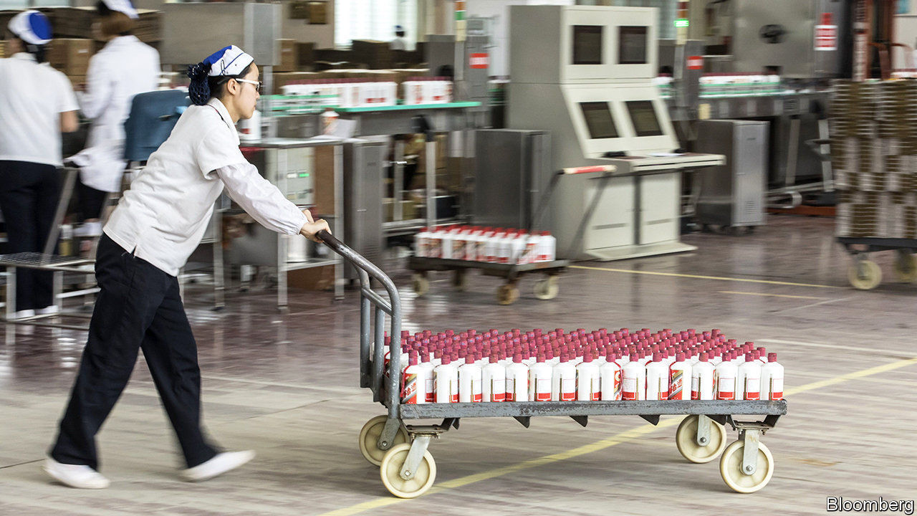

CHINESE DISTILLERS of baijiu are proud of their role in Mao’s Long March, when the firewater produced by Kweichow Moutai is fabled to have sterilised soldiers’ wounds and steeled their resolve. It is only fitting, then, that they would mobilise for what China has termed a “people’s war” against covid-19. Moutai has donated 114m yuan ($16m). Others have gone further, setting up sidelines in medical disinfectant made with 75% ethanol. Amid an acute shortage of antivirus gear, the state is handing out production licences.

Last month Li Keqiang, China’s prime minister, urged firms to boost supplies of protective kit for medical workers by expanding or converting production lines. Yibin Guomei Liquor, a baijiu distiller from Sichuan province, had already swung into action. By February 4th a sister company that makes ethanol was sending sanitiser to its baijiu workshops for bottling and packaging. Two assembly lines now produce 250,000 bottles of disinfectant a day.

Yibin Guomei’s first 2m bottles were sold (at a loss) to the local government, which distributed one to each home in Yibin. The next batch went to the fire brigade, traffic police and other departments. The next lot was distributed nationwide—at full price. Liao Maolan, who helps run Yibin Guomei, expects subsidies. The firm is already drawing up plans for a permanent disinfectant-packaging workshop.

It is not just booze businesses that are retooling. An affiliate of GEM, a battery recycler, is producing sanitiser. BYD, a maker of electric cars, aims to churn out 50,000 bottles of disinfectant and 5m masks a day—a quarter of China’s usual capacity. Shaanxi Automobile Group, which builds lorries, is producing goggles. So is Xingchi Hengdong, a division of China South Industries Group, an armsmaker (it normally 3D-prints spacecraft parts). Daddy Baby, a nappy producer, has gone into masks.

All told, over 10,000 companies have added masks, hazmat suits, thermometers and the like to their product lines in the past two months, estimates Tianyancha, a data firm. Thomas Luedi of Bain, a consultancy, says weak demand during the outbreak spurred factories to redeploy workers to make vital goods. Licence in hand, Yibin Guomei called back labourers on their spring-festival break. Making masks and disinfectant is “not awfully complicated”, Mr Luedi adds.

Firms are also producing antivirus kit for their own use, in order to meet new workplace standards. Yibin Guomei is scrubbing its baijiu factories with its disinfectant. Foxconn, a contract manufacturer that assembles iPhones, is making masks for its 1m-plus employees. State-owned enterprises have been commandeered to produce and donate much-needed supplies. For market-oriented firms, the sooner covid-19 is contained, the sooner they can get back to business, notes Mr Luedi. Most expect a surge in orders because of pent-up demand, and will quickly return assembly lines to their original purpose.

The government has assured virus-fighting firms that it will buy leftover stock. It has also directed state banks to grant cheap loans to those making crucial equipment. Xiaomi, a smartphone-maker, is among those seeking a 5bn-yuan loan to make thermometers and other gear, according to Reuters. Authorities have already reportedly caught some 50 state-owned borrowers masquerading, literally, as makers of face masks and such.■

Dig deeper:

* For more coverage of covid-19 see our [coronavirus hub](https://www.economist.com/news/2020/03/11/the-economists-coverage-of-the-coronavirus)
* The science of the virus
* Fatality rates for covid-19 could vary enormously
* How to deal with a new sort of financial shock
* Should other countries copy Italy’s nationwide lockdown?

This article was downloaded by calibre from <https://www.economist.com/business/2020/03/14/chinese-companies-rush-to-produce-anti-covid-kit>

|  |  |  |  |
| --- | --- | --- | --- |
| Previous | Articles | Sections | Next |

|  |  |  |  |
| --- | --- | --- | --- |
| Previous | Articles | Sections | Next |

#### Bartleby

# Rethinking sick leave

Attitudes towards employee illness are out of step with the times

Mar 14th 2020 |



THE GLOBAL spread of covid-19 has led to calls for those who might be infected with the new disease to “self-isolate” at home. That could prove a threat to economic activity. It also represents a terrible dilemma for workers, some of whom could face financial hardship if they don’t turn up.

The quandary is all the greater when the disease is unfamiliar, with symptoms that are often mild, at first, and resemble common ailments. And if, like a quarter of all Americans working in the private sector, employees get no paid sick leave at all, they are more likely to take the risk and attend. In 2009 the outbreak of swine flu presented workers with a similar decision. Many American ones decided to turn up for work regardless, further spreading the infection. One study* estimated that around 7m co-workers were infected as a result.

The most recent global survey** of sick pay by the International Labour Organisation, from 2010, showed that 145 countries provided for paid sick leave at the time. Most mandated replacement pay of around 50-75% of wages. More than 100 allowed employees to be absent for a month or more.

The fear of employers and governments is that generous benefits will be costly and create the temptation for employees to malinger. It is true that Britain and America, which have stingy (if any) benefits, see almost no days of absence, on average. But most countries with generous benefits experience fewer than ten days a year of absence. Based on OECD data from 2017 the gap between annual days lost to sickness in France, where 50-100% of income is replaced during sick leave, and in America was a mere 4.4 days.

Other evidence does not suggest that more generous sick pay leads to extra skiving. The Earned Sick Time Act became law in New York in 2014. A survey of 352 employers four years ago found that almost 85% had experienced no increase in costs and only 3% had suffered more than a token rise. Connecticut adopted similar legislation in 2011 in the face of opposition from business lobbies. A study of companies in 2013 found that many noted benefits such as improved morale and fewer infections in the workplace.

The problem may be that sick-pay rules are too strict for employees, not too generous. Given the need to pay the rent, many low-paid workers may feel they have to work unless they are so sick as to be physically incapable of leaving the house. But things may be changing. In America the Democrats have long proposed statutory sick leave. President Donald Trump now talks of emergency relief for sick workers.

British policy has also shifted. Statutory sick pay will now be payable on the first day of absence, rather than the fourth. In its budget on March 11th the government removed a minimum income requirement that kept many part-time workers from qualifying for sick pay. It will also allow workers to get a sick note online rather than travel to a clinic and risk infecting other patients. Further change may still be needed. The statutory weekly rate, at £94.25 ($123), is less than 20% of average earnings, and may tempt more workers to turn up when feeling iffy.

At some stage in their careers most people will have turned up to work when they were feeling under the weather, be it because of a looming deadline or for fear of displeasing their boss. The health of fellow citizens, whether at work or on public transport, tends to be treated as collateral damage.

In a world where global travel is common and easy, and diseases have the scope to spread quickly, social norms may therefore need to change. That means not just washing hands, or indeed forgoing the handshake as a greeting. It could also require a shift in attitudes towards workers who turn up while sick and potentially infectious, from plaudits for their diligence to scorn for their lack of consideration.

Countering pandemics requires all sorts of public action, from forging new social norms to devising vaccines that authorities have the duty to supply. Ensuring that workers do not have a financial incentive to spread disease is another example. That requires governments to guarantee a decent level of sick pay, and rules on sick leave that do not punish responsible citizens.

** “Paid Sick Leave: Incidence, Patterns and Expenditure in Times of Crises”, by Xenia Scheil-Adlung and Lydia Sandner

Dig deeper:

* For more coverage of covid-19 see our [coronavirus hub](https://www.economist.com/news/2020/03/11/the-economists-coverage-of-the-coronavirus)
* The science of the virus
* Fatality rates for covid-19 could vary enormously
* How to deal with a new sort of financial shock
* Should other countries copy Italy’s nationwide lockdown?

This article was downloaded by calibre from <https://www.economist.com/business/2020/03/14/rethinking-sick-leave>

|  |  |  |  |
| --- | --- | --- | --- |
| Previous | Articles | Sections | Next |

|  |  |  |  |
| --- | --- | --- | --- |
| Previous | Articles | Sections | Next |

#### Altocumulus

# How corporate IT is entering the multi-cloud

A new formation is rising in the computing skies

Mar 14th 2020 | SAN FRANCISCO

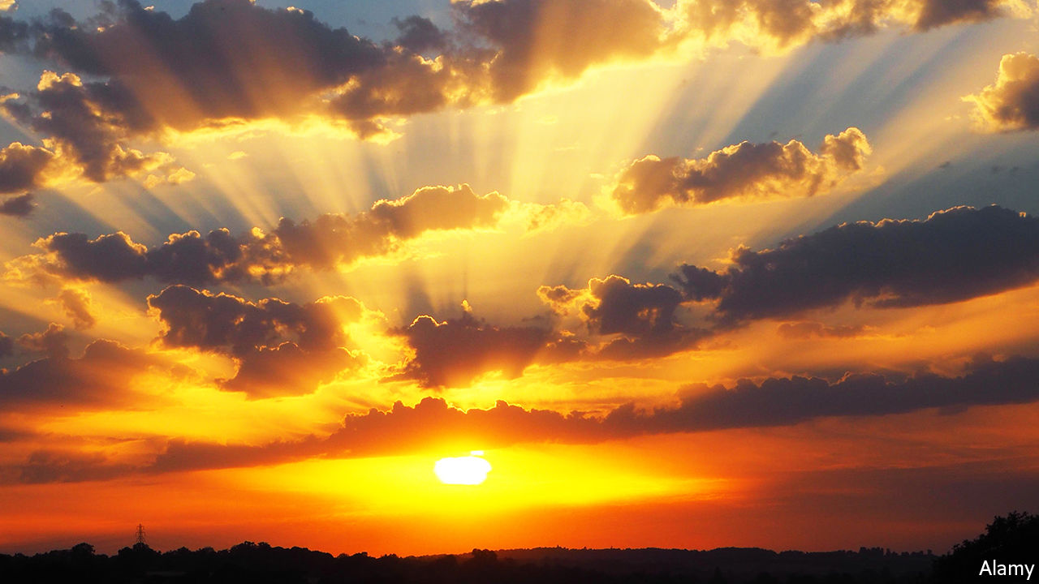

CORPORATE COMPUTING is supposed to solve problems, but often creates new ones, which have to be mended with more IT. These fixes create yet more problems and so on. The newest layer of IT geology is the “multi-cloud”. On March 10th VMware became the latest big software-maker to unveil its contribution.

The computing cloud is old hat. Most companies use at least one business service provided over the internet, be it raw number-crunching or web-based applications. In all, businesses spent nearly $230bn globally in 2019 on the cloud, according to Gartner, a research firm, and could splurge as much as $355bn in 2022. The lion’s share goes to three market leaders: Amazon Web Services (AWS), Microsoft Azure and Google Cloud.

Yet individual firms tend to use more than one cloud provider. Plenty employ dozens of them. They fear shackling themselves to just one—or, in the words of Pat Gelsinger, VMware’s chief executive, “they don’t just want to have a new IBM mainframe called AWS”. And they have diverse needs, related to specific digital tasks, necessary redundancy or compliance with data-localisation requirements. All this means that—in keeping with another eternal IT constant—their technological infrastructure is fragmented.

Enter the multi-cloud. The basic idea is to create an overarching, unified platform—a cloud of clouds, if you will. One approach is the “hybrid cloud”, which combines a customer’s own computers with the ones operated by, say, AWS. Another is to connect applications hosted by different cloud providers.

The third, which VMware promises, is the multi-cloud holy grail: to allow companies to shift computing workloads easily from one provider to another, depending on things like price, reliability and distance to the customer. This task has been made considerably easier by Kubernetes, an increasingly popular piece of open-source software that packages computing tasks in standard digital containers and allows firms to manage these, as if they were the commander of a container vessel (kubernetes is Greek for “helmsman”).

VMware’s offerings look particularly ambitious. It already helps companies run their local computer systems but now wants to be the main pilot to assist them in navigating their dispersed clouds. With a similar goal in mind, last July IBM acquired Red Hat, whose software resembles VMware’s. The big three cloud providers are also getting into the game, albeit more gingerly for the time being. Google’s multi-cloud technology is called Anthos. Amazon and Microsoft have launched, respectively, AWS Outposts and Azure Stack, which let firms build local clouds that are then connected to the firms’ bigger remote one. Both companies also have agreements with VMware, which enable the firm’s customers to run its software on AWS and Azure.

These deals point to another iron rule of IT: always try to turn your rivals’ competitive advantage into a commodity. If VMware and IBM are trying to create an über-cloud, it is to turn the big three into mere peddlers of cheap computing power.

This strategy is not guaranteed to work, warns Mark Moerdler of Bernstein, a research firm. The number of companies that really need to move their workloads around seamlessly is small, he argues. And the multi-cloud’s universality comes at the expense of specificity. It is, for instance, unable to accommodate the entire suite of features, some of them proprietary, offered by each of the big providers. Many customers would hesitate to forsake such benefits.

That leaves one last, related question. Is the perennial IT promise of “write once, run everywhere” realistic? It was supposed to work for Java, a programming language, and the software written in it was predicated on this idea. It proved tricky in real life. “There has always been this dream, on the West Coast in particular, that we should live in a Utopia where all the vendors are interchangeable,” quips Lydia Leong of Gartner. The multi-cloud may be here to stay. But do not expect it to cover the entire computing sky any time soon.■

This article was downloaded by calibre from <https://www.economist.com/business/2020/03/14/how-corporate-it-is-entering-the-multi-cloud>

|  |  |  |  |
| --- | --- | --- | --- |
| Previous | Articles | Sections | Next |

|  |  |  |  |
| --- | --- | --- | --- |
| Previous | Articles | Sections | Next |

#### Going in circles

# Academics make an empirical case again stakeholderism

A new paper shows that corporate professions of purpose look mostly like a publicity stunt

Mar 14th 2020 | NEW YORK



“EACH OF OUR stakeholders is essential.” Those words were part of a declaration signed last August by 181 bosses of big American companies belonging to the Business Roundtable (BRT), an eminent lobby group. It seemed to represent quite a U-turn—nothing short of a repudiation of America Inc’s shareholder-first orthodoxy. As investors pour billions into funds promoting environmental, social and governance objectives beyond profitability, a vision of a cuddlier capitalism has taken hold.

Or has it? In a new paper Lucian Bebchuk and Roberto Tallarita of Harvard Law School pore over data from the companies of some of the BRT signatories and find little evidence (so far) that the declaration has altered corporate behaviour. For example, they found that only three of the 20 companies whose CEOs sit on the BRT’s board—Boeing, Stryker and Marriott—have amended their corporate-governance guidelines in any way since the declaration. And none of the amendments had anything to do with stakeholder welfare, the authors say.

The latest data on incentives suggest shareholders come first. The 20 firms’ non-executive directors earn an average 56% of their compensation in the form of equity stakes, which are by definition driven by shareholder value; 87-95% of their bosses’ pay is tied to performance. Only Duke Energy, Eastman and Marriott tie bonuses to a quantified stakeholder metric—and only in a limited way. Eastman includes three measures of employee safety, but it is up to the compensation committee to decide what weight to assign to each.

The firms’ hands may have been tied. Fully 70% of the BRT statement’s signatories are incorporated in Delaware, whose corporate law is shareholder-friendly. The state’s former chief justice goes so far as to argue in a recent article that “within the limits of their discretion, directors must make stockholder welfare their sole end”.

This need not be a problem, Messrs Bebchuk and Tallarita think. Farsighted bosses have always known that promoting long-term shareholder value requires delivering for customers and treating workers and suppliers reasonably. It is unclear if the same can be said of championing fuzzy stakeholderism.

This article was downloaded by calibre from <https://www.economist.com/business/2020/03/14/academics-make-an-empirical-case-again-stakeholderism>

|  |  |  |  |
| --- | --- | --- | --- |
| Previous | Articles | Sections | Next |

|  |  |  |  |
| --- | --- | --- | --- |
| Previous | Articles | Sections | Next |

#### Schumpeter

# The rise and rise of Accenture

The consultancy has ballooned into a consulting behemoth. Can it keep growing?

Mar 14th 2020 |

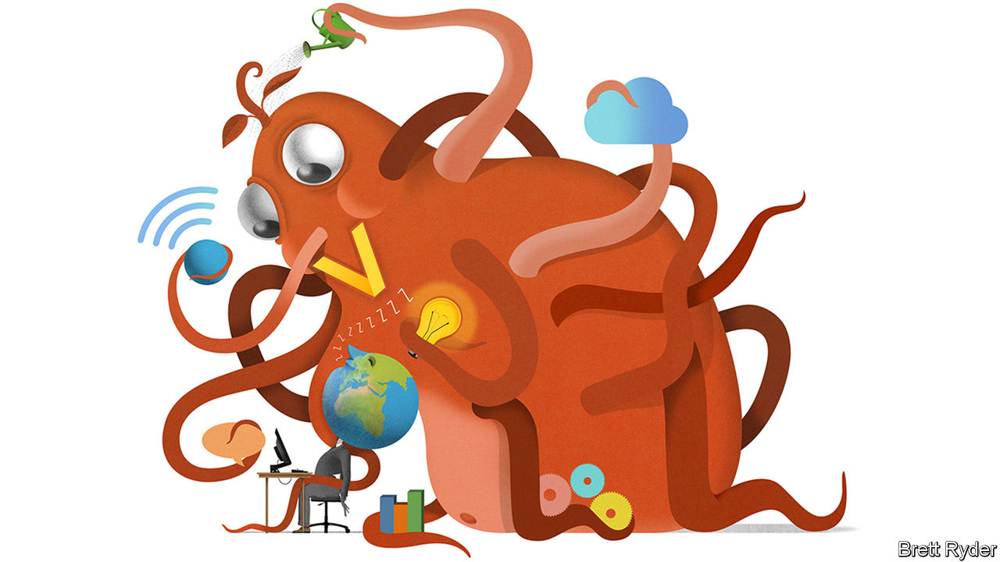

MANAGEMENT CONSULTANTS thrive on a simple business model. First, scare companies by laying bare where they are failing. Then soothe them with counsel on how to improve. The scaring part has grown easier as technology upends one industry after another. Rare is the chief executive these days unconcerned about cyber-security, artificial intelligence (AI) or their online offering. The soothing, though, may have become harder. Who is a boss to trust when consultancies themselves are only slowly getting to grips with the meaning of technological upheaval?

To a growing number of CEOs the answer is Accenture. The firm, whose name is a portmanteau of “accent on the future”, certainly has pedigree when it comes to tech. It is descended from Arthur Andersen, an accounting-and-advisory giant which helped persuade General Electric to install a UNIVAC 1, corporate America’s first computer, in 1954. In 2000 Andersen Consulting finally severed its strained ties to its parent (whose remaining accountancy business was felled two years later by the Enron fraud scandal). It changed its name and, in 2001, listed on the stockmarket at a value of $14bn.

Since then its growth has been tentacular. Today around 200 clients are thought to pay Accenture at least $100m each annually to keep their tech humming. Its 500,000 or so employees perform menial functions (running clients’ overseas call centres or making their sales software connect properly to accounting) and more glamorous ones (uploading businesses to the cloud, designing their apps, building AI chatbots, even imagining their next ad campaign). Last year the firm’s revenues reached $43bn. Total shareholder returns, including dividends, come to 118% over the past five years, compared with 56% for the S&P 500 index. In February its market capitalisation hit $137bn.

Two things help explain Accenture’s rise. One was beyond its control: technology’s role within companies has moved from the back office to the core of what many of them do—hence those corner-office jitters. The second factor was a tech-heavy soothing strategy. Pierre Nanterme, a Frenchman who led Accenture from 2011 until shortly before his death in January 2019, doubled down on all things analytics, mobile, cloud and cyber-security. Each year the firm spends roughly $1bn on around two dozen acquisitions to get on top of the buzziest tech trends. What Accenture calls “The New” now accounts for around two-thirds of its sales, up from one-third five years ago.

“The New” complements Accenture’s older capabilities in a way that is hard for rivals to match. Unlike outsourcing competitors such as India’s Infosys or Tata Consultancy Services, it has management-consulting chops from the Andersen days. At the same time, in contrast to august strategy firms like McKinsey or accountant-advisers like Deloitte, EY or PwC, its army of relatively cheap white-collar labour, roughly half of it in India and the Philippines, can be enlisted to perform labour-intensive tasks such as taking down dodgy videos on social media (which Accenture does for Facebook and Google). A global footprint helps insulate it against downturns in any particular region. Despite rivals’ claims of the superiority of the limited-partnership model, which still dominates the industry, Accenture’s stockmarket listing does not appear to have hurt its growth.

The result is an unusual ability to offer clients a comprehensive service. Refocusing your business around a new app? Accenture will be on hand to write the code—but can also supply designers to make it look pretty. Need an ad blitz to sell it to consumers? Accenture’s marketing arm grossed $10bn in revenue last year, placing it among the five biggest ad groups in the world—it has become a creative agency not dissimilar from WPP or Publicis Groupe. Want to expand into new markets? Just ring one of its more than 200 offices in 51 countries.

The question for Julie Sweet, an American who took charge in September, is whether Accenture can keep ballooning. She faces three challenges. First, the sheer scale of the firm already feels daunting. No listed corporation bar Amazon and Chinese hardware-makers added more employees in the 2010s. It is tricky to build a culture—and foster a sense of purpose that clever clogs now demand of their employers—that appeals to both buttoned-down database managers in Bangalore and tattooed creative directors in Spitalfields. Accenture has morphed into a white-collar conglomerate at a time when investors favour focused businesses. Its margins are less juicy than those of the Indian outsourcers.

The second challenge is an economic downturn, like the one that looks increasingly possible as covid-19 goes pandemic. Recessions hurt consultants as cash-strapped clients focus on survival rather than expansion. Accenture weathered the financial crisis of 2007-09 but its revenues sank. Its share price has now fallen as it did back then, this time by a quarter since its February peak, faster than the covid-infected markets as a whole.

Ms Sweet’s final predicament is perhaps the most consequential. If her firm keeps doing such a bang-up job in convincing clients that technology is central to their success, more of them might opt to build and run a bigger slice of it in-house rather than splurging on outside advice. Accenture seems at times to suggest that companies should let its consultants handle not just their brand and tech innards, but also their power to innovate.

## Tech tonic

Still, the Nanterme-era digital strategy has life in it yet. Many companies are behind in the technology race. Before most so much as ask themselves how zippy 5G networks, the “Internet of Things” or machine learning will transform their businesses, Accenture already has some answers. If someone, some day, finds a function for blockchain, expect Accenture to be there to advise bosses on its use—and to soothe frayed nerves.■

This article was downloaded by calibre from <https://www.economist.com/business/2020/03/14/the-rise-and-rise-of-accenture>

|  |  |  |  |
| --- | --- | --- | --- |
| Previous | Articles | Sections | Next |

|  |  |  |
| --- | --- | --- |
| Business | Sections | Science and ... |

Finance and economics

The cash question: In a sea of debt

.

Oil prices: Scorched earth

.

Italy in crisis: Mr Conte counts the costs of covid

.

The bear facts: Entering a bear market

.

Indian banks: When Yes means no

.

Buttonwood: Involuntary code

.

Free exchange: The ravages of time

.

|  |  |  |
| --- | --- | --- |
| Business | Sections | Science and ... |

|  |  |  |  |
| --- | --- | --- | --- |
|  | Articles | Sections | Next |

#### A sea of debt

# Corporate bonds and loans are at the centre of a new financial scare

The pool of corporate lending has risen to $74trn

Mar 12th 2020 |

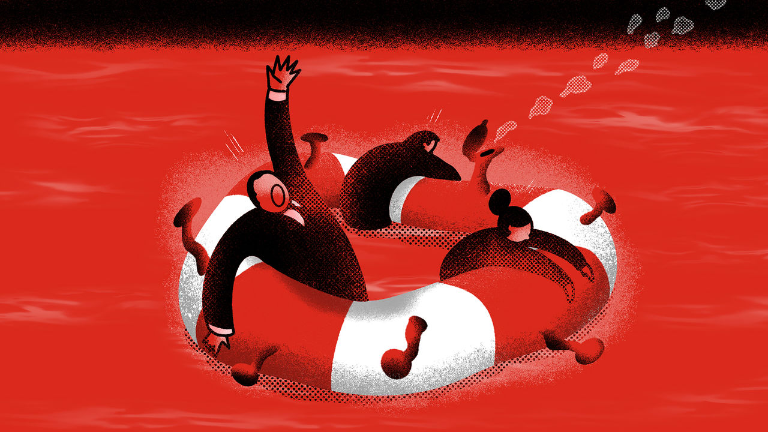

OVER THE past decade officials—and some bankers—have tried to redesign the financial system so that it acts as a buffer that absorbs economic shocks rather than as an amplifier that makes things worse. It faces a stern test from the covid-19 virus and the economic ruptures it has triggered, not least a Saudi-led oil-price war (see next article). The locus of concern is in the world’s ocean of corporate debt, worth $74trn. On Wall Street the credit spreads of risky bonds have blown out, while in Italy, a bank-dominated economy that is already in lockdown, the share prices of the two biggest lenders, Intesa Sanpaolo and UniCredit, have dropped in the past month by 28% and 40% respectively.

The scare has four elements: a queasy long-term rise in borrowing; a looming cash crunch at firms as offices and factories are shut and quarantines imposed; the gumming-up of some credit markets; and doubts about the resilience of banks and debt funds that would bear any losses.

Take the borrowing first. Companies came out of the 2007-09 financial crisis in a relatively sober mood, but since then have let rip. Global corporate debt (excluding financial firms) has risen from 84% of GDP in 2009 to 92% in 2019, reckons the Institute of International Finance. The ratio has risen in 33 of the 52 countries it tracks. In America non-financial corporate debt has climbed to 47% of GDP from 43% a decade ago, according to the Federal Reserve.

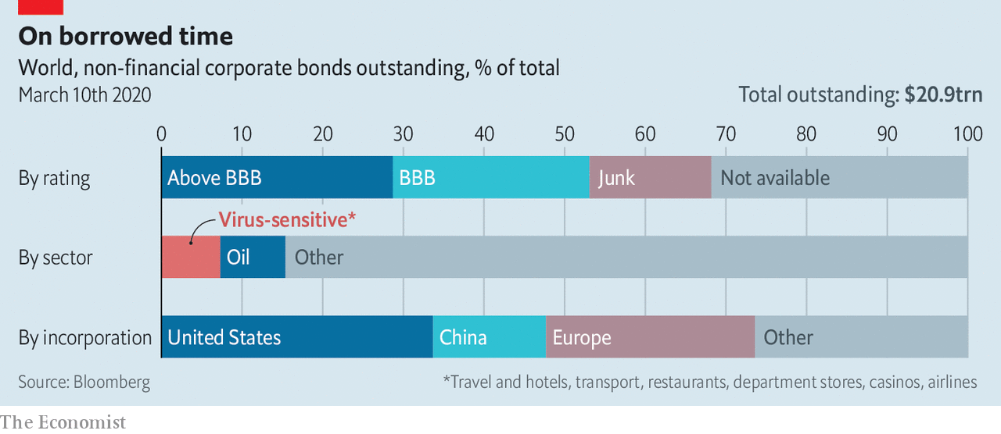

Underwriting standards have slipped. Two-thirds of non-financial corporate bonds in America are rated “junk” or “BBB”, the category just above junk. Outside America the figure is 39%. Firms that you might think have rock-solid balance-sheets—AT&T—have seen their ratings slip, while others have been saddled with debts from buyouts. Naughty habits have crept in: for example, using flattering measures of profit to calculate firms’ leverage.

All this leaves business more vulnerable to the second factor, the shock from covid-19 and the oil-price slump. Some 7% of non-financial corporate bonds globally are owed by industries being walloped by the virus, such as airlines and hotels. With oil close to $35, America’s debt-addicted frackers and other oil firms are in trouble. Energy is 8% of the bond market.

A far broader set of firms could face a cash crunch if temporary shutdowns and quarantines spread. In China over the past months, financial distress—and informal forbearance—has been widespread. One multinational says it has relaxed its payment terms with suppliers in China. HNA, an outrageously indebted conglomerate than runs an airline, has been bailed out.

To get a sense of the potential damage in other countries The Economist has done a crude “cash-crunch stress-test” of 3,000-odd listed non-financial firms outside China. It assumes their sales slump by two-thirds and that they continue to pay running costs, such as interest and wages. Within three months 13% of firms, accounting for 16% of total debt, exhaust their cash at hand. They would be forced to borrow, retrench or default on some of their combined $2trn of debt. If the freeze extended to six months, almost a quarter of all firms would run out of cash at hand.

The near-certainty of rating downgrades and defaults in the travel-related and oil industries, and the possibility of a broader crunch, is the third concern. Credit derivatives, the most actively traded part of the fixed-income markets, have recoiled. The CDX index, which reflects the cost of insuring against default on investment-grade debt, is at its highest level since 2016, as is the iTraxx crossover, which covers riskier European borrowers. Out of the public eye, privately traded debt may now only change hands at heavily discounted prices. The issuance of new debt has “dried up”, says the head of a big fund manager. This could fast become a serious problem because firms need to refinance $1.9trn of debt worldwide in 2020, including $350bn in America.

Fractured markets mean the fourth element, the resilience of the institutions that make loans and buy bonds, is critical. A majority of American bonds are owned by pension funds, insurers and mutual funds that can cope with losses. But some will be reluctant to buy more. And 10-20% of all American corporate debt (bonds and loans) is owned by more esoteric vehicles such as collateralised-loan obligations and exchange-traded funds. Such exposures have yet to be fully tested in an extended period of severe market stress.

Who, then, can act as a source of stability and fresh lending? Some big cash-rich firms such as Apple could grant more favourable payment terms to their supply chains. Private-equity firms have capital to burn. But in the end much will rest on the banks, who have the relationships and flexibility to extend credit to tide firms over. America’s banks have their flaws—Goldman Sachs is sitting on $180bn of loans and lending commitments with ratings of BBB or below, for example. But broadly speaking they are in reasonable shape, with solid profits and capital positions.

Outside America the picture is less reassuring. Europe’s banks make puny profits, partly because interest rates are so low; Italian banks had a return on equity of just 5% last year. Since the virus struck, the cost of insuring their debt against default has flared up, hinting that they could yet become a source of contagion. State-backed banks in China and India will do as directed by politicians. But they are already labouring under large bad debts.

Global business may need a giant “bridging loan” to get through a tough few months. And governments may need to intervene to make it happen: by flooding credit markets with liquidity; by cutting taxes to get cash to companies; and by prodding banks to lend and show forbearance. The world’s financial system has not yet become a source of contagion in its own right. But neither has it shown it can spontaneously help firms and households absorb a nasty but transitory shock.■

This article was downloaded by calibre from <https://www.economist.com/finance-and-economics/2020/03/12/corporate-bonds-and-loans-are-at-the-centre-of-a-new-financial-scare>

|  |  |  |  |
| --- | --- | --- | --- |
|  | Articles | Sections | Next |

|  |  |  |  |
| --- | --- | --- | --- |
| Previous | Articles | Sections | Next |

#### Scorched earth

# No one is likely to win the oil-price war

Saudi Arabia, Russia and America will all suffer

Mar 14th 2020 |

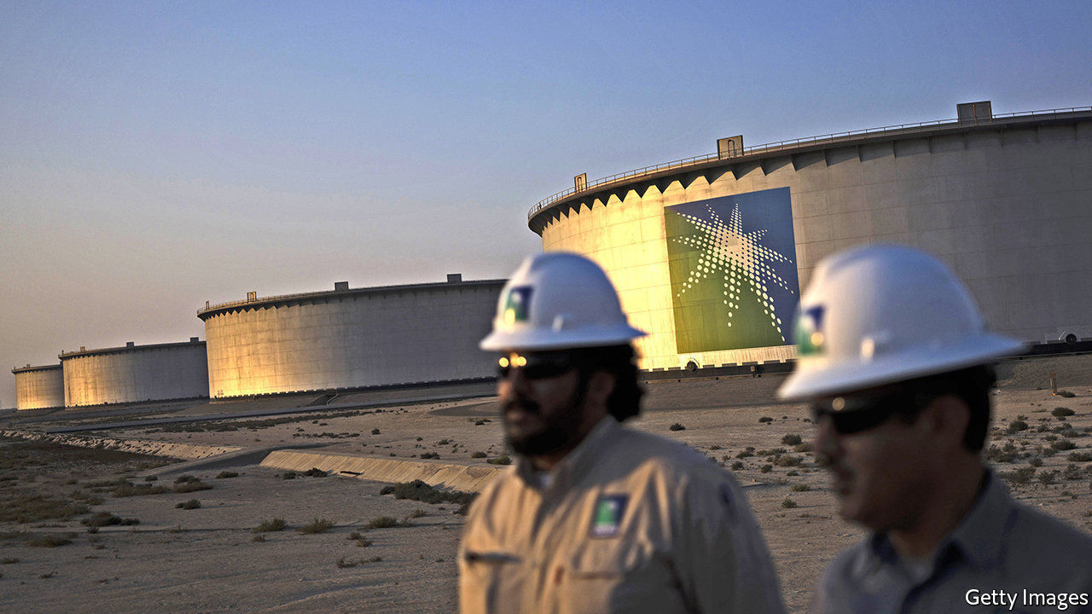

SAUDI ARABIA and Russia are used to fighting their enemies via proxies. But the oil-price war that has broken out between them is head-on and has swiftly escalated. It started when Russia refused to slash production during a meeting with the Organisation of the Petroleum Exporting Countries in Vienna on March 6th. Saudi Arabia, OPEC’s de facto leader, hit back with discounts to buyers and a promise to pump more crude. Shortly thereafter it said it would provide customers with 12.3m barrels a day (b/d) in April, about 25% more than it supplied last month—and a level it has never before attained. Russia said it could raise output, too, adding up to 500,000 b/d to its 11.2m b/d. The price of Brent crude plunged by 24%, to $34 a barrel, on March 9th—its steepest one-day drop in nearly 30 years.

Amid turmoil in global markets unleashed by the plummeting oil price, and panic about its impact on the global economy, Saudi Arabia upped the ante again on March 11th, ordering Saudi Aramco, its state-owned oil giant, to raise national production capacity by a further 1m b/d. Is the kingdom merely strengthening its bargaining position to force Russia back to the table? Or is it waging a fierce price war to crowd out rivals that will instead ensure what analysts at Bernstein, an investment firm, call “mutually assured destruction”? The answer may determine how long the disruption will last.

The fallout caps a seismic decade for oilmen. Power has shifted between Saudi Arabia, Russia and America (see chart). In 2014 Saudi Arabia sought to check America’s ascendant shale industry by flooding the market with oil. The result was cataclysmic for all producers. Two years later OPEC restored its grip on output by forging an alliance with Russia and others.

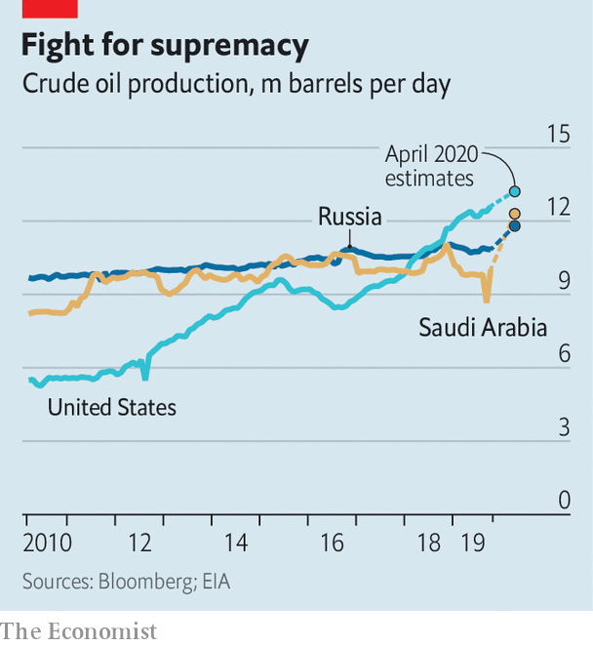

In recent years, though, Russia has flouted the terms of its deals with OPEC. Its oil companies, led by Rosneft, have chafed at market share lost to American frackers. As troubling for Russia, America has become less shy about leaning on foreigners. In December it announced sanctions to delay Nord Stream 2, a Russian gas pipeline to Europe. In February America imposed sanctions to punish Rosneft for its dealings with Venezuela.

Russia’s partnership with OPEC has won it new influence in the Middle East, while Saudi Arabia has borne most of the burden of production cuts. The Saudis are getting tired of the role of swing producer. That position has become all the more invidious since January, when the outbreak of covid-19 in China, the world’s biggest oil importer, put downward pressure on prices.

The Saudi decision to open the spigots is nevertheless extremely rash. With the coronavirus raging, global appetite for oil may decline in 2020 for only the third time in more than 30 years. Increasing supply at a time of falling demand may send the price of Brent crude below $30 in the second quarter, estimates Citi, a bank.

The pain may be most acute for smaller, unstable countries dependent on oil revenue, such as Nigeria. Iraq’s government is already teetering—a collapsing oil price may topple it. The movement of forward contracts on Gulf currencies pegged to the dollar, such as Oman’s rial, suggest incipient concerns about the ability to sustain the pegs if dollar revenues from oil remain depressed for a long time.

America, too, will be hit hard. Cheap oil used to be a boon to America’s economy. That is no longer the case. In a viral outbreak, savings on petrol are unlikely to translate into more spending on other things, especially ones that involve crowds. Even if it did, any boost to the economy from consumers would be outweighed by damage to shale states such as Texas and North Dakota. Breakeven prices—those oil producers need to turn a profit—in America’s shale basins range from $23 to $75 a barrel, according to the Dallas Federal Reserve. Production cuts and lay-offs are likely.

Making matters worse, shale firms were suffering even before the latest sell-off, as investors questioned their capacity for sustained profits. Capital markets have all but closed to the industry. It will not collapse; many shale firms are hedged against falling prices this year. Those on their knees may well be taken over by bigger competitors. Analysts say larger rivals such as ExxonMobil have the balance-sheets to cope with cheap oil.

Russia may fail in its attempt to kill off America’s shale industry. Moreover, weak oil prices will hurt its economy. But unlike Saudi Arabia, whose currency is pegged to the dollar, the rouble floats. When oil prices fall, the currency does, too, lowering production costs. On March 10th Russia’s finance ministry said that the country had enough foreign-currency reserves to withstand a decade of prices hovering between $25 and $30. It seems in no hurry to go back to negotiations with OPEC.

With some of the world’s cheapest oil, Saudi Arabia may be able to pile more pressure on the Russians. Aramco has more than 50 years of reserves, and costs per barrel of less than $9, according to Rystad Energy, a data firm, compared with $15 for Russia. Still, Saudi Arabia may struggle to maintain production—even 12.3m b/d will require tapping its vast inventories.

Moreover, the kingdom’s budget requires an oil price of more than $80, estimates the IMF. Goldman Sachs, a bank, reckons that if it increases output and oil prices recover, its finances will weather temporary pain. But if the virus persists and demand keeps plunging, the damage may be more lasting. It is a price war that no one looks likely to win. ■

This article was downloaded by calibre from <https://www.economist.com/finance-and-economics/2020/03/14/no-one-is-likely-to-win-the-oil-price-war>

|  |  |  |  |
| --- | --- | --- | --- |
| Previous | Articles | Sections | Next |

|  |  |  |  |
| --- | --- | --- | --- |
| Previous | Articles | Sections | Next |

#### Sticking plasters

# The challenge of addressing covid-19’s economic effects in Europe

A swift response depends not only on national governments

Mar 14th 2020 |

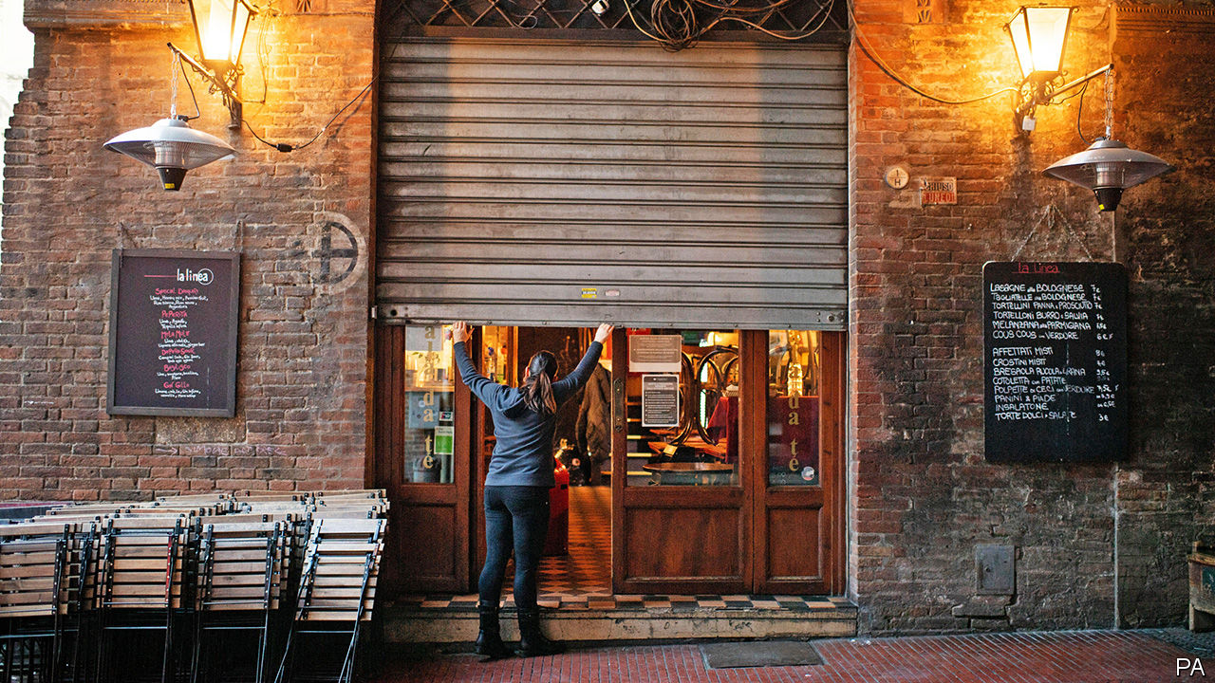

FEW PEOPLE would wish to trade places with Giuseppe Conte, Italy’s prime minister. As covid-19 spread he put the entire country into lockdown for the first time since the second world war. Now he must try to contain the economic effects. But he is finding that tackling them also depends on lenders and Europe’s institutions.

The immediate prognosis is a severe contraction. Economists at JPMorgan Chase, a bank, expect GDP to fall at an annualised rate of 7.5% in the first quarter of the year. The hope at least is that recovery is rapid. To that end, Mr Conte said on March 11th that he would set aside €25bn ($28bn, or 1.4% of GDP) in order to cushion the epidemic’s economic effects. The precise measures were yet to be agreed as The Economist went to press, but were expected to include compensation for companies that lose revenues and workers who are laid off. Ministers have also promised to help banks suspend repayments on mortgages and small-business loans for a year.

As people fall ill and quarantines are imposed, businesses and households face abrupt disruptions to their income. That means quick fixes are in high demand. Unlike public-spending measures, bank forbearance does not need legislation, and so can take immediate effect. But Italy’s lenders, which already have higher non-performing loan ratios than the euro-area average, warn that they cannot cope with the loss in interest income unless the government guarantees unpaid loans, so that they do not have to hold more provisions.

In any case, leniency from lenders will help some of those most disrupted by the epidemic, but not all. Small firms, which are more likely to rely on bank finance, will benefit. But only 15% of Italian households have mortgages. The neediest, says Tito Boeri, a former head of the social-security administration, cannot take out loans in the first place. More helpful would be to extend unemployment benefit to cover the self-employed, who make up a fifth of the workforce, and temporary workers whose contracts are due to expire. For as long as the outbreak lasts, benefits will need to be unconditional and generous, notes Francesco Giavazzi of Bocconi University. If they are too stingy, people will start hoarding cash, fearing that the government could withdraw its support.

Italy’s membership of the euro means that tackling the epidemic depends not just on ministers in Rome. The European Central Bank (ECB) could help lenders continue to provide liquidity. As this newspaper went to press, the ECB was expected to loosen policy, either by cutting interest rates or offering banks cheap funding to lend to companies. But, with its interest rates already at -0.5%, it cannot cut rates much further. By contrast, both the Federal Reserve and the Bank of England have cut rates by 0.5 percentage points.

That means fiscal policy in Europe will have to do more work. But here Italy’s public finances pose a complication. Government debt is already high: in 2019 it exceeded 130% of GDP. The extra spending means that Italy seems likely to exceed the European Commission’s deficit ceiling, of 3% of GDP, this year. In a sign that investors are fearing for the state of Italy’s finances, and perhaps nervous of a row with Brussels, yields on ten-year sovereign bonds have risen in recent weeks, while those on German bunds have fallen. But if Mr Conte does not borrow more now, the consequence will be a more prolonged downturn—and therefore a higher debt-to-GDP ratio in the long term, warns Mr Giavazzi.

That is perhaps why the European Commission says it will allow Italy to break its fiscal rules. The commission plans to issue new guidelines on spending next week. Emmanuel Macron, France’s president, wants bolder action. He is pressing for the rules to be suspended altogether, and for member states to co-ordinate spending increases; that could shore up confidence that Europe will do what it takes to cushion the economic blow from the virus. But Mr Macron’s efforts have so far come to nothing, because his counterparts in Germany and other northern countries prefer a wait-and-see approach. As the epidemic spreads, though, the advantages of a decisive response will only become clearer. ■

This article was downloaded by calibre from <https://www.economist.com/finance-and-economics/2020/03/14/the-challenge-of-addressing-covid-19s-economic-effects-in-europe>

|  |  |  |  |
| --- | --- | --- | --- |
| Previous | Articles | Sections | Next |

|  |  |  |  |
| --- | --- | --- | --- |
| Previous | Articles | Sections | Next |

#### Webfly

# Entering a bear market

Mar 14th 2020 |

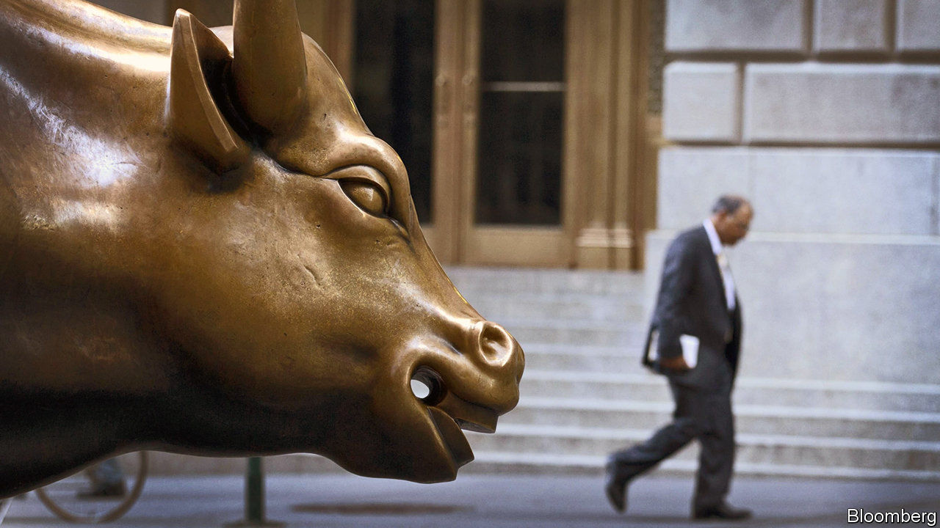

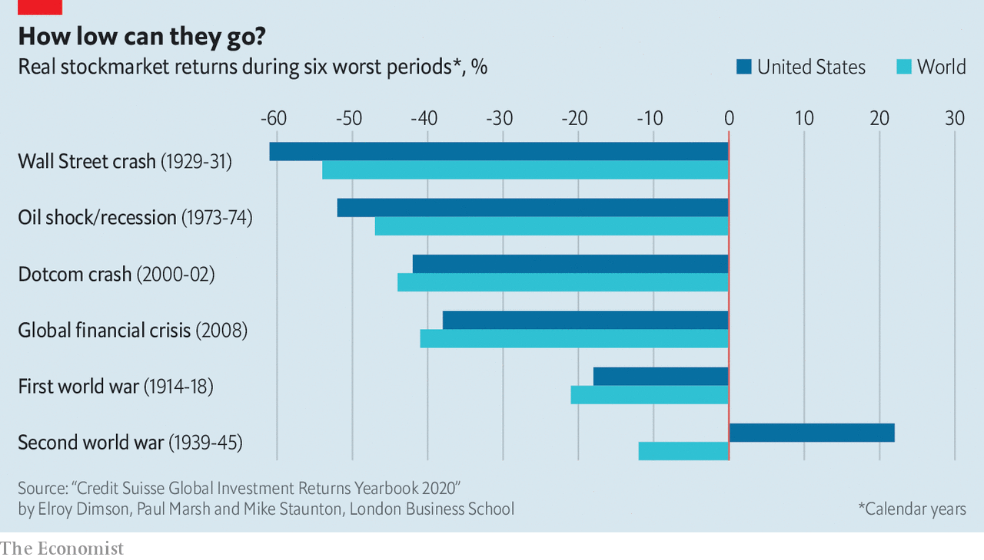

IT MAY HAVE been lost amid the stockmarket panic but on March 9 America’s bull market turned 11 years old. Two days later, it was history. Concerns about the covid-19 epidemic have caused a rout in the Dow Jones Industrial Average, pushing it down more than 20% from its high on February 12th—a fall that fits the definition of a bear market. The worst sell-off in history began with the Wall Street crash of 1929. Two big bear markets have occurred this century. For this one to become truly grizzly will probably require a severe economic downturn, not just a temporary halt to growth.

This article was downloaded by calibre from <https://www.economist.com/finance-and-economics/2020/03/14/entering-a-bear-market>

|  |  |  |  |
| --- | --- | --- | --- |
| Previous | Articles | Sections | Next |

|  |  |  |  |
| --- | --- | --- | --- |
| Previous | Articles | Sections | Next |

#### Indian banks

# Yes Bank’s rescue deepens worries about Indian finance

It is the second bank scare in six months. Who is in charge?

Mar 14th 2020 | MUMBAI

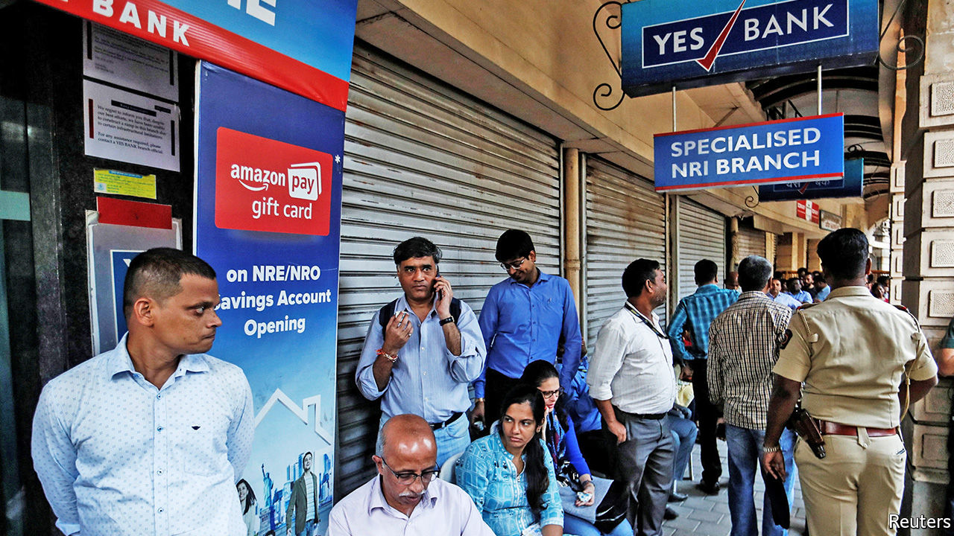

INDIA, WHICH has few declared cases of covid-19, has not escaped the turmoil in global markets. On March 9th its stockmarkets suffered their biggest one-day fall in absolute terms ever, notwithstanding the positive impact low oil prices should have on a big energy importer. Its problems go beyond people’s health.

On March 6th a different crisis came to a head when a government-controlled but publicly listed lender, State Bank of India (SBI), threw a lifeline to Yes Bank, once a darling of the stockmarket, which now faced a scramble to withdraw deposits. It was India’s second banking scare in six months. It raises questions about who is safeguarding the financial system.

Yes’s problems are hardly new. As far back as 2013 concerns were raised by a small group of sceptics at the Reserve Bank of India (RBI), the central bank, that Yes, then a nine-year-old institution, had grown at an extraordinary rate while reporting only a trivial number of bad loans, even though it lent to some of India’s most troubled companies.

Its name was widely understood to contrast it with stodgier operators too willing to say “no”. Investors were entranced. Yes’s share price went on a tear. At its peak in 2017 it was valued at $13.4bn, making its co-founder and chief executive, Rana Kapoor, a billionaire.

By 2019 reality had set in. The RBI forced Mr Kapoor out of his job and new management reported a pile of bad loans. A search for desperately needed new capital failed to satisfy regulators, prompting the RBI on March 5th to depose Mr Kapoor’s successor and the bank’s board in favour of its own caretaker regime.

A series of dramatic actions followed. Deposit withdrawals were capped at 50,000 rupees ($670). Then SBI stepped in, agreeing to inject $330m as part of a $1.5bn resolution plan in exchange for up to 49% of Yes’s shares, as well as the cancellation of $1.2bn of bonds on Yes’s balance-sheet.

Mr Kapoor was arrested and formally charged on March 8th with money laundering and corruption, which he denies. He becomes merely the latest among once-prominent Indian financiers to find themselves in the hands of the law. As the bank’s customers lined up in the streets to withdraw money from ATMs, others found their electronic payments disrupted, a consequence of Yes’s pivotal role in India’s digital-payments architecture.

The finance minister, Nirmala Sitharaman, sought to allay depositors’ fears by pledging that no financial institution would “fall of the cliff” during her tenure. The RBI attested to the soundness of the banks and the safety of depositors. Less reassuringly, the comments echoed what they had both said in September during the collapse of yet another financial institution, the Punjab & Maharashtra Co-operative Bank.

While the technical issues were swiftly sorted out, fundamental ones remain. The resolution plan was far short of the $4bn needed for provisioning, reckons Ashish Gupta, an analyst at Credit Suisse, a bank. SBI has said it does not intend to merge with Yes, leaving the latter’s fate unclear and, to use Mr Gupta’s careful phrasing, its “reconstruction…unlikely”. The chaotic approach has complicated the life of other small and mid-sized banks, he says, affecting their liquidity and ability to raise deposits, which in turn may aggravate the country’s deepening credit crunch.

This half-baked outcome was not inevitable. A private-equity investor says he heard of more than 40 private-equity firms, mostly from outside India, who had expressed interest in buying Yes, only to be dissuaded at the last minute by the thicket of regulations, particularly for foreign investors, not to mention the business risks. A handful of the same names are reported to be in discussions with SBI about buying stakes. Yet falling stockmarkets and financial mayhem make it an inopportune time for dealmaking. Many of the former optimists of Indian finance who bought into Mr Kapoor’s story may never say yes so eagerly again. ■

This article was downloaded by calibre from <https://www.economist.com/finance-and-economics/2020/03/14/yes-banks-rescue-deepens-worries-about-indian-finance>

|  |  |  |  |
| --- | --- | --- | --- |
| Previous | Articles | Sections | Next |

|  |  |  |  |
| --- | --- | --- | --- |
| Previous | Articles | Sections | Next |

#### Buttonwood

# A spike in the dollar has been a reliable signal of global panic

Are we due one?

Mar 12th 2020 |

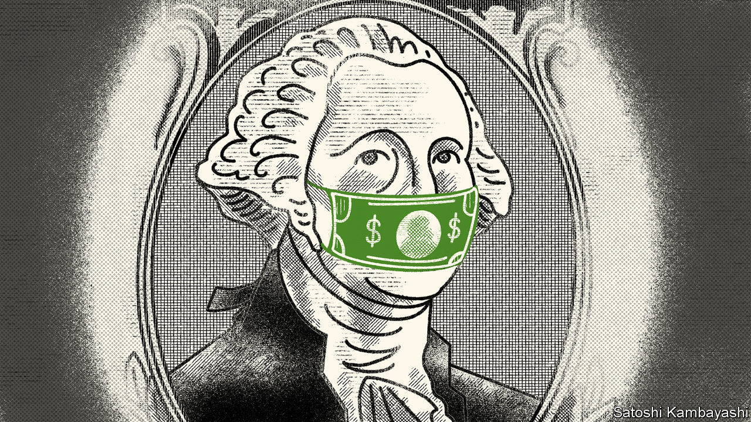

THERE ARE two types of sellers in financial markets. The first kind sell because they want to. They may need cash to meet a contingency; or they might coolly judge that the risks of holding an asset are not matched by the prospective rewards. The second kind sell because they have to. The archetype is an investor who has borrowed to fund his purchase and has his loan called. If there are lots of forced sellers, as can happen in periods of stress, the result is a rout.

Involuntary selling can amplify any decline in asset prices. A called loan is not the only trigger. It might be a ratings downgrade; an order from a regulator; or a jump in volatility that breaches a risk limit. What happens in the markets then feeds back to the broader economy, making a bad situation worse.

This brings us to the dollar. An evergreen concern is the scale of dollar securities issued or held outside America. In the midst of the financial crisis of 2007-09, the Federal Reserve set up currency-swap lines with other central banks to deal with a lack of dollars, as borrowers outside America were caught short. In stressed markets a spike in the greenback is a tell. Investors sell what they own to buy the dollar not because they want to but because they have to.

So far the dollar has traded reasonably. In recent weeks it has rallied against a clutch of currencies hurt most by the slump in oil and commodity prices and lost ground against the yen and Swiss franc (the other havens in a storm) as well as the euro (see chart). Perhaps there are stresses out there, but they are obscured by other factors weighing on the dollar. There has been a sense that it is due a fall. It looks expensive on yardsticks of value, such as purchasing-power parity. The Fed’s interest-rate cut earlier this month, with further reductions likely, means that holding dollars has become less appealing.

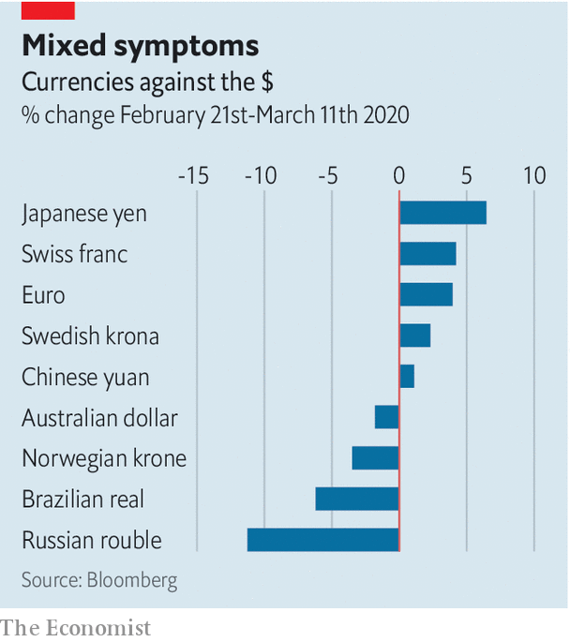

Yet it is easy to forget how bearish sentiment on the dollar was in 2008. Many expected it to fall in the teeth of a crisis that had, after all, originated in America. Instead it spiked as banks outside America scrambled to get hold of greenbacks in order to roll over the short-term dollar borrowings that funded their holdings of mortgage securities. In 2015-16 China ran down its reserves by $1trn in part to meet demand for dollars from Chinese companies who had borrowed heavily offshore. And notwithstanding attempts by countries, such as Russia, to de-dollarise their economies, the greenback is as central to the world economy as it ever was. If there are hidden strains in cross-border finance, they will eventually be revealed by spikes in the dollar.

It would be foolish to rule this out. No doubt pockets of stress will emerge in the coming weeks—a hedge fund, say, that has borrowed dollars to buy riskier sorts of assets and faces a cash crunch. But the sort of aggressive borrow-short-to-lend-long bets that intensified the 2007-09 crisis have been much harder to make. Banks have tighter constraints on their lending. Panic by overborrowed foreigners does not seem a first-order concern.

Other plausible, but voluntary, changes in behaviour would affect the dollar in a variety of ways, or not at all. Foreign investors might simply choose to sell (or refrain from buying) American securities amid the current turmoil—a sort of financial self-quarantine. But surplus savings must be put to work somewhere. Asian funds have been steady buyers of overseas debt securities. Japan’s Government Pension Investment Fund, a $1.6trn pool of retirement savings, had signalled that it will increase its holdings of foreign debt and equities in the coming financial year. There is no sign that it is backing away from this, says Mansoor Mohi-uddin, of NatWest Markets in Singapore. Indeed there is a logic to its front-loading foreign-asset purchases, as a means of weakening the yen and helping Japan’s exporters.

Japanese funds have in recent years preferred to buy euro-denominated debt, because the costs of hedging euro currency risk is low. But if the Fed keeps cutting rates, dollar hedges will become cheaper. Currency-hedged Asian investors might then tilt towards American assets. That would be neutral for the dollar (because of the hedging) but a welcome fillip for issuers of corporate debt in America.

The dollar remains an unloved currency. Witness the surge in gold prices spurred by seekers of an alternative. It is the currency investors are forced to buy, not the one they want to buy. The dollar’s calmness is reassuring. A sudden spike in its value would be a bad sign indeed.

This article was downloaded by calibre from <https://www.economist.com/finance-and-economics/2020/03/12/a-spike-in-the-dollar-has-been-a-reliable-signal-of-global-panic>

|  |  |  |  |
| --- | --- | --- | --- |
| Previous | Articles | Sections | Next |

|  |  |  |  |
| --- | --- | --- | --- |
| Previous | Articles | Sections | Next |

#### Free exchange

# Throughout history, pandemics have had profound economic effects

Long-run economic effects are not always dreadful

Mar 14th 2020 |

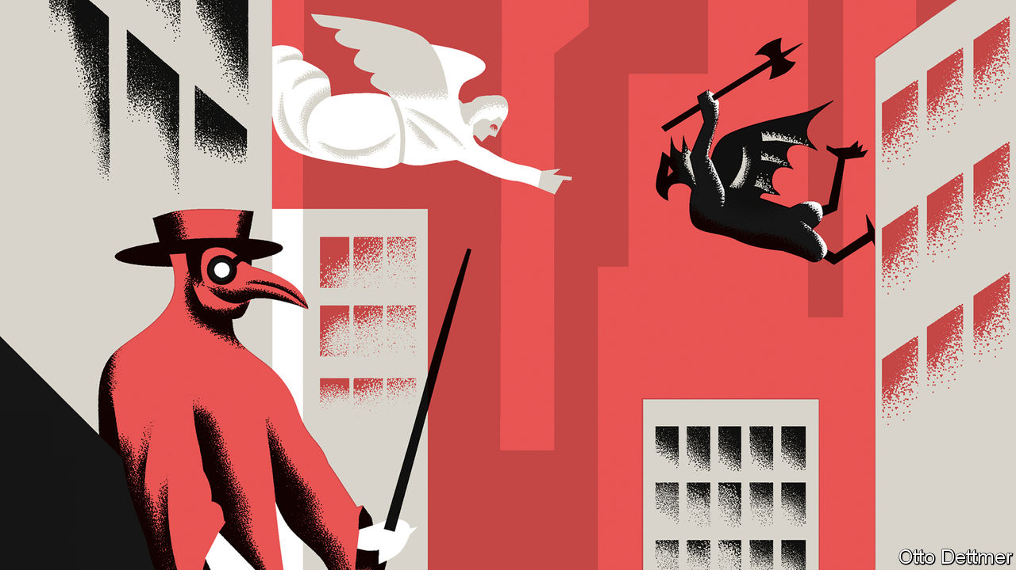

PANDEMICS ARE the inevitable attendants of economic progress. Interconnected trade networks and teeming cities have made societies both richer and more vulnerable, from the empires of antiquity to the integrated global economy of the present. The effects of covid-19 will be very different from those of past pathogens, which struck populations far poorer than people today, and with less knowledge of things like viruses and bacteria. The toll should be on a different scale than that exacted by the Black Death or Spanish flu. Even so, the ravages of the past offer some guide as to how the global economy may change as a result of the coronavirus.

Though the human costs of pandemics are dreadful, the long-run economic effects are not always so. The Black Death carried off an astounding one-third to two-thirds of the population of Europe, leaving lasting scars. But in the wake of the plague there was far more arable acreage than workers to farm it. The sudden scarcity of workers raised labourers’ bargaining power relative to landlords and contributed to the breakdown of the feudal economy.

It seems also to have ushered parts of north-west Europe onto a more promising growth path. Real incomes of European workers rose sharply following the pandemic, which struck the continent from 1347 to 1351. In pre-industrial times, higher incomes usually enabled faster population growth, which eventually squeezed incomes back to subsistence levels (as observed by Thomas Malthus). But in parts of Europe, Malthusian rules did not reassert themselves after the pandemic receded. Nico Voigtländer, of the University of California, Los Angeles, and Hans-Joachim Voth, now of the University of Zurich, argue that the high incomes induced by plague led to more spending on manufactured goods produced in cities, and thus to higher rates of urbanisation. The plague effectively shoved parts of Europe from a low-wage, less urbanised equilibrium on a path more congenial to the development of a commercial, and then an industrial, economy.

Something similar occurred in the aftermath of the Spanish flu, which killed between 20m and 100m people from 1918 to 1920. The industrial economies of the early 20th century were no longer bound by Malthusian constraints. Even so, reckon Elizabeth Brainerd, now at Brandeis University, and Mark Siegler, of California State University, American states harder hit by the disease grew faster in its aftermath. After controlling for a range of economic and demographic factors, they find that one additional death per thousand people was associated with an increase in average annual growth of real income per person over the next decade of at least 0.15 percentage points. Though the toll of covid-19 is likely to be too low to boost real wages, it may force firms to embrace new technologies in order to operate while warehouses and offices are empty, with lasting effects on growth and productivity.

More often, though, a pandemic’s economic consequences are unambiguously negative. Trade links which spread a pathogen can themselves be undone by its effects. During the Roman Empire, a high degree of specialisation and trade lifted incomes to levels that would not be reached again for more than a millennium. Alas, the same links facilitated the spread of disease. The Roman economy was dealt a blow in the late second century AD, when an outbreak of what is thought to have been smallpox ravaged the empire. A century later, the Plague of Cyprian, which may have been a haemorrhagic fever, emptied many Roman cities and coincided with a sharp and permanent decline in economic activity, as measured by numbers of shipwrecks (a proxy for trade volumes) and levels of lead pollution (generated by mining activity). Reduced trade fed a cycle of falling incomes and weakened state capacity from which the western empire never recovered.

More recently, trade may well have tumbled as a result of Spanish flu, had the first world war not already brought a curtain down on the industrialised world’s first great era of globalisation. Covid-19 also strikes at what may be the tail end of a long period of rapid global integration, which is likewise threatened by great-power competition. The circumstances are not identical, and trade is unlikely to suffer as badly as it did in the 1910s. Still, it would not be surprising if historians identify the pandemic as one of several consequences of globalisation that eventually precipitated a new era in global trade.

Just as pandemics have a way of demarcating historical eras, they can also pinpoint shifts in the fortunes of some places relative to others. The Black Death lifted real incomes across Europe. But the fortunes of Europeans subsequently diverged, and disease again played a role. Plague returned to the continent in the 17th century in several deadly waves. The effects of these outbreaks varied greatly across Europe, argues Guido Alfani, of Bocconi University in Milan. Though at most a tenth of the population of England and Wales was lost to plague, for example, more than 40% of Italians may have died from the disease over the course of the century. While Italy’s population stagnated and rates of urbanisation tumbled, north-west Europe continued to benefit from growth and urbanisation despite the pandemic. The fiscal capacity of Italian states suffered badly, as did the textile industries of northern Italy, and northern and southern Europe embarked on quite different economic trajectories.

## Disease is not destiny

In the battle against covid-19, countries’ fates are in their own hands to a far greater degree than in the pre-industrial past. Governments know much more about how epidemics can be managed. Different experiences with the disease are as much an indicator of underlying state capacity as a cause of future economic divergence. Still, history reveals how pandemics nudge societies listing in one direction or another in a decisive and consequential direction. We cannot know what long-run effects covid-19 may have, but we can feel reasonably sure there will be some.■

This article was downloaded by calibre from <https://www.economist.com/finance-and-economics/2020/03/14/throughout-history-pandemics-have-had-profound-economic-effects>

|  |  |  |  |
| --- | --- | --- | --- |
| Previous | Articles | Sections | Next |

|  |  |  |
| --- | --- | --- |
| Finance and ... | Sections | Books and arts |

Science and technology

Big wet data: An ocean of things

.

Ecology: Siren smell

.

Atomic energy: Fun-sized fission

.

Palaeontology: The smallest dinosaur?

.

|  |  |  |
| --- | --- | --- |
| Finance and ... | Sections | Books and arts |

|  |  |  |  |
| --- | --- | --- | --- |
|  | Articles | Sections | Next |

#### Monitoring the high seas

# American researchers want to fill the oceans with sensors

They could track ships, storms, wildlife and weather

Mar 14th 2020 |



THERE IS TWICE as much water on Earth as land. Oceanographers are nevertheless fond of saying that science knows less about the high seas than it does about the moon. If John Waterston gets his way, though, that could soon change.

Mr Waterston is the head of the “Ocean of Things” project at the Defence Advanced Research Projects Agency (DARPA), an American military think-tank that has helped develop everything from the internet to stealthy fighter planes. The project’s name is a play on the “Internet of Things”, the awkward phrase which describes the trend for stuffing sensors and an internet connection into all manner of ordinary objects, from cars and toothbrushes to factory robots and doorbells. The Ocean of Things aims to likewise wire up the high seas with swarms of floating, connected sensors.

Such devices are not in themselves new. There are around 6,000 floating sensors deployed around the world’s oceans, run by navies and research institutes. What is unprecedented is the scale of Mr Waterston’s ambition. Over the next few years he hopes to deploy 50,000 sensors across 1m square kilometres of sea, an area considerably larger than Texas. The eventual goal—much more distant—is to enable the continuous monitoring and analysis of a significant fraction of the world’s oceans.

## Peering into Neptune’s kingdom

The project’s main aim, mindful of the “D” in DARPA’s name, is tracking ships. But rather than building something that can do just one job, Mr Waterston wants the Ocean of Things to supply a wealth of other information, from water temperature to wave heights, weather conditions, nearby wildlife and more. All this would then be made freely available to scientific and commercial users.

Existing “floating instrument packages”, known as floats or drifters, are often custom-built, and usually contain the highest-quality instruments available. They therefore tend to be expensive, and are bought only in small numbers. A typical existing float, designed for scientific research, is the Argo. It costs around $20,000, and can measure water temperature and salinity.

The Ocean of Things takes the opposite approach. The aim is to cram as many cheap, off-the-shelf components as possible into a single low-cost package. Current float prototypes cost around $750, and Mr Waterston hopes that economies of scale could drive the cost down further. That would allow tens of thousands to be deployed without breaking the bank. Large numbers are crucial for coverage. They also help compensate for inaccuracies in individual instruments. “Can a $5 sensor do the same things as a $1,000 temperature gauge?” Mr Waterston asks rhetorically. “The answer is ‘yes’ if you have a lot of them, because you can cross-correlate. Maths solves the problem for you.”

The project’s researchers are evaluating three designs from different manufacturers, ranging in size from about six to 18 litres. One, proposed by Xerox’s Palo Alto Research Centre, is made of glass, like a traditional Japanese fishing float. A second, from a firm called Areté Associates, has an aluminium shell, and uses wood for buoyancy. Both models feature solar panels. The third, made by a company called Numurus, is made of lacquered cardboard, and relies entirely on its batteries. All three are designed to last for a year or so and are made to be as environmentally friendly as possible, with minimal use of plastics. That is important because, at the end of their mission, the floats are designed to scuttle themselves.

Some of the instruments on offer are common to any smartphone—GPS sensors, accelerometers to detect motion, a compass, a microphone, temperature sensors and a camera. Others are more directly tailored for the job, such as an underwater microphone, a gizmo to measure the water’s conductivity (and therefore its salinity), and detectors to pick up radar and radio signals, including transmissions from marine anti-collision beacons. Some data from these instruments will be crunched on board, but most will be sent back to land in bursts, for onshore analysis. For now, that connectivity is provided by the Iridium network of geosynchronous satellites. But the modems necessary to talk to those satellites, says Mr Waterston, are the most expensive and power-hungry devices on the floats. He hopes that new, lower-flying satellite networks, currently being built by firms such as SpaceX and OneWeb, will provide cheaper alternatives.

Having lots of different sensors will help the floats build the best possible picture of what is going on around them. For example, if the microphone picks up a sound at the same time as the accelerometer shows movement, it could mean that a bird has landed on the float. Several birds landing on several floats could show how a flock is moving. Their presence, in turn, might be an indicator of shoals of fish or other biological activity.

Similarly, a ship sailing through a float field will leave all sorts of traces. It might be detected by its radio beacon, or its radar. It might sail close enough for a float to take a picture, or hear it on the hydrophone, or be disturbed by its wake. Correlating data from several floats will reveal the ship’s speed and direction. By building a database of such encounters, the project’s scientists hope to learn quickly how to tell different sorts of craft apart. Fishing vessels might be using fish-finding sonar or noisy trawl nets. A giant supertanker will sound different from a naval frigate.

The range of sensors on a float will also produce a mass of data of interest to oceanographers, meteorologists and biologists. The cameras and microphones on a field of floats could, for example, detect and track whales and dolphins. At the moment, whenever a marine mammal is spotted in the shipping lanes off Los Angeles harbour, one of the busiest in America, traffic is slowed down. Better tracking would allow traffic to be rerouted, benefiting both critters and commerce. Float fields could watch for illegal fishing, smuggling and icebergs. They could monitor and track oil spills and algal blooms.

That, at least, is the long-term goal. So far, DARPA has bought around 4,500 floats, and has tested them only in small numbers. The next stage, starting this spring, will see fields of 1,000 at a time deployed in the Gulf of Mexico and in the waters off California. The plan is to deploy one float for every three square kilometres of ocean. The hope is that, as the technology matures, useful data could be gleaned from densities as low as one float per 20 square kilometres. With 361m square kilometres of ocean on the planet, a true Ocean of Things, monitoring everything on and under the water, would require about 18m floats. That will not happen for a while yet. But Mr Waterston’s plans are a start. ■

This article was downloaded by calibre from <https://www.economist.com/science-and-technology/2020/03/14/american-researchers-want-to-fill-the-oceans-with-sensors>

|  |  |  |  |
| --- | --- | --- | --- |
|  | Articles | Sections | Next |

|  |  |  |  |
| --- | --- | --- | --- |
| Previous | Articles | Sections | Next |

#### Ocean pollution

# Plastic rubbish smells good to turtles

That seems to be why they eat it

Mar 14th 2020 |

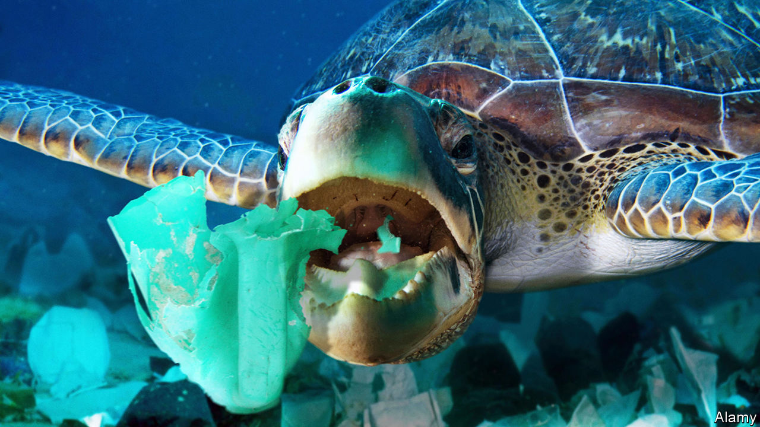

TURTLES HAVE an unfortunate habit of devouring plastic objects floating in the sea. These then get snared in their alimentary canals, cannot be broken down by the animals’ digestive enzymes and may ultimately kill them. It is widely assumed that this penchant for plastics is a matter of mistaken identity. Drifting plastic bags, for instance, look similar to jellyfish, which many types of turtles love to eat. Yet lots of plastic objects that end up inside turtles have no resemblance to jellyfish. Joseph Pfaller of the University of Florida therefore suspects that something more complicated is going on. As he writes in Current Biology, he thinks that the odour of marine micro-organisms which colonise floating plastic objects induces turtles to feed.

The idea that the smell of plastic flotsam might lure animals to their doom first emerged in 2016. Researchers at the University of California, Davis, noticed that certain chemicals, notably dimethyl sulphide, which are released into the air by micro-organism-colonised plastics, are those which many seabirds sniff to track down food. These chemicals mark good places to hunt because they indicate an abundance of the algae and bacteria that lie at the bottom of marine food chains. The researchers also found that birds which pursue their food in this way are five or six times more likely to eat plastic than those which do not.

Since turtles are known to break the surface periodically and sniff the air when navigating towards their feeding areas, Dr Pfaller theorised that they are following these same chemicals, and are likewise fooled into thinking that floating plastic objects are edible.

To test that idea, he and his colleagues set up an experiment involving loggerhead turtles, a species frequently killed by plastic. They arranged for 15 of the animals, each around five months old, to be exposed, in random order, to four odours delivered through a pipe to the air above an experimental arena. The odours were: the vapour from deionised water; the smell of turtle-feeding pellets made of shrimp and fish meal; the smell of a clean plastic bottle chopped up into ten pieces; and the smell of a similarly chopped bottle that had been kept in the ocean for five weeks to allow algae and bacteria to grow on it.

Two of the smells proved far more attractive to the animals than the others. When sniffing both the odour of food pellets and that of five-week-old bottles turtles kept their nostrils out of the water more than three times as long, and took twice as many breaths as they did when what was on offer was the smell of fresh bottle-plastic or deionised-water vapour. On the face of it, then, the turtles were responding to the smell of old bottles as if it were the smell of food.

Though they have not yet tested whether dimethyl sulphide is the culprit, Dr Pfaller and his colleagues think it is the most likely candidate. In an unpolluted ocean, pretty well anything which had this smell would be edible—or, at least, harmless. Unfortunately, five-week-old plastic bottles and their like are not.■

This article was downloaded by calibre from <https://www.economist.com/science-and-technology/2020/03/14/plastic-rubbish-smells-good-to-turtles>

|  |  |  |  |
| --- | --- | --- | --- |
| Previous | Articles | Sections | Next |

|  |  |  |  |
| --- | --- | --- | --- |
| Previous | Articles | Sections | Next |

#### Atomic energy

# Nuclear power plants are coming to the battlefield

They could supply energy to far-flung bases, power laser weapons and charge electric vehicles

Mar 14th 2020 |

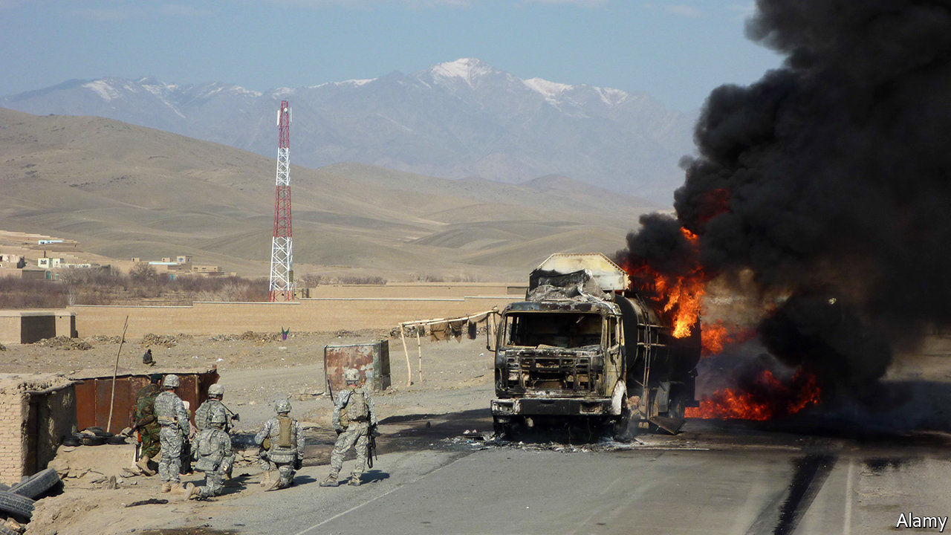

WAR ZONES are dangerous places. Where better, then, for a nuclear reactor? On March 9th America’s government awarded a trio of firms $39.7m to design “microreactors” that can supply a few megawatts of power to remote military bases, and be moved quickly by road, rail, sea and air.

The idea of small reactors is as old as nuclear power itself. In July 1951, five months before a reactor in Idaho became the first in the world to produce usable electricity through fission, America began building USS Nautilus, a nuclear-powered submarine. In the 1960s and 1970s small reactors powered bases in Alaska and Greenland, a radar facility in Wyoming, a research station in Antarctica and—from a cargo ship—the Panama Canal Zone. America still uses nuclear-powered submarines and aircraft-carriers. But land-based mini-reactors proved unreliable and expensive and have fallen out of favour.

Interest has been revived by recent wars, in which American forces proved extraordinarily hungry for energy. Early in the Iraq war, fuel made up over a third of the tonnage transported to the region. Between 2001 and 2010, over half of American casualties in Iraq and Afghanistan occurred during land-transport missions, many involving fuel deliveries to remote outposts. Portable reactors could substitute for unreliable power grids or the generators that often take their place.

America’s armed forces use about 30 terawatt-hours of electricity per year—about the same as Ireland—and more than 35m litres of fuel per day. In 2016 a report by the Defence Science Board, a committee of experts, concluded that demand would surge as new power-hungry weapons, like lasers and rail-guns, come to maturity. Vehicles are also moving away from fossil fuels: America expects to have all-electric brigades within the decade. A report by the army in 2018 said that Holos, a prototype mobile nuclear reactor, would be 62% cheaper than using liquid fuel.

It is not just American troops experimenting with mobile nuclear power. NASA is developing smaller “Kilopower” reactors for space missions, designed to power small lunar outposts. Russia already uses larger floating reactors for its nuclear-powered icebreakers. China plans to install similar devices on disputed islands in the South China Sea.

But the planned microreactors would be distinct in several ways. They are intended to be assembled in a factory and shipped in one piece, doing away with the need for tricky engineering in remote places. They should weigh under 40 tonnes and fit onto the back of an articulated lorry. And they are supposed to run themselves, with “minimal monitoring” from afar.

The risks are manageable, say proponents. Designs feature “passive safety” systems, which keep working even if electricity is lost or a component breaks. Cooling pumps can be replaced by natural convection currents, for instance. The reactors use “tristructural isotropic particle fuel”, in which blobs of fissile uranium (along with oxygen and carbon) are wrapped in layers of carbon and silicon carbide. The pellets can withstand high temperatures, contain radioactive contamination and limit the impact of accidents. The reactors themselves “would be shielded and protected, and possibly placed in a hole in the ground”, says Bill Lee, a nuclear engineer and materials scientist at Bangor University, in Wales. A nuclear meltdown should be “physically impossible”, says the Pentagon. The grunts on the ground will be hoping that is right. ■

This article was downloaded by calibre from <https://www.economist.com/science-and-technology/2020/03/14/nuclear-power-plants-are-coming-to-the-battlefield>

|  |  |  |  |
| --- | --- | --- | --- |
| Previous | Articles | Sections | Next |

|  |  |  |  |
| --- | --- | --- | --- |
| Previous | Articles | Sections | Next |

#### Palaeontology

# The smallest dinosaur?

Another intriguing discovery from the amber mines of Myanmar

Mar 12th 2020 |



OCCASIONALLY, A FOSSIL turns up that reminds people of how little is really known about the past. This, perhaps, is such a discovery. It is the skull, a mere 7mm long, of a tiny, yet full-grown dinosaur, preserved in amber from a deposit in northern Myanmar which is 99m years old. That dates it to the middle of the Cretaceous, more than 30m years before this period’s more famous dinosaurian denizens, Ankylosaurus, Triceratops and Tyrannosaurus, bestrode what is now North America.

Extrapolating from its skull, Oculudentavis khaungraae would have been about the size of a bee hummingbird, the smallest bird now alive. And—confusingly to modern sensibilities, which are used to thinking of “dinosaurs” and “birds” as separate categories—it was a bird, too. It belonged to a group called the Enantiornithes, which were similar to modern birds, the Neornithes, except that evolution did not deprive them of either their teeth or the claws on their forelimbs, even though those forelimbs were fully functional wings.

The Enantiornithes perished along with most other dinosaurs (and about three-quarters of the rest of the planet’s animal and plant species) in a collision, 66m years ago, between Earth and an asteroid. The Neornithes, though, survived this catastrophe and went on to become, in 1758, the class of animals called Aves in Linnaeus’s “Systema Naturae”. This classification predated the discovery of fossil dinosaurs (indeed, it predated the realisation that Earth is far older than suggested by Biblical and other mythical traditions). That, and the everyday familarity of birds, has made it hard to grasp that the Aves truly are a group of dinosaurs.

The formal description of O. khaungraae was published this week in Nature by Xing Lida of the China University of Geosciences, in Beijing, who has many previous discoveries from the north-Burmese amber to his name. There is evidence that the area in which it lived was, at the time, an island in an archipelago in a vanished ocean called Tethys. Dr Xing and his colleagues therefore speculate that it may have been a product of island dwarfism—a tendency of insular species to shrink, compared to their mainland relatives. Whatever the explanation for its size, though, O. khaungraae now shares with the bee hummingbird (which is not a product of island dwarfism, but rather of its habit of feeding on the nectar of flowers) the title of “smallest dinosaur known”.

This article was downloaded by calibre from <https://www.economist.com/science-and-technology/2020/03/12/the-smallest-dinosaur>

|  |  |  |  |
| --- | --- | --- | --- |
| Previous | Articles | Sections | Next |

|  |  |  |
| --- | --- | --- |
| Science and ... | Sections | Economic and ... |

Books and arts

Music and protest: The beat goes on

.

Global scourges: The famished

.

Future histories: Fragments and ruins

.

Fiction of reality: Brothers in arms

.

Johnson: Old wine, new bottles

.

|  |  |  |
| --- | --- | --- |
| Science and ... | Sections | Economic and ... |

|  |  |  |  |
| --- | --- | --- | --- |
|  | Articles | Sections | Next |

#### The beat goes on

# Demonstrators in Chile are looking to the past for their soundtrack

Once-silenced voices are resounding in Santiago—and new protest songs are being added to the canon

Mar 14th 2020 | SANTIAGO

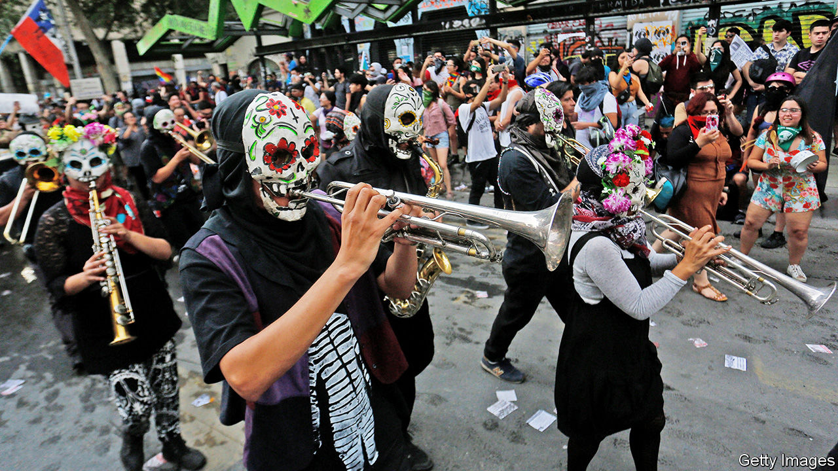

AS HIS PRESIDENTIAL campaign reached its climax in 1970, Salvador Allende appeared at the Teatro Caupolicán in Santiago beneath a banner that read: “There is no revolution without music.” He was flanked by some of the revered performers who in the preceding years had thrust Chile’s music onto the world stage. Among them was Víctor Jara, a singer who would be tortured and murdered soon after the coup that ended Allende’s socialist administration in 1973. The ensuing dictatorship of General Augusto Pinochet lasted 17 years; but Jara’s music, and that of other artists who were censored, exiled or killed, lived on.

As Chile is convulsed by protests against inequality and poor public services, politics and music, old and new, have again become entwined. On October 25th last year, when more than 1m people took to the streets of Santiago, guitarists mustered on the steps of the national library to play Jara’s ode to peace and freedom, “El derecho de vivir en paz” (“The right to live in peace”). In Plaza Italia crowds sang “El baile de los que sobran” (“The dance of those left over”), a protest anthem of 1986 by the band Los Prisioneros. The song “reflects the primal discontent of a society whose rights are not represented,” reckons Miguel Tapia, the group’s drummer. Unfortunately, he says, “its message still resonates.” Elsewhere musicians serenaded the throng from street corners and balconies.

In response to the looting and arson that erupted alongside the protests, President Sebastián Piñera had earlier imposed a curfew and deployed the armed forces to restore order. But a familiar soundtrack rang out even when the streets emptied. At 8pm each evening, when the curfew took effect, demonstrators played “El derecho de vivir en paz” in synchrony from their apartments. A pianist’s rendition of “Gracias a la vida” (“Thanks to life”), by the legendary songwriter Violeta Parra, drifted through the trees on one of Santiago’s wide, lamplit avenues. And during the days, crowds sang the refrain of “El pueblo unido jamás será vencido” (“The people united will never be defeated”) by Quilapayún, a venerable folk group.

As the armed forces took over the country in 1973, this was the song broadcast on the radio after Allende bade an emotional farewell to the nation. It “immediately became a symbol of the fight against the Pinochet dictatorship, and it has accompanied many other struggles from the moment it was conceived,” says Eduardo Carrasco, one of Quilapayún’s founding members, who is now 79. He recalls that it was borrowed by opponents of Portugal’s authoritarian regime and of General Franco in Spain; more recently it was adopted by activists during the Arab spring and by the gilets jaunes in France. The aloof elite that has alienated many 21st-century Chileans is a far cry from the monstrous rulers of the 1970s and 1980s; still, thinks Mr Carrasco, “this song is as relevant now as it ever was.”

Another, more rudimentary kind of ensemble has provided a backbeat to the events. The collective bashing of saucepans on balconies, a rowdy percussion known as cacerolazo, is popular across South America, from Buenos Aires to Caracas. In Chile it emerged during the Allende years: in 1971, during Fidel Castro’s visit to the country, there was a “march of the empty pots” in protest at food shortages. The ritual was a practical way to express dissent during the dictatorship, when public criticisms were repressed.

Since democracy returned in 1990, cacerolazos have spilled out from the safety of homes and back onto the streets, says Javier Osorio, a historian of contemporary music at Alberto Hurtado University in Santiago. “The sound of the cacerolazo has no borders,” he says; “it’s an all-encompassing form of protest.” Amid the current unrest, some Chileans have thrashed their saucepans furiously while others have kept to a rhythm. Pans have been strapped to the handlebars of bicycles to be banged with a spoon while the rider is on the move.

## Ears and eyes

Old musical traditions have been revived; once-silenced voices echo between the concrete apartment blocks in the centre of Santiago. At the same time, modern artists have added new protest songs to the canon, drawing on the past but incorporating the mood and themes of today.

A new single by Ana Tijoux, a Franco-Chilean rapper, is called “Cacerolazo”. The rhythm of the cacerolazo also resounds in a song by Mon Laferte, who scrawled “In Chile they torture, rape and kill” on her bare chest for the Latin Grammy awards in November. (More than 5,000 complaints of alleged abuse by the police and armed forces have been lodged; by the end of January prosecutors were investigating 31 deaths.) Nano Stern’s “Regalé mis ojos”—“I gave my eyes”—refers to the hundreds of eye injuries inflicted after rubber bullets and shotgun pellets were fired towards protesters’ faces (tactics that have now been revised).

In tribute to those injuries, “El violador eres tu” (“The rapist is you”), a feminist anthem created by a group of women in Valparaiso, is typically performed wearing blindfolds. Linking police violence with abuses of women more generally, the song has struck a chord around the world. “La Caravana” by Kuervos del Sur, a rock band from the central city of Curicó, alludes to the steady flow of marchers along the Alameda, Santiago’s main drag. The marches, and the tumult, abated in the summer heat, but despite some government concessions (see [article](https://www.economist.com/node/21781442)), they are now redoubling in the run-up to a referendum on constitutional reform on April 26th.

Allende harnessed the power of music as he became Latin America’s first elected socialist leader; it fortified Pinochet’s long-suffering opponents. Now, in very different circumstances, it has again become the heartbeat of Chilean politics. “Music is what creates a sense of belonging at times like these,” comments Mr Osorio. “Everyone who plays these songs, who hears them, who picks up a spoon and taps out that same rhythm on a saucepan—these people are all feeling the same thing.” ■

This article was downloaded by calibre from <https://www.economist.com/books-and-arts/2020/03/14/demonstrators-in-chile-are-looking-to-the-past-for-their-soundtrack>

|  |  |  |  |
| --- | --- | --- | --- |
|  | Articles | Sections | Next |

|  |  |  |  |
| --- | --- | --- | --- |
| Previous | Articles | Sections | Next |

#### The famished

# Listening to the voices of the hungry

For all its eccentricities, Martín Caparrós’s new book powerfully captures their plight

Mar 14th 2020 |

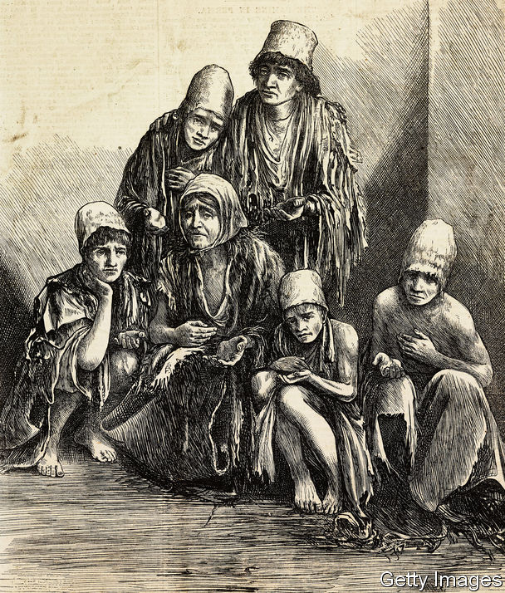

Hunger: The Oldest Problem. By Martín Caparrós.Melville House; 544 pages; $32 and £26.99.

DUNCAN GREEN, an in-house thinker at Oxfam, a charity, and an academic at the London School of Economics, makes an intriguing observation. Often, he notes, a person’s views about poverty and development are shaped by the first region of the developing world that he or she gets to know. Those who begin by studying Africa tend to have strong views on foreign aid (whether for or against) and are obsessed with the quality of government. Those who learned first about east Asia tend to focus on economic growth. And those whose first experience is in Latin America are preoccupied with justice and power.

Martín Caparrós is an Argentinian journalist and novelist whose book, “Hunger”, has already appeared in French, German and Spanish. It has now been updated and translated into English. The book introduces English-speaking readers to a Latin American perspective on poverty. But “Hunger” is also highly idiosyncratic—a peculiar, often perplexing tour through some of the world’s most desperate places, interspersed with muddled ranting. It is an off-putting, infuriating book that nonetheless gets one big thing right.

The best parts of the book are the sections in which Mr Caparrós interviews hungry people. He hangs out with a woman who scavenges a rubbish tip in Argentina, with an Indian widow who has been left to die in a holy city and with a peasant farmer in Niger who keeps glancing at his chunky digital watch. He asks stupid questions, as good journalists do, and gets answers that reveal much about how extremely poor people think.

Why, the author asks, is an Indian mother taking her malnourished daughter out of the hospital before she has recovered? Because, the mother explains, her sister-in-law has fallen ill, and she must look after the household. What would a poor woman in South Sudan eat, if she could eat anything? Walwal, she replies—a kind of sorghum porridge. But suppose you could have meat or fish, Mr Caparrós presses. No: she would eat walwal.

“Hunger” is also a political book. Mr Caparrós believes that people go hungry chiefly because the powerful behave in unjust ways. He is against multinational agribusiness firms such as Cargill (though not against crop science), and implies that trade is a major cause of high food prices. He thinks little of humanitarian or development aid, and describes welfare as “a way of maintaining poverty” because it keeps the poor from rebelling. Much of this is nonsense, and it is not even clear that the author believes it. He has travelled too widely and interviewed too many people to hold fast to simple explanations.

Strangest of all are the chapters in which Mr Caparrós steps back to address the reader and his own conscience. More than once he poses the question: “How the hell do we manage to live knowing these things?” Sometimes he seems to be fighting an internal battle, in which his desire for justice pushes against his feelings of despair and horror about the lives of the poorest: “I’ve got enough problems without going around thinking about those poor bastards in Africa or Kolkata or those places I don’t even…” At such moments the book seems not just Latin American but distinctively Argentinian. Few countries are so thick with psychoanalysts.

The great thing about “Hunger” is its relentlessness. Most books about poverty (indeed, most articles in The Economist about poverty) introduce the reader to the poor, then pull back into dispassionate consideration of agricultural productivity, social safety-nets, credit constraints and the like. All that policy talk is fine, but it is not how extremely poor people think about their lives. Deep poverty and hunger often make no sense to those who suffer those things, except perhaps as evidence of God’s will. Misfortune simply hit them, when the rains failed, when a husband vanished or a child fell ill. Mr Caparrós holds you there, in the unsettling presence of the desperate, and forces you to listen to them. ■

This article was downloaded by calibre from <https://www.economist.com/books-and-arts/2020/03/14/listening-to-the-voices-of-the-hungry>

|  |  |  |  |
| --- | --- | --- | --- |
| Previous | Articles | Sections | Next |

|  |  |  |  |
| --- | --- | --- | --- |
| Previous | Articles | Sections | Next |

#### Fragments and ruins

# A journey through the lasting traces of human civilisation

In “Footprints”, David Farrier asks what will remain of the Anthropocene

Mar 14th 2020 |

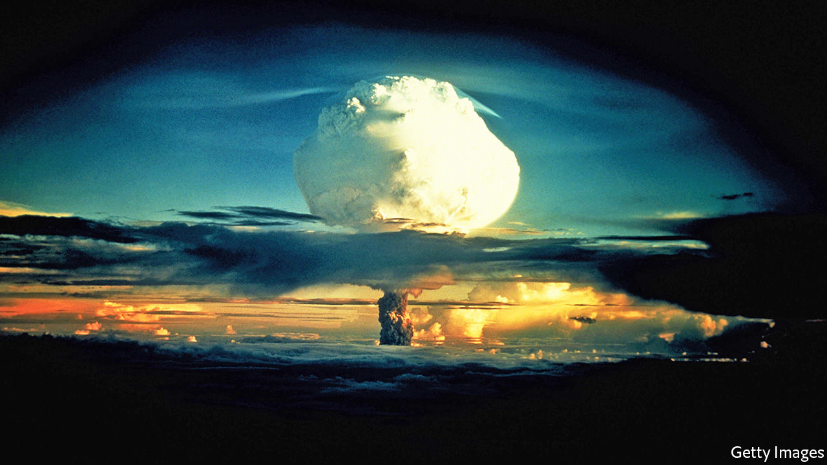

Footprints: In Search of Future Fossils. By David Farrier.Farrar, Straus and Giroux; 320 pages; $28. Fourth Estate; £16.99.

THE BLASTS flung debris into the sky and rucked the sea-floor like a rug. The flash from the largest—which, at 15 megatons, was 1,000 times stronger than the detonation that flattened Hiroshima—was visible in Okinawa, 2,600 miles away. Radiation from its fallout was detected in cattle in Tennessee. The atomic-bomb tests on the Marshall Islands from 1946-58 were an awesome display of American might, and of mankind’s power to reshape the world.

Their effects lingered long after the mushroom clouds dispersed. Rates of cancer soared among islanders downwind of the fallout. There were stillbirths and “jellyfish babies” (children born without bones, and skin so translucent their hearts could be seen flickering within). Yet, as David Farrier reports in his thoughtful book, the full impact of this “carnival of atomic energy” cannot yet be known. The half-life of the plutonium-239 released in nuclear reactions is 24,100 years—several times the length of recorded history. In fact, Mr Farrier writes, those blasts will constitute one of humanity’s most enduring signatures, legible “at both poles and on every continent, in lake sediments and ice cores, in tree rings and living tissues”.

In “Footprints” he asks what material traces, or “future fossils”, will remain of what is sometimes known as the Anthropocene, the epoch in which people have held sway over the environment. His explorations take him from Shanghai, a megacity of 24m people, to the tomb-like hush of a laboratory in Tasmania that analyses Antarctic ice. He ranges from the deep past to the far distant future to tell the story of humankind’s lasting imprint.

Despite its sobering theme, Mr Farrier’s prose glitters. His journey takes in marvels. He meets a poet who aspires to encode verse into the DNA of Deinococcus radiodurans, a hardy bacterium that is nearly unkillable; inscribing its genome is an attempt “not to preserve information but to write an eternal poem”. Mr Farrier listens to the moaning made by the Ross Ice Shelf as it melts, the eerie keening “of its own dissolution”. Perhaps most movingly, he holds a 200,000-year-old Palaeolithic tool, which seems blunt and clumsy until he flips it over and realises that its craftsman was probably left-handed, as he is. Wonder rather than anger is his default response in contemplating humanity’s legacy.

Though a literature teacher by profession, he draws equally from science, philosophy and the arts, paleoclimatologists as well as poets. This approach owes something to the work of the 17th-century polymath Sir Thomas Browne as well as modern writers such as Gavin Francis and Rebecca Solnit. Occasionally readers may feel lost amid the vertiginous data; for instance, “50m kilometres of roads” is hard to picture, the sheer scale wrenching the reference towards meaninglessness.

By contrast, when Mr Farrier indulges his bookishness the result is exhilarating. His central idea, that language and storytelling might be the most enduring of human traces, is beautifully expressed. The fables of surrealists such as Jorge Luis Borges and J.G. Ballard frame understanding of the Anthropocene, he believes. Insights of poets such as Alice Oswald bring the “bright unbearable reality” into focus.

“Footprints” is a meditation, not a finger-wagging harangue. As Mr Farrier notes, even if pollution and consumption ceased tomorrow, their effects would take millennia to unwind. Human life is etched into the fossil record for aeons to come. “The challenge is to learn…to examine our present,” he writes, “by the eerie light cast by the onrushing future.” His subtle, elegant book rises to that challenge. ■

This article was downloaded by calibre from <https://www.economist.com/books-and-arts/2020/03/14/a-journey-through-the-lasting-traces-of-human-civilisation>

|  |  |  |  |
| --- | --- | --- | --- |
| Previous | Articles | Sections | Next |

|  |  |  |  |
| --- | --- | --- | --- |
| Previous | Articles | Sections | Next |

#### Brothers in arms

# “Apeirogon” depicts a moving Israeli-Palestinian friendship

Colum McCann’s new novel captures their heartbreak in vivid tesserae of prose

Mar 14th 2020 |

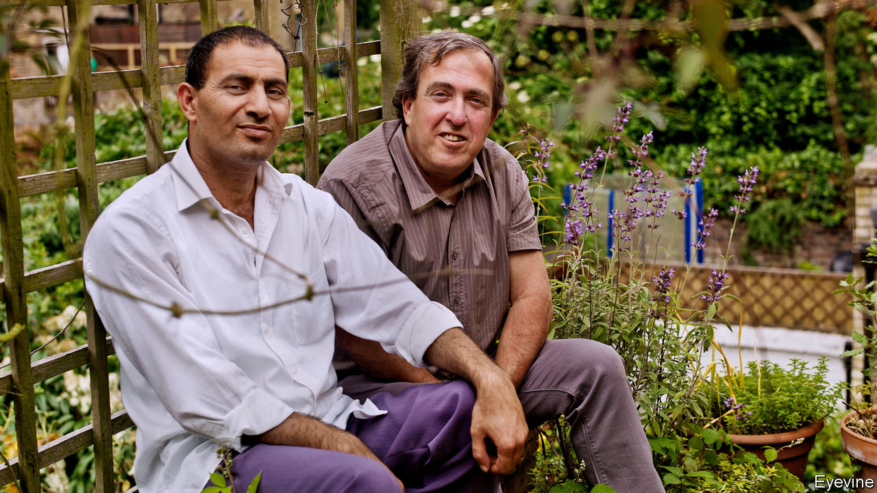

Apeirogon. By Colum McCann. Random House; 480 pages; $28. Bloomsbury; £18.99.

COLUM MCCANN’S new novel refers at one point to the “Jerusalem Syndrome”: the messianic delusions that “proximity to the holy places” can induce in pilgrims to the city. Foreign writers and artists often display their own version of this mania. It consists in ordering the divided peoples of the Holy Land to recognise how much they have in common (in history, heritage, culture, even genetics) and instructing them to live in peace.

Irish-born but long resident in New York, Mr McCann knows every pitfall that awaits the moralising traveller keen to swell the region’s “corny” and “trite” rhetoric “of justice, of kinship, of reconciliation”. From its mysterious title onwards, the oblique storytelling of “Apeirogon”, his seventh novel, shuns the conventions of the high-minded outsider’s reportage. Yet, for all his sophisticated artistry, the authority of this work of fiction rests ultimately on its truth.

Mr McCann did not invent the entwined destinies of Bassam Aramin and Rami Elhanan. Rather, their real, conjoined lives inspired this “hybrid novel”, which weaves documentary and imagination into its toughly lyrical fabric. Both bereaved fathers, the pair of friends decided that “the only revenge is making peace”. Brought up in Hebron, Mr Aramin was a Fatah militant who served seven years in jail but soon set out “to pit himself against the ignorance of violence, including his own”. In 2007 an Israeli soldier killed his ten-year-old daughter Abir with a rubber bullet as she bought sweets in the West Bank town of Anata.

Mr Elhanan is an Israeli whose father, a Holocaust survivor, immigrated from Hungary, but whose mother’s family had lived in Jerusalem for six generations. Hamas terrorists killed his 13-year-old daughter Smadar in 1997 in a suicide-bomb attack on the city’s Ben Yehuda Street. But he progressed from viewing Palestinians as threats from “the dark side of the moon” to acknowledging “the equality of pain”. First in Combatants for Peace (Mr Elhanan fought in three of Israel’s wars), then in the Parents Circle that brings together bereaved families from both sides, the duo have sought through their activism to replace the clear lines of enmity with “the tangle of knowing each other”.

Journalists and film-makers have told their story before. Mr McCann, too, co-operated closely with the friends. “Apeirogon”, though, wraps the facts of their journeys, and their griefs, into an elliptical and fragmentary narrative. It situates their quest for hope within the art and landscape of Israel-Palestine and the “smashed jigsaw” of rival histories. “Geography here is everything,” Mr McCann writes. His mosaic of 1,001 colourful, enigmatic paragraphs range across the scenery of a military occupation that stifles the West Bank like “the rim of a tightening lung” and, for Palestinians, “deprives you of tomorrow”.

The reader glimpses the men’s zigzag route through loss into peacemaking via vivid, jagged tesserae of prose. Meanwhile, images of flight, flux and movement—involving migratory birds, watercourses, artworks, even weaponised drones—offer a hawk’s, or dove’s, eye view of the seething cauldron that the novelised Mr Elhanan calls a “condensed everywhere”.

An “apeirogon”, the geometric term that becomes Mr McCann’s key metaphor, is a shape “with a countably infinite number of sides”. The patchwork pattern of this novel matches the polyhedral complexity of the pasts it evokes. With “one story becoming another”, “Apeirogon” insists on “the sheer simultaneity of all things”. The results are frequently beautiful, sometimes baffling. The imagery often dazzles, but plainer passages that inhabit the men’s minds as they wrestle against rage and bitterness towards an “ethic of reciprocity” have the greatest emotional power. At the core of this fractal fiction is a simple, radiant myth: “The hero makes a friend of his enemy.” ■

This article was downloaded by calibre from <https://www.economist.com/books-and-arts/2020/03/14/apeirogon-depicts-a-moving-israeli-palestinian-friendship>

|  |  |  |  |
| --- | --- | --- | --- |
| Previous | Articles | Sections | Next |

|  |  |  |  |
| --- | --- | --- | --- |
| Previous | Articles | Sections | Next |

#### Johnson

# “Medicare for all” and the art of political branding

But framing policies in focus-grouped language gets politicians only so far

Mar 14th 2020 |

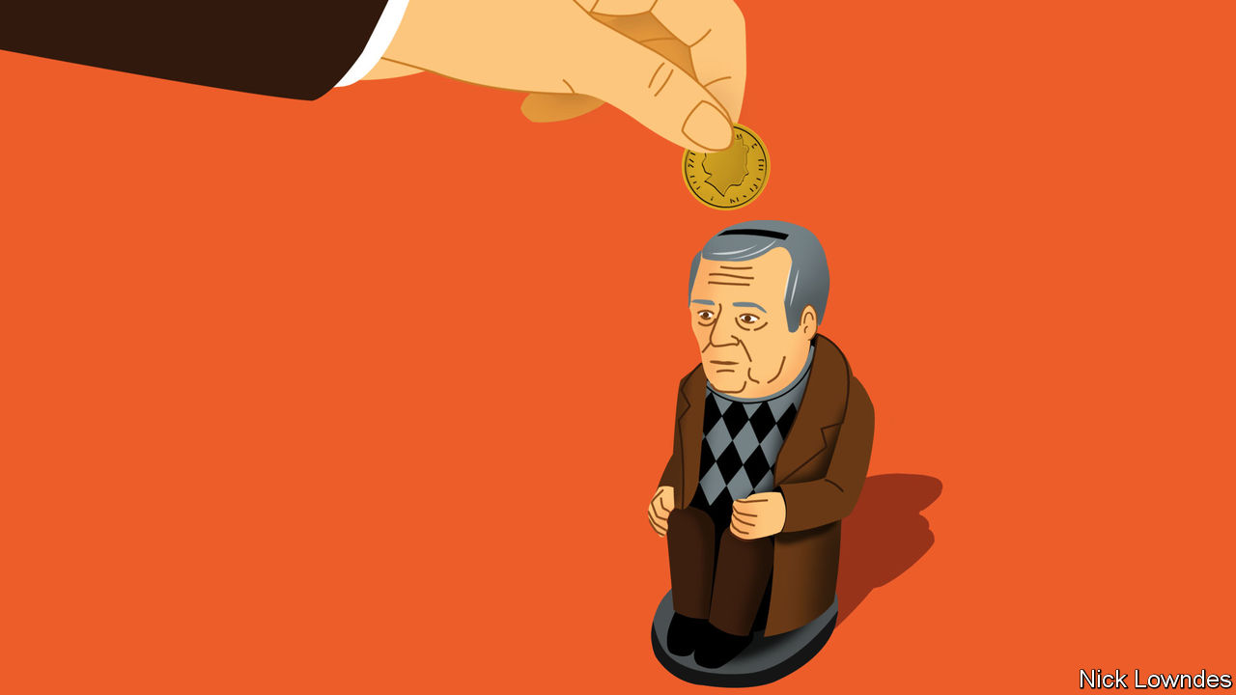

LAST MONTH Ronnie Cowan, a Westminster MP from the Scottish National Party, wrote to Britain’s Department for Work and Pensions on behalf of some incensed pensioners in his constituency. Pensioners are often incensed, but these complaints were not about inflation-indexing or retirement ages; they were linguistic. The irate retirees did not want their pensions to be called a “benefit”.

In some other Anglophone countries, this might sound odd. What could be better than a “benefit”, which (America’s) Merriam-Webster dictionary defines as “something that produces good or helpful results or effects or that promotes well-being”? In Britain, the word means much the same in most contexts, but its other definition is more salient: as the Oxford English Dictionary has it, “That which a person is entitled to in the way of pecuniary assistance, medical or other attendance, pension, and the like, under the National Insurance Act of 1911 and similar subsequent Acts”.

This is where teachers of English might helpfully note the difference between denotation (dictionary meaning) and connotation (associations that may not be part of a formal definition). In Britain, “benefits” carry a strong connotation. For many people, a benefit is money handed out by the state, often to the undeserving. Consider “Benefits Street”, a documentary series on Channel 4 that was widely accused of portraying recipients of benefits as scroungers.

In America the equivalent term is “welfare”, which has been applied to government aid for poor families since at least the 1930s. From the 1960s and 1970s, as Republicans became the champions of small government, they began to characterise welfare-recipients as disempowered dependents on the state, or even, sometimes, as conniving parasites upon it. Campaigning for president in 1980, Ronald Reagan famously told the story of a high-living “welfare queen” from Chicago (whose exploits turned out to be somewhat exaggerated).

A lot of thought goes into the names of policies, which politicians naturally want to resonate in a positive way. Sometimes that means rebranding old ideas, or borrowing words from another domain. Democrats who say the state should pay for every American’s health care are a case in point. “Universal health care”, one way of expressing that goal, has a whiff of socialism about it. “Government-run health care” is even more off-putting, after Reagan memorably decried government as the problem rather than the solution.

Hence “Medicare for All”, touted by Bernie Sanders and Elizabeth Warren. Medicare is the hugely popular health-care programme for retirees; Mr Sanders and Ms Warren have borrowed its sainted name to propose extending care to everyone. George Lakoff, a linguist at the University of California, Berkeley, and a left-wing activist, has been pushing Democrats to adopt more effective “frames” for their policies for years, arguing that Republicans consistently out-frame them. Mr Lakoff is a long-term advocate of “Medicare for All”. (Notably, proponents of the policy have avoided the name of Medicaid, the health-care scheme for lower-income Americans. “Medicaid” shares the taint of “welfare”; “Medicare” does not.)

But rebranding and renaming policies gets you only so far. Even upbeat words with positive associations can be tarnished and discredited. After all, “socialism” has the same root as the friendly concept of “society”. Even more starkly, “communism” is a relative of “community”, but no amount of etymology can make up for the ideology’s complicity in the deaths and immiseration of millions.

Even without such baggage, the enemy gets a vote too, as soldiers sometimes say. As soon as a shiny new idea is launched, opponents will try to associate it with everything evil under the sun. The “Green New Deal”, a set of leftish, climate-friendly proposals supported by some American Democrats, has been under relentless Republican attack since the concept was floated. Despite the bid to invoke the New Deal of the 1930s, for many voters it is now synonymous with a wild left-wing power grab.

Tainting ideas is easier than decontaminating them. And though a new slogan might help remove the stigma that has accrued, the cycle is liable to begin again, and before long yet another new label is needed. Political rebranding is sometimes necessary, but it is nowhere near sufficient. In other words, politicians can’t prevail by linguistic engineering alone. They still have to win the underlying arguments.

This article was downloaded by calibre from <https://www.economist.com/books-and-arts/2020/03/14/medicare-for-all-and-the-art-of-political-branding>

|  |  |  |  |
| --- | --- | --- | --- |
| Previous | Articles | Sections | Next |

|  |  |  |
| --- | --- | --- |
| Books and arts | Sections | Graphic detail |

Economic and financial indicators

Economic data, commodities and markets

.

|  |  |  |
| --- | --- | --- |
| Books and arts | Sections | Graphic detail |

|  |  |  |  |
| --- | --- | --- | --- |
|  | Articles | Sections | Next |

# Economic data, commodities and markets

Mar 14th 2020 |

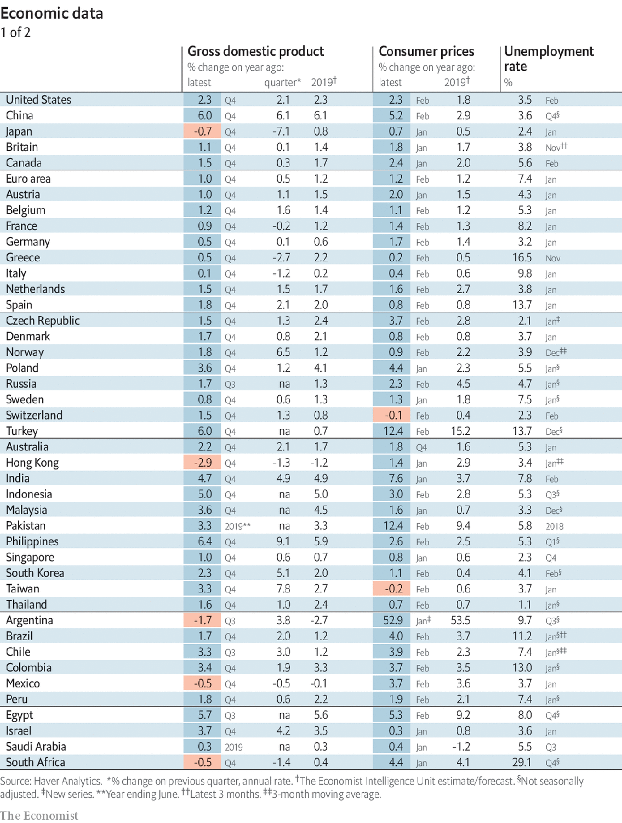

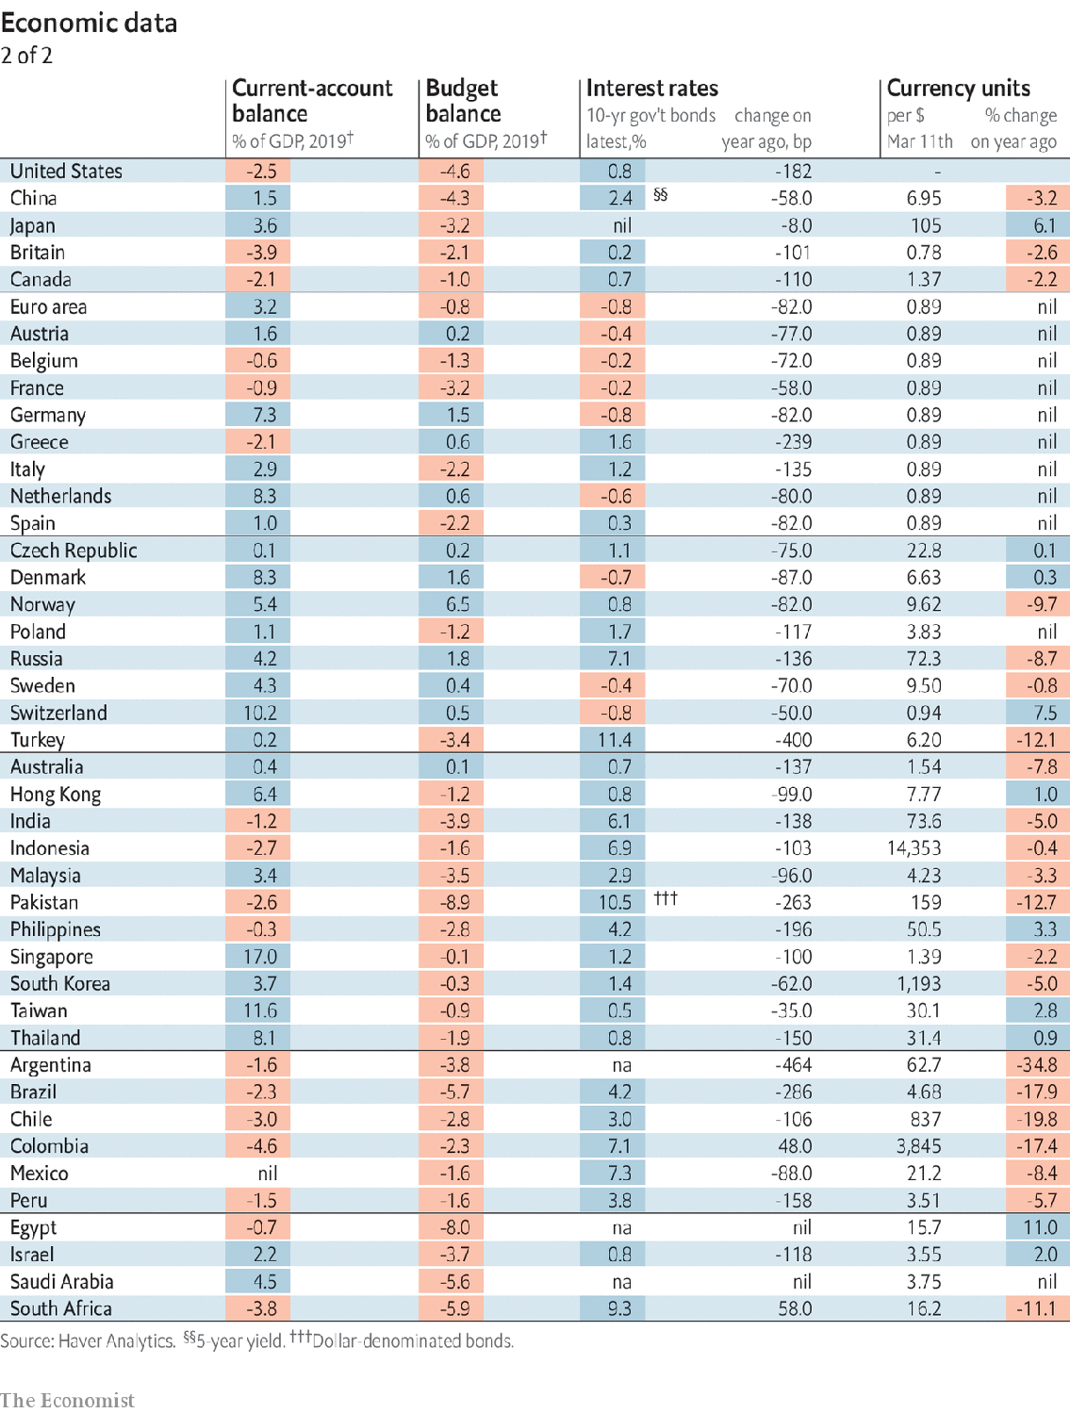

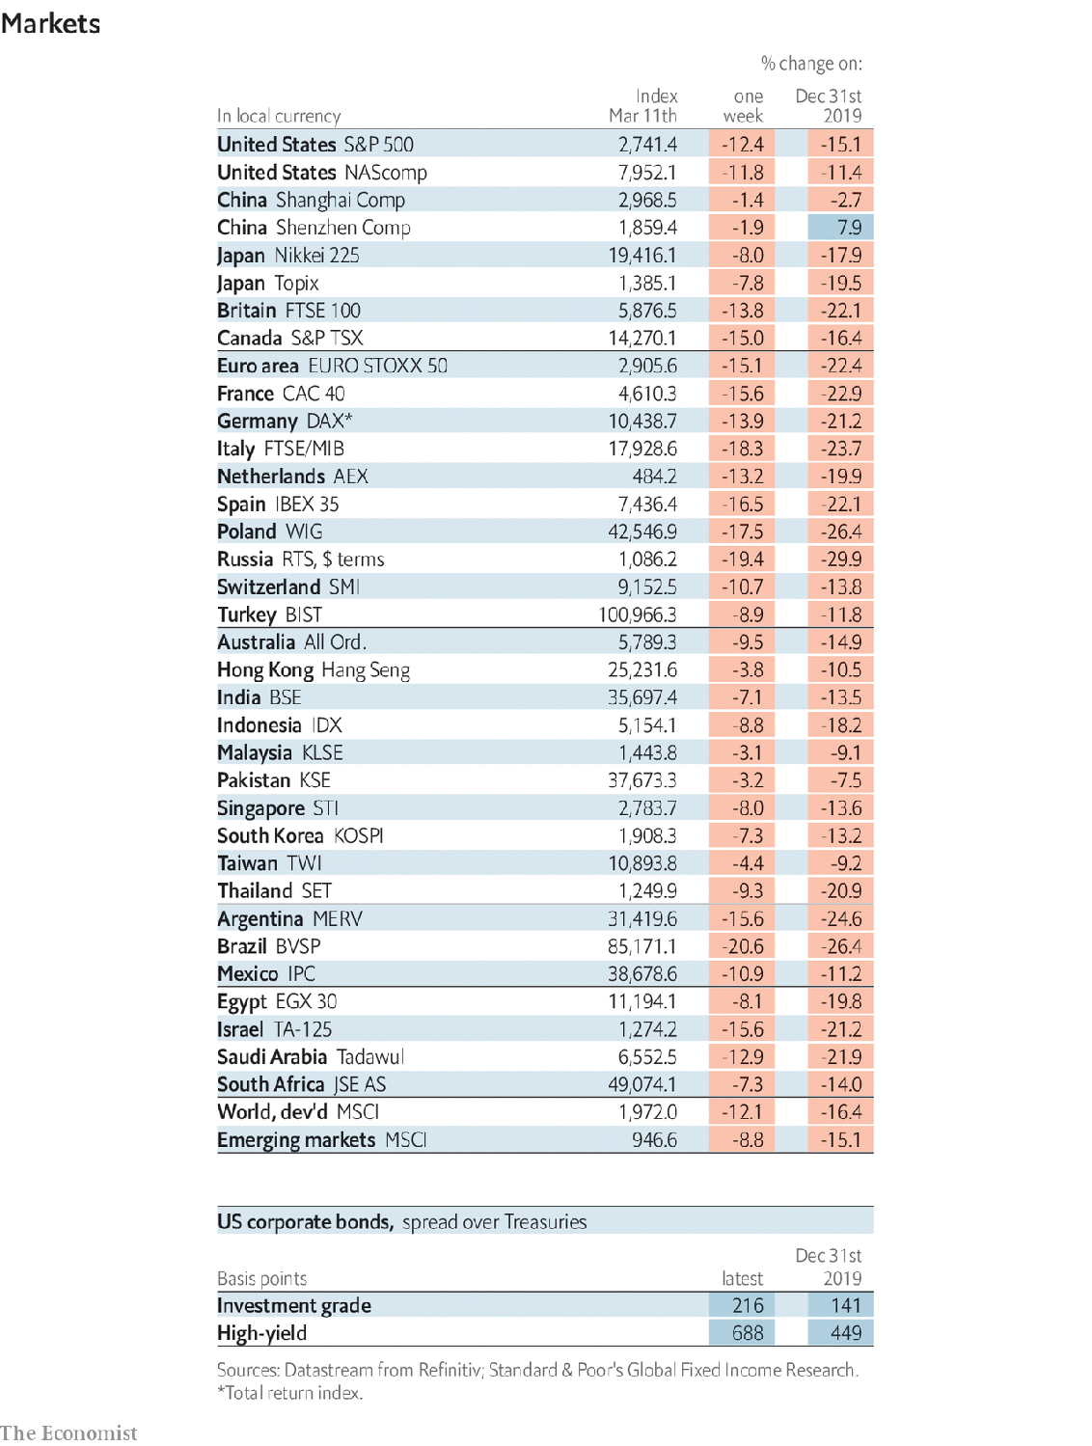

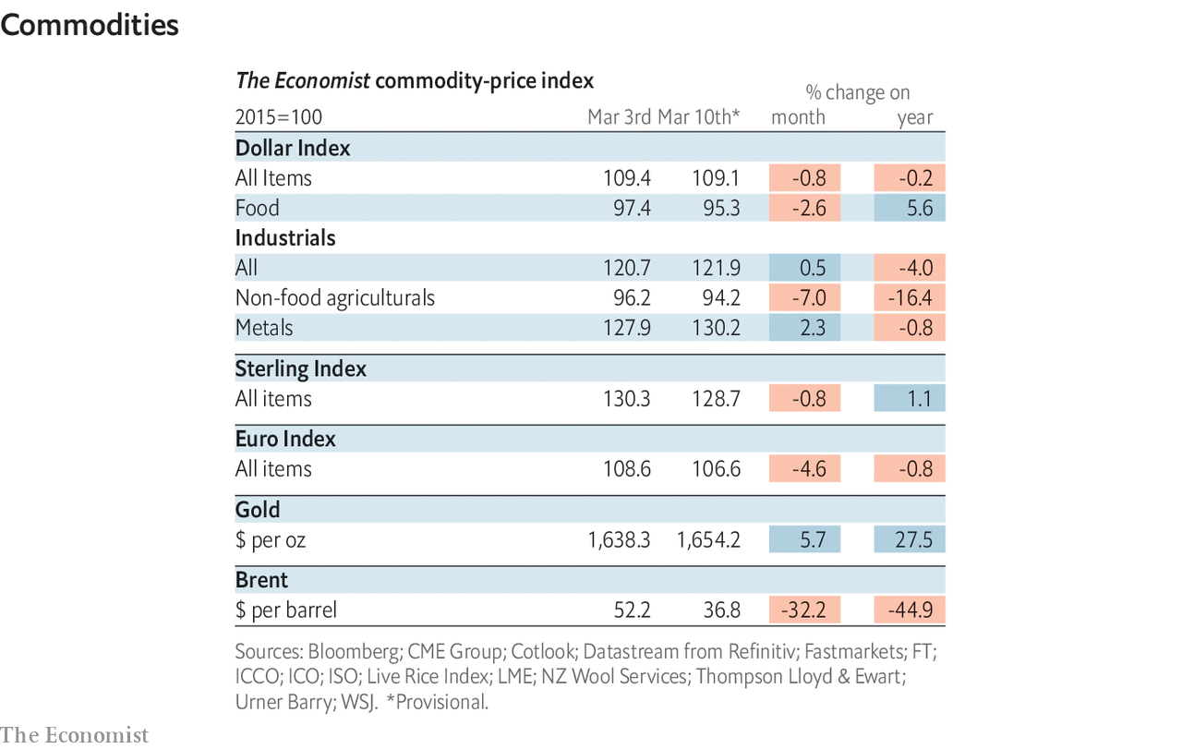

This article was downloaded by calibre from <https://www.economist.com/economic-and-financial-indicators/2020/03/14/economic-data-commodities-and-markets>

|  |  |  |  |
| --- | --- | --- | --- |
|  | Articles | Sections | Next |

|  |  |  |
| --- | --- | --- |
| Economic and ... | Sections | Obituary |

Graphic detail

Covid-19 in cities: Ghost towns

.

|  |  |  |
| --- | --- | --- |
| Economic and ... | Sections | Obituary |

|  |  |  |  |
| --- | --- | --- | --- |
|  | Articles | Sections | Next |

#### Ghost towns

# Foot traffic has fallen sharply in cities with big coronavirus outbreaks

Google data show Rome has been one-third less busy than usual

Mar 14th 2020 |

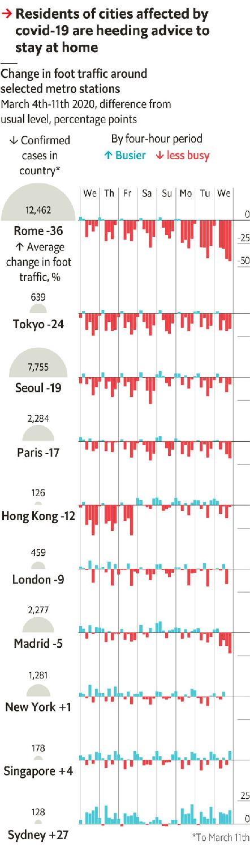

THE PHOTOS look like stills from “28 Days Later”, a post-apocalyptic film. In St Mark’s Square in Venice, pigeons outnumber tourists. Madrid is closing prestigious art museums, including the Prado and the Reina Sofía. Beijing’s Forbidden City has been shut for weeks. Football matches are being played in front of empty stands.

The quarantines and directives to avoid travel set up in response to covid-19, a new disease, have reduced visits to tourist sites. But do these eerie images reflect a broad retreat from public spaces? Data from Google show that the virus has indeed prompted a sharp decline in overall foot traffic. They also suggest that shops and restaurants in places where covid-19 is now taking root should prepare for similar slowdowns.

By tracking mobile phones, Google constantly estimates how busy places are relative to historical averages. For example, Rome’s central train station, Termini, is typically most crowded at 9am on Fridays. Google assigns this peak level a value of 100, and expresses footfall at other times as a share of this maximum. The average value throughout the week at Termini is 30.

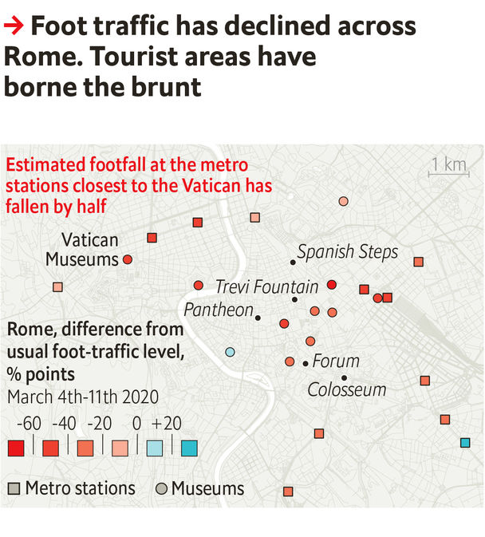

March 6th, however, was an unusual Friday. Even though Rome was not yet subject to an official lockdown, at 9am that day Google reported a foot-traffic level at Termini of just 31, 69 points below the average for that time. The pattern was similar at other times, and at 14 other stations and 11 museums in Rome—though the declines were steeper in tourist areas than in places frequented by locals. In total, Rome’s metro was about one-third less busy during the past week than normal, the biggest drop-off among the 18 cities we tracked. Moreover, the decline in Rome’s pedestrian traffic sharpened from 15% when the week began to around 50% when it ended.

Rome is the capital of a country with a dire outbreak, but it reflects a broad pattern. From March 3rd to 11th, footfall at metro stations was below the usual rate in 12 of the 18 cities. Among those 12, the average drop was 15%. The other cities with big dips were mainly in Asia, where covid-19 began.

In some Asian cities, the rate of new cases has fallen and normal life is resuming. Foot traffic in Hong Kong returned to standard levels on March 7th. Conversely, metro stations in New York are as busy as ever, just as the city’s outbreak gathers speed. If its counterparts elsewhere are any guide, the worst lies ahead.■

Sources: Google; Johns Hopkins CSSE; The Economist

This article was downloaded by calibre from <https://www.economist.com/graphic-detail/2020/03/14/foot-traffic-has-fallen-sharply-in-cities-with-big-coronavirus-outbreaks>

|  |  |  |  |
| --- | --- | --- | --- |
|  | Articles | Sections | Next |

|  |  |  |
| --- | --- | --- |
| Graphic detail | Sections |  |

Obituary

Freeman Dyson: Infinite possibilities

.

|  |  |  |
| --- | --- | --- |
| Graphic detail | Sections |  |

|  |  |  |  |
| --- | --- | --- | --- |
|  | Articles | Sections | Next |

#### Infinite possibilities

# Freeman Dyson died on February 28th

The maverick physicist and big thinker was 96

Mar 14th 2020 |

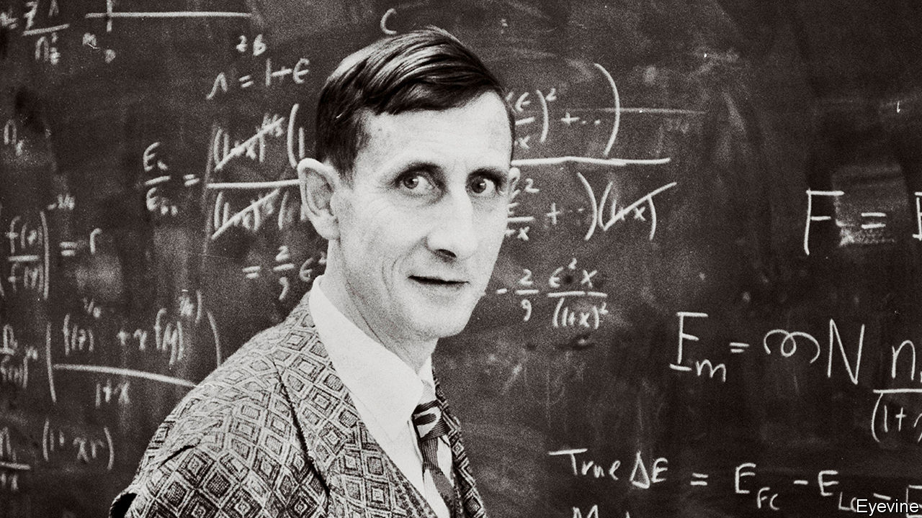

THERE ARE, wrote Freeman Dyson towards the end of his long life, two different kinds of mathematicians. Some are birds, who fly high, surveying the broad vistas and spotting unexpected links between different bits of the mathematical landscape. Others are frogs, who prefer to be up close and on the ground, delighting in the details and the beauty of the flowers.

He counted himself among the frogs, and started there. At the age of 24 he made a fundamental contribution to the study of Diophantine equations, a branch of mathematics dating back to the ancient Greeks. A year later he resolved a tricky conundrum in quantum electrodynamics, a field so new that it had hardly existed when he was born. But already the airborne tendencies were stirring. He was fascinated by biology, engineering, international relations and, in particular, physics, at which he became a master. For him, it was an ideal subject. Its mathematical underpinnings might be abstruse and theoretical, but in the 20th century those theories handed blunt, world-changing power to nations that could master their applications. In the second world war, he applied his mathematics at Britain’s Bomber Command to calculate the most destructive (but safe) formations for the planes to fly in. After the war, when he moved to the Institute for Advanced Study in Princeton, he rubbed shoulders with both Albert Einstein, whose theorising on relativity he had revered since boyhood, and Robert Oppenheimer, who had developed the atomic bomb.

Despite a lack of credentials (he never got round to earning his PhD; friends joked that he was the world’s most accomplished graduate student), he was plainly clever. By the age of five, growing up in Berkshire, he had tried to calculate how many atoms there were in the sun. His leisure reading as a teenager was Piaggio’s “Differential Equations”; and he had solved that quantum electrodynamics puzzle, without pen or paper, while riding in a Greyhound bus. His very cleverness, his vivid language and his faith in the potential of science—which marked him as it marked the century—meant that, even when his schemes were wildly bizarre, they were not dismissed. Colleagues respected him too much.

And the schemes came thick and fast. He proposed using genetically altered trees to turn comets into places where humans could resume an “arboreal existence”; these trees would grow hundreds of miles high, until the comet would look like a sprouting potato. He also popularised a wild thought called the Dyson sphere, a gigantic shell made of pulverised asteroids that might be spread by a very advanced civilisation round its parent star to capture all its energy. (Looking for such structures and their infra-red glow elsewhere in the galaxy, he argued, might be a good way to detect super-advanced aliens.) He imagined plants that could grow greenhouses round themselves, and genetically altered microbes that could harvest minerals and clear up plastic litter from space.

In 1958 he was briefly lured away from his professorship at the IAS to work on Project Orion: a plan to build a rocket, propelled by nuclear power, that would be faster and more efficient than any other. The basic principle was to throw a stream of nuclear bombs out of the back of the rocket, detonate them, and ride the shock waves to Mars and beyond. On paper, it seemed to work. Flight tests on small models, using conventional explosives, were encouraging. Orion could reach Mars in weeks, where chemical rockets would take six months or more. A more powerful version could cross the vast void to Alpha Centauri, the nearest star to the sun, in a bit over a century. Since the bigger the rocket, the more efficient it was, he proposed a 240m-ton ship 90 miles in diameter, designed to carry thousands of colonists and make humanity an interstellar species. Whether he was serious, even he may not have known.

The project was scuppered in the end by a mix of political queasiness over the fallout (rather literally—later modelling suggested that each launch of a modestly-sized rocket from Earth’s surface would kill about ten people) and the partial test ban treaty of 1963, which forbade nuclear explosions except underground. He was involved in that too, arguing in favour of the ban, in his clipped home-counties tones, in front of America’s Senate. Since the power they had unleashed thrust physicists into high places, he also became a government adviser on science and grand strategy. He was on the board of sponsors of the Bulletin of the Atomic Scientists, maintainers of the nuclear Doomsday Clock, which now stands at 100 seconds to midnight. There was far more to nuclear weapons, he knew, than the science that had spawned them. He wrestled with the moral questions they raised, studying game theory in an effort to work out when, if ever, it might make sense to use such a weapon in anger. The problem of nuclear war, it seemed to him, was fundamentally not technical but human and historical.

He was an iconoclast, too, and enjoyed being known as one. Heretics were useful in science. It was far better to be contradicted than ignored; better to be wrong than vague. As a colleague said, whenever consensus was forming like ice hardening on a lake, he would do his best to chip away at it. He dared to challenge natural selection as the only driver of evolution, and he queried climate change: not the fact that it was happening, but the usefulness of the models that aimed to predict its effects. In any case, some of those effects might be beneficial—a longer growing season, for example, and fewer deaths from the cold. Environmentalism struck him as more a religion than a science.

Not that he was against religion; he supported it, in a diffident Church of England way. To get back beyond the Big Bang, certainly, you needed religion. But the real faith that sustained him was a boundless belief in the power and possibilities of science. He had witnessed at first hand how it could give mere mortals the power to destroy their own world. Perhaps they could use science to save it, too—or, if not, leave it for another altogether. ■

This article was downloaded by calibre from <https://www.economist.com/obituary/2020/03/14/freeman-dyson-died-on-february-28th>

|  |  |  |  |
| --- | --- | --- | --- |
|  | Articles | Sections | Next |